

**Capstone Project Report**

**Report 7 – Software Design Document**

– Ho Chi Minh, August 2021 –

**Table of Contents**

**Acknowledge 21**

**Definition and Acronyms 21**

**I. Project Introduction 22**

**1. Overview 22**

**1.1 Project Information 22**

**1.2 Project Team 22**

**2. Product Background 23**

**3. Existing Systems 23**

**4. Business Opportunity 23**

**5. Software Product Vision 24**

**6. Project Scope & Limitations 24**

**6.1 Major Features 24**

**6.2 Limitations & Exclusions 25**

**II. Project Management Plan 25**

**1. Overview 25**

**1.1 WBS & Estimation 25**

**1.2 Project Objectives 30**

**1.3 Project Risks 30**

**2. Management Approach 30**

**2.1 Project Process 30**

**2.2 Quality Management 31**

**2.3 Training Plan 32**

**3. Master Schedule 32**

**4. Project Organization 33**

**4.1 Team & Structures 33**

**4.2 Roles & Responsibilities 33**

**5. Project Communication 34**

**5.1 Communication Plan 34**

**5.2 External Interface 34**

**6. Configuration Management 35**

**6.1 Tools & Infrastructures 35**

**6.2 Document Management 35**

**6.3 Source Code Management 35**

**III. System Requirement Specification 35**

**1. Overall Description 35**

**1.1 Product Overview 35**

**1.2 Business Rules 37**

**2. User Requirements 45**

**2.1 Overview 45**

**2.2 User case specification (Web Application) 48**

**2.3 User case specification (Mobile) 130**

**3. Functional Requirements 208**

**3.1 System Functional Overview 208**

**4. Non-Functional Requirements 226**

**4.1 External Interfaces 226**

**4.2 Quality Attributes 227**

**5. Other Requirements 228**

**5.1 Messages List 228**

**IV. Software Design Description 234**

**1. Overall Description 234**

**1.1 Assumptions 234**

**1.2 Design Constraints 235**

**2. System Architecture Design 235**

**2.1 Overall Architecture 235**

**2.2 Package Diagram 236**

**3. System Detailed Design 239**

**3.1 Class Diagram 239**

**3.2 Class Specification 239**

**3.3 Sequence Diagrams 248**

**3.4 Activity Diagrams 285**

**4. Data & Database Design 323**

**4.1 Database Design 323**

**5. Algorithms & Research 330**

**5.1 Detect emotion 330**

**5.2 Counting the customers 341**

**V. Software Testing Documentation 346**

**1. Overall Description 346**

**1.1 Test Model 346**

**1.2 Testing Levels 346**

**1.3 Testing Types 346**

**2. Test Plan 346**

**2.1 Test Stages 346**

**2.2 Resources 347**

**2.3 Test Milestones 347**

**2.4 Deliverables 347**

**3. Test Cases 347**

**4. Test Reports 348**

**VI. Release Package & User Guides 350**

**1. Deliverable Package 350**

**1.1 Source codes & documents 350**

**1.2 Known Issues, Limitations & Restrictions 350**

**2. Installation Guides 350**

**2.1 System Requirements 350**

**2.2 Environment setup requirements 352**

**2.3 Setup Files 352**

**2.4 Installation Instruction 353**

**3. User Manual 369**

**3.1 Application Usage 369**

**VII. Appendix 502**

**1. Glossary 502**

**2. References 502**

**List of Figures**

Figure 1. DevOps lifecycle 31

Figure 2. Team Structures 33

Figure 3. <Use Case Overview> CFFE Web Application 46

Figure 4. <Use Case Overview> CFFE Mobile Application 46

Figure 5. <Overview Use Case> Unauthenticated User 48

Figure 6. <Use Case> Login by account 48

Figure 7. <Overview Use Case> Authenticated User 50

Figure 8. <Use Case> Logout 51

Figure 9. <Use Case> Get own profile 52

Figure 10. <Use Case> Update own profile 53

Figure 11. <Use Case> Get the report 56

Figure 12. <Use Case> Download the report 57

Figure 13. <Use Case> Get the video 59

Figure 14. <Use Case> Get the products 60

Figure 15. <Use Case> Get product detail 61

Figure 16. <Use Case> Get the categories 62

Figure 17. <Use Case> Get category detail 63

Figure 18. <Use Case> Get the cameras 64

Figure 19. <Use Case> Get camera detail 65

Figure 20. <Overview Use Case> Manager 67

Figure 21. <Use Case> Get the shelves 68

Figure 22. <Use Case> Get shelf detail 69

Figure 23. <Use Case> Update the shelf 70

Figure 24. <Use Case> Delete the shelf 73

Figure 25. <Use Case> Create the shelf 74

Figure 26. <Use Case> Get the stacks 76

Figure 27. <Use Case> Get stack detail 77

Figure 28. <Use Case> Update the stack 78

Figure 29. <Use Case> Delete the shelf 81

Figure 30. <Use Case> Create the stack 83

Figure 31. <Use Case> Upload the videos 84

Figure 32. <Use Case> Get the cameras 86

Figure 33. <Use Case> Get the stores 87

Figure 34. <Use Case> Get store detail 88

Figure 35. <Use Case> Update the store 89

Figure 36. <Use Case> Delete the store 93

Figure 37. <Use Case> Create the store 95

Figure 38. <Use Case> Get the manager 97

Figure 39. <Use Case> Get store detail 98

Figure 40. <Use Case> Update the manager 99

Figure 41. <Use Case> Reset account's password 103

Figure 42. <Use Case> Delete the manager 105

Figure 43. <Use Case> Create the manager 106

Figure 44. <Use Case> Create the account 109

Figure 45. <Use Case> Update the product 110

Figure 46. <Use Case> Delete the product 113

Figure 47. <Use Case> Create the product 114

Figure 48. <Use Case> Update the camera 116

Figure 49. <Use Case> Delete the camera 119

Figure 50. <Use Case> Create the camera 120

Figure 51. <Use Case> Update the category 122

Figure 52. <Use Case> Delete the category 124

Figure 53. <Use Case> Create the category 125

Figure 54. <Overview Use Case> System AI 127

Figure 55. <Use Case> Analyze facial emotion 128

Figure 56. <Use Case> Count the customers 129

Figure 57. <Overview Use Case> Unauthenticated User 130

Figure 58. <Use Case> Login by account 131

Figure 59. <Overview Use Case> Authenticated User 133

Figure 60. <Use Case> Logout 133

Figure 61. <Use Case> Get own profile 134

Figure 62. <Use Case> Update own profile 135

Figure 63. <Use Case> Get the report 138

Figure 64. <Use Case> Download the report 139

Figure 65. <Use Case> Get the video 141

Figure 66. <Use Case> Get the products 142

Figure 67. <Use Case> Get product detail 143

Figure 68. <Use Case> Get the categories 144

Figure 69. <Use Case> Get category detail 145

Figure 70. <Use Case> Get the cameras 146

Figure 71. <Use Case> Get camera detail 147

Figure 72. <Overview Use Case> Manager 149

Figure 73. <Use Case> Get the shelves 149

Figure 74. <Use Case> Get shelf detail 151

Figure 75. <Use Case> Update the shelf 152

Figure 76. <Use Case> Delete the shelf 155

Figure 77. <Use Case> Create the shelf 156

Figure 78. <Use Case> Get the stacks 158

Figure 79. <Use Case> Get stack detail 159

Figure 80. <Use Case> Update the stack 160

Figure 81. <Use Case> Delete the shelf 163

Figure 82. <Use Case> Create the stack 165

Figure 83. <Use Case> Get the cameras 167

Figure 84. <Use Case> Get the stores 168

Figure 85. <Use Case> Get store detail 169

Figure 86. <Use Case> Update the store 170

Figure 87. <Use Case> Delete the store 174

Figure 88. <Use Case> Create the store 176

Figure 89. <Use Case> Get the manager 178

Figure 90. <Use Case> Get store detail 179

Figure 91. <Use Case> Update the manager 180

Figure 92. <Use Case> Reset account's password 184

Figure 93. <Use Case> Delete the manager 186

Figure 94. <Use Case> Create the manager 187

Figure 95. <Use Case> Create the account 190

Figure 96. <Use Case> Update the product 191

Figure 97. <Use Case> Delete the product 194

Figure 98. <Use Case> Create the product 195

Figure 99. <Use Case> Update the camera 197

Figure 100. <Use Case> Delete the camera 200

Figure 101. <Use Case> Create the camera 201

Figure 102. <Use Case> Update the category 203

Figure 103. <Use Case> Update the category 205

Figure 104. <Use Case> Create the category 207

Figure 105. <Screen Flow> Admin Mobile App 209

Figure 106. <Screen Flow> Admin Web App 210

Figure 107. <Screen Flow> Manager Mobile App 211

Figure 108. <Screen Flow> Manager Web App 212

Figure 109. <Entity Relationship Diagram> Conceptual 224

Figure 110. <Entity Relationship Diagram> Logical 225

Figure 111. Overall architecture 235

Figure 112. Overall architecture technology applied 235

Figure 113. <Package Diagram> Back-end 236

Figure 114. <Package Diagram> Web App 237

Figure 115. <Package Diagram> Mobile App 238

Figure 116. Class Diagram 239

Figure 117. <Sequence Diagram> Login 248

Figure 118. <Sequence Diagram> Reset manager’s account password 249

Figure 119. <Sequence Diagram> Change the password 250

Figure 120. <Sequence Diagram> Get own profile 251

Figure 121. <Sequence Diagram> Update the own profile 252

Figure 122. <Sequence Diagram> Create the manager 253

Figure 123. <Sequence Diagram> Delete the manager 254

Figure 124. <Sequence Diagram> Update the manager 255

Figure 125. <Sequence Diagram> Get the manager detail 256

Figure 126. <Sequence Diagram> Get the managers 257

Figure 127. <Sequence Diagram> Create the store 258

Figure 128. <Sequence Diagram> Delete the store 259

Figure 129. <Sequence Diagram> Update the store 260

Figure 130. <Sequence Diagram> Get the store detail 261

Figure 131. <Sequence Diagram> Get the stores 262

Figure 132. <Sequence Diagram> Create the shelf 263

Figure 133. <Sequence Diagram> Delete the shelf 264

Figure 134. <Sequence Diagram> Update the shelf 265

Figure 135. <Sequence Diagram> Get the shelf detail 266

Figure 136. <Sequence Diagram> Get the shelves 267

Figure 137. <Sequence Diagram> Create the stack 268

Figure 138. <Sequence Diagram> Delete the stack 269

Figure 139. <Sequence Diagram> Update the stack 270

Figure 140. <Sequence Diagram> Get the stack detail 271

Figure 141. <Sequence Diagram> Get the stacks 272

Figure 142. <Sequence Diagram> Create the product 273

Figure 143. <Sequence Diagram> Delete the product 274

Figure 144. <Sequence Diagram> Update the product 275

Figure 145. <Sequence Diagram> Get the product detail 276

Figure 146. <Sequence Diagram> Get the products 277

Figure 147. <Sequence Diagram> Create the category 278

Figure 148. <Sequence Diagram> Delete the category 279

Figure 149. <Sequence Diagram> Update the category 280

Figure 150. <Sequence Diagram> Get the category detail 281

Figure 151. <Sequence Diagram> Get the categories 282

Figure 152. <Sequence Diagram> Get the video 283

Figure 153. <Sequence Diagram> Upload the video 284

Figure 154. <Activity Diagram> Login 285

Figure 155. <Activity Diagram> Get the stores 286

Figure 156. <Activity Diagram> Get store detail 287

Figure 157. <Activity Diagram> Update the store 288

Figure 158. <Activity Diagram> Delete the store 289

Figure 159. <Activity Diagram> Create the store 290

Figure 160. <Activity Diagram> Get the managers 291

Figure 161. <Activity Diagram> Get manager detail 292

Figure 162. <Activity Diagram> Update the manager 293

Figure 163. <Activity Diagram> Delete the manager 294

Figure 164. <Activity Diagram> Create the manager 295

Figure 165. <Activity Diagram> Update the product 296

Figure 166. <Activity Diagram> Delete the product 297

Figure 167. <Activity Diagram> Create the product 298

Figure 168. <Activity Diagram> Update the camera 299

Figure 169. <Activity Diagram> Create the camera 300

Figure 170. <Activity Diagram> Delete the camera 301

Figure 171. <Activity Diagram> Update the category 302

Figure 172. <Activity Diagram> Create the category 303

Figure 173. <Activity Diagram> Get the shelves 304

Figure 174. <Activity Diagram> Get shelf detail 305

Figure 175. <Activity Diagram> Update the shelf 306

Figure 176. <Activity Diagram> Delete the shelf 307

Figure 177. <Activity Diagram> Create the shelf 308

Figure 178. <Activity Diagram> Get the stacks 309

Figure 179. <Activity Diagram> Get stack detail 310

Figure 180. <Activity Diagram> Update the stack 311

Figure 181. <Activity Diagram> Delete the stack 312

Figure 182. <Activity Diagram> Logout 313

Figure 183. <Activity Diagram> Change account's password 314

Figure 184. <Activity Diagram> Get the report 315

Figure 185. <Activity Diagram> Get the video 316

Figure 186. <Activity Diagram> Get the products 317

Figure 187. <Activity Diagram> Get product detail 318

Figure 188. <Activity Diagram> Get the categories 319

Figure 189. <Activity Diagram> Get category detail 320

Figure 190. <Activity Diagram> Get camera detail 321

Figure 191. <Activity Diagram> Get the cameras 322

Figure 192. Database Design 323

Figure 193. CNN architecture 331

Figure 194. Extracting critical features in convolution layer 331

Figure 195. Convolution example in process 332

Figure 196. Pooling example in process 332

Figure 197. Max pooling 333

Figure 198. Fully-connected example in process 333

Figure 199. ReLU example in process 334

Figure 200. Softmax example in process 334

Figure 201. MTCNN architecture 334

Figure 202. Resizing image 335

Figure 203. Stage 1 example process 335

Figure 204. Stage 2 example process 335

Figure 205. Stage 3 example process 336

Figure 206. Modified VGG-Face model architecture 336

Figure 207. Step 1 in emotion classification 337

Figure 208. Step 2 in emotion classification 337

Figure 209. Step 3 in emotion classification 337

Figure 210. Step 4 in emotion classification 338

Figure 211. Step 5 in emotion classification 338

Figure 212. Data augmentation 338

Figure 213. Single image 339

Figure 214. Evaluate MTCNN model 340

Figure 215. Evaluate VGG-Face model 340

Figure 216. Compare between models 341

Figure 217. SSD300(VGG16) Architecture 342

Figure 218. Step 1 in Tracking Object Algorithm 343

Figure 219. Step 2 in Tracking Object Algorithm 344

Figure 220. Step 3 in Tracking Object Algorithm 344

Figure 221. Step 4 in Tracking Object Algorithm 345

Figure 222. Agile model 346

Figure 223. Test Case Report 348

Figure 224. Unit Test Case Report 350

Figure 225. Login GCP form 353

Figure 226. Choose configs VM 355

Figure 227. Run as root user 355

Figure 228. “InstallModules.sh” file contents. 356

Figure 229. Run the bash script file 356

Figure 230. Reload the config bash file 357

Figure 231. Check the installed modules 357

Figure 232. Check “CFFE_SYSTEM.zip” file 358

Figure 233. View MySQL temporary password 358

Figure 234. Change MySQL password 359

Figure 235. Execute database script file 359

Figure 236. Check database created 360

Figure 237. Configure the MySQL new password for Backend API 360

Figure 238. Get public IP backend API server 361

Figure 239. Configure URL API for Font-end 361

Figure 240. Deploy Backend API 362

Figure 241. Access Backend API 362

Figure 242. Access CFFE web Access CFFE web 363

Figure 243. Mobile Install Step 1 364

Figure 244. Mobile Install Step 2 365

Figure 245. Mobile Install Step 3 366

Figure 246. Mobile Install Step 4 367

Figure 247. Login Page 368

Figure 248. <Flow Screen> Web Application - Admin 370

Figure 249. Login Page 371

Figure 250. <User Guide> Home Page 371

Figure 251. <User Guide> Home Page 372

Figure 252. Profile page 373

Figure 253. Change own avatar 373

Figure 254. Change own password 374

Figure 255. Update own information 375

Figure 256. Video page 376

Figure 257. Manager page 376

Figure 258. Create the manager 377

Figure 259. Manager detail page 378

Figure 260. Manager detail page 378

Figure 261. Change the manger avatar 379

Figure 262. Delete the manger 380

Figure 263. Reset the manager password 381

Figure 264. Update the manger information 381

Figure 265. Add the store into the manager 382

Figure 266. Remove the store from the manager 383

Figure 267. Store page 383

Figure 268. Create the store 384

Figure 269. Store detail page 385

Figure 270. Store detail page 385

Figure 271. Change the store avatar 386

Figure 272. Delete the store 387

Figure 273. Update the store information 387

Figure 274. Add the manager into the store 388

Figure 275. Remove the manager from the store 389

Figure 276. Camera page 389

Figure 277. Create the camera 390

Figure 278. Camera detail page 391

Figure 279. Change the camera avatar 391

Figure 280. Delete the camera 392

Figure 281. Update the camera information 393

Figure 282. Product page 393

Figure 283. Create the product 394

Figure 284. Product detail page 395

Figure 285. Change the product avatar 395

Figure 286. Delete the product 396

Figure 287. Update the product information 397

Figure 288. Category page 397

Figure 289. Category page 398

Figure 290. Create the category 399

Figure 291. Update the category information 399

Figure 292. Delete the category 400

Figure 293. <Flow Screen> Web Application - Manager 401

Figure 294. Login page 402

Figure 295. Home page 402

Figure 296. Home page 403

Figure 297. Profile page 403

Figure 298. Change own avatar 404

Figure 299. Change own password 405

Figure 300. Update own information 406

Figure 301. Video page 406

Figure 302. Upload video 407

Figure 303. Shelf page 408

Figure 304. Create the shelf 408

Figure 305. Shelf detail page 409

Figure 306. Shelf detail page 409

Figure 307. Shelf detail page 410

Figure 308. Update the shelf information 411

Figure 309. Delete the shelf 412

Figure 310. Add the camera into the shelf 412

Figure 311. Add the product into the stack 413

Figure 312. Remove the camera from the shelf 414

Figure 313. Delete the stack 414

Figure 314. Remove the product from the stack 415

Figure 315. Add the camera into the stack 416

Figure 316. Remove the camera from the stack 417

Figure 317. Camera page 417

Figure 318. Product page 418

Figure 319. Category page 419

Figure 320. <Flow Screen> Mobile Application - Admin 420

Figure 321. Login Page 421

Figure 322. Dashboard Page 422

Figure 323. Dashboard Page 423

Figure 324. Manager detail page 424

Figure 325. Change own information 425

Figure 326. Change own avatar 426

Figure 327. Change own avatar 427

Figure 328. Change own password 428

Figure 329. Video page 429

Figure 330. Manager page 430

Figure 331. Create the manager 431

Figure 332. Manager detail page 432

Figure 333. Manager detail page 433

Figure 334. Change the manager’s information 434

Figure 335. Change the manager’s avatar 435

Figure 336. Change the manager’s avatar 436

Figure 337. Reset the manager’s password 437

Figure 338. Delete the manager 438

Figure 339. Add the store into the manager 439

Figure 340. Add the store into the manager 440

Figure 341. Remove the store from the manager 441

Figure 342. Store page 442

Figure 343. Create the store 443

Figure 344. Store detail page 444

Figure 345. Store detail page 445

Figure 346. Change the store’s information 446

Figure 347. Change the store’s image 447

Figure 348. Change the store’s image 448

Figure 349. Delete the store 449

Figure 350. Add the manager into the store 450

Figure 351. Add the manager into the store 451

Figure 352. Remove the manager from the store 452

Figure 353. Camera page 453

Figure 354. Create the camera 454

Figure 355. Camera detail page 455

Figure 356. Change the camera’s information 456

Figure 357. Change the camera’s image 457

Figure 358. Change the camera’s image 458

Figure 359. Delete the camera 459

Figure 360. Product page 460

Figure 361. Create the product 461

Figure 362. Product detail page 462

Figure 363. Change the product’s information 463

Figure 364. Change the product’s image 464

Figure 365. Change the product’s image 465

Figure 366. Delete the product 466

Figure 367. Category page 467

Figure 368. Create the category 468

Figure 369. Category detail page 469

Figure 370. Change the category’s information 470

Figure 371. Delete the category 471

Figure 372. <Flow Screen> Mobile Application - Manager 472

Figure 373. Login page 473

Figure 374. Dashboard page 474

Figure 375. Navigator 475

Figure 376. Manager profile page 476

Figure 377. Change the own information 477

Figure 378. Change own avatar 478

Figure 379. Change own avatar 479

Figure 380. Change own password 480

Figure 381. Video page 481

Figure 382. Shelf page 482

Figure 383. Create the shelf 483

Figure 384. Shelf detail page 484

Figure 385. Shelf detail page 485

Figure 386. Change the shelf’s information 486

Figure 387. Delete the shelf 487

Figure 388. Add the camera into the shelf 488

Figure 389. Add the camera into the shelf 489

Figure 390. Remove the camera form the shelf 490

Figure 391. Stack detail page 491

Figure 392. Stack detail page 492

Figure 393. Delete the stack 493

Figure 394. Add the product into the stack 494

Figure 395. Add the product into the stack 495

Figure 396. Add the camera into the stack 496

Figure 397. Add the camera into the stack 497

Figure 398. Remove the camera from the stack 498

Figure 399. Remove the product from the stack 499

Figure 400. Camera page 500

Figure 401. Product page 501

Figure 402. Category page 502

**List of Tables**

Table 1. Definitions and Acronyms 20

Table 2. Supervisors 21

Table 3. Team Members 21

Table 4. WBS & Estimation 24

Table 5. Project Risks 28

Table 6. Training Plan 30

Table 7. Master Schedule 30

Table 8. Roles & Responsibilities 31

Table 9. Communication Plan 32

Table 10. FU Contacts 32

Table 11. Tools & Infrastructures 33

Table 12. Business Rules 35

Table 13. System actors 44

Table 14. Use case list 45

Table 15. <Use Case> Login by account 47

Table 16. <Use Case> Logout 49

Table 17. <Use Case> Get own profile 50

Table 18. <Use Case> Update own profile 51

Table 19. <Use Case> Get the report 54

Table 20. <Use Case> Download the report 55

Table 21. <Use Case> Get the video 57

Table 22. <Use Case> Get the products 58

Table 23. <Use Case> Get product detail 59

Table 24. <Use Case> Get the categories 60

Table 25. <Use Case> Get category detail 61

Table 26. <Use Case> Get the cameras 62

Table 27. <Use Case> Get camera detail 64

Table 28. <Use Case> Get the shelves 66

Table 29. <Use Case> Get shelf detail 67

Table 30. <Use Case> Update the shelf 68

Table 31. <Use Case> Delete the shelf 71

Table 32. <Use Case> Create the shelf 73

Table 33. <Use Case> Get the stacks 74

Table 34. <Use Case> Get stack detail 75

Table 35. <Use Case> Update the stack 76

Table 36. <Use Case> Delete the shelf 79

Table 37. <Use Case> Create the stack 81

Table 38. <Use Case> Upload the videos 82

Table 39. <Use Case> Get the stores 85

Table 40. <Use Case> Get store detail 86

Table 41. <Use Case> Update the store 87

Table 42. <Use Case> Delete the store 91

Table 43. <Use Case> Create the store 93

Table 44. <Use Case> Get the manager 95

Table 45. <Use Case> Get store detail 96

Table 46. <Use Case> Update the manager 97

Table 47. <Use Case> Reset account's password 101

Table 48. <Use Case> Delete the manager 103

Table 49. <Use Case> Create the manager 105

Table 50. <Use Case> Create the account 107

Table 51. <Use Case> Update the product 108

Table 52. <Use Case> Delete the product 111

Table 53. <Use Case> Create the product 113

Table 54. <Use Case> Update the camera 114

Table 55. <Use Case> Delete the camera 117

Table 56. <Use Case> Create the camera 118

Table 57. <Use Case> Update the category 120

Table 58. <Use Case> Delete the category 122

Table 59. <Use Case> Create the category 124

Table 60. <Use Case> Analyze facial emotion 126

Table 61. <Use Case> Count the customers 127

Table 62. <Use Case> Login by account 129

Table 63. <Use Case> Logout 131

Table 64. <Use Case> Get own profile 132

Table 65. <Use Case> Update own profile 133

Table 66. <Use Case> Get the report 136

Table 67. <Use Case> Download the report 137

Table 68. <Use Case> Get the video 139

Table 69. <Use Case> Get the products 140

Table 70. <Use Case> Get product detail 141

Table 71. <Use Case> Get the categories 142

Table 72. <Use Case> Get category detail 143

Table 73. <Use Case> Get the cameras 144

Table 74. <Use Case> Get camera detail 146

Table 75. <Use Case> Get the shelves 148

Table 76. <Use Case> Get shelf detail 149

Table 77. <Use Case> Update the shelf 150

Table 78. <Use Case> Delete the shelf 153

Table 79. <Use Case> Create the shelf 154

Table 80. <Use Case> Get the stacks 156

Table 81. <Use Case> Get stack detail 157

Table 82. <Use Case> Update the stack 158

Table 83. <Use Case> Delete the shelf 161

Table 84. <Use Case> Create the stack 163

Table 85. <Use Case> Get the stores 166

Table 86. <Use Case> Get store detail 167

Table 87. <Use Case> Update the store 168

Table 88. <Use Case> Delete the store 172

Table 89. <Use Case> Create the store 174

Table 90. <Use Case> Get the manager 176

Table 91. <Use Case> Get store detail 177

Table 92. <Use Case> Update the manager 178

Table 93. <Use Case> Reset account's password 182

Table 94. <Use Case> Delete the manager 184

Table 95. <Use Case> Create the manager 186

Table 96. <Use Case> Create the account 188

Table 97. <Use Case> Update the product 189

Table 98. <Use Case> Delete the product 192

Table 99. <Use Case> Create the product 194

Table 100. <Use Case> Update the camera 195

Table 101. <Use Case> Delete the camera 198

Table 102. <Use Case> Create the camera 200

Table 103. <Use Case> Update the category 201

Table 104. <Use Case> Update the category 203

Table 105. <Use Case> Create the category 205

Table 106. Admin Mobile App Screen Detail 210

Table 107. Admin Web App Screen Detail 212

Table 108. Manager Mobile App Screen Detail 214

Table 109. Manager Web App Screen Detail 216

Table 110. Web Application Screen Authorization 217

Table 111. Web Application Screen Authorization 219

Table 112. Non-Screen functions 222

Table 113. Entity Description 223

Table 114. Message List 226

Table 115. <Class Specification> Camera 237

Table 116. <Class Specification> Category 238

Table 117. <Class Specification> City 238

Table 118. <Class Specification> District 238

Table 119. <Class Specification> Emotion 239

Table 120. <Class Specification> HotSpot 239

Table 121. <Class Specification> Product 240

Table 122. <Class Specification> ProductCategoryMapping 240

Table 123. <Class Specification> Role 241

Table 124. <Class Specification> Shelf 241

Table 125. <Class Specification> ShelfCameraMapping 241

Table 126. <Class Specification> Stack 242

Table 127. <Class Specification> StackProductCameraMapping 242

Table 128. <Class Specification> Status 243

Table 129. <Class Specification> Store 243

Table 130. <Class Specification> User 244

Table 131. <Class Specification> UserStoreMapping 244

Table 132. <Class Specification> Video 245

Table 133. <Database Design> tblCity 321

Table 134. <Database Design> tblDistrict 321

Table 135. <Database Design> tblRole 322

Table 136. <Database Design> tblStatus 322

Table 137. <Database Design> tblUser 322

Table 138. <Database Design> tblStore 323

Table 139. <Database Design> tblCamera 323

Table 140. <Database Design> tblCategory 324

Table 141. <Database Design> tblEmotion 324

Table 142. <Database Design> tblHotSpot 324

Table 143. <Database Design> tblProduct 325

Table 144. <Database Design> tblProductCategoryMapping 325

Table 145. <Database Design> tblShelf 325

Table 146. <Database Design> tblShelfCameraMapping 326

Table 147. <Database Design> tblStack 326

Table 148. <Database Design> tblStackProductCameraMapping 327

Table 149. <Database Design> tblUserStoreMapping 327

Table 150. <Database Design> tblVideo 327

Table 151. Test stages 344

Table 152. Human resources 345

Table 153. Test milestones 345

Table 154. Deliverables 345

Table 155. Source Codes & Documents 348

Table 156. Back End Server – Recommended Hardware Configuration 349

Table 157. Web Server – Recommended hardware configuration 349

Table 158. Mobile Device – Recommended hardware configuration 350

Table 159. <User Guide> Login 369

Table 160. <User Guide> Home Page 370

Table 161. <User Guide> Profile page 371

Table 162. <User Guide> Change own avatar 372

Table 163. <User Guide> Change own password 372

Table 164. <User Guide> Update own information 373

Table 165. <User Guide> Video page 374

Table 166. <User Guide> Manager page 375

Table 167. <User Guide> Create the manager 375

Table 168. <User Guide> Manager detail page 377

Table 169. <User Guide> Manager detail page 377

Table 170. <User Guide> Delete the manger 378

Table 171. <User Guide> Reset the manager password 379

Table 172. <User Guide> Update the manger information 380

Table 173. <User Guide> Add the store into the manager 380

Table 174. <User Guide> Remove the store from the manager 381

Table 175. <User Guide> Store page 382

Table 176. <User Guide> Create the store 382

Table 177. <User Guide> Store detail page 383

Table 178. <User Guide> Change the store avatar 384

Table 179. <User Guide> Delete the store 385

Table 180. <User Guide> Update the store information 386

Table 181. <User Guide> Add the manager into the store 386

Table 182. <User Guide> Remove the manager from the store 387

Table 183. <User Guide> Camera page 388

Table 184. <User Guide> Create the camera 388

Table 185. <User Guide> Camera detail page 389

Table 186. <User Guide> Change the camera avatar 390

Table 187. <User Guide> Delete the camera 390

Table 188. <User Guide> Update the camera information 391

Table 189. <User Guide> Product page 392

Table 190. <User Guide> Create the product 392

Table 191. <User Guide> Product detail page 393

Table 192. <User Guide> Change the product avatar 394

Table 193. <User Guide> Delete the product 394

Table 194. <User Guide> Update the product information 395

Table 195. <User Guide> Category page 396

Table 196. <User Guide> Create the category 397

Table 197. <User Guide> Update the category information 398

Table 198. <User Guide> Delete the category 398

Table 199. <User Guide> Login page 400

Table 200. <User Guide> Home page 401

Table 201. <User Guide> Profile page 402

Table 202. <User Guide> Change own avatar 402

Table 203. <User Guide> Change own password 403

Table 204. <User Guide> Update own information 404

Table 205. <User Guide> Video page 405

Table 206. <User Guide> Upload video 405

Table 207. <User Guide> Shelf page 406

Table 208. <User Guide> Create the shelf 406

Table 209. <User Guide> Shelf detail page 408

Table 210. <User Guide> Update the shelf information 409

Table 211. <User Guide> Delete the shelf 410

Table 212. <User Guide> Add the camera into the shelf 411

Table 213. <User Guide> Add the product into the stack 411

Table 214. <User Guide> Remove the camera from the shelf 412

Table 215. <User Guide> Delete the stack 413

Table 216. <User Guide> Remove the product from the stack 413

Table 217. <User Guide> Add the camera into the stack 414

Table 218. <User Guide> Remove the camera from the stack 415

Table 219. <User Guide> Camera page 416

Table 220. <User Guide> Product page 416

Table 221. <User Guide> Category page 417

Table 222. <User Guide> Login 419

Table 223. <User Guide> Navigation 421

Table 224. <User Guide> Manager detail page 422

Table 225. <User Guide> Change own information 423

Table 226. <User Guide> Change own avatar 425

Table 227. <User Guide> Change own password 426

Table 228. <User Guide> Video page 427

Table 229. <User Guide> Manager page 428

Table 230. <User Guide> Create the manager 429

Table 231. <User Guide> Manager detail page 431

Table 232. <User Guide> Change the manager’s information 432

Table 233. <User Guide> Change the manager’s avatar 434

Table 234. <User Guide> Reset the manager’s password 435

Table 235. <User Guide> Delete the manager 436

Table 236. <User Guide> Add the store into the manager 438

Table 237. <User Guide> Remove the store from the manager 439

Table 238. <User Guide> Store page 440

Table 239. <User Guide> Create the store 441

Table 240. <User Guide> Store detail page 443

Table 241. <User Guide> Change the store’s information 444

Table 242. <User Guide> Change the store’s image 446

Table 243. <User Guide> Delete the store 447

Table 244. <User Guide> Add the manager into the store 449

Table 245. <User Guide> Remove the manager from the store 450

Table 246. <User Guide> Camera page 451

Table 247. <User Guide> Create the camera 452

Table 248. <User Guide> Camera detail page 453

Table 249. <User Guide> Change the camera’s information 454

Table 250. <User Guide> Change the camera’s image 456

Table 251. <User Guide> Delete the camera 457

Table 252. <User Guide> Product page 458

Table 253. <User Guide> Create the product 459

Table 254. <User Guide> Product detail page 460

Table 255. <User Guide> Change the product’s information 461

Table 256. <User Guide> Change the product’s image 463

Table 257. <User Guide> Delete the product 464

Table 258. <User Guide> Category page 465

Table 259. <User Guide> Create the category 466

Table 260. <User Guide> Category detail page 467

Table 261. <User Guide> Change the category’s information 468

Table 262. <User Guide> Delete the category 469

Table 263. <User Guide> Login page 471

Table 264. <User Guide> Dashboard page 473

Table 265. <User Guide> Manager profile page 474

Table 266. <User Guide> Change the own information 475

Table 267. <User Guide> Change own avatar 477

Table 268. <User Guide> Change own password 478

Table 269. <User Guide> Video page 479

Table 270. <User Guide> Shelf page 480

Table 271. <User Guide> Create the shelf 481

Table 272. <User Guide> Shelf detail page 483

Table 273. <User Guide> Change the shelf’s information 484

Table 274. <User Guide> Delete the shelf 485

Table 275. <User Guide> Add the camera into the shelf 487

Table 276. <User Guide> Remove the camera from the shelf 488

Table 277. <User Guide> Stack detail page 490

Table 278. <User Guide> Delete the stack 491

Table 279. <User Guide> Add the product into the stack 493

Table 280. <User Guide> Add the camera into the stack 495

Table 281. <User Guide> Remove the camera from the stack 496

Table 282. <User Guide> Remove the product from the stack 497

Table 283. <User Guide> Camera page 498

Table 284. <User Guide> Product page 499

Table 285. <User Guide> Category page 500

**Acknowledge**

First of all, we would like to express our sincere and deepest gratitude to our supervisors, Mr. Pham Cong Thanh and Mr. Doan Nguyen Thanh Hoa, for giving us the precious opportunity to participate in this project. During the process of making the project, the enthusiasm, understanding and valuable knowledge you bring to us are what makes us very grateful. No matter day or night, as long as we have problems, you are always ready to support without complaining, once again we would like to sincerely thank you Mr. Thanh and Mr. Hoa.

We owe deep thanks to lecturers for taking valuable time to help us review this project. Furthermore, all of you also gave very sincere and accurate suggestions to help us realize where the problem is and what we should do to make this project more complete.

We would like to thanks to each individual in our group for our enthusiasm, hard-working, and non-stop effort. Sometimes our group fell into a state of deadlock, stress, and fatigue, but luckily, we all tried to overcome them to reach today. Special thanks to Than Nhat Truong for being a great leader, always be the one who gives the best effort and direction for group members. Thanks, Do Ngoc Huu for always tolerating the mistakes of us and the diligent no matter day or night. Much appreciations to Nguyen Thanh Hieu for his silent contributions and always actively taking care of other members. Thanks, Nguyen Minh Luan for not giving up and always trying to care about the smallest things.

Last but not least, we would like to extend our gratitude to our families and friends who have provided emotional and practical support for this project. Thanks for everything all of you give us, we will forever be engraved in our hearts.

# Definition and Acronyms

Table 1. Definitions and Acronyms

|  |  |
| --- | --- |
| **Acronym** | **Definition** |
| BR | Business Rule |
| BA | Business Analysis |
| ERD | Entity Relationship Diagram |
| GUI | Graphical User Interface |
| UC | Use Case |
| API | Application Programming Interface |
| FE | Feature |
| LI | Limitation |
| EX | Exclusion |
| WBS | Work Breakdown Structure |
| JSON | JavaScript Object Notation |
| CUDA | Compute Unified Device Architecture |
| IIS | Internet Information Services |
| CFFE | Customer Feedback Through Facial Expression Analysis |
| Hot Spot | Count number of customers in specific area |

**I. Project Introduction**

**1. Overview**

**1.1 Project Information**

* Project name: Customer Feedback Through Facial Expression Analysis
* Project code: CFFE
* Group name: CFFE Team
* Software type: Web App, Mobile App

**1.2 Project Team**

**a. Supervisors**

Table . Supervisors

|  |  |  |  |
| --- | --- | --- | --- |
| **Full Name** | **Email** | **Phone Number** | **Title** |
| Pham Cong Thanh | thanhpc@fe.edu.vn | 0908316748 | Lecturer |
| Doan Nguyen Thanh Hoa | hoadnt@fe.edu.vn | 0985050004 | Lecturer |

**b. Team Members**

Table . Team Members

|  |  |  |  |
| --- | --- | --- | --- |
| **Full Name** | **Email** | **Mobile** | **Role** |
| Than Nhat Truong | truongtnse130426@fpt.edu.vn | 0971601584 | Leader |
| Do Ngoc Huu | huudnse130557@fpt.edu.vn | 0397189696 | Member |
| Nguyen Thanh Hieu | hieuntse130434@fpt.edu.vn | 0392997510 | Member |
| Nguyen Minh Luan | luannmse62431@fpt.edu.vn | 0336808288 | Member |

**2. Product Background**

Capturing customer psychology and product experience emotions, identifying areas where customers often have a habit of going back and forth is always a matter of concern for product suppliers. They can make better product judgments and strategies based on customer experience reports from distribution affiliates.

Specifically, based on the report, the product supplier can determine which products are of interest, which areas of the store have a lot of people passing through. So that they can easily make decisions such as promoting advertising, discounting items of little interest, and placing new products in high-traffic areas.

**3. Existing Systems**

In the process of market research, we found that companies and organizations in Vietnam mostly choose the traditional solution: hiring staff to collect data manually, follow up with eyes. This traditional approach is inefficient due to human error, and high operating costs.

**4. Business Opportunity**

With the development of computers, we are interested in applying AI solutions to shorten the current manual process, thereby improving efficiency in capturing the emotions of product experience in products designated areas, and count the number of customers passing through the store. This system is developed in accordance with the actual conditions and infrastructure in Vietnam today.

**5. Software Product Vision**

CFFE is a system that will automate some manual steps in the entire process. This can save employees' time, reduce costs for companies, organizations, and reduce processes that depend on people.

In more detail, CFFE is a system that uses IP cameras installed in specific areas of the system to count people in certain areas, and analyze customers' emotions automatically. After that, the system will store the analyzed video so that the user can check the authenticity of the data.

**6. Project Scope & Limitations**

**6.1 Major Features**

1. **Admin**

**FE-01:** Create, view, update, delete, reset password, create account for manager.

**FE-02**: Create, view, update, delete store.

**FE-03**: Create, update, delete product.

**FE-04**: Create, update, delete camera.

**FE-05**: Create, update, delete category.

1. **Manager**

**FE-06:** Create, view, update, delete shelf.

**FE-07:** Create, view, update, delete stack.

**FE-08:** Upload video.

1. **System AI**

**FE-09:** Analyze facial emotion.

**FE-10:** Count the customer.

1. **Unauthenticated User**

**FE-11:** Login by account.

1. **Authenticated User**

**FE-12:** View category.

**FE-13:** View video.

**FE-14:** View camera.

**FE-15:** View product.

**FE-16:** View, update own profile.

**FE-17:** View, download the report.

**FE-18:** Logout.

**6.2 Limitations & Exclusions**

**LI-01:** The CFFE only assists humans in detecting, it does not completely replace humans, and still need human participation to upload the video.

**LI-02:** The CFFE is currently only used for the system which has one or many stores, and has not been applied for many systems.

**LI-03:** The detection result depends on the quality of camera’s video.

**LI-04:** The CFFE has no the update detection model feature.

**LI-06:** In case too many customers in store at a time, the customer counting results may not be highly accurate.

# II. Project Management Plan

## 1. Overview

### 1.1 WBS & Estimation

Table . WBS & Estimation

|  |  |  |  |
| --- | --- | --- | --- |
| **#** | **WBS Item** | **Complexity** | **Est. Effort** |
| **1** | **Web Application for Admin** |  |  |
| **1.1** | **Manage manager** |  |  |
|  | Get the managers | Simple | 1 |
|  | Get the manager detail | Simple | 1 |
|  | Update the manager | Simple | 1 |
|  | Delete the manager | Simple | 1 |
|  | Create the manager | Simple | 1 |
| **1.2** | **Manage store** |  |  |
|  | Get the stores | Simple | 1 |
|  | Get the store detail | Simple | 1 |
|  | Update the store | Simple | 1 |
|  | Delete the store | Simple | 1 |
|  | Create the store | Simple | 1 |
| **1.3** | **Manage product** |  |  |
|  | Get the products | Simple | 1 |
|  | Get the product detail | Simple | 1 |
|  | Update the product | Simple | 1 |
|  | Delete the product | Simple | 1 |
|  | Create the product | Simple | 1 |
| **1.4** | **Manage camera** |  |  |
|  | Get the cameras | Medium | 3 |
|  | Get the camera detail | Medium | 3 |
|  | Update the camera | Simple | 1 |
|  | Delete the camera | Simple | 1 |
|  | Create the camera | Simple | 1 |
| **1.5** | **Manage category** |  |  |
|  | Get the categories | Simple | 1 |
|  | Get the category detail | Simple | 1 |
|  | Update the category | Simple | 1 |
|  | Delete the category | Simple | 1 |
|  | Create the category | Simple | 1 |
| **1.6** | **Get the report** | Medium | 3 |
| **1.7** | **Get the video** | Simple | 1 |
| **1.8** | **Reset manager’s account password** | Simple | 1 |
| **1.9** | **Get own profile** | Simple | 1 |
| **1.10** | **Update own profile** | Simple | 1 |
| **1.11** | **Login** | Simple | 1 |
| **1.12** | **Logout** | Simple | 1 |
| **2** | **Web Application for Manager** |  |  |
| **2.1** | **Manage shelf** |  |  |
|  | Get the shelves | Simple | 1 |
|  | Get the shelf detail | Medium | 3 |
|  | Update the shelf | Medium | 3 |
|  | Delete the shelf | Simple | 1 |
|  | Create the shelf | Simple | 1 |
| **2.2** | **Manage stack** |  |  |
|  | Get the stacks | Simple | 1 |
|  | Get the stack detail | Medium | 3 |
|  | Update the stack | Medium | 3 |
|  | Delete the stack | Simple | 1 |
|  | Create the stack | Simple | 1 |
| **2.3** | **Get the report** | Medium | 3 |
| **2.4** | **Get the video** | Medium | 3 |
| **2.5** | **Upload video** | Complex | 7 |
| **2.6** | **Get own profile** | Simple | 1 |
| **2.7** | **Update own profile** | Simple | 1 |
| **2.8** | **Login** | Simple | 1 |
| **2.9** | **Logout** | Simple | 1 |
| **3** | **Mobile Application for Admin** |  |  |
| **3.1** | **Manage manager** |  |  |
|  | Get the managers | Simple | 1 |
|  | Get the manager detail | Simple | 1 |
|  | Update the manager | Simple | 1 |
|  | Delete the manager | Simple | 1 |
|  | Create the manager | Simple | 1 |
| **3.2** | **Manage store** |  |  |
|  | Get the stores | Simple | 1 |
|  | Get the store detail | Simple | 1 |
|  | Update the store | Simple | 1 |
|  | Delete the store | Simple | 1 |
|  | Create the store | Simple | 1 |
| **3.3** | **Manage product** |  |  |
|  | Get the products | Simple | 1 |
|  | Get the product detail | Simple | 1 |
|  | Update the product | Simple | 1 |
|  | Delete the product | Simple | 1 |
|  | Create the product | Simple | 1 |
| **3.4** | **Manage camera** |  |  |
|  | Get the cameras | Medium | 3 |
|  | Get the camera detail | Medium | 3 |
|  | Update the camera | Simple | 1 |
|  | Delete the camera | Simple | 1 |
|  | Create the camera | Simple | 1 |
| **3.5** | **Manage category** |  |  |
|  | Get the categories | Simple | 1 |
|  | Get the category detail | Simple | 1 |
|  | Update the category | Simple | 1 |
|  | Delete the category | Simple | 1 |
|  | Create the category | Simple | 1 |
| **3.6** | **Get the report** | Medium | 3 |
| **3.7** | **Get the video** | Medium | 3 |
| **3.8** | **Change manager’s account password** | Simple | 1 |
| **3.9** | **Get own profile** | Simple | 1 |
| **3.10** | **Update own profile** | Simple | 1 |
| **3.11** | **Login** | Simple | 1 |
| **3.12** | **Logout** | Simple | 1 |
| **4** | **Mobile Application for Manager** |  |  |
| **4.1** | **Manage shelf** |  |  |
|  | Get the shelves | Simple | 1 |
|  | Get the shelf detail | Medium | 3 |
|  | Update the shelf | Medium | 3 |
|  | Delete the shelf | Simple | 1 |
|  | Create the shelf | Simple | 1 |
| **4.2** | **Manage stack** |  |  |
|  | Get the stacks | Simple | 1 |
|  | Get the stack detail | Medium | 3 |
|  | Update the stack | Simple | 3 |
|  | Delete the stack | Simple | 1 |
|  | Create the stack | Simple | 1 |
| **4.3** | **Get the report** | Simple | 3 |
| **4.4** | **Get the video** | Medium | 3 |
| **4.5** | **Get own profile** | Simple | 1 |
| **4.6** | **Update own profile** | Simple | 1 |
| **4.7** | **Login** | Simple | 1 |
| **4.8** | **Logout** | Simple | 1 |
| **5** | **System AI** |  |  |
| **5.1** | **Analyze facial emotion** | Complex | 7 |
| **5.2** | **Count the customers** | Complex | 7 |
| **Total Estimated Effort (man-days)** | | | **161** |

### 1.2 Project Objectives

* Timeliness: 70%
* Allocated Effort: 4 (members) * 4 (months) * 21 (days/month) = 336 man-days
* Estimated total cost: 7 million VNĐ

### 1.3 Project Risks

Table . Project Risks

|  |  |  |  |  |
| --- | --- | --- | --- | --- |
| **#** | **Risk Description** | **Impact** | **Possibility** | **Response Plans** |
| 1 | Team cannot find the real store environment. | Delayed progress. | Medium | Finding and setting up a simulating environment. |
| 2 | Need to research new technologies and solutions. | Delayed progress. | Low | Spending more time learning. |

## 2. Management Approach

### 2.1 Project Process



Figure . DevOps lifecycle

***Source:***[*https://www.guru99.com/devops-tutorial.html*](https://www.guru99.com/devops-tutorial.html)

CFFE system is developed using the DevOps model is a simple framework for the most effective coordination among development team members when implementing complex products.

Some reasons why we choose DevOps:

* Easy to learn and use.
* Suitable for small and medium projects.
* Optimize team performance and efficiency.

Continuous DevOps Life-cycle:

* Development
* Testing
* Integration
* Deployment
* Monitoring

### 2.2 Quality Management

* Make rules about clean coding convention to easily manage and support each other.
* Carefully cross-review code.
* Do user testing.

### 2.3 Training Plan

Table . Training Plan

|  |  |  |  |
| --- | --- | --- | --- |
| **Training Area** | **Participants** | **When, Duration** | **Waiver Criteria** |
| Machine Learning basic | All member | Week 1, 7 days | Mandatory |
| Git, Github | All member | Week 2, 3 days | Mandatory |
| Flutter | All member | Week 3, 5 days | Mandatory |
| VueJS | All member | Week 3-4, 7 days | Mandatory |

## 3. Master Schedule

***Note:*** *Effort unit is day*

Table . Master Schedule

|  |  |  |  |
| --- | --- | --- | --- |
| **#** | **Deliverable** | **Due Date** | **Deliverable Scope** |
| 1 | Project Plan document | 08/06/2021 | Overall project plan |
| 2 | Report 1 | 11/06/2021 | Project introduction |
| 3 | Report 2 | 18/06/2021 | Project management plan |
| 4 | Report 3 | 25/06/2021 | Software requirement specification |
| 5 | Report 4 | 2/07/2021 | Software design document |
| 6 | Report 5 | 25/08/2021 | Test case document, test documentation |
| 7 | Report 6 | 12/07/2021 | Software user guides |
| 8 | Report 7 | 18/08/2021 | Final project final |
| 9 | Code package 1 | 18/06/2021 | Code, System test reports |
| 10 | Code package 2 | 1/07/2021 | Code, System test reports |
| 11 | Code package 3 | 15/08/2021 | Code, System test reports |
| 12 | Code font-end 1 | 18/06/2021 | Code, design screen |
| 13 | Code font-end 2 | 1/07/2021 | Code, design screen |
| 14 | Code font-end 3 | 15/08/2021 | Code, design screen |
| 15 | Final package | 18/08/2021 | Final code package and documents |

## 4. Project Organization

### 4.1 Team & Structures



Figure . Team Structures

### 4.2 Roles & Responsibilities

Table . Roles & Responsibilities

|  |  |
| --- | --- |
| **Role** | **Responsibility** |
| Project Manager | * Specify user requirements. * Specify system’s features. * Support team in technical and business analysis. |
| Team Leader | * Plan projects and assign tasks to team members. * Support members to complete tasks on time. |
| Analysis Team | * Analyses user requirements and business rules. * Research other directions to promptly change and correct. |
| System Design Team | * Determine the appropriate architecture for the property of the project. * Outline the goals of the project. * Propose solutions to meet the given objectives. |
| Mobile Module Development Team | * Implement user interface. * Implement code for management. |
| Web Module Development Team | * Implement user interface. * Implement code for management. |
| Counting Customers Module Development Team | * Implement code for counting the customers. |
| Detection Emotion Module Development Team | * Implement code for emotion detection. |
| Backend Module Development Team | * Implement code for backend API. |

## 5. Project Communication

### 5.1 Communication Plan

Table . Communication Plan

|  |  |  |  |  |
| --- | --- | --- | --- | --- |
| **Communication Item** | **Who/ Target** | **Purpose** | **When, Frequency** | **Type, Tool, Method(s)** |
| Working in group | Team members | * Improve group solidarity. * Members with good skills can train other members. * Discuss and work together to help each other | 6 days per week | Face to face, Online |
| Mentoring | Team members and Mentors | * Review team’s work progress. * Give advice and direction. * Technical support. | 3, 4 times per week | Face to face, Online |

### 5.2 External Interface

#### a. FU Contacts

Table . FU Contacts

|  |  |  |  |
| --- | --- | --- | --- |
| **Function** | **Contact Person**  **(name, position)** | **Contact address**  **(email, telephone)** | **Responsibility** |
| Supervisor | Pham Cong Thanh  Doan Nguyen Thanh Hoa | ThanhPC3@fe.edu.vn  HoaDNT@fe.edu.vn | * Provide document template. * Give instruction to project team. * Review deliverables. * Supervise project status |

## 6. Configuration Management

### 6.1 Tools & Infrastructures

Table . Tools & Infrastructures

|  |  |
| --- | --- |
| **Programming languages** | **Java, JavaScript, Dart, Python** |
| Framework | Spring Boot, MyBatis, VueJS, Flutter, Tensorflow, Keras |
| API | Rest API |
| DBMS | MySQL |
| IDEs/Editors | IntelliJ, Visual Studio Code |
| UML tools | Draw.io, StarUML |
| Version Control | Git |
| Deployment server | Google Compute Service |
| Project management tool | Trello |

### 6.2 Document Management

Use Google Shared Drives and Trello to manage easily.

### 6.3 Source Code Management

Use Git.

# III. System Requirement Specification

## 1. Overall Description

### 1.1 Product Overview

#### Unauthenticated User Requirements

Unauthenticated user who has not been identified by CFFE system. Unauthenticated user has limited access to the system with the following feature:

* Login by account

#### Authenticated User Requirements

Authenticated User who has been logged into the CFFE system. Authenticated user can use the following functions:

* Logout
* Get own profile
* Update own profile
* Get the report
* Download the report
* Get the video
* Get the products
* Get product detail
* Get the categories
* Get category detail
* Get the cameras
* Get camera detail

#### Manager Requirements

Manager is a person who accesses to the system as manager role. Manager can use the following functions:

* Get the shelves
* Get shelf detail
* Update the shelf
* Delete the shelf
* Create the shelf
* Get the stacks
* Get stack detail
* Update the stack
* Delete the stack
* Create the stack
* Upload the videos

#### Admin Requirements

Admin is a person who accesses to the system as admin role. Admin can use the following functions:

* Get the stores
* Get store detail
* Update the store
* Delete the store
* Create the store
* Get the managers
* Get manager detail
* Update the manager
* Reset account's password
* Delete the manager
* Create the manager
* Create the account
* Update the product
* Delete the product
* Create the product
* Update the camera
* Delete the camera
* Create the camera
* Update the category
* Delete the category
* Create the category

#### System AI Requirements

System AI is an actor which can do:

* Analyze facial expression
* Count the customers

### 1.2 Business Rules

Table 12. Business Rules

|  |  |
| --- | --- |
| **ID** | **Rule Definition** |
| BR-001 | User logs in CFFE system by username and password are registered. If the username and password are correct, CFFE system redirects users to "Dash board" page. |
| BR-002 | After successful login, the system will automatically generate a token and send it to the client. The client will save in local storage and cookies. |
| BR-003 | When changing the manager status to inactive, there must be a reason and sure that this store is removed from the manager. |
| BR-004 | After logging out successfully, user becomes the “Unauthenticated User” and CFFE system will redirect to login page. |
| BR-005 | Information on local storage will be removed on the client-side. |
| BR-006 | Cookies will be destroyed on the client-side. |
| BR-007 | The password must be SHA256 encrypted before sending it to the server. |
| BR-008 | After resting account's password or creating account successfully, CFFE system sends an email for the manager that includes:   * Username * Password |
| BR-009 | Stack's status has three options:   * Active (active and has added the camera and the product) * Pending (active but has not added the product or camera) * Inactive (inactive) |
| BR-010 | CFFE system only allows users to play video that has been analyzed and stored. |
| BR-011 | Displays a list of videos with the following information:   * Store * Shelf (Counting type) * Video name * Start time * End time * Upload time * Analyzed result |
| BR-012 | Password must be at least 8 characters and contain the following:   * At least one uppercase letter * At least one lowercase letter * At least one digits |
| BR-013 | User can search the categories with following conditions:   * Category name * Status (Category’s status includes all statuses, active, and inactive) * Status's default value is all statuses. |
| BR-014 | Shelf select box can select multiple values that include:   * All shelves * Specific shelves (including active, pending, and inactive shelves that sort by shelf's name)   Default value is all shelves. |
| BR-015 | Displays a list of managers with the following information:   * No * Username * Full name * Store * Updated Time * Status |
| BR-016 | Product select box can select multiple values that include:   * All products * Specific products (including active, and inactive products that sort by product's name   Default value is all products |
| BR-017 | Admin can search the manager with following conditions:   * Search text * Option (Option includes Full name, User name) * Status (Manager’s status includes all statuses, active, pending, and inactive)   Option's default value is username  Status's default value is all status. |
| BR-018 | Analyzed options checkbox can select single values that include:   * Counting * Emotion   Default value is emotion and counting. |
| BR-019 | Video uploading is mp4 format and their name must follow the pattern:  [Camera type]_[MAC address]_[File order]  In there:   * Value of camera type is 1: counting or 2: emotion. * MAC address is for the added cameras on the shelves or stacks. |
| BR-020 | Duplicate videos could not be uploaded by checking video name, video creation date, and checking in Database. |
| BR-021 | User can search the videos with following conditions:   * Start Date * End Date * Video type: counting/emotion * Store * Shelf * Product   Start Date and End Date's default interval value is 10 days from the current date.  Store's default value is all stores.  Shelf's default value is all shelves.  Product's default value is the first value.  Video type's default value is counting.  If counting checkbox is chosen, shelf field is hidden. Else if emotion checkbox is chosen,  product field is hidden.  If user is a manager, the store will be specifically assigned the managing store and hide the store field. |
| BR-022 | Managers can only view the camera in the store they are managing and the camera has pending and inactive status. |
| BR-023 | Displays the user detail with the following information:   * Full name * Email * Gender * Birthdate * Phone * Identity card * Username * Store |
| BR-024 | The shelf can add maximum of two cameras. |
| BR-025 | After creating a successful shelf, the stacks will automatically create based on the number of stacks. |
| BR-026 | Manager can search the shelves with following conditions:   * Shelf name * Status (Shelf’s status includes all status, active, and inactive)   Status's default value is all status. |
| BR-027 | Displays a list of shelves with the following information:   * No * Shelf name * Description * Number of stacks * Updated time * Status |
| BR-028 | Displays the shelf detail with the following information:   * Shelf name * Description * Number of stacks * Created time * Updated time * Reason inactive * Status * Camera added * List of stacks * Stack detail |
| BR-029 | If the pending camera is used by any shelf or stack, the camera's status will change to active automatically.  If the active camera is removed from any shelf or stack, the camera's status will change to pending automatically. |
| BR-030 | When changing the shelf's status to inactive, there must be a reason and sure that all the stacks are inactive and all cameras on the shelf are removed. |
| BR-031 | A shelf information required fields:   * Name: between 1 - 100 characters, unique in a store * Description: between 1 - 250 characters * Number of stacks: between 1 - 30 stacks * Status: active/pending/inactive |
| BR-032 | After updating or deleting, CFFE system updates the Updated Time. |
| BR-033 | Deletion is a change to inactive status |
| BR-034 | Manager's status has three options:   * Active (Manager is active and is managing a store) * Pending (Manager is active and isn't managing a store) * Inactive (Manager is inactive) |
| BR-035 | After creation, CFFE system stores the create time. |
| BR-036 | The product must be added before the camera can be added to the stack. Conversely, camera removal is required before the product is removed from the stack. |
| BR-037 | * Displays a list of stacks with the following information: * No * Product * Camera * Status |
| BR-038 | * Displays the stack detail with the following information: * No * Product added * Camera added * Created time * Updated time * Reason inactive * Status |
| BR-039 | Manager only can select a pending camera, product to set up on the shelf, stack. |
| BR-040 | * Only stores and managers with pending status can be selected for manager and store management. |
| BR-041 | When changing the stack status from pending to inactive, there must be a reason and sure that the product and camera on the stack are removed. |
| BR-042 | If the product and camera are already on the stack, the stack's status will change to active automatically. If the product or camera on the stack is missed, the status will change to pending automatically. |
| BR-043 | A new account will be generated by the following method:   * Username: [Manager's first name] + [First letter of manager's last name] + [Sequence number]. * Password: automatically generate. |
| BR-044 | User can search the products with following conditions:   * Product name * Product category * Status (Product’s status includes all statuses, active, and inactive)   Product category's default value is all categories.  Status's default value is all statuses. |
| BR-045 | * Displays a list of products with the following information: * No * Product name * Product image * Description * Category * Updated time * Status |
| BR-046 | * Displays the product detail with the following information: * Product name * Product image * Category * Description * List of stores * List of stacks * Created * Updated time * Reason inactive * Status |
| BR-047 | * A product information required fields: * Product name: between 1 - 100 characters, unique * Image: must be png, jpg, jpeg format * Category: 1 - 3 categories * Description: between 1 - 250 characters * Status: active/inactive |
| BR-048 | * Shelf's status has three options: * Active (active and has added one or two cameras) * Pending (active but has not added the camera) * Inactive (inactive) |
| BR-049 | When changing the product status to inactive, there must be a reason and sure that this product on all stacks is removed. |
| BR-050 | Stack's No is the position on the shelf that is automatically generated by the CFFE system in the order of creation. |
| BR-051 | If the camera is already on the shelf, the shelf's status will change to active automatically.  If the camera on the shelf is missed, the shelf's status will change to pending automatically. |
| BR-052 | User can search the cameras with following conditions:   * Camera name * Store * Status (Camera’s status includes all status, active, pending, and inactive)   Store's default value is all stores  Status's default value is all status. |
| BR-053 | * Displays a list of cameras with the following information: * No * Camera name * Camera image * Store * MAC address * Updated time * Status |
| BR-054 | * Displays the camera detail with the following information: * Camera name * Camera image * Ip address * RTSP string * Shelf * Stack * Created * Updated time * Reason inactive * Status |
| BR-055 | * A camera information required fields: * Camera name: between 1 - 100 characters, unique * Image: must be png, jpg, jpeg format * IP address: x.x.x.x (x is number between 0 to 255), unique * MAC address: hexadecimal separated by "-", unique * RTSP string: at least 1 character, unique * Status: active/pending/inactive |
| BR-056 | * Camera status has three options: * Active (active and has added on a shelf or stack) * Pending (active but has not added on a shelf or stack) * Inactive (inactive) |
| BR-057 | When changing the category status to inactive, make sure that all products that have this category remove mapping. |
| BR-058 | When changing the camera status to inactive, there must be a reason and sure that this camera is removed from the shelf or stack. |
| BR-059 | Store's status has three options:   * Active (active and had added the manager) * Pending (active but hadn't added the manager) * Inactive (inactive) |
| BR-060 | A user information required fields:   * Full name: between 1 - 100 characters * Username: between 1 - 30 characters * Image: must be png, jpg, jpeg format + Gender: Male/Female * Birthday: must be DD:MM:YYYY * Identity card: between 9 - 12 digits * Phone: between 10 - 13 digits * Email: must match /^(([^<>()[\]\\.,;:\s@"]+(\.[^<>()[\]\\.,;:\s@"]+)*)|(".+"))@((\[[0-9]{1,3}\.[0-9]{1,3}\.[0-9]{1,3}\.[0-9]{1,3}\])|(([a-zA-Z\-0-9]+\.)+[a-zA-Z]{2,}))$/ regex * Address: between 1 - 250 characters + City + District * Status: active/pending/inactive |
| BR-061 | * Displays the store detail with the following information: * Full name * Username * Avatar * Gender * Birthday * Identity Card * Phone * Email * Store * Address * City * District * Created Time * Updated time * Reason inactive * Status |
| BR-062 | * Displays the category detail with the following information: * Category name * Products belongs to the category |
| BR-063 | * A category information required fields: * Category name: between 1 - 100 characters, unique |
| BR-064 | * Admin can search the stores with following conditions: * Store name * City * Status (Store’s status includes all status, active and inactive) * Status's default value is all status. * City's default value is all cities. |
| BR-065 | * Displays a list of stores with the following information: * No * Store name * Image * Manager * Address * District * City * Updated Time * Status |
| BR-066 | * Displays the store detail with the following information: * Store name * Image * Manager * Address * City * District * Product list * Camera list * Created * Updated time * Reason inactive * Status |
| BR-067 | * A store information required fields: * Store name: between 1 - 100 characters, unique * Image: must be png, jpg, jpeg format * Address: between 1 - 250 characters * City: 1 city * District: 1 district * Status: active/pending/inactive |
| BR-068 | * When granting store management rights to the manager, the status of the store and manager will automatically change to active. * When removing the manager from the store, the status of the store and manager will automatically change to pending. |
| BR-069 | When changing the store status to inactive, there must be a reason and sure that this manager is removed from the store and all shelves of this store are inactive. |
| BR-070 | After creating, the objects have the following status:   * Store: Pending * Manager: Pending * Camera: Pending * Shelf: Pending * Stack: Pending * Product: Active * Category: Active |

## 2. User Requirements

### 2.1 Overview

#### 2.1.1 Use Case Diagram

##### a. Web Application

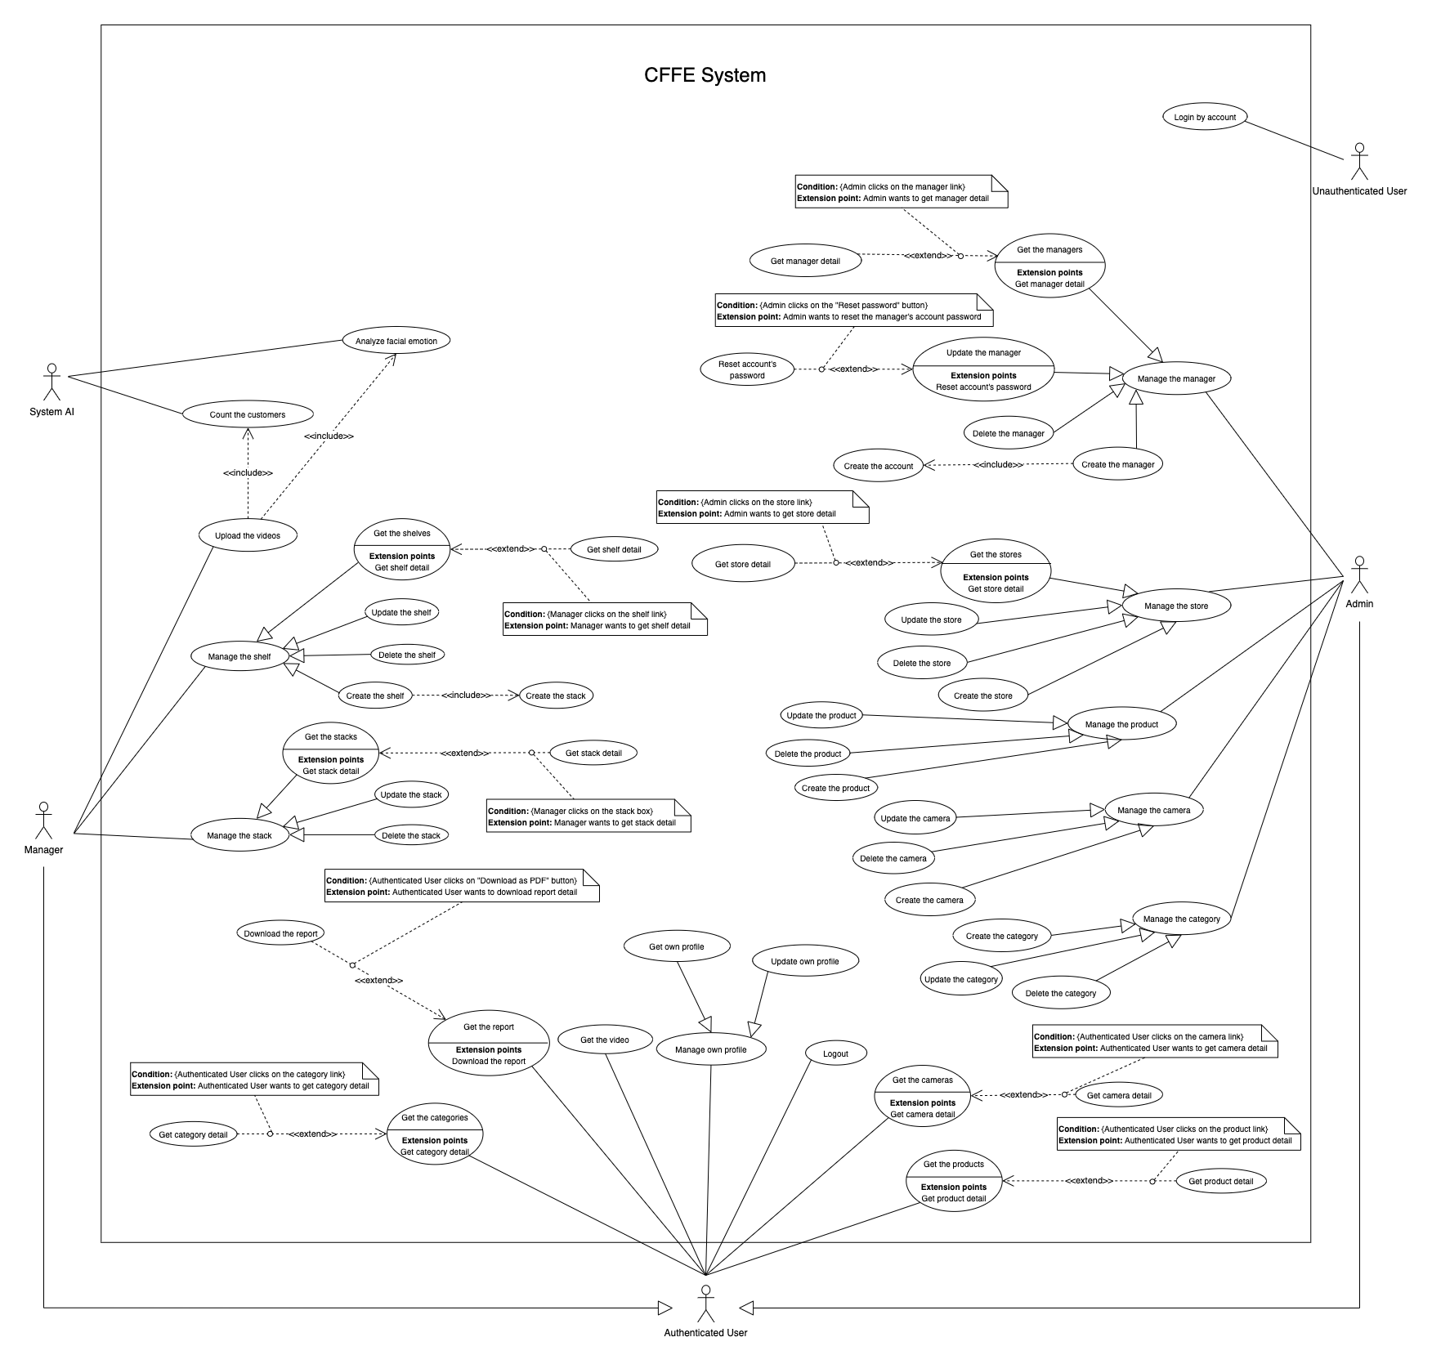

Figure . <Use Case Overview> CFFE Web Application

##### b. Mobile Application

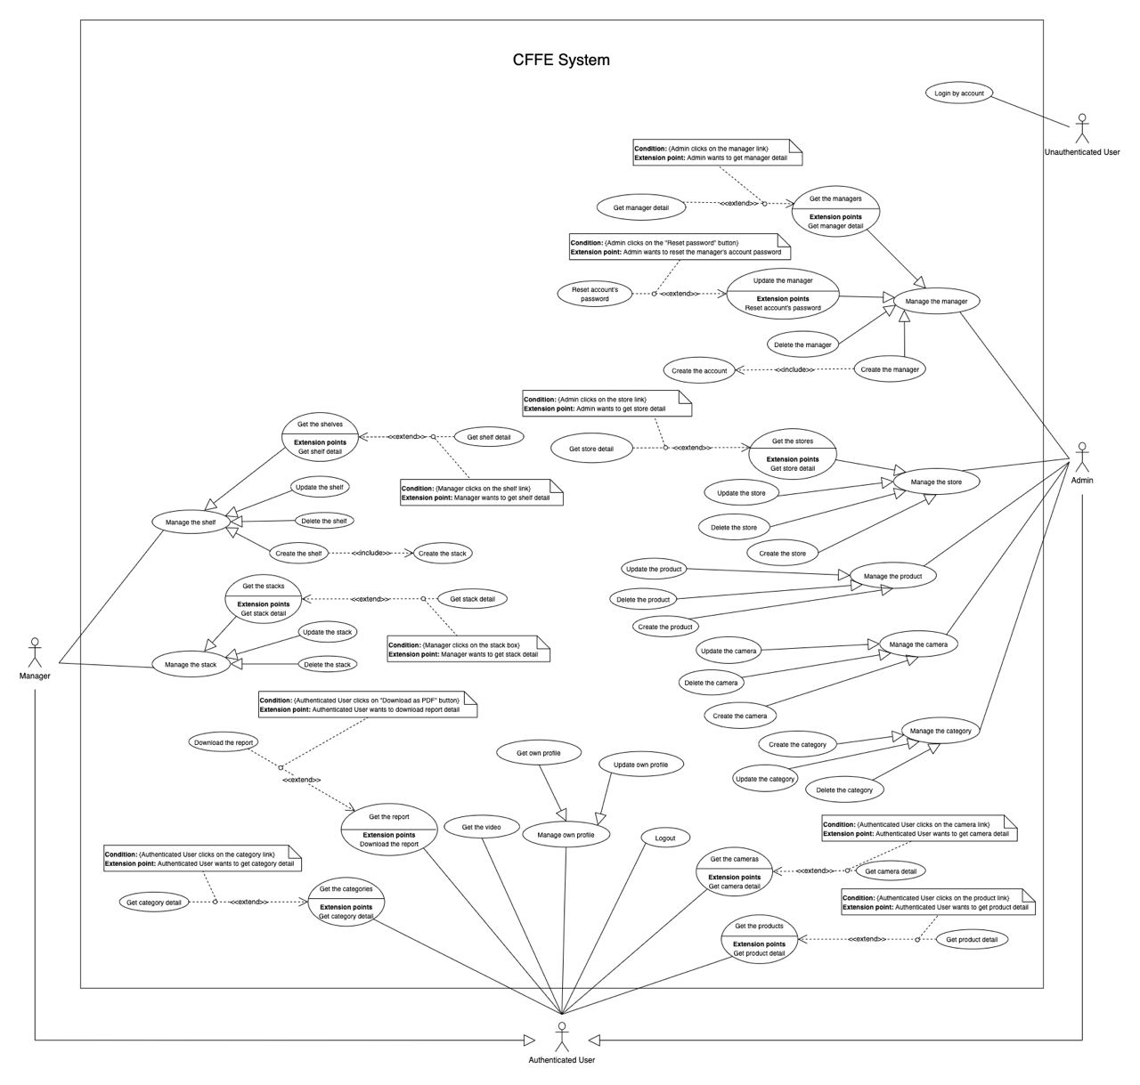

Figure . <Use Case Overview> CFFE Mobile Application

#### 2.1.2 System Actors

Table 13. System actors

|  |  |  |
| --- | --- | --- |
| **#** | **Actor** | **Description** |
| 1 | Unauthenticated User | Unauthenticated User is person who has no account. |
| 2 | Authenticated User | Authenticated User is a person who has an account in the system (There are two roles that are admin and manager). |
| 3 | Manager | Manager manages the store's products, categories, shelves, stacks, and cameras. |
| 4 | Admin | Admin manages the managers, products, cameras, categories, and stores in the system. |
| 5 | System AI | System AI analyses customers' emotions and count the customers in the stores. |

#### 2.1.3 Use Case List

Table 14. Use case list

|  |  |  |  |
| --- | --- | --- | --- |
| **ID** | **Use Case** | **Primary Actors** | **Secondary Actors** |
| UC-01 | **Login by account** | Unauthenticated User | N/A |
| UC-02 | **Logout** | Authenticated User | N/A |
| UC-03 | **Get own profile** | Authenticated User | N/A |
| UC-04 | **Update own profile** | Authenticated User | N/A |
| UC-05 | **Get the report** | Authenticated User | N/A |
| UC-06 | **Download the report** | Authenticated User | N/A |
| UC-07 | **Get the video** | Authenticated User | N/A |
| UC-08 | **Get the products** | Authenticated User | N/A |
| UC-09 | **Get product detail** | Authenticated User | N/A |
| UC-10 | **Get the categories** | Authenticated User | N/A |
| UC-11 | **Get category detail** | Authenticated User | N/A |
| UC-12 | **Get the cameras** | Authenticated User | N/A |
| UC-13 | **Get camera detail** | Authenticated User | N/A |
| UC-14 | **Get the shelves** | Manager | N/A |
| UC-15 | **Get shelf detail** | Manager | N/A |
| UC-16 | **Update the shelf** | Manager | N/A |
| UC-17 | **Delete the shelf** | Manager | N/A |
| UC-18 | **Create the shelf** | Manager | N/A |
| UC-19 | **Get the stacks** | Manager | N/A |
| UC-20 | **Get stack detail** | Manager | N/A |
| UC-21 | **Update the stack** | Manager | N/A |
| UC-22 | **Delete the stack** | Manager | N/A |
| UC-23 | **Create the stack** | Manager | N/A |
| UC-24 | **Upload the videos** | Manager | N/A |
| UC-25 | **Get the stores** | Admin | N/A |
| UC-26 | **Get store detail** | Admin | N/A |
| UC-27 | **Update the store** | Admin | N/A |
| UC-28 | **Delete the store** | Admin | N/A |
| UC-29 | **Create the store** | Admin | N/A |
| UC-30 | **Get the managers** | Admin | N/A |
| UC-31 | **Get manager detail** | Admin | N/A |
| UC-32 | **Update the manager** | Admin | N/A |
| UC-33 | **Reset account's password** | Admin | N/A |
| UC-34 | **Delete the manager** | Admin | N/A |
| UC-35 | **Create the manager** | Admin | N/A |
| UC-36 | **Create the account** | Admin | N/A |
| UC-37 | **Update the product** | Admin | N/A |
| UC-38 | **Delete the product** | Admin | N/A |
| UC-39 | **Create the product** | Admin | N/A |
| UC-40 | **Update the camera** | Admin | N/A |
| UC-41 | **Delete the camera** | Admin | N/A |
| UC-42 | **Create the camera** | Admin | N/A |
| UC-43 | **Update the category** | Admin | N/A |
| UC-44 | **Delete the category** | Admin | N/A |
| UC-45 | **Create the category** | Admin | N/A |
| UC-46 | **Analyze facial emotion** | System AI | N/A |
| UC-47 | **Count the customers** | System AI | N/A |

### 2.2 User case specification (Web Application)



#### 2.2.1 <Unauthenticated User> Overview Use Case

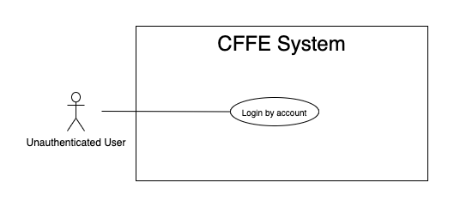

Figure . <Overview Use Case> Unauthenticated User

##### 2.2.1.1 <Unauthenticated User> Login by account



Figure . <Use Case> Login by account

Table 15. <Use Case> Login by account

|  |  |  |  |
| --- | --- | --- | --- |
| ID and Name: | **UC-01 Login by account** | | |
| Created By: | TruongTN | Date Created: | 25/06/2021 |
| Primary Actor: | Unauthenticated User | Secondary Actors: | N/A |
| Description: | This feature allows the unauthenticated user to login to CFFE system to verify the role and gives them access to more features. | | |
| Trigger: | Unauthenticated User sends a request to login to CFFE system. | | |
| Pre-conditions: | PRE-01. User's account has been created.  PRE-02. User's account has been authorized as Admin or Manager role.  PRE-03. User has not logged in to CFFE system. | | |
| Post-conditions: | POST-01:   * Success: User logins to CFFE system with own role successfully and redirect to "Dashboard" page. * Fail: CFFE system shows error message. | | |
| Normal Flow: | **1.0 Login by account**   1. Unauthenticated User send a request to login to the CFFE system. 2. CFFE system requires information from Unauthenticated User:  * “Username”: input text * “Password”: input text * “Login”: button  1. Unauthenticated User inputs a login form: username, password. 2. Unauthenticated User clicks to “Login” button. 3. CFFE system validates the username and password. (Exception 1.0.E1, 1.0.E2) 4. CFFE system determines the user’s identity, role, and permission then redirects to the "Dashboard" page. | | |
| Alternative Flows: | N/A | | |
| Exceptions: | **1.0.E1 Unauthenticated User does not enter the required fields**   1. CFFE system returns to Unauthenticated User to fill the required fields again (MSG-001, MSG-002). 2. If Unauthenticated User inputs the required fields again, CFFE system returns to step 3 of the normal flow. 3. Else if Unauthenticated User cancels the login process, then CFFE system terminates this use case.   **1.0.E2 Unauthenticated User enters wrong username or password.**   1. CFFE system returns to Unauthenticated User to fill the required fields again (MSG-003). 2. If Unauthenticated User inputs username and password again, CFFE system returns to step 3 of the normal flow. 3. Else if Unauthenticated User cancels the login process, then CFFE system terminates this use case. | | |
| Priority: | High | | |
| Frequency of Use: | Always | | |
| Business Rules: | BR-001, BR-002, BR-007 | | |
| Other Information: | In case of internet connection failure, Unauthenticated User cannot finish this use case. | | |
| Assumptions: | N/A | | |

#### 2.2.2 <Authenticated User> Overview Use Case

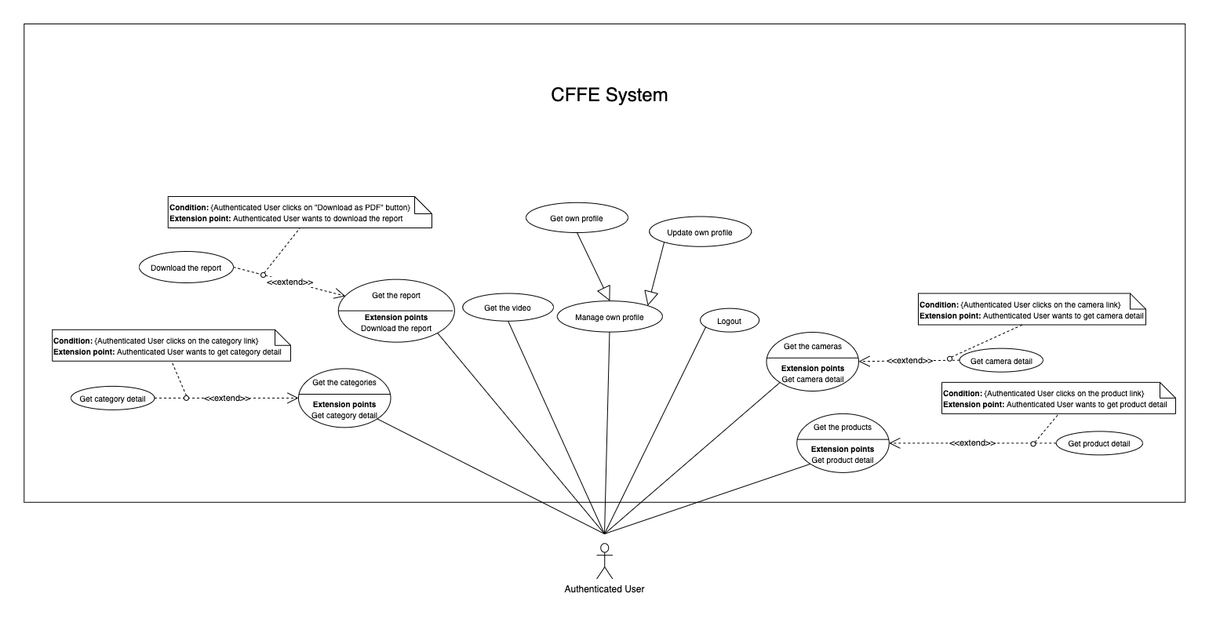

Figure . <Overview Use Case> Authenticated User

##### 2.2.2.1 <Authenticated User> Logout

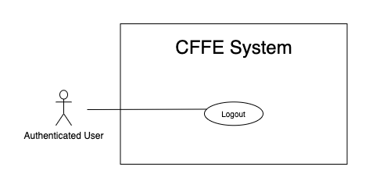

Figure . <Use Case> Logout

Table 16. <Use Case> Logout

|  |  |  |  |
| --- | --- | --- | --- |
| ID and Name: | **UC-02 Logout** | | |
| Created By: | TruongTN | Date Created: | 25/06/2021 |
| Primary Actor: | Authenticated User | Secondary Actors: | N/A |
| Description: | This feature allows the authenticated user to log out from CFFE system. | | |
| Trigger: | Authenticated user sends a request to log out from CFFE system. | | |
| Pre-conditions: | PRE-01. User has logged into CFFE system. | | |
| Post-conditions: | POST-01. User has successfully logged out CFFE system. | | |
| Normal Flow: | **2.0 Logout**   1. Authenticated user focus on username then clicks on “Logout” button on the navigation bar. 2. CFFE system deletes information on their local storage and cookie. 3. CFFE system redirects to "Login" page. | | |
| Alternative Flows: | N/A | | |
| Exceptions: | N/A | | |
| Priority: | Medium | | |
| Frequency of Use: | Usually | | |
| Business Rules: | BR-004, BR-005, BR-006 | | |
| Other Information: | In case of internet connection failure, Authenticated User cannot finish this use case. | | |
| Assumptions: | N/A | | |

##### 2.2.2.2 <Authenticated User> Get own profile

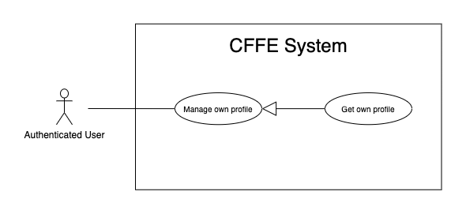

Figure . <Use Case> Get own profile

Table 17. <Use Case> Get own profile

|  |  |  |  |
| --- | --- | --- | --- |
| ID and Name: | **UC-03 Get own profile** | | |
| Created By: | HuuDN | Date Created: | 17/06/2021 |
| Primary Actor: | Authenticated User | Secondary Actors: | N/A |
| Description: | This feature allows the authenticated user to get own profile. | | |
| Trigger: | Authenticated User sends a request to get own profile. | | |
| Preconditions: | PRE-01. User has logged into CFFE system. | | |
| Post-conditions: | POST-01:   * Success: CFFE system redirects to own profile page. * Fail: CFFE system shows error message. | | |
| Normal Flow: | **3.0 Get own profile**   1. Authenticated User focus on username then clicks on "Profile" button on the navigation bar. 2. CFFE system returns own profile and redirects to profile page. (Exception 3.0.E1) | | |
| Alternative Flows: | N/A | | |
| Exceptions: | **3.0.E1 Authenticated User does not exist.**  1. CFFE system returns the message (MSG-041) and terminates this use case. | | |
| Priority: | Normal | | |
| Frequency of Use: | Sometime | | |
| Business Rules: | N/A | | |
| Other Information: | In case of internet connection failure, Authenticated User cannot finish this use case properly. | | |
| Assumptions: | N/A | | |

##### 2.2.2.3 <Authenticated User> Update own profile

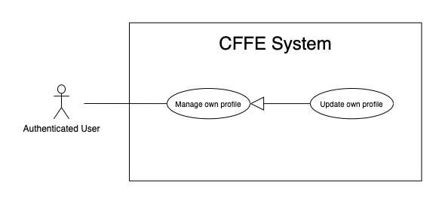

Figure 10. <Use Case> Update own profile

Table 18. <Use Case> Update own profile

|  |  |  |  |
| --- | --- | --- | --- |
| ID and Name: | **UC-04 Update own profile** | | |
| Created By: | HuuDN | Date Created: | 17/06/2021 |
| Primary Actor: | Authenticated User | Secondary Actors: | N/A |
| Description: | This feature allows the authenticated user to update own profile. | | |
| Trigger: | Authenticated User sends a request to update own profile. | | |
| Preconditions: | PRE-01. User has logged in CFFE system.  PRE-02. User is on “Profile” page. | | |
| Post-conditions: | POST-01:   * Success: CFFE system shows success message and reloads "Profile" page. * Fail: CFFE system shows error message. | | |
| Normal Flow: | **4.0 Update information** (Alternative 4.0, 4.1)   1. Authenticated User clicks on "Edit Information" button. 2. CFFE system requires profile that includes:  * “Full name”: input text * “Gender”: radio button * “Birthday”: date picker * “Identity card”: input text * “Phone number”: input text * “Email”: input text * “Address”: input text * “City”: select box * “District”: select box * “Cancel”: button * “Update”: button  1. Authenticated User inputs/selects the required fields. 2. Authenticated User clicks on “Update” button. (Alternative 4.2) 3. CFFE system validates the fields (Exception 4.0.E1, 4.0.E2) 4. CFFE system updates own profile and returns the success message (MSG-013). | | |
| Alternative Flows: | **4.0 Update Avatar**   1. Authenticated User clicks on "Update avatar" button. 2. CFFE system shows popup that includes:    * "Avatar": label    * "Choose": button    * "OK": button    * "Cancel": button 3. Authenticated User clicks on "Choose" button and selects an image. 4. Authenticated User clicks on "OK" button. (Alternative 4.2, 4.3) 5. CFFE system validates the image (Exception 4.0.E3, 4.0.E4, 4.0.E7) 6. CFFE system updates own avatar and returns the success message (MSG-013).   **4.1 Update password**   1. Authenticated User clicks on "Change password" button. 2. CFFE system shows popup that includes:    * "Old password": input text    * "New password": input text    * "Retype password": input text    * "OK": button    * "Cancel": button 3. Authenticated User inputs all fields. 4. Authenticated User clicks on "OK" button. (Alternative 4.2, 4.3) 5. CFFE system validates the image (Exception 4.0.E5, 4.0.E6) 6. CFFE system updates own password and returns the success message (MSG-013).   **4.2 Authenticated User cancels the updating process.**   1. Authenticated User clicks on "Cancel" button. 2. CFFE system closes this popup and terminates this use case.   **4.3 Authenticated User clicks outside of popup.**   1. Authenticated User clicks outside of popup. 2. CFFE system closes this popup and terminates this use case. | | |
| Exceptions: | **4.0.E1 Authenticated User does not input/select the required fields**   1. CFFE system returns to Authenticated User to input/select the required fields again (MSG-014, MSG-036, MSG-038, MSG-039, MSG-049, MSG-044, MSG-047, MSG-051, MSG-054). 2. If Authenticated User inputs/selects the required fields again, CFFE system returns to step 3 of the normal flow. 3. Else if Authenticated User cancels the updating process, then CFFE system terminates this use case.   **4.0.E2 Authenticated User inputs/selects the fields that are not valid**   1. CFFE system returns to Authenticated Users to input/select the fields again (MSG-015, MSG-037, MSG-042, MSG-045, MSG-052, MSG-073). 2. If Authenticated User inputs/selects the fields again, CFFE system returns to step 3 of the normal flow. 3. Else if Authenticated User cancels the updating process, then CFFE system terminates this use case.   **4.0.E3 Authenticated User does not select an image**   1. CFFE system returns to Authenticated User to select the required fields again (MSG-112). 2. If Authenticated User inputs/selects the required fields again, CFFE system returns to step 3 of the alternative flow 4.0. 3. Else if Authenticated User cancels the updating process, then CFFE system terminates this use case.   **4.0.E4 Image is not png/jpg/jpeg format.**   1. CFFE system shows message (MSG-027) and terminates this use case.   **4.0.E5 Authenticated User does not input the required fields**   1. CFFE system returns to Authenticated User to input/select the required fields again (MSG-004, MSG-005, MSG-006). 2. If Authenticated User inputs/selects the required fields again, CFFE system returns to step 3 of the alternative flow 4.1. 3. Else if Authenticated User cancels the updating process, then CFFE system terminates this use case.   **4.0.E6 Authenticated User inputs the fields that are not valid**   1. CFFE system returns to Authenticated Users to input/select the fields again (MSG-007, MSG-008, MSG-068). 2. If Authenticated User inputs/selects the fields again, CFFE system returns to step 3 of the alternative flow 4.1. 3. Else if Authenticated User cancels the updating process, then CFFE system terminates this use case.   **4.0.E7 CFFE system cannot upload the image.**   1. CFFE system shows error message (MSG-114) and terminates this use case. | | |
| Priority: | Medium | | |
| Frequency of Use: | Often | | |
| Business Rules: | BR-032, BR-034, BR-060 | | |
| Other Information: | In case of internet connection failure, Authenticated User cannot finish this use case properly. | | |
| Assumptions: | N/A | | |

##### 2.2.2.4 <Authenticated User> Get the report

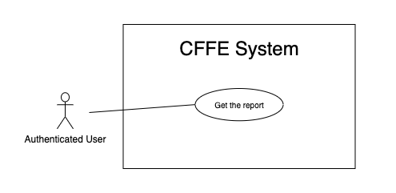

Figure . <Use Case> Get the report

Table 19. <Use Case> Get the report

|  |  |  |  |
| --- | --- | --- | --- |
| ID and Name: | **UC-05 Get the report** | | |
| Created By: | HuuDN | Date Created: | 15/06/2021 |
| Primary Actor: | Authenticated User | Secondary Actors: | N/A |
| Description: | This feature allows the Authenticated User to get the report. | | |
| Trigger: | Authenticated User sends a request to get the report. | | |
| Preconditions: | PRE-01. User has logged into CFFE system as admin or manager role. | | |
| Post-conditions: | POST-01. Authenticated User has successfully got the report. | | |
| Normal Flow: | **5.0 Get the facial expression analysis report** (Alternative 5.0)   1. Authenticated User clicks on "Dashboard" button on the navigation bar 2. Authenticated User clicks on "Emotion" button on the left-bottom navigation bar of the frame. 3. CFFE system requires the report's information from Authenticated User:  * “Product name”: select box * “Store name”: select box * “Date rage”: date range picker  1. Authenticated User selects all fields. 2. CFFE system returns the reports (Exception 5.0.E1). | | |
| Alternative Flows: | **5.0 Get the counting customer report**   1. Authenticated User clicks on "Dashboard" button on the navigation bar. 2. Authenticated User clicks on "Counting customer" button on the left-bottom navigation bar of the frame. 3. CFFE system requires the report's information from Authenticated User:  * “Store name”: select box * “Shelf name”: select box * “Date rage”: date range picker  1. Authenticated User selects all fields. 2. CFFE system returns the reports (Exception 5.0.E1). | | |
| Exceptions: | **5.0.E1 The report has no data.**   1. CFFE system returns the message (MSG-009). | | |
| Priority: | High | | |
| Frequency of Use: | Often | | |
| Business Rules: | BR-013, BR-014, BR-016 | | |
| Other Information: | In case of internet connection failure, Authenticated User cannot finish this use case properly. | | |
| Assumptions: | N/A | | |

##### 2.2.2.5 <Authenticated User> Download the report

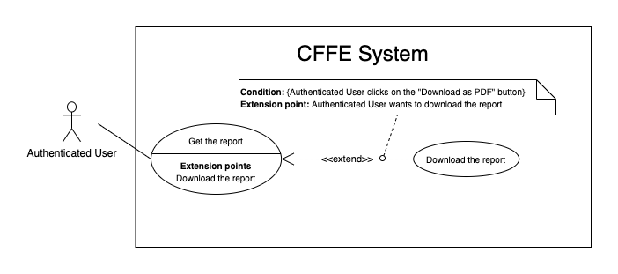

Figure . <Use Case> Download the report

Table 20. <Use Case> Download the report

|  |  |  |  |
| --- | --- | --- | --- |
| ID and Name: | **UC-06 Download the report** | | |
| Created By: | HuuDN | Date Created: | 18/06/2021 |
| Primary Actor: | Authenticated User | Secondary Actors: | N/A |
| Description: | This feature allows Authenticated User to download the report. | | |
| Trigger: | Authenticated User sends a request to download the report. | | |
| Preconditions: | PRE-01. User has logged into CFFE system as admin or manager role.  PRE-02. Authenticated User on "Dashboard" page. | | |
| Post-conditions: | POST-01. Authenticated User has successfully downloaded the report. | | |
| Normal Flow: | **6.0 Download the report**   1. Authenticated User right clicks on "Dashboard" page. 2. Authenticated User clicks on "Download as PDF" 3. CFFE system shows the popup that includes:    * "All pages": radio button    * "Select pages": radio button    * "Additional Options": dropdown list      + "Ignore custom background color": check box      + "Add a link back to report": check box      + "Password protect report": check box    * "Download": button    * "Cancel": button 4. Authenticated User selects that fields 5. Authenticated User clicks on "Download" button. (Alternative 6.0, 6.1) 6. CFFE system downloads this report on client-side. | | |
| Alternative Flows: | **6.0 Authenticated User cancels the downloading process.**   1. Authenticated User clicks on "Cancel" button. 2. CFFE system closes this popup and terminates this use case.   **6.1 Authenticated User clicks outside of popup.**   1. Authenticated User clicks outside of popup. 2. CFFE system closes this popup and terminates this use case. | | |
| Exceptions: | N/A | | |
| Priority: | High | | |
| Frequency of Use: | Often | | |
| Business Rules: | BR-008, BR-009. | | |
| Other Information: | In case of internet connection failure, Authenticated User cannot finish this use case properly. | | |
| Assumptions: | N/A | | |

##### 2.2.2.6 <Authenticated User> Get the video

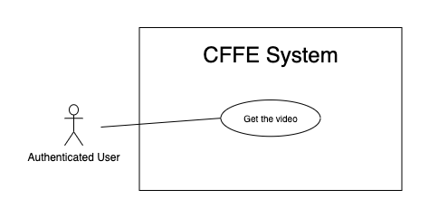

Figure . <Use Case> Get the video

Table 21. <Use Case> Get the video

|  |  |  |  |
| --- | --- | --- | --- |
| ID and Name: | **UC-07 Get the video** | | |
| Created By: | HuuDN | Date Created: | 11/06/2021 |
| Primary Actor: | Authenticated User | Secondary Actors: | N/A |
| Description: | This feature allows Authenticated User to get the video. | | |
| Trigger: | Authenticated User sends a request to get the video. | | |
| Preconditions: | PRE-01. User has logged into CFFE system as admin or manager role. | | |
| Post-conditions: | POST-01. Authenticated User has successfully got the video. | | |
| Normal Flow: | **7.0 Get the video**   1. Authenticated User clicks on "Video" button on the navigation bar. 2. CFFE system requires the video's information from Authenticated User:  * “Start Date”: text input * “End Date”: text input * “Counting”: check box * “Emotion”: check box * “Store”: select box * “Shelf”: select box * “Product”: select box  1. Authenticated User inputs/selects the fields. 2. CFFE system returns the corresponding videos (Exception 7.0.E1). | | |
| Alternative Flows: | N/A | | |
| Exceptions: | **7.0.E1 The video list has no data.**   1. CFFE system returns the message (MSG-009). | | |
| Priority: | High | | |
| Frequency of Use: | Often | | |
| Business Rules: | BR-010, BR-011, BR-021 | | |
| Other Information: | In case of internet connection failure, Authenticated User cannot finish this use case properly. | | |
| Assumptions: | N/A | | |

##### 2.2.2.7 <Authenticated User> Get the products

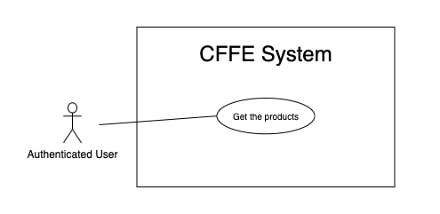

Figure . <Use Case> Get the products

Table 22. <Use Case> Get the products

|  |  |  |  |
| --- | --- | --- | --- |
| ID and Name: | **UC-08 Get the products** | | |
| Created By: | HieuNT | Date Created: | 08/05/2021 |
| Primary Actor: | Authenticated User | Secondary Actors: | N/A |
| Description: | This feature allows authenticated user to get the products. | | |
| Trigger: | Authenticated user sends a request to get the products. | | |
| Pre-conditions: | PRE-01. User has logged into the system as admin or manager role. | | |
| Post-conditions: | POST-01. CFFE system returns the list of products. | | |
| Normal Flow: | **8.0 Get the products**   1. Authenticated User clicks on "Product" button on the navigation bar. 2. CFFE system requires the product information:  * “Product name”: input text * “Category”: select box * “Status”: select box  1. Authenticated user inputs/selects the fields: product name, category, status. 2. CFFE system returns the list of products based on below conditions and display them (Exception 8.0.E1). | | |
| Alternative Flows: | N/A | | |
| Exceptions: | **8.0.E1 The list of product has no data.**   1. CFFE system returns the message (MSG-009). | | |
| Priority: | High | | |
| Frequency of Use: | Usually | | |
| Business Rules: | BR-044, BR-045 | | |
| Other Information: | In case of internet connection failure, authenticated user cannot finish this use case properly. | | |
| Assumptions: | N/A | | |

##### 2.2.2.8 <Authenticated User> Get product detail

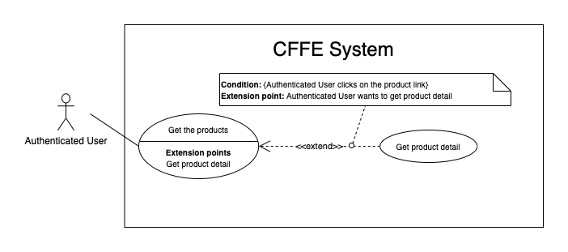

Figure . <Use Case> Get product detail

Table 23. <Use Case> Get product detail

|  |  |  |  |
| --- | --- | --- | --- |
| ID and Name: | **UC-09 Get product detail** | | |
| Created By: | HieuNT | Date Created: | 10/05/2021 |
| Primary Actor: | Authenticated User | Secondary Actors: | N/A |
| Description: | This feature allows the authenticated user to getproductdetail. | | |
| Trigger: | Authenticated user sends a request to get product detail. | | |
| Preconditions: | PRE-01. User has logged in the system as admin or manager role.  PRE-02. There is at least one product link. | | |
| Post-conditions: | POST-01:   * Success: CFFE system redirects to "Product Detail" page. * Fail: CFFE system shows error message. | | |
| Normal Flow: | **9.0 Get product detail**   1. Authenticated user clicks on the product link. 2. CFFE system validates the product exists (Exception 9.0.E1) 3. CFFE system returns the product information and redirects to product detail page. | | |
| Alternative Flows: | N/A | | |
| Exceptions: | **9.0.E1 The product does not exist.**  1. CFFE system returns the message (MSG-023) and terminates this use case. | | |
| Priority: | High | | |
| Frequency of Use: | Usually | | |
| Business Rules: | BR-046 | | |
| Other Information: | In case of internet connection failure, Authenticated user cannot finish this use case properly. | | |
| Assumptions: | N/A | | |

*Table 22 - <Use Case> Get product detail*

##### 2.2.2.9 <Authenticated User> Get the categories

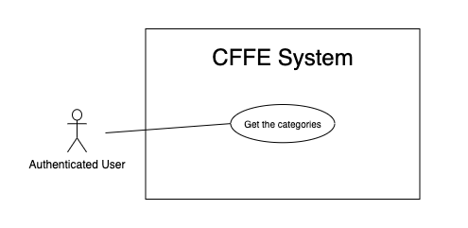

Figure . <Use Case> Get the categories

Table 24. <Use Case> Get the categories

|  |  |  |  |
| --- | --- | --- | --- |
| ID and Name: | **UC-10 Get the categories** | | |
| Created By: | TruongTN | Date Created: | 08/05/2021 |
| Primary Actor: | Authenticated user | Secondary Actors: | N/A |
| Description: | This feature allows manager to get the categories. | | |
| Trigger: | Authenticated user sends a request to get the categories. | | |
| Pre-conditions: | PRE-01. User has logged into the system as admin or manager role. | | |
| Post-conditions: | POST-01. CFFE system returns the list of categories. | | |
| Normal Flow: | **10.0 Get the categories**   1. Authenticated user clicks on "Category" button on the navigation bar. 2. CFFE system requires the category information:  * “Category name”: input text * “Status”: select box  1. Authenticated user inputs/selects the fields: category name, status 2. CFFE system returns the list of categories based on below conditions and display them (Exception 10.0.E1). | | |
| Alternative Flows: | N/A | | |
| Exceptions: | **10.0.E1 The list of categories has no data.**   1. CFFE system returns the message (MSG-009). | | |
| Priority: | High | | |
| Frequency of Use: | Usually | | |
| Business Rules: | BR-013, BR-062 | | |
| Other Information: | In case of internet connection failure, authenticated user cannot finish this use case properly. | | |
| Assumptions: | N/A | | |

##### 2.2.2.10 <Authenticated User> Get category detail

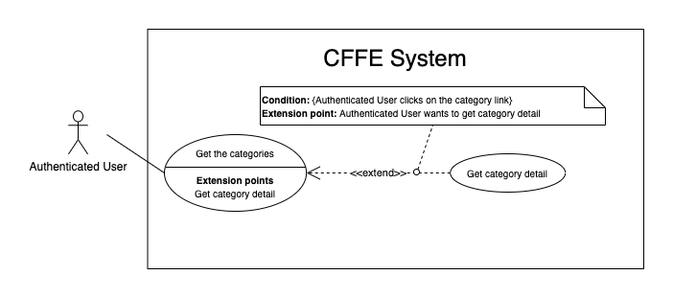

Figure . <Use Case> Get category detail

Table 25. <Use Case> Get category detail

|  |  |  |  |
| --- | --- | --- | --- |
| ID and Name: | **UC-11 Get category detail** | | |
| Created By: | HuuDN | Date Created: | 10/05/2021 |
| Primary Actor: | Authenticated User | Secondary Actors: | N/A |
| Description: | This feature allows the authenticated user to getcategorydetail. | | |
| Trigger: | Authenticated user sends a request to get categorydetail. | | |
| Preconditions: | PRE-01. User has logged in the system as admin or manager role.  PRE-02. User is on "Category" page. | | |
| Post-conditions: | POST-01:   * Success: CFFE system returns category detail successfully. * Fail: CFFE system shows error message. | | |
| Normal Flow: | **11.0 Get category detail**   1. Authenticated user clicks on the category button of the left-side list. 2. CFFE system validates the categoryexists (Exception 11.0.E1) 3. CFFE system returns the categoryinformation. | | |
| Alternative Flows: | N/A | | |
| Exceptions: | **11.0.E1 The category does not exist.**  1. CFFE system returns the message (MSG-029) and terminates this use case.  **11.0.E2 The list of products that belong to this category has no data.**  1. CFFE system returns the message (MSG-009). | | |
| Priority: | High | | |
| Frequency of Use: | Usually | | |
| Business Rules: | BR-062 | | |
| Other Information: | In case of internet connection failure, Authenticated User cannot finish this use case properly. | | |
| Assumptions: | N/A | | |

##### 2.2.2.11 <Authenticated User> Get the cameras

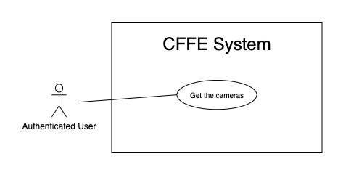

Figure . <Use Case> Get the cameras

Table 26. <Use Case> Get the cameras

|  |  |  |  |
| --- | --- | --- | --- |
| ID and Name: | **UC-12 Get the cameras** | | |
| Created By: | HuuDN | Date Created: | 08/05/2021 |
| Primary Actor: | Authenticated user | Secondary Actors: | N/A |
| Description: | This feature allows authenticated user to get the cameras. | | |
| Trigger: | Authenticated user sends a request to get the cameras. | | |
| Pre-conditions: | PRE-01. User has logged into the system as admin or manager role. | | |
| Post-conditions: | POST-01. CFFE system returns the list of cameras. | | |
| Normal Flow: | **12.0 Get the cameras**   1. Authenticated user clicks on “Camera” button on the navigation bar. 2. CFFE system requires the camera information:  * “Camera name”: input text * “Store”: select box * “Status”: select box  1. Authenticated user inputs/selects the fields. 2. CFFE system returns the list of cameras based on below conditions and display them (Exception 12.0.E1). | | |
| Alternative Flows: | N/A | | |
| Exceptions: | **12.0.E1 The list of cameras has no data.**   1. CFFE system returns the message (MSG-009). | | |
| Priority: | High | | |
| Frequency of Use: | Usually | | |
| Business Rules: | BR-052, BR-053, BR-056 | | |
| Other Information: | In case of internet connection failure, authenticated user cannot finish this use case properly. | | |
| Assumptions: | N/A | | |

##### 2.2.2.12 <Authenticated User> Get camera detail

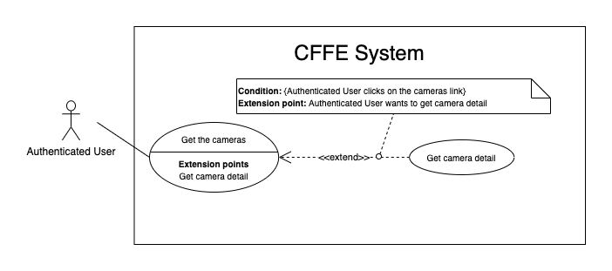

Figure . <Use Case> Get camera detail

Table 27. <Use Case> Get camera detail

|  |  |  |  |
| --- | --- | --- | --- |
| ID and Name: | **UC-13 Get camera detail** | | |
| Created By: | HuuDN | Date Created: | 10/05/2021 |
| Primary Actor: | Authenticated User | Secondary Actors: | N/A |
| Description: | This feature allows the authenticated user to getcameradetail. | | |
| Trigger: | Authenticated User sends a request to get camera detail. | | |
| Preconditions: | PRE-01. User has logged in the system as admin or manager role.  PRE-02. There is at least one camera link. | | |
| Post-conditions: | POST-01:   * Success: CFFE system returns camera detail successfully and redirects to "Camera Detail" page. * Fail: CFFE system shows error message. | | |
| Normal Flow: | **13.0 Get camera detail**   1. Authenticated User clicks on the camera link. 2. CFFE system validates the camera exists (Exception 13.0.E1). 3. CFFE system returns the camera information and redirects to camera detail page. | | |
| Alternative Flows: | N/A | | |
| Exceptions: | **13.0.E1 The camera does not exist.**  1. CFFE system returns the message (MSG-009) and terminates this use case. | | |
| Priority: | High | | |
| Frequency of Use: | Usually | | |
| Business Rules: | BR-022, BR-054, BR-056 | | |
| Other Information: | In case of internet connection failure, Authenticated User cannot finish this use case properly. | | |
| Assumptions: | N/A | | |

#### 2.2.3 <Manager> Overview Use Case

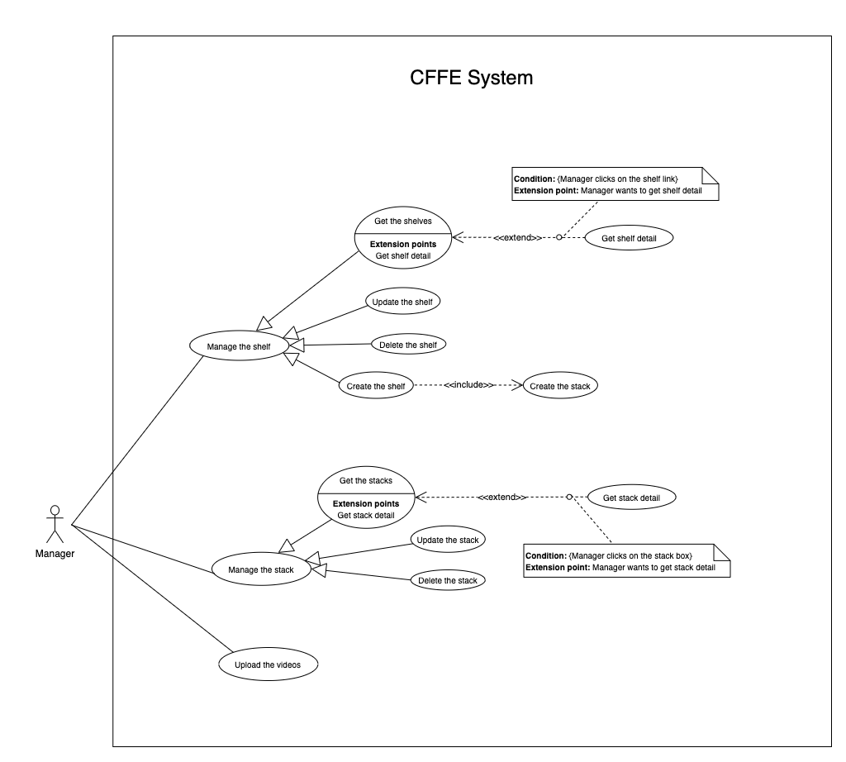

Figure . <Overview Use Case> Manager

##### 2.2.3.1 <Manager> Get the shelves

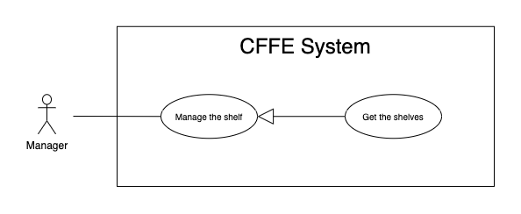

Figure . <Use Case> Get the shelves

Table 28. <Use Case> Get the shelves

|  |  |  |  |
| --- | --- | --- | --- |
| ID and Name: | **UC-14 Get the shelves** | | |
| Created By: | TruongTN | Date Created: | 08/05/2021 |
| Primary Actor: | Manager | Secondary Actors: | N/A |
| Description: | This feature allows Manager to get the shelves. | | |
| Trigger: | Manager sends a request to get the shelves. | | |
| Pre-conditions: | PRE-01. User has logged into the system as manager role.  PRE-02. Manager is managing a store. | | |
| Post-conditions: | POST-01. CFFE system returns the list of shelves. | | |
| Normal Flow: | **14.0 Get the shelves**   1. Manager clicks on "Shelf" button on the navigation bar. 2. CFFE system requires the shelf information from Manager:  * “Shelf name”: input text * “Status”: select box  1. Manager inputs/selects the fields. 2. CFFE system returns the shelves based on below conditions and display them (Exception 14.0.E1). | | |
| Alternative Flows: | N/A | | |
| Exceptions: | **14.0.E1 The list of shelves has no data.**   1. CFFE system returns the message (MSG-009). | | |
| Priority: | High | | |
| Frequency of Use: | Usually | | |
| Business Rules: | BR-026, BR-027, BR-048 | | |
| Other Information: | In case of internet connection failure, Manager cannot finish this use case properly. | | |
| Assumptions: | N/A | | |

##### 2.2.3.2 <Manager> Get shelf detail

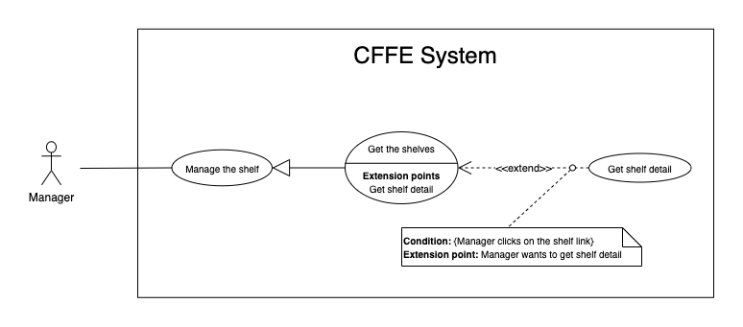

Figure . <Use Case> Get shelf detail

Table 29. <Use Case> Get shelf detail

|  |  |  |  |
| --- | --- | --- | --- |
| ID and Name: | **UC-15 Get shelf detail** | | |
| Created By: | TruongTN | Date Created: | 10/05/2021 |
| Primary Actor: | Manager | Secondary Actors: | N/A |
| Description: | This feature allows Manager to get shelf detail. | | |
| Trigger: | Manager sends a request to get shelf detail. | | |
| Preconditions: | PRE-01. User has logged in the system as manager role.  PRE-02. There is at least one shelf link. | | |
| Post-conditions: | POST-01:   * Success: CFFE system returns shelf detail successfully and redirects to "Shelf Detail" page. * Fail: CFFE system shows error message. | | |
| Normal Flow: | **15.0 Get shelf detail**   1. Manager clicks on the shelf link. 2. CFFE system validates the shelf exists (Exception 15.0.E1) 3. CFFE system returns the shelf information and redirects to "Shelf Detail" page. | | |
| Alternative Flows: | N/A | | |
| Exceptions: | **15.0.E1 The shelf does not exist.**  1. CFFE system returns the message (MSG-009) and terminates this use case. | | |
| Priority: | High | | |
| Frequency of Use: | Usually | | |
| Business Rules: | BR-028, BR-048 | | |
| Other Information: | In case of internet connection failure, Manager cannot finish this use case properly. | | |
| Assumptions: | N/A | | |

*Table 12 - <Use Case> Get shelf detail*

##### 2.2.3.3 <Manager> Update the shelf

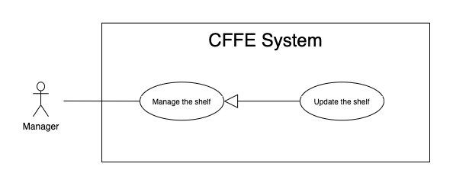

Figure . <Use Case> Update the shelf

Table 30. <Use Case> Update the shelf

|  |  |  |  |
| --- | --- | --- | --- |
| ID and Name: | **UC-16 Update the shelf** | | |
| Created By: | TruongTN | Date Created: | 18/06/2021 |
| Primary Actor: | Manager | Secondary Actors: | N/A |
| Description: | This feature allows Manager to update shelf in CFFE system. | | |
| Trigger: | Manager sends a request to update the shelf. | | |
| Preconditions: | PRE-01. User has logged in the system as manager role.  PRE-02. Manager is on “Shelf detail” page. | | |
| Post-conditions: | POST-01:   * Success: CFFE system shows success message and reloads "Shelf Detail" page. * Fail: CFFE system shows error message. | | |
| Normal Flow: | **16.0 Update the shelf information** (Alternative 16.0, 16.1, 16.2)   1. Manager clicks on "Edit Information" button on the shelf box. 2. CFFE system requires shelf information that includes:  * “Shelf name”: input text * “Description”: input text * “Update”: button * “Cancel”: button  1. Manager inputs the required fields. 2. Manager clicks on “Update” button. (Alternative 16.3) 3. CFFE system validates the required fields (Exception 16.0.E1, 16.0.E2) 4. CFFE system updates shelf information and returns the success message (MSG-013). | | |
| Alternative Flows: | **16.0 Adding the camera to the shelf**   1. Manager clicks on "Add camera" button on the camera box. 2. CFFE system shows popup that includes:    * “Camera”: list box    * "OK": button    * "Cancel": button 3. Manager selects a camera box. 4. Manager clicks on "OK" button. (Alternative 16.3, 16.4) 5. CFFE system validates the chosen camera and shelf. (Exception 16.0.E3, 16.0.E4, 16.0.E5) 6. CFFE system adds the camera to the shelf and returns the success message (MSG-013).   **16.1 Removing the camera from the shelf**   1. Manager clicks on "Remove camera" button on the camera box. 2. CFFE system shows confirm popup with message "Do you want to remove this camera from this shelf?" and two buttons for Manager selecting:    * "OK" button    * "Cancel" button 3. Manager clicks on "OK" button. (Alternative 16.3, 16.4) 4. CFFE system validates the camera and shelf. (Exception 16.0.E6) 5. CFFE system remove the camera from the shelf and returns the success message (MSG-013).   **16.2 Reactivate the inactive shelf.**   1. Manager focus on "Inactive" button then clicks on "Pending" button. 2. CFFE system shows confirm popup with message "Do you want to active this shelf?" and two buttons for Manager select:    * "OK" button    * "Cancel" button 3. Manager clicks on "OK" button. (Alternative 16.3, 16.4) 4. CFFE system validates the shelf. (Exception 16.0.E7) 5. CFFE system updates the shelf's status and returns the success message (MSG-013).   **16.3 Manager cancels the updating process.**   1. Manager clicks on "Cancel" button. 2. CFFE system closes this popup and terminates this use case.   **16.4 Manager clicks outside of popup.**   1. Manager clicks outside of popup. 2. CFFE system closes this popup and terminates this use case. | | |
| Exceptions: | **16.0.E1 Manager does not input the required fields**   1. CFFE system returns to Manager to fill the required fields again (MSG-079, MSG-016). 2. If Manager inputs the required fields again, CFFE system returns to step 3 of the normal flow. 3. Else if Manager cancels the updating process, then CFFE system terminates this use case.   **16.0.E2 Manager inputs the required fields that are not valid**   1. CFFE system returns to Manager to fill the required fields again (MSG-080, MSG-017). 2. If Manager inputs the required fields again, CFFE system returns to step 3 of the normal flow. 3. Else if Manager cancels the updating process, then CFFE system terminates this use case.   **16.0.E3 Shelf does not exist or is active.**   1. CFFE system returns error message (MSG-085) and terminates this use case.   **16.0.E4 Camera does not exist or is active.**   1. CFFE system returns the error message (MSG-086) and terminates this use case.   **16.0.E5 Shelf does not exist.**   1. CFFE system returns the error message (MSG-012) and terminates this use case.   **16.0.E6 Camera on the shelf is full.**   1. CFFE system returns the error message (MSG-128) and terminates this use case.   **16.0.E7 Camera is not on the shelf.**   1. CFFE system returns the error message (MSG-088) and terminates this use case. | | |
| Priority: | High | | |
| Frequency of Use: | Usually | | |
| Business Rules: | BR-024, BR-031, BR-032, BR-039, BR-048, BR-051 | | |
| Other Information: | In case of internet connection failure, Manager cannot finish this use case properly. | | |
| Assumptions: | N/A | | |

##### 2.2.3.4 <Manager> Delete the shelf

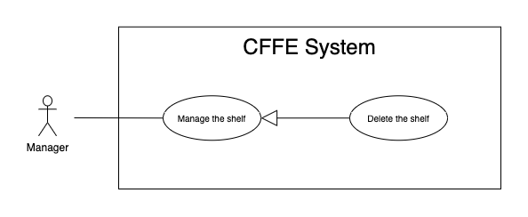

Figure . <Use Case> Delete the shelf

Table 31. <Use Case> Delete the shelf

|  |  |  |  |
| --- | --- | --- | --- |
| ID and Name: | **UC-17 Delete the shelf** | | |
| Created By: | TruongTN | Date Created: | 18/06/2021 |
| Primary Actor: | Manager | Secondary Actors: | N/A |
| Description: | This feature allows Manager to delete the shelf. | | |
| Trigger: | Manager sends a request to delete the shelf. | | |
| Preconditions: | PRE-01. User has logged in the system as manager role.  PRE-02. Manager is on “Shelf detail” page. | | |
| Post-conditions: | POST-01:   * Success: CFFE system shows success message and reloads "Shelf Detail" page. * Fail: CFFE system shows error message. | | |
| Normal Flow: | **17.0 Delete the shelf**   1. Manager focus on "Pending" button then clicks on "Inactive" button. 2. CFFE system shows delete popup with message: "Do you want to inactive this shelf?" and required form:  * "Inactive reason": text area * "OK": button * "Cancel": button  1. Manager inputs the field. 2. Manager clicks on "OK" button. (Alternative 17.0, 17.1) 3. CFFE system validates the required field and the shelf. (Exception 17.0.E1, 17.0.E2, 17.0.E3) 4. CFFE system updates the shelf's status and returns the success message (MSG-040). | | |
| Alternative Flows: | **17.0 Manager cancels the deleting process.**   1. Manager clicks on "Cancel" button. 2. CFFE system closes this popup and terminates this use case.   **17.1 Manager clicks outside of popup.**   1. Manager clicks outside of popup. 2. CFFE system closes this popup and terminates this use case. | | |
| Exceptions: | **17.0.E1 The shelf does not exist**   1. CFFE system returns error message (MSG-012) and terminates this use case.   **17.0.E2 Manager does not input the inactive reason and remove all stacks, cameras.**   1. CFFE system returns error message (MSG-066) and terminates this use case.   **17.0.E3 Manager inputs the inactive reason fields that are not valid**   1. CFFE system returns error message (MSG-067) and terminates this use case. | | |
| Priority: | Medium | | |
| Frequency of Use: | Often | | |
| Business Rules: | BR-030, BR-032, BR-033, BR-048 | | |
| Other Information: | In case of internet connection failure, Manager cannot finish this use case properly. | | |
| Assumptions: | N/A | | |

*Table 14 - <Use Case> Delete the shelf*

##### 2.2.3.5 <Manager> Create the shelf

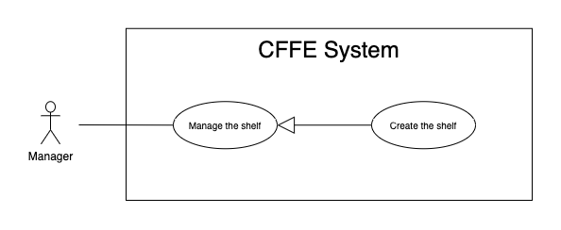

Figure . <Use Case> Create the shelf

Table 32. <Use Case> Create the shelf

|  |  |  |  |
| --- | --- | --- | --- |
| ID and Name: | **UC-18 Create the shelf** | | |
| Created By: | TruongTN | Date Created: | 10/05/2021 |
| Primary Actor: | Manager | Secondary Actors: | N/A |
| Description: | This feature allows Manager to create the shelf. | | |
| Trigger: | Manager sends a request to create the shelf. | | |
| Preconditions: | PRE-01. User has logged in the system as manager role.  PRE-02. Manager is on “Manage Shelf” page. | | |
| Post-conditions: | POST-01:   * Success: CFFE system shows success message and reloads "Shelf" page. * Fail: CFFE system shows error message. | | |
| Normal Flow: | **18.0 Create the** **shelf**   1. Manager clicks on "New" button. 2. CFFE system shows the popup that includes:  * “Shelf name”: input text * “Description”: input text * “Number of stacks”: input text * “Create”: button * “Cancel”: button  1. Manager inputs the required fields. 2. Manager clicks on “Create” button. (Alternative 18.0, 18.1) 3. CFFE system validates the required fields. (Exception 18.0.E1, 18.0.E2) 4. CFFE system creates newly shelf and returns the success message (MSG-011). | | |
| Alternative Flows: | **18.0 Manager cancels the creating process.**   1. Manager clicks on "Cancel" button. 2. CFFE system closes this popup and terminates this use case.   **18.1 Manager clicks outside of popup.**   1. Manager clicks outside of popup. 2. CFFE system closes this popup and terminates this use case. | | |
| Exceptions: | **18.0.E1 Manager does not input the required fields**   1. CFFE system returns to Manager to fill the required fields again (MSG-079, MSG-016). 2. If Manager inputs the required fields again, CFFE system returns to step 3 of the normal flow. 3. Else if Manager cancels the creating process, then CFFE system terminates this use case.   **18.0.E2 Manager inputs the required fields that are not valid**   1. CFFE system returns to Manager to fill the required fields again (MSG-080, MSG-017, MSG-019). 2. If Manager inputs the required fields again, CFFE system returns to step 3 of the normal flow. 3. Else if Manager cancels the creating process, then CFFE system terminates this use case. | | |
| Priority: | Medium | | |
| Frequency of Use: | Often | | |
| Business Rules: | BR-025, BR-031, BR-035, BR-048, BR-070 | | |
| Other Information: | In case of internet connection failure, Manager cannot finish this use case properly. | | |
| Assumptions: | N/A | | |

##### 2.2.3.6 <Manager> Get the stacks

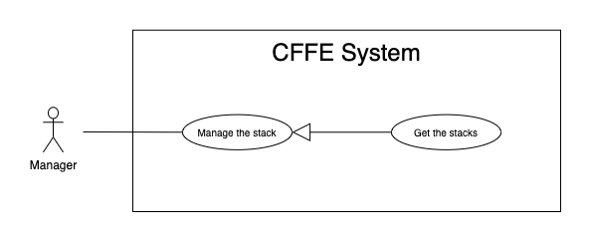

Figure . <Use Case> Get the stacks

Table 33. <Use Case> Get the stacks

|  |  |  |  |
| --- | --- | --- | --- |
| ID and Name: | **UC19- Get the stacks** | | |
| Created By: | LuanNM | Date Created: | 08/05/2021 |
| Primary Actor: | Manager | Secondary Actors: | N/A |
| Description: | This feature allows manager to get the stacks. | | |
| Trigger: | Manager sends a request to get the stacks. | | |
| Pre-conditions: | PRE-01. User has logged into the system as manager role.  PRE-02. Manager is managing a store.  PRE-03. There is at least one shelf link. | | |
| Post-conditions: | POST-01. CFFE system returns the list of stacks. | | |
| Normal Flow: | **19.0 Get the stacks**   1. Manager clicks on the shelf link. 2. CFFE system validates the shelf and stacks exists (Exception 19.0.E1, 19.0.E2) 3. CFFE system returns the stack list and redirects to "Shelf Detail" page. | | |
| Alternative Flows: | N/A | | |
| Exceptions: | **19.0.E1 The shelf does not exist.**  1. CFFE system returns the message (MSG-046) and terminates this use case.  **19.0.E2 The list of stacks has no data.**   1. CFFE system returns the message (MSG-009) and terminates this use case. | | |
| Priority: | High | | |
| Frequency of Use: | Usually | | |
| Business Rules: | BR-009, BR-037 | | |
| Other Information: | In case of internet connection failure, Manager cannot finish this use case properly. | | |
| Assumptions: | N/A | | |

##### 2.2.3.7 <Manager> Get stack detail

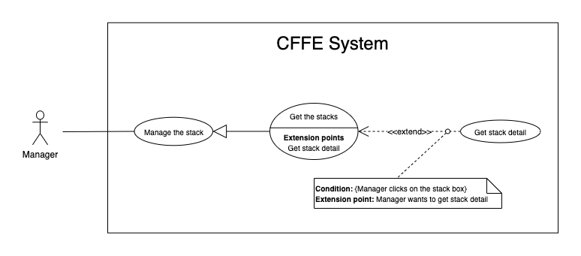

Figure . <Use Case> Get stack detail

Table 34. <Use Case> Get stack detail

|  |  |  |  |
| --- | --- | --- | --- |
| ID and Name: | **UC-20 Get stack detail** | | |
| Created By: | LuanNM | Date Created: | 10/05/2021 |
| Primary Actor: | Manager | Secondary Actors: | N/A |
| Description: | This feature allows Manager to getstackdetail. | | |
| Trigger: | Manager sends a request to get stack detail. | | |
| Preconditions: | PRE-01. User has logged in the system as manager role.  PRE-02. Manager is on "Shelf Detail" page. | | |
| Post-conditions: | POST-01. CFFE system returns stack information. | | |
| Normal Flow: | **20.0 Get stack detail**   1. Manager clicks on the stack box. 2. CFFE system validates the stack exists (Exception 20.0.E1) 3. CFFE system returns the stack information and displays it. | | |
| Alternative Flows: | N/A | | |
| Exceptions: | **20.0.E1 The stack does not exist.**  1. CFFE system returns the message (MSG-022) and terminates this use case. | | |
| Priority: | High | | |
| Frequency of Use: | Usually | | |
| Business Rules: | BR-009, BR-038 | | |
| Other Information: | In case of internet connection failure, Manager cannot finish this use case properly. | | |
| Assumptions: | N/A | | |

*Table 17 - <Use Case> Get stack detail*

##### 2.2.3.8 <Manager> Update the stack

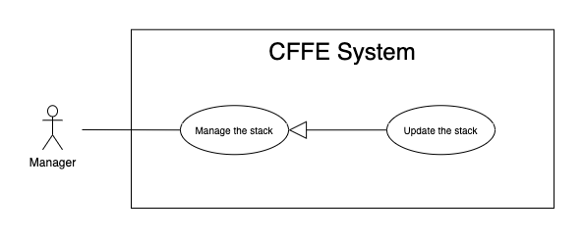

Figure . <Use Case> Update the stack

Table 35. <Use Case> Update the stack

|  |  |  |  |
| --- | --- | --- | --- |
| ID and Name: | **UC-21 Update the stack** | | |
| Created By: | LuanNM | Date Created: | 18/06/2021 |
| Primary Actor: | Manager | Secondary Actors: | N/A |
| Description: | This feature allows Manager to update stack in CFFE system. | | |
| Trigger: | Manager sends a request to update the stack. | | |
| Preconditions: | PRE-01. User has logged in the system as manager role.  PRE-02. Manager is on “Shelf detail” page.  PRE-03. Manager selects a stack. | | |
| Post-conditions: | POST-01:   * Success: CFFE system shows success message and reloads "Shelf Detail" page. * Fail: CFFE system shows error message. | | |
| Normal Flow: | **21.0 Reactive the inactive stack.** (Alternative 21.0, 21.1, 21.2, 21.3)   1. Manager focus on "Inactive" button then clicks on "Pending" button. 2. CFFE system shows confirm popup with message "Do you want to active this stack?" and two buttons for Manager selecting:  * “OK” button * “Cancel” button  1. Manager clicks on "OK" button. (Alternative 21.4, 21.5) 2. CFFE system validates the stack. (Exception 21.0.E1) 3. CFFE system updates stack information and returns the success message (MSG-013). | | |
| Alternative Flows: | **21.0 Adding the product to the stack**   1. Manager clicks on "Add product" button on the product box. 2. CFFE system shows popup that includes:    * "Product": list box    * "OK": button    * "Cancel": button 3. Manager selects a product box. 4. Manager clicks on "OK" button. (Alternative 21.4, 21.5) 5. CFFE system validates the chosen product and stack (Exception 21.0.E1, 21.0.E2, 21.0.E3, 21.0.E4) 6. CFFE system adds the product to the stack and returns the success message (MSG-013).   **21.1 Removing the product from the stack**   1. Manager clicks on "Remove product" button on the product box. 2. CFFE system shows confirm popup with message "Do you want to remove this product from this stack?" and two buttons for Manager selecting:    * "OK" button    * "Cancel" button 3. Manager clicks on "OK" button. (Alternative 21.4, 21.5) 4. CFFE system validates the product and stack. (Exception 21.0.E1, 21.0.E5) 5. CFFE system remove the product from the stack and returns the success message (MSG-013).   **21.2 Adding the camera to the stack**   1. Manager clicks on "Add camera" button on the camera box. 2. CFFE system shows popup that includes:    * “Camera”: list box    * "OK": button    * "Cancel": button 3. Manager selects a camera box. 4. Manager clicks on "OK" button. (Alternative 21.4, 21.5) 5. CFFE system validates the chosen camera and stack. (Exception 21.0.E1, 21.0.E6, 21.0.E7, 21.0.E8) 6. CFFE system adds the camera to the stack and returns the success message (MSG-013).   **21.3 Removing the camera from the stack**   1. Manager clicks on "Remove camera" button on the camera box. 2. CFFE system shows confirm popup with message "Do you want to remove this camera from this stack?" and two buttons for Manager selecting:    * "OK" button    * "Cancel" button 3. Manager clicks on "OK" button. (Alternative 21.4, 21.5) 4. CFFE system validates the camera and stack. (Exception 21.0.E1, 21.0.E9) 5. CFFE system remove the camera from the stack and returns the success message (MSG-013).   **21.4 Manager cancels the updating process.**   1. Manager clicks on "Cancel" button. 2. CFFE system closes this popup and terminates this use case.   **21.5 Manager clicks outside of popup.**   1. Manager clicks outside of popup. 2. CFFE system closes this popup and terminates this use case. | | |
| Exceptions: | **21.0.E1 Stack does not exist.**   1. CFFE system returns error message (MSG-022) and terminates this use case.   **21.0.E2 Product does not exist.**   1. CFFE system returns error message (MSG-023) and terminates this use case.   **21.0.E3 Product is inactive.**   1. CFFE system returns error message (MSG-089) and terminates this use case.   **21.0.E4 Stack already has a product.**   1. CFFE system returns error message (MSG-089) and terminates this use case.   **21.0.E5 Product is not on this stack or Camera is already on this stack.**   1. CFFE system returns error message (MSG-092) and terminates this use case.   **21.0.E6 Camera does not exist.**   1. CFFE system returns error message (MSG-020) and terminates this use case.   **21.0.E7 Camera has active or inactive status.**   1. CFFE system returns error message (MSG-093) and terminates this use case.   **21.0.E8 Stack has not a product.**   1. CFFE system returns error message (MSG-100) and terminates this use case.   **21.0.E9 Camera is not on this stack.**   1. CFFE system returns error message (MSG-094) and terminates this use case. | | |
| Priority: | High | | |
| Frequency of Use: | Often | | |
| Business Rules: | BR-009, BR-029, BR-032, BR-036, BR-039, BR-042 | | |
| Other Information: | In case of internet connection failure, Manager cannot finish this use case properly. | | |
| Assumptions: | N/A | | |

##### 2.2.3.9 <Manager> Delete the stack

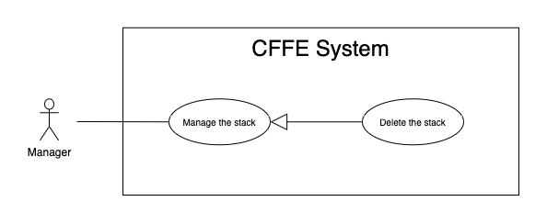

Figure . <Use Case> Delete the shelf

Table 36. <Use Case> Delete the shelf

|  |  |  |  |
| --- | --- | --- | --- |
| ID and Name: | **UC-22 Delete the stack** | | |
| Created By: | LuanNM | Date Created: | 10/05/2021 |
| Primary Actor: | Manager | Secondary Actors: | N/A |
| Description: | This feature allows Manager to delete the stack. | | |
| Trigger: | Manager sends a request to delete the stack. | | |
| Preconditions: | PRE-01. User has logged in the system as manager role.  PRE-02. Manager is on “Shelf detail” page.  PRE-03. Manager has selected a stack. | | |
| Post-conditions: | POST-01:   * Success: CFFE system shows success message and reloads "Shelf Detail" page. * Fail: CFFE system shows error message. | | |
| Normal Flow: | **22.0 Delete the stack**   1. Manager focus on "Pending" button then clicks on "Inactive" button. 2. CFFE system shows delete popup with message: "Do you want to inactive this stack?" and required form:  * "Inactive reason": text area * "OK": button * "Cancel": button  1. Manager inputs the field. 2. Manager clicks on "OK" button. (Alternative 22.0) 3. CFFE system validates the required field and the stack. (Exception 22.0.E1, 22.0.E2, 22.0.E3) 4. CFFE system updates the stack's status and returns the success message (MSG-040). | | |
| Alternative Flows: | **22.0 Manager cancels the deleting process.**   1. Manager clicks on "Cancel" button. 2. CFFE system closes this popup and terminates this use case. | | |
| Exceptions: | **22.0.E1 The stack does not exist**   1. CFFE system returns error message (MSG-022) and terminates this use case.   **22.0.E2 Manager does not input the inactive reason and remove the product.**   1. CFFE system returns error message (MSG-095) and terminates this use case.   **22.0.E3 Manager inputs the inactive reason fields that are not valid**   1. CFFE system returns error message (MSG-067) and terminates this use case. | | |
| Priority: | Medium | | |
| Frequency of Use: | Often | | |
| Business Rules: | BR-009, BR-032, BR-033, BR-041 | | |
| Other Information: | In case of internet connection failure, Manager cannot finish this use case properly. | | |
| Assumptions: | N/A | | |

##### 2.2.3.10 <Manager> Create the stack

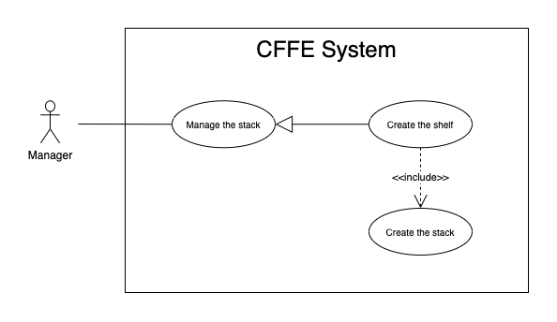

Figure . <Use Case> Create the stack

Table 37. <Use Case> Create the stack

|  |  |  |  |
| --- | --- | --- | --- |
| ID and Name: | **UC-23 Create the stack** | | |
| Created By: | LuanNM | Date Created: | 10/05/2021 |
| Primary Actor: | Manager | Secondary Actors: | N/A |
| Description: | This feature allows Manager to create the stack. | | |
| Trigger: | Manager sends a request to create the stack. | | |
| Preconditions: | PRE-01. User has logged in the system as manager role.  PRE-02. Manager creates the shelf successfully. | | |
| Post-conditions: | POST-01. CFFE system stores newly created stack information. | | |
| Normal Flow: | **23.0 Create the stack**   1. CFFE system creates the stacks based on "number of stacks" of the shelf. | | |
| Alternative Flows: | N/A | | |
| Exceptions: | N/A | | |
| Priority: | Medium | | |
| Frequency of Use: | Often | | |
| Business Rules: | BR-009, BR-035, BR-50, BR-070 | | |
| Other Information: | In case of internet connection failure, Manager cannot finish this use case properly. | | |
| Assumptions: | N/A | | |

##### 2.2.3.11 <Manager> Upload the videos

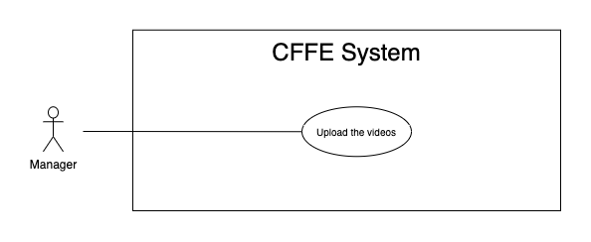

Figure . <Use Case> Upload the videos

Table 38. <Use Case> Upload the videos

|  |  |  |  |
| --- | --- | --- | --- |
| ID and Name: | **UC-24 Upload the videos** | | |
| Created By: | HuuDN | Date Created: | 10/05/2021 |
| Primary Actor: | Manager | Secondary Actors: | N/A |
| Description: | This feature allows Manager to upload the videos. | | |
| Trigger: | Manager sends a request to upload the videos. | | |
| Preconditions: | PRE-01. User has logged in the system as manager role.  PRE-02. Manager is on "Video" page. | | |
| Post-conditions: | POST-01:   * Success: CFFE system shows success message and closes "Upload" popup. * Fail: CFFE system shows error message. | | |
| Normal Flow: | **24.0 Upload the videos**   1. Manager clicks on "Upload video" button on the search bar. 2. CFFE systems displays the upload popup that includes:    * "Upload video area": upload area    * "OK": button    * "Cancel": button 3. Manager clicks or drags the videos into the uploading area. 4. Manager clicks on "OK" button. (Alternative 24.0, 24.1) 5. CFFE system validates the videos. (Exception 24.0.E1, 24.0.E2, 24.0.E3) 6. CFFE system uploads the videos and returns the success message (MSG-010). | | |
| Alternative Flows: | **24.0 Manager cancels the updating process.**   1. Manager clicks on "Cancel" button. 2. CFFE system closes this popup and terminates this use case.   **24.1 Manager clicks outside of popup.**   1. Manager clicks outside of popup. 2. CFFE system closes this popup and terminates this use case. | | |
| Exceptions: | **24.0.E1 Manager does not select the required video.**   1. CFFE system returns to Manager to select the video again (MSG-119). 2. If Manager inputs the required fields again, CFFE system returns to step 3 of the normal flow. 3. Else if Manager cancels the uploading process, then CFFE system terminates this use case.   **24.0.E2 Manager selects the videos that do not valid.**   1. CFFE system shows error message (MSG-118, MSG-119, MSG-122, MSG-123) and terminates this use case.   **24.0.E3 CFFE system cannot upload the videos.**   1. CFFE system shows error message (MSG-114) and terminates this use case. | | |
| Priority: | High | | |
| Frequency of Use: | Often | | |
| Business Rules: | BR-019, BR-020 | | |
| Other Information: | In case of internet connection failure, Manager cannot finish this use case properly. | | |
| Assumptions: | N/A | | |

#### 2.2.4 <Admin> Overview Use Case

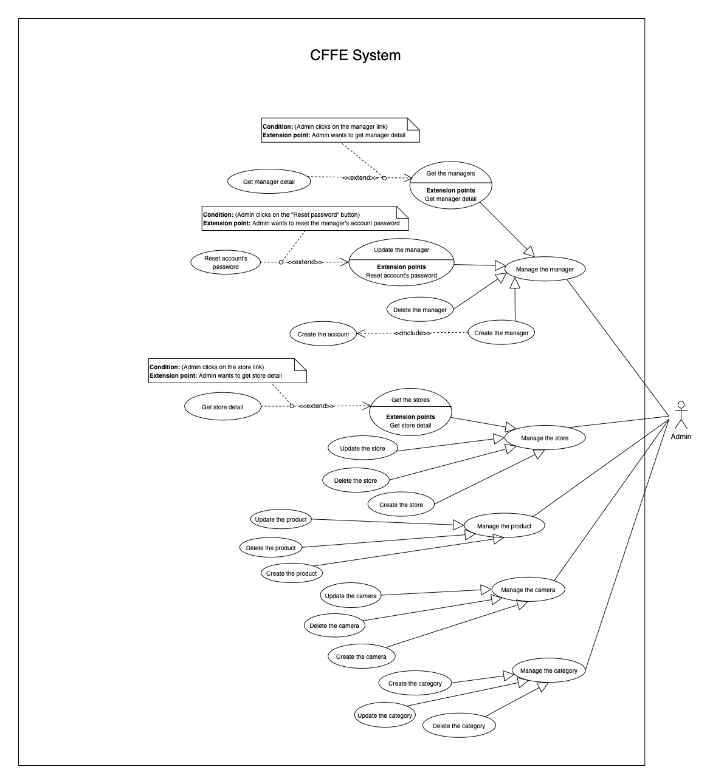

Figure . <Use Case> Get the cameras

##### 2.2.4.1 <Admin> Get the stores

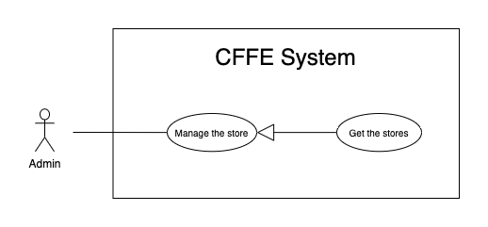

Figure . <Use Case> Get the stores

Table 39. <Use Case> Get the stores

|  |  |  |  |
| --- | --- | --- | --- |
| ID and Name: | **UC-25 Get the stores** | | |
| Created By: | LuanNM | Date Created: | 08/05/2021 |
| Primary Actor: | Admin | Secondary Actors: | N/A |
| Description: | This feature allows admin to get the stores. | | |
| Trigger: | Admin sends a request to get the stores. | | |
| Pre-conditions: | PRE-01. User has logged into the system as admin role. | | |
| Post-conditions: | POST-01. CFFE system returns the list of stores. | | |
| Normal Flow: | **25.0 Get the stores**   1. Admin clicks on "Store" button on the navigation bar. 2. CFFE system requires the store information from Admin:  * “Store name”: input text * “City”: select box * “Status”: select box  1. Admin inputs/selects the fields. 2. CFFE system returns the list of stores based on below conditions and display them (Exception 25.0.E1). | | |
| Alternative Flows: | N/A | | |
| Exceptions: | **25.0.E1 The list of stores has no data.**   1. CFFE system returns the message (MSG-009). | | |
| Priority: | High | | |
| Frequency of Use: | Usually | | |
| Business Rules: | BR-059, BR-064, BR-065 | | |
| Other Information: | In case of internet connection failure, Admin cannot finish this use case properly. | | |
| Assumptions: | N/A | | |

##### 2.2.4.2 <Admin> Get store detail

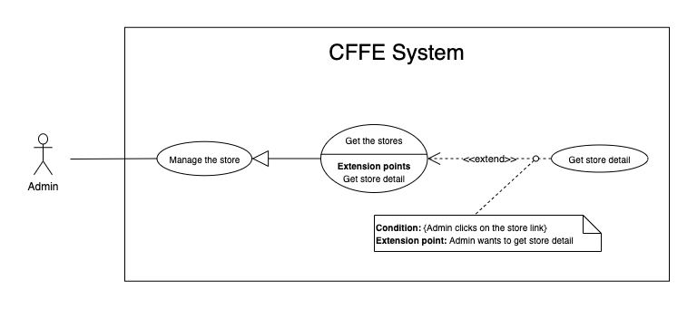

Figure . <Use Case> Get store detail

Table 40. <Use Case> Get store detail

|  |  |  |  |
| --- | --- | --- | --- |
| ID and Name: | **UC-26 Get store detail** | | |
| Created By: | LuanNM | Date Created: | 10/05/2021 |
| Primary Actor: | Admin | Secondary Actors: | N/A |
| Description: | This feature allows Admin to getstoredetail. | | |
| Trigger: | Admin sends a request to get store detail. | | |
| Preconditions: | PRE-01. User has logged in the system as admin role.  PRE-02. There is at least one store link. | | |
| Post-conditions: | POST-01:   * Success: CFFE system returns store detail successfully and redirects to "Store Detail" page. * Fail: CFFE system shows error message. | | |
| Normal Flow: | **26.0 Get store detail**   1. Admin clicks on the store link. 2. CFFE system validates the store exists (Exception 26.0.E1) 3. CFFE system returns the stores information and redirects to store detail page. | | |
| Alternative Flows: | N/A | | |
| Exceptions: | **26.0.E1 The stores does not exist.**  1. CFFE system returns the message (MSG-035) and terminates this use case. | | |
| Priority: | High | | |
| Frequency of Use: | Usually | | |
| Business Rules: | BR-059, BR-066 | | |
| Other Information: | In case of internet connection failure, Admin cannot finish this use case properly. | | |
| Assumptions: | N/A | | |

*Table 36 - <Use Case> Get camera detail*

##### 2.2.4.3 <Admin> Update the store

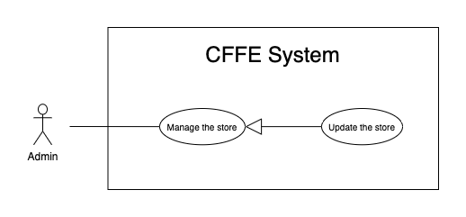

Figure . <Use Case> Update the store

Table 41. <Use Case> Update the store

|  |  |  |  |
| --- | --- | --- | --- |
| ID and Name: | **UC-27 Update the store** | | |
| Created By: | LuanNM | Date Created: | 18/06/2021 |
| Primary Actor: | Admin | Secondary Actors: | N/A |
| Description: | This feature allows Admin to update store in CFFE system. | | |
| Trigger: | Admin sends a request to update the store. | | |
| Preconditions: | PRE-01. User has logged in the system as admin role.  PRE-02. Admin is on “Store detail” page. | | |
| Post-conditions: | POST-01:   * Success: CFFE system shows success message and reloads "Store Detail" page. * Fail: CFFE system shows error message. | | |
| Normal Flow: | **27.0 Update the store information** (Alternative 27.0, 27.1, 27.2, 27.3)   1. Admin clicks on "Edit Information" button. 2. CFFE system requires store information that includes:  * “Store Name”: input text * “Address”: input text * “City”: select box * “District”: select box * “Update”: button * “Cancel”: button  1. Admin inputs/selects the required fields. 2. Admin clicks on “Update” button. (Alternative 27.4) 3. CFFE system validates the fields (Exception 27.0.E1, 27.0.E2) 4. CFFE system updates store information and returns the success message (MSG-013). | | |
| Alternative Flows: | **27.0 Adding the manager to managing this store**   1. Admin clicks on "Add manager" button. 2. CFFE system shows popup that includes:    * "Manager": list box    * "OK": button    * "Cancel": button 3. Admin selects a manager box. 4. Admin clicks on "OK" button. (Alternative 27.4, 27.5) 5. CFFE system validates the chosen manager and store. (Exception 27.0.E3, 27.0.E4) 6. CFFE system adds the manager to the store and returns the success message. (MSG-013)   **27.1 Removing the manager from this store**   1. Admin clicks on "Remove manager" button. 2. CFFE system shows confirm popup with message "Do you want to remove this manager from this store?" and two buttons for Admin selecting:    * "OK" button    * "Cancel" button 3. Admin clicks on "OK" button. (Alternative 27.4, 27.5) 4. CFFE system validates the manager and store. (Exception 27.0.E5, 27.0.E6, 27.0.E7) 5. CFFE system remove the manager from the store and returns the success message (MSG-013).   **27.2 Updating store's image.**   1. Admin clicks on "Update image" button. 2. CFFE system shows updating image popup for Admin selecting:    * "Image": label    * "Choose": button    * "OK": button    * "Cancel": button 3. Admin clicks on "Choose" button. 4. Admin selects an image. 5. Admin clicks on "OK" button. (Alternative 27.4, 27.5) 6. CFFE system validates the image. (Exception 27.0.E9, 27.0.E10, 27.0.E11) 7. CFFE system updates the store's image and returns the success message (MSG-013).   **27.3 Reactivate the inactive store.**   1. Admin focuses on "Inactive" button then clicks on "Pending" button. 2. CFFE system shows confirm popup with message "Do you want to active this store?" and two buttons for Admin selecting:    * "OK" button    * "Cancel" button 3. Admin clicks on "OK" button. (Alternative 27.4, 27.5) 4. CFFE system validates the store. (Exception 27.0.E5) 5. CFFE system updates the store's status and returns the success message (MSG-013).   **27.4 Admin cancels the updating process.**   1. Admin clicks on "Cancel" button. 2. CFFE system closes this popup and terminates this use case.   **27.5 Admin clicks outside of popup.**   1. Admin clicks outside of popup. 2. CFFE system closes this popup and terminates this use case. | | |
| Exceptions: | **27.0.E1 Admin does not input/select the required fields**   1. CFFE system returns to Admin to input/select the required fields again (MSG-106, MSG-036, MSG-038, MSG-039). 2. If Admin inputs/selects the required fields again, CFFE system returns to step 3 of the normal flow. 3. Else if Admin cancels the updating process, then CFFE system terminates this use case.   **27.0.E2 Admin inputs/selects the fields that are not valid**   1. CFFE system returns to Admin to input/select the fields again (MSG-129, MSG-037). 2. If Admin inputs/selects the fields again, CFFE system returns to step 3 of the normal flow. 3. Else if Admin cancels the updating process, then CFFE system terminates this use case.   **27.0.E3 Store does not exist or has not pending status.**   1. CFFE system returns error message (MSG-075) and terminates this use case.   **27.0.E4 Manager does not exist or has not pending status.**   1. CFFE system returns error message (MSG-074) and terminates this use case.   **27.0.E5 Store does not exist.**   1. CFFE system returns error message (MSG-035) and terminates this use case.   **27.0.E6 Manager does not exist.**   1. CFFE system returns error message (MSG-041) and terminates this use case.   **27.0.E7 Manager is not managing this store**   1. CFFE system returns error message (MSG-077) and terminates this use case.   **27.0.E8 Manager is not managing this store**   1. CFFE system returns error message (MSG-077) and terminates this use case.   **27.0.E9 Admin does not select the image**   1. CFFE system returns to Admin to select the image again (MSG-112). 2. If Admin selects the image again, CFFE system returns to step 3 of the alternative flow 27.2. 3. Else if Admin cancels the updating process, then CFFE system terminates this use case.   **27.0.E10 Image is not jpg/jpeg/png format.**   1. CFFE system returns to Admin to select the image again (MSG-113). 2. If Admin selects the image again, CFFE system returns to step 3 of the alternative flow 27.2. 3. Else if Admin cancels the updating process, then CFFE system terminates this use case.   **27.0.E11 CFFE system cannot upload the image.**   1. CFFE system shows error message (MSG-114) and terminates this use case. | | |
| Priority: | Medium | | |
| Frequency of Use: | Often | | |
| Business Rules: | BR-032, BR-040, BR-059, BR-067, BR-68 | | |
| Other Information: | In case of internet connection failure, Admin cannot finish this use case properly. | | |
| Assumptions: | N/A | | |

##### 2.2.4.4 <Admin> Delete the store

Figure . <Use Case> Delete the store

Table 42. <Use Case> Delete the store

|  |  |  |  |
| --- | --- | --- | --- |
| ID and Name: | **UC-28 Delete the store** | | |
| Created By: | LuanNM | Date Created: | 10/05/2021 |
| Primary Actor: | Admin | Secondary Actors: | N/A |
| Description: | This feature allows Admin to delete the store. | | |
| Trigger: | Admin sends a request to delete the store. | | |
| Preconditions: | PRE-01. User has logged in the system as admin role.  PRE-02. Admin is on “Store detail” page. | | |
| Post-conditions: | POST-01:   * Success: CFFE system shows success message and reloads "Store Detail" page. * Fail: CFFE system shows error message. | | |
| Normal Flow: | **28.0 Delete the store**   1. Admin focuses on "Pending" button then clicks on "Inactive" button. 2. CFFE system shows delete popup with message: "Do you want to inactive this store?" and required form:  * "Inactive reason": text area * "OK": button * "Cancel" button  1. Admin inputs the field. 2. Admin clicks on "OK" button. (Alternative 28.0) 3. CFFE system validates the required field and the store. (Exception 28.0.E1, 28.0.E2, 28.0.E3) 4. CFFE system updates the store's status and returns the success message (MSG-040). | | |
| Alternative Flows: | **28.0 Admin cancels the deleting process.**   1. Admin clicks on "Cancel" button. 2. CFFE system closes this popup and terminates this use case. | | |
| Exceptions: | **28.0.E1 The store does not exist**   1. CFFE system returns error message (MSG-012) and terminates this use case.   **28.0.E2 The store has an manager that is managing and has active or pending shelves.**   1. CFFE system returns error message (MSG-066, MSG-081) and terminates this use case.   **28.0.E3 Admin inputs the inactive reason fields that are not valid**   1. CFFE system returns error message (MSG-067) and terminates this use case. | | |
| Priority: | Medium | | |
| Frequency of Use: | Often | | |
| Business Rules: | BR-032, BR-033, BR-059, BR-069 | | |
| Other Information: | In case of internet connection failure, Admin cannot finish this use case properly. | | |
| Assumptions: | N/A | | |

##### 2.2.4.5 <Admin> Create the store

Figure . <Use Case> Create the store

Table 43. <Use Case> Create the store

|  |  |  |  |
| --- | --- | --- | --- |
| ID and Name: | **UC-29 Create the store** | | |
| Created By: | LuanNM | Date Created: | 10/05/2021 |
| Primary Actor: | Admin | Secondary Actors: | N/A |
| Description: | This feature allows Admin to create the store. | | |
| Trigger: | Admin sends a request to create the store. | | |
| Preconditions: | PRE-01. User has logged in the system as admin role.  PRE-02. Admin is on “Store” page. | | |
| Post-conditions: | POST-01:   * Success: CFFE system shows success message and reloads "Store" page. * Fail: CFFE system shows error message. | | |
| Normal Flow: | **29.0 Create the store**   1. Admin clicks on "New" button. 2. CFFE system shows creating store popup that includes:    * "Store name": input text    * "Image": button    * "Address": input text    * "City": select box    * "District": select box    * "Create": button    * "Cancel": button 3. Admin inputs/selects the required fields. 4. Admin clicks on the "Create" button to create new store. (Alternative 29.0, 29.1) 5. CFFE system validates the required fields (Exception 29.0.E1, 29.0.E2). 6. CFFE system stores newly created store and returns the success message (MSG-011). | | |
| Alternative Flows: | **29.0 Admin cancels the creating process.**   1. Admin clicks on "Cancel" button. 2. CFFE system closes this popup and terminates this use case.   **29.1 Admin clicks outside of popup.**   1. Admin clicks outside of popup. 2. CFFE system closes this popup and terminates this use case. | | |
| Exceptions: | **29.0.E1 Admin does not input/select the required fields**   1. CFFE system returns to Admin to input/select the required fields again (MSG-106, MSG-036, MSG-038, MSG-039). 2. If Admin inputs/selects the required fields again, CFFE system returns to step 3 of the normal flow. 3. Else if Admin cancels the creating process, then CFFE system terminates this use case.   **29.0.E2 Admin** **inputs/selects the fields that are not valid**   1. CFFE system returns to Admin to input/select the fields again (MSG-109, MSG-037, MSG-062). 2. If Admin inputs/selects the fields again, CFFE system returns to step 3 of the normal flow. 3. Else if Admin cancels the creating process, then CFFE system terminates this use case. | | |
| Priority: | Medium | | |
| Frequency of Use: | Often | | |
| Business Rules: | BR-035, BR-059, BR-067, BR-070 | | |
| Other Information: | In case of internet connection failure, Admin cannot finish this use case properly. | | |
| Assumptions: | N/A | | |

##### 2.2.4.6 <Admin> Get the managers

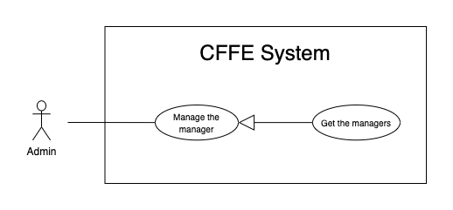

Figure . <Use Case> Get the manager

Table 44. <Use Case> Get the manager

|  |  |  |  |
| --- | --- | --- | --- |
| ID and Name: | **UC-30 Get the managers** | | |
| Created By: | HieuNT | Date Created: | 08/05/2021 |
| Primary Actor: | Admin | Secondary Actors: | N/A |
| Description: | This feature allows admin to get the managers. | | |
| Trigger: | Admin sends a request to get the managers. | | |
| Pre-conditions: | PRE-01. User has logged into the system as admin role. | | |
| Post-conditions: | POST-01. CFFE system returns the list of managers. | | |
| Normal Flow: | **30.0 Get the managers**   1. Admin clicks on "Manager" button on the navigation bar. 2. CFFE system requires the manager information from Admin:  * “Name”: input text, blank * “Options”: input text, blank * “Status”: select box  1. Admin inputs/selects the fields. 2. CFFE system returns the list of managers based on below conditions and display them (Exception 30.0.E1). | | |
| Alternative Flows: | N/A | | |
| Exceptions: | **30.0.E1 The list of managers has no data.**   1. CFFE system returns the message (MSG-009). | | |
| Priority: | High | | |
| Frequency of Use: | Usually | | |
| Business Rules: | BR-015, BR-017, BR-034 | | |
| Other Information: | In case of internet connection failure, Admin cannot finish this use case properly. | | |
| Assumptions: | N/A | | |

##### 2.2.4.7 <Admin> Get manager detail

.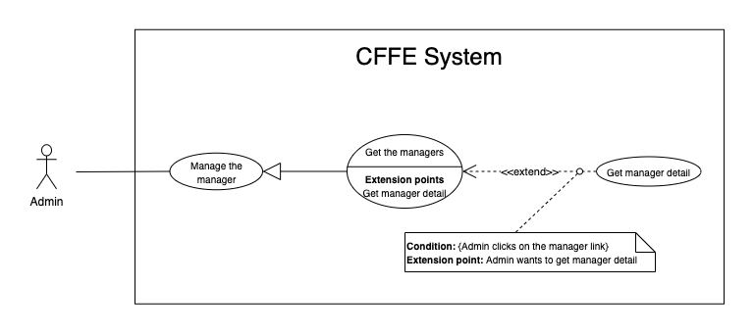

Figure . <Use Case> Get store detail

Table 45. <Use Case> Get store detail

|  |  |  |  |
| --- | --- | --- | --- |
| ID and Name: | **UC-31 Get manager detail** | | |
| Created By: | HieuNT | Date Created: | 10/05/2021 |
| Primary Actor: | Admin | Secondary Actors: | N/A |
| Description: | This feature allows Admin to getmanagerdetail. | | |
| Trigger: | Admin sends a request to get manager detail. | | |
| Preconditions: | PRE-01. User has logged in the system as admin role.  PRE-02. There is at least one manager link. | | |
| Post-conditions: | POST-01:   * Success: CFFE system returns manager detail successfully and redirects to "Manager Detail" page. * Fail: CFFE system shows error message. | | |
| Normal Flow: | **31.0 Get manager detail**   1. Admin clicks on the manager link. 2. CFFE system validates the manager exists. (Exception 31.0.E1) 3. CFFE system returns the manager information and redirects to manager detail page. | | |
| Alternative Flows: | N/A | | |
| Exceptions: | **31.0.E1 The manager does not exist.**  1. CFFE system returns the message (MSG-041) and terminates this use case. | | |
| Priority: | High | | |
| Frequency of Use: | Usually | | |
| Business Rules: | BR-034, BR-061 | | |
| Other Information: | In case of internet connection failure, Admin cannot finish this use case properly. | | |
| Assumptions: | N/A | | |

##### 2.2.4.8 <Admin> Update the manager

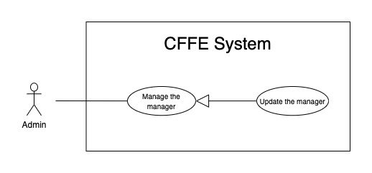

Figure . <Use Case> Update the manager

Table 46. <Use Case> Update the manager

|  |  |  |  |
| --- | --- | --- | --- |
| ID and Name: | **UC-32 Update the manager** | | |
| Created By: | HieuNT | Date Created: | 18/06/2021 |
| Primary Actor: | Admin | Secondary Actors: | N/A |
| Description: | This feature allows Admin to update manager in CFFE system. | | |
| Trigger: | Admin sends a request to update the manager. | | |
| Preconditions: | PRE-01. User has logged in the system as admin role.  PRE-02. Admin is on “Manager detail” page. | | |
| Post-conditions: | POST-01:   * Success: CFFE system shows success message and reloads "Manager Detail" page. * Fail: CFFE system shows error message. | | |
| Normal Flow: | **32.0 Update the manager information** (Alternative 32.0, 32.1, 32.2, 32.3, 32.4)   1. Admin clicks on "Edit information" button. 2. CFFE system requires manager information that includes:  * “Full name”: input text * “Gender”: checkbox * “Birthday”: date picker * “Identity card”: input text * “Phone number”: input text * “Email”: input text * “Address”: input text * “City”: select box * “District”: select box * “Update”: button * “Cancel”: button  1. Admin inputs/selects the required fields. 2. Admin clicks on “Update” button. (Alternative 32.4) 3. CFFE system validates the fields. (Exception 32.0.E1, 32.0.E2) 4. CFFE system updates manager information and returns the success message (MSG-013). | | |
| Alternative Flows: | **32.0 Adding the store to manage**   1. Admin clicks on "Add store" button. 2. CFFE system shows popup that includes:    * "Store": list box    * "OK": button    * "Cancel": button 3. Admin clicks on a store box. 4. Admin clicks on "OK" button. (Alternative 32.4, 32.5) 5. CFFE system validates the chosen manager and store. (Exception 32.0.E3, 32.0.E4) 6. CFFE system adds the store to the manager and returns the success message. (MSG-013)   **32.1 Removing the store that is managing**   1. Admin clicks on "Remove store" button. 2. CFFE system shows confirm popup with message "Do you want to remove this store from this manager?" and two buttons for Admin selecting:    * "OK" button    * "Cancel" button 3. Admin clicks on "OK" button. (Alternative 32.4, 32.5) 4. CFFE system validates the manager and store. (Exception 32.0.E5, 32.0.E6, 32.0.E7) 5. CFFE system removes the store from the manager and returns the success message (MSG-013).   **32.2 Updating manager avatar.**   1. Admin clicks on "Update avatar" button. 2. CFFE system shows updating image popup for Admin selecting:    * "Avatar": label    * "Choose": button    * "OK": button    * "Cancel": button 3. Admin clicks on "Choose" button. 4. Admin selects an image. 5. Admin clicks on "OK" button. (Alternative 32.4, 32.5) 6. CFFE system validates the image. (Exception 32.0.E9, 32.0.E10, 32.0.E11) 7. CFFE system updates the manager's avatar and returns the success message (MSG-013).   **32.3 Reactivate the inactive manager.**   1. Admin focuses on "Inactive" button then clicks on "Pending" button. 2. CFFE system shows confirm popup with message "Do you want to active this manager?" and two buttons for Admin selecting:    * "OK" button    * "Cancel" button 3. Admin clicks on "OK" button. (Alternative 32.4, 32.5) 4. CFFE system validates the manager. (Exception 32.0.E6) 5. CFFE system updates the manager's status and returns the success message (MSG-013).   **32.4 Admin cancels the updating process.**   1. Admin clicks on "Cancel" button. 2. CFFE system closes this popup and terminates this use case.   **32.5 Admin clicks outside of popup.**   1. Admin clicks outside of popup. 2. CFFE system closes this popup and terminates this use case. | | |
| Exceptions: | **32.0.E1 Admin does not input/select the required fields**   1. CFFE system returns to Admin to input/select the required fields again (MSG-014, MSG-036, MSG-038, MSG-039, MSG-049, MSG-044, MSG-047, MSG-051, MSG-054). 2. If Admin inputs/selects the required fields again, CFFE system returns to step 3 of the normal flow. 3. Else if Admin cancels the updating process, then CFFE system terminates this use case.   **32.0.E2 Admin inputs/selects the fields that are not valid**   1. CFFE system returns to Admin to input/select the fields again (MSG-015, MSG-037, MSG-042, MSG-045, MSG-052, MSG-073). 2. If Admin inputs/selects the fields again, CFFE system returns to step 3 of the normal flow. 3. Else if Admin cancels the updating process, then CFFE system terminates this use case.   **32.0.E3 Store does not exist or has not pending status.**   1. CFFE system returns error message (MSG-075) and terminates this use case.   **32.0.E4 Manager does not exist or has not pending status.**   1. CFFE system returns error message (MSG-074) and terminates this use case.   **32.0.E5 Store does not exist.**   1. CFFE system returns error message (MSG-035) and terminates this use case.   **32.0.E6 Manager does not exist.**   1. CFFE system returns error message (MSG-041) and terminates this use case.   **32.0.E7 Manager is not managing this store**   1. CFFE system returns error message (MSG-077) and terminates this use case.   **32.0.E9 Admin does not select the image**   1. CFFE system returns to Admin to select the image again (MSG-112). 2. If Admin selects the image again, CFFE system returns to step 3 of the alternative flow 32.2. 3. Else if Admin cancels the updating process, then CFFE system terminates this use case.   **32.0.E10 Image is not jpg/jpeg/png format.**   1. CFFE system returns to Admin to select the image again (MSG-113). 2. If Admin selects the image again, CFFE system returns to step 3 of the alternative flow 32.2. 3. Else if Admin cancels the updating process, then CFFE system terminates this use case.   **32.0.E11 CFFE system cannot upload the image.**   1. CFFE system shows error message (MSG-114) and terminates this use case. | | |
| Priority: | Medium | | |
| Frequency of Use: | Often | | |
| Business Rules: | BR-032, BR-034, BR-040, BR-060, BR-068 | | |
| Other Information: | In case of internet connection failure, Admin cannot finish this use case properly. | | |
| Assumptions: | N/A | | |

##### 2.2.4.9 <Admin> Reset account's password

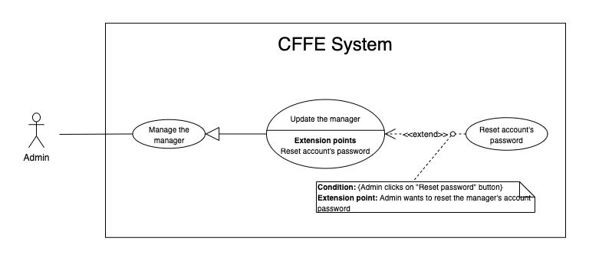

Figure . <Use Case> Reset account's password

Table 47. <Use Case> Reset account's password

|  |  |  |  |
| --- | --- | --- | --- |
| ID and Name: | **UC-33 Reset account's password** | | |
| Created By: | HieuNT | Date Created: | 18/06/2021 |
| Primary Actor: | Admin | Secondary Actors: | N/A |
| Description: | This feature allows Admin to reset account's password in CFFE system. | | |
| Trigger: | Admin sends a request to reset account's password. | | |
| Preconditions: | PRE-01. User has logged in the system as admin role.  PRE-02. Admin is on “Manager detail” page. | | |
| Post-conditions: | POST-01:   * Success: CFFE system shows success message and sends account's password to manager's email. * Fail: CFFE system shows error message. | | |
| Normal Flow: | **33.0 Reset account's password**   1. Admin clicks on "Reset password" button. 2. CFFE system shows confirm popup with message "Do you want to reset password?" and two buttons for Admin selecting:    * "OK" button    * "Cancel" button 3. Admin clicks on “OK” button. (Alternative 33.0, 33.1) 4. CFFE system validates the manager and send account's new password to manager's email (Exception 33.0.E1, 33.0.E2) 5. CFFE system updates manager information and returns the success message (MSG-013). | | |
| Alternative Flows: | **33.0 Admin cancels the resetting process.**   1. Admin clicks on "Cancel" button. 2. CFFE system closes this popup and terminates this use case.   **33.1 Admin clicks outside of popup.**   1. Admin clicks outside of popup. 2. CFFE system closes this popup and terminates this use case. | | |
| Exceptions: | **33.0.E1 Manager is not found**   1. CFFE system returns error message (MSG-063) and terminates this use case.   **33.0.E2 Send email failed**   1. CFFE system shows error message (MSG-124). | | |
| Priority: | Medium | | |
| Frequency of Use: | Often | | |
| Business Rules: | BR-008, BR-012 | | |
| Other Information: | In case of internet connection failure, Admin cannot finish this use case properly. | | |
| Assumptions: | N/A | | |

##### 2.2.4.10 <Admin> Delete the manager

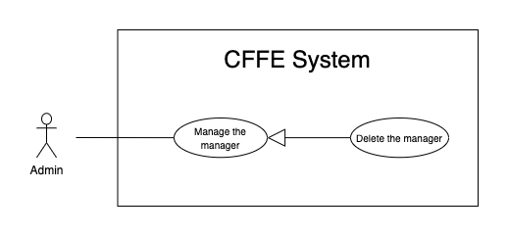

Figure . <Use Case> Delete the manager

Table 48. <Use Case> Delete the manager

|  |  |  |  |
| --- | --- | --- | --- |
| ID and Name: | **UC-34 Delete the manager** | | |
| Created By: | LuanNM | Date Created: | 10/05/2021 |
| Primary Actor: | Admin | Secondary Actors: | N/A |
| Description: | This feature allows Admin to delete the manager. | | |
| Trigger: | Admin sends a request to delete the manager. | | |
| Preconditions: | PRE-01. User has logged in the system as admin role.  PRE-02. Admin is on “Manager detail” page. | | |
| Post-conditions: | POST-01:   * Success: CFFE system shows success message and reloads "Manager Detail" page. * Fail: CFFE system shows error message. | | |
| Normal Flow: | **34.0 Delete the manager**   1. Admin focuses on "Pending" button then clicks on "Inactive" button. 2. CFFE system shows delete popup with message: "Do you want to inactive this manager?" and required form:  * "Inactive reason": text area * "OK": button * "Cancel" button  1. Admin inputs the field. 2. Admin clicks on "OK" button. (Alternative 34.0) 3. CFFE system validates the required field and the manager. (Exception 34.0.E1, 34.0.E2, 34.0.E3) 4. CFFE system updates the manager's status and returns the success message (MSG-040). | | |
| Alternative Flows: | **34.0 Admin cancels the deleting process.**   1. Admin clicks on "Cancel" button. 2. CFFE system closes this popup and terminates this use case. | | |
| Exceptions: | **34.0.E1 Manager is not found**   1. CFFE system returns error message (MSG-063) and terminates this use case.   **34.0.E2 Manager is managing a store**   1. CFFE system shows error message (MSG-066) and terminates this use case.   **34.0.E3 Admin inputs the inactive reason fields that are not valid**   1. CFFE system returns error message (MSG-067) and terminates this use case. | | |
| Priority: | Medium | | |
| Frequency of Use: | Often | | |
| Business Rules: | BR-003, BR-032, BR-033, BR-034 | | |
| Other Information: | In case of internet connection failure, Admin cannot finish this use case properly. | | |
| Assumptions: | N/A | | |

##### 2.2.4.11 <Admin> Create the manager

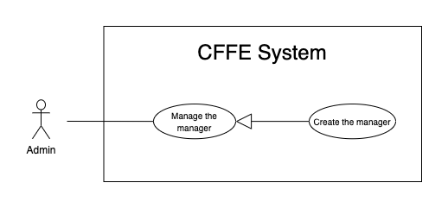

Figure . <Use Case> Create the manager

Table 49. <Use Case> Create the manager

|  |  |  |  |
| --- | --- | --- | --- |
| ID and Name: | **UC-35 Create the manager** | | |
| Created By: | LuanNM | Date Created: | 10/05/2021 |
| Primary Actor: | Admin | Secondary Actors: | N/A |
| Description: | This feature allows Admin to create the manager. | | |
| Trigger: | Admin sends a request to create the manager. | | |
| Preconditions: | PRE-01. User has logged in the system as admin role.  PRE-02. Admin is on “Manager” page. | | |
| Post-conditions: | POST-01:   * Success: CFFE system shows success message and reloads "Manager" page. * Fail: CFFE system shows error message. | | |
| Normal Flow: | **35.0 Create the manager**   1. Admin clicks on "New" button. 2. CFFE system shows creating popup that includes:    * "Avatar": button    * "Full name": input text    * "Email": input text    * "Identity card": input text    * "Phone number": input text    * "Gender": checkbox    * "Birthday": date picker    * "Address": input text    * "City": select box    * "District": select box    * "Create": button    * "Cancel": button 3. Admin inputs/selects the required fields. 4. Admin clicks on the "Create" button to create the manager. (Alternative 35.0, 35.1) 5. CFFE system validates the required fields. (Exception 35.0.E1, 35.0.E2) 6. CFFE system stores newly created manager, returns the success message (MSG-011). | | |
| Alternative Flows: | **35.0 Admin cancels the creating process.**   1. Admin clicks on "Cancel" button. 2. CFFE system closes this popup and terminates this use case.   **35.1 Admin clicks outside of popup.**   1. Admin clicks outside of popup. 2. CFFE system closes this popup and terminates this use case. | | |
| Exceptions: | **35.0.E1 Admin does not input/select the required fields**   1. CFFE system returns to Admin to input/select the required fields again (MSG-014, MSG-036, MSG-038, MSG-039, MSG-044, MSG-047, MSG-049, MSG-051, MSG-054). 2. If Admin inputs/selects the required fields again, CFFE system returns to step 3 of the normal flow. 3. Else if Admin cancels the creating process, then CFFE system terminates this use case.   **35.0.E2 Admin inputs/selects the fields that are not valid**   1. CFFE system returns to Admin to input/select the fields again (MSG-015, MSG-037, MSG-042, MSG-045, MSG-048, MSG-052, MSG-055, MSG-056, MSG-073). 2. If Admin inputs/selects the fields again, CFFE system returns to step 3 of the normal flow. 3. Else if Admin cancels the creating process, then CFFE system terminates this use case. | | |
| Priority: | Medium | | |
| Frequency of Use: | Often | | |
| Business Rules: | BR-034, BR-035, BR-060, BR-070 | | |
| Other Information: | In case of internet connection failure, Admin cannot finish this use case properly. | | |
| Assumptions: | N/A | | |

##### 2.2.4.12 <Admin> Create the account

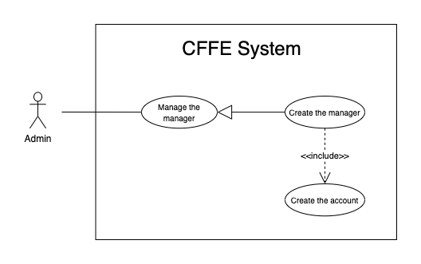

Figure . <Use Case> Create the account

Table 50. <Use Case> Create the account

|  |  |  |  |
| --- | --- | --- | --- |
| ID and Name: | **UC-36 Create the account** | | |
| Created By: | LuanNM | Date Created: | 10/05/2021 |
| Primary Actor: | Admin | Secondary Actors: | N/A |
| Description: | This feature allows Admin to create the manager. | | |
| Trigger: | Admin sends a request to create the account. | | |
| Preconditions: | PRE-01. User has logged in the system as admin role.  PRE-02. Admin creates a manager successfully. | | |
| Post-conditions: | POST-01. CFFE system stores newly accounts and sends manager's account to manager's email. | | |
| Normal Flow: | **36.0 Create the account**   1. CFFE system creates the account for newly manager and sends account to manager's email (Exception 36.0.E1). | | |
| Alternative Flows: | N/A | | |
| Exceptions: | **36.0.E1 Send email failed**   1. CFFE system shows error message (MSG-124). | | |
| Priority: | Medium | | |
| Frequency of Use: | Often | | |
| Business Rules: | BR-008, BR-012, BR-043 | | |
| Other Information: | In case of internet connection failure, Admin cannot finish this use case properly. | | |
| Assumptions: | N/A | | |

##### 2.2.4.13 <Admin> Update the product

Figure . <Use Case> Update the product

Table 51. <Use Case> Update the product

|  |  |  |  |
| --- | --- | --- | --- |
| ID and Name: | **UC-37 Update the product** | | |
| Created By: | HieuNT | Date Created: | 18/06/2021 |
| Primary Actor: | Admin | Secondary Actors: | N/A |
| Description: | This feature allows admin to update product in CFFE system. | | |
| Trigger: | Admin sends a request to update the product. | | |
| Preconditions: | PRE-01. User has logged in the system as admin role.  PRE-02. Admin is on “Product detail” page. | | |
| Post-conditions: | POST-01:   * Success: CFFE system shows success message and reloads "Product Detail" page. * Fail: CFFE system shows error message. | | |
| Normal Flow: | **37.0 Update the product information** (Alternative 37.0, 37.1)   1. Admin clicks on "Edit information" button on the About box. 2. CFFE system requires product popup that includes:  * “Product name”: input text * “Description”: input text * “Category”: dropdown list * "Update": button * "Cancel": button  1. Admin inputs/selects the required fields. 2. Admin clicks on “Update” button. (Alternative 37.2) 3. CFFE system validates the fields. (Exception 37.0.E1, 37.0.E2, 37.0.E6) 4. CFFE system updates product information and returns the success message (MSG-013). | | |
| Alternative Flows: | **37.0 Updating product image.**   1. Admin clicks on "Update avatar" button. 2. CFFE system shows updating image popup for Admin selecting:    * "Avatar": label    * "Choose": button    * "OK": button    * "Cancel": button 3. Admin clicks on "Choose" button. 4. Admin selects an image. 5. Admin clicks on "OK" button. (Alternative 37.2, 37.3) 6. CFFE system validates the image. (Exception 37.0.E3, 37.0.E4, 37.0.E5, 37.0.E6) 7. CFFE system updates the product's image and returns the success message (MSG-013).   **37.1 Reactivate the inactive product.**   1. Admin focuses on "Inactive" button then clicks on "Active" button. 2. CFFE system shows confirm popup with message "Do you want to active this product?" and two buttons for Admin selecting:    * "OK" button    * "Cancel" button 3. Admin clicks on "OK" button. (Alternative 37.2, 37.3) 4. CFFE system validates the product. (Exception 37.0.E6) 5. CFFE system updates the product's status and returns the success message (MSG-013).   **37.2 Admin cancels the updating process.**   1. Admin clicks on "Cancel" button. 2. CFFE system closes this popup and terminates this use case.   **37.3 Admin clicks outside of popup.**   1. Admin clicks outside of popup. 2. CFFE system closes this popup and terminates this use case. | | |
| Exceptions: | **37.0.E1 Admin does not input/select the required fields**   1. CFFE system returns to Admin to input/select the required fields again (MSG-016, MSG-099, MSG-102). 2. If Admin inputs/selects the required fields again, CFFE system returns to step 3 of the normal flow. 3. Else if Admin cancels the updating process, then CFFE system terminates this use case.   **37.0.E2 Admin inputs/selects the fields that are not valid**   1. CFFE system returns to Admin to input/select the fields again (MSG-017, MSG-060, MSG-103, MSG-104, MSG-130). 2. If Admin inputs/selects the fields again, CFFE system returns to step 3 of the normal flow. 3. Else if Admin cancels the updating process, then CFFE system terminates this use case.   **37.0.E3 Admin does not select the image**   1. CFFE system returns to Admin to select the image again (MSG-112). 2. If Admin selects the image again, CFFE system returns to step 3 of the alternative flow 37.0. 3. Else if Admin cancels the updating process, then CFFE system terminates this use case.   **37.0.E4 Image is not jpg/jpeg/png format.**   1. CFFE system returns to Admin to select the image again (MSG-113). 2. If Admin selects the image again, CFFE system returns to step 3 of the alternative flow 37.0. 3. Else if Admin cancels the updating process, then CFFE system terminates this use case.   **37.0.E5 CFFE system cannot upload the image.**   1. CFFE system shows error message (MSG-114) and terminates this use case.   **37.0.E6 Product does not exist.**   1. CFFE system returns error message (MSG-023) and terminates this use case. | | |
| Priority: | Medium | | |
| Frequency of Use: | Often | | |
| Business Rules: | BR-032, BR-047 | | |
| Other Information: | In case of internet connection failure, Admin cannot finish this use case properly. | | |
| Assumptions: | N/A | | |

##### 2.2.4.14 <Admin> Delete the product

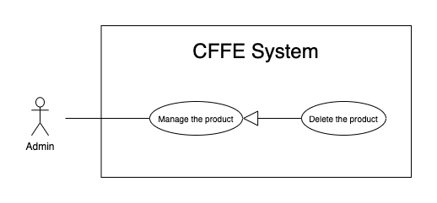

Figure . <Use Case> Delete the product

Table 52. <Use Case> Delete the product

|  |  |  |  |
| --- | --- | --- | --- |
| ID and Name: | **UC-38 Delete the product** | | |
| Created By: | HieuNT | Date Created: | 10/05/2021 |
| Primary Actor: | Admin | Secondary Actors: | N/A |
| Description: | This feature allows Admin to delete the product. | | |
| Trigger: | Admin sends a request to delete the product. | | |
| Preconditions: | PRE-01. User has logged in the system as Admin role.  PRE-02. Admin is on “Product detail” page. | | |
| Post-conditions: | POST-01:   * Success: CFFE system shows success message and reloads "Product Detail" page. * Fail: CFFE system shows error message. | | |
| Normal Flow: | **38.0 Delete the product**   1. Admin focuses on "Active" button then clicks on "Inactive" button. 2. CFFE system shows delete popup with message: "Do you want to inactive this product?" and required form:  * "Inactive reason": text area * "OK": button * "Cancel" button  1. Admin inputs the field. 2. Admin clicks on "OK" button. (Alternative 38.0) 3. CFFE system validates the product. (Exception 38.0.E1, 38.0.E2, 38.E3) 4. CFFE system updates the product's status and returns the success message (MSG-040). | | |
| Alternative Flows: | **38.0 Admin cancels the deleting process.**   1. Admin clicks on "Cancel" button. 2. CFFE system closes this popup and terminates this use case. | | |
| Exceptions: | **38.0.E1 Product does not exist**   1. CFFE system returns error message (MSG-023) and terminates this use case.   **38.0.E2 The product is still on the stack.**   1. CFFE system shows error message (MSG-097) and terminates this use case.   **38.0.E3 Admin inputs the inactive reason fields that are not valid**   1. CFFE system returns error message (MSG-067) and terminates this use case. | | |
| Priority: | Medium | | |
| Frequency of Use: | Often | | |
| Business Rules: | BR-032, BR-033, BR-049 | | |
| Other Information: | In case of internet connection failure, Admin cannot finish this use case properly. | | |
| Assumptions: | N/A | | |

##### 2.2.4.15 <Admin> Create the product

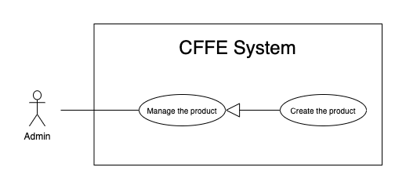

Figure . <Use Case> Create the product

Table 53. <Use Case> Create the product

|  |  |  |  |
| --- | --- | --- | --- |
| ID and Name: | **UC-39 Create the product** | | |
| Created By: | HieuNT | Date Created: | 10/05/2021 |
| Primary Actor: | Admin | Secondary Actors: | N/A |
| Description: | This feature allows Admin to create the product. | | |
| Trigger: | Admin sends a request to create the product. | | |
| Preconditions: | PRE-01. User has logged in the system as Admin role.  PRE-02. Admin is on “Product” page. | | |
| Post-conditions: | POST-01:   * Success: CFFE system shows success message and reloads "Product" page. * Fail: CFFE system shows error message. | | |
| Normal Flow: | **39.0 Create the product**   1. Admin clicks on "New" button to create new product. 2. CFFE system requires the product information:    * "Image": button    * "Product name": input text    * "Description": input text    * "Category": dropdown list    * "Create": button    * "Cancel": button 3. Admin inputs/selects the required fields. 4. Admin clicks on the "Create" button to create new product. (Alternative 39.0, 39.1) 5. CFFE system validates the required fields (Exception 39.0.E1, 39.0.E2) 6. CFFE system stores newly created product information and returns the success message (MSG-011). | | |
| Alternative Flows: | **39.0 Admin cancels the creating process.**   1. Admin clicks on "Cancel" button. 2. CFFE system closes this popup and terminates this use case.   **39.1 Admin clicks outside of popup.**   1. Admin clicks outside of popup. 2. CFFE system closes this popup and terminates this use case. | | |
| Exceptions: | **39.0.E1 Admin does not input/select the required fields**   1. CFFE system returns to Admin to input/select the required fields again (MSG-016, MSG-099, MSG-102). 2. If Admin inputs/selects the required fields again, CFFE system returns to step 3 of the normal flow. 3. Else if Admin cancels the updating process, then CFFE system terminates this use case.   **39.0.E2 Admin inputs/selects the fields that are not valid**   1. CFFE system returns to Admin to input/select the fields again (MSG-017, MSG-060, MSG-103, MSG-104, MSG-130). 2. If Admin inputs/selects the fields again, CFFE system returns to step 3 of the normal flow. 3. Else if Admin cancels the updating process, then CFFE system terminates this use case. | | |
| Priority: | Medium | | |
| Frequency of Use: | Often | | |
| Business Rules: | BR-035, BR-047, BR-070 | | |
| Other Information: | In case of internet connection failure, Admin cannot finish this use case properly. | | |
| Assumptions: | N/A | | |

##### 2.2.4.15 <Admin> Update the camera

Figure . <Use Case> Update the camera

Table 54. <Use Case> Update the camera

|  |  |  |  |
| --- | --- | --- | --- |
| ID and Name: | **UC-40 Update the camera** | | |
| Created By: | HuuDN | Date Created: | 18/06/2021 |
| Primary Actor: | Admin | Secondary Actors: | N/A |
| Description: | This feature allows Admin to update camera in CFFE system. | | |
| Trigger: | Admin sends a request to update the camera. | | |
| Preconditions: | PRE-01. User has logged in the system as Admin role.  PRE-02. Manager is on “Camera detail” page. | | |
| Post-conditions: | POST-01:   * Success: CFFE system shows success message and reloads "Camera Detail" page. * Fail: CFFE system shows error message. | | |
| Normal Flow: | **40.0 Update the camera information**   1. Admin clicks on "Edit information" button to update camera information. 2. CFFE system requires camera information that includes:  * “Camera name”: input text * “IP address”: input text * "MAC address": input text * “RTSP string”: input text  1. Admin inputs the required fields. 2. Admin clicks on “Update” button to edit camera information. (Alternative 40.2) 3. CFFE system validates the fields (Exception 40.0.E1, 40.0.E2, 40.0.E6) 4. CFFE system updates camera information and returns the success message (MSG-013). | | |
| Alternative Flows: | **40.0 Updating camera image.**   1. Admin clicks on "Update camera" button. 2. CFFE system shows updating image popup for Admin selecting:    * "Image": label    * "Choose": button    * "OK": button    * "Cancel": button 3. Admin clicks on "Choose" button. 4. Admin selects an image. 5. Admin clicks on "OK" button. (Alternative 40.2, 40.3) 6. CFFE system validates the image. (Exception 40.0.E3, 40.0.E4, 40.0.E5, 40.0.E6) 7. CFFE system updates the camera's image and returns the success message (MSG-013).   **40.1 Reactivate the inactive camera.**   1. Admin focuses on "Inactive" button then clicks on "Pending" button. 2. CFFE system shows confirm popup with message "Do you want to active this camera?" and two buttons for Admin selecting:    * "OK" button    * "Cancel" button 3. Admin clicks on "OK" button. (Alternative 40.2, 40.3) 4. CFFE system validates the camera. (Exception 40.0.E6) 5. CFFE system updates the camera's status and returns the success message (MSG-013).   **40.2 Admin cancels the updating process.**   1. Admin clicks on "Cancel" button. 2. CFFE system closes this popup and terminates this use case.   **40.3 Admin clicks outside of popup.**   1. Admin clicks outside of popup. 2. CFFE system closes this popup and terminates this use case. | | |
| Exceptions: | **40.0.E1 Admin does not input the required fields**   1. CFFE system returns to Admin to input the required fields again (MSG-031, MSG-030, MSG-082, MSG-125). 2. If Admin inputs the required fields again, CFFE system returns to step 3 of the normal flow. 3. Else if Admin cancels the updating process, then CFFE system terminates this use case.   **40.0.E2 Admin inputs the fields that are not valid**   1. CFFE system returns to Admin to input the fields again (MSG-032, MSG-059, MSG-083, MSG-126). 2. If Admin inputs the fields again, CFFE system returns to step 3 of the normal flow. 3. Else if Admin cancels the updating process, then CFFE system terminates this use case.   **40.0.E3 Admin does not select the image**   1. CFFE system returns to Admin to select the image again (MSG-112). 2. If Admin selects the image again, CFFE system returns to step 3 of the alternative flow 40.0. 3. Else if Admin cancels the updating process, then CFFE system terminates this use case.   **40.0.E4 Image is not jpg/jpeg/png format.**   1. CFFE system returns to Admin to select the image again (MSG-113). 2. If Admin selects the image again, CFFE system returns to step 3 of the alternative flow 40.0. 3. Else if Admin cancels the updating process, then CFFE system terminates this use case.   **40.0.E5 CFFE system cannot upload the image.**   1. CFFE system shows error message (MSG-114) and terminates this use case.   **40.0.E6 Camera does not exist.**   1. CFFE system returns error message (MSG-020) and terminates this use case. | | |
| Priority: | Medium | | |
| Frequency of Use: | Often | | |
| Business Rules: | BR-029, BR-032, BR-055, BR-056 | | |
| Other Information: | In case of internet connection failure, Admin cannot finish this use case properly. | | |
| Assumptions: | N/A | | |

##### 2.2.4.15 <Admin> Delete the camera

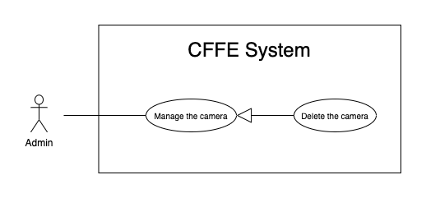

Figure . <Use Case> Delete the camera

Table 55. <Use Case> Delete the camera

|  |  |  |  |
| --- | --- | --- | --- |
| ID and Name: | **UC-41 Delete the camera** | | |
| Created By: | HuuDN | Date Created: | 10/05/2021 |
| Primary Actor: | Admin | Secondary Actors: | N/A |
| Description: | This feature allows Admin to delete the camera. | | |
| Trigger: | Admin sends a request to delete the camera. | | |
| Preconditions: | PRE-01. User has logged in the system as manager role.  PRE-02. Admin is on “Camera detail” page. | | |
| Post-conditions: | POST-01:   * Success: CFFE system shows success message and reloads "Camera Detail" page. * Fail: CFFE system shows error message. | | |
| Normal Flow: | **41.0 Delete the camera**   1. Admin focuses on "Pending" button then clicks on "Inactive" button. 2. CFFE system shows delete popup with message: "Do you want to inactive this camera?" and required form:  * "Inactive reason": text area * "OK": button * "Cancel" button  1. Admin inputs the field. 2. Admin clicks on "OK" button. (Alternative 41.0) 3. CFFE system validates the camera. (Exception 41.0.E1, 41.0.E2, 41.0.E3) 4. CFFE system updates the camera's status and returns the success message (MSG-040). | | |
| Alternative Flows: | **41.0 Admin cancels the deleting process.**   1. Admin clicks on "Cancel" button. 2. CFFE system closes this popup and terminates this use case. | | |
| Exceptions: | **41.0.E1 Camera does not exist**   1. CFFE system returns error message (MSG-020) and terminates this use case.   **41.0.E2 The camera is still on the shelf or stack.**   1. CFFE system shows error message (MSG-066) and terminates this use case.   **41.0.E3 Admin inputs the inactive reason fields that are not valid**   1. CFFE system returns error message (MSG-067) and terminates this use case. | | |
| Priority: | Medium | | |
| Frequency of Use: | Often | | |
| Business Rules: | BR-032, BR-033, BR-056, BR-058 | | |
| Other Information: | In case of internet connection failure, Admin cannot finish this use case properly. | | |
| Assumptions: | N/A | | |

##### 2.2.4.18 <Admin> Create the camera

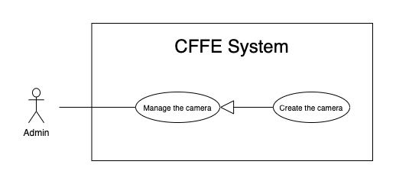

Figure . <Use Case> Create the camera

Table 56. <Use Case> Create the camera

|  |  |  |  |
| --- | --- | --- | --- |
| ID and Name: | **UC-42 Create the camera** | | |
| Created By: | HuuDN | Date Created: | 10/05/2021 |
| Primary Actor: | Admin | Secondary Actors: | N/A |
| Description: | This feature allows Admin to create new camera. | | |
| Trigger: | Admin sends a request to create new camera. | | |
| Preconditions: | PRE-01. User has logged in the system as Admin role.  PRE-02. Admin is on “Camera” page. | | |
| Post-conditions: | POST-01:   * Success: CFFE system shows success message and reloads “Camera” page. * Fail: CFFE system shows error message. | | |
| Normal Flow: | **42.0 Create the camera**   1. Admin clicks on "New" to create new camera. 2. CFFE system shows creating camera popup that includes:    * "Image" button    * "Camera name": input text    * "IP address": input text    * "MAC address": input text    * "RPST string": input text    * "Type detect": radio button    * "Create": button    * "Cancel": button 3. Admin inputs/selects the required fields. 4. Admin clicks on the "Create" button to create new camera. 5. CFFE system validates the required fields (Exception 42.0.E1, 42.0.E2). 6. CFFE system stores newly created camera information and returns the success message (MSG-011). | | |
| Alternative Flows: | **42.0 Admin cancels the creating process.**   1. Admin clicks on "Cancel" button. 2. CFFE system closes this popup and terminates this use case.   **42.1 Admin clicks outside of popup.**   1. Admin clicks outside of popup. 2. CFFE system closes this popup and terminates this use case. | | |
| Exceptions: | **42.0.E1 Admin does not input/select the required fields**   1. CFFE system returns to Admin to input/select the required fields again (MSG-031, MSG-030, MSG-082, MSG-125). 2. If Admin inputs/selects the required fields again, CFFE system returns to step 3 of the normal flow. 3. Else if Admin cancels the creating process, then CFFE system terminates this use case.   **42.0.E1 Admin inputs/selects the fields that are not valid**   1. CFFE system returns to Admin to input/select the fields again (MSG-032, MSG-059, MSG-083, MSG-084, MSG-126). 2. If Admin inputs/selects the fields again, CFFE system returns to step 3 of the normal flow. 3. Else if Admin cancels the creating process, then CFFE system terminates this use case. | | |
| Priority: | Medium | | |
| Frequency of Use: | Often | | |
| Business Rules: | BR-035, BR-055, BR-056, BR-070 | | |
| Other Information: | In case of internet connection failure, Admin cannot finish this use case properly. | | |
| Assumptions: | N/A | | |

##### 2.2.4.19 <Admin> Update the category

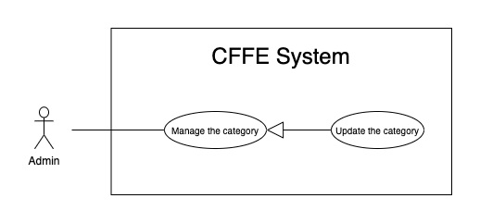

Figure . <Use Case> Update the category

Table 57. <Use Case> Update the category

|  |  |  |  |
| --- | --- | --- | --- |
| ID and Name: | **UC-43 Update the category** | | |
| Created By: | HuuDN | Date Created: | 18/06/2021 |
| Primary Actor: | Admin | Secondary Actors: | N/A |
| Description: | This feature allows Admin to update category in CFFE system. | | |
| Trigger: | Admin sends a request to update the category. | | |
| Preconditions: | PRE-01. User has logged in the system as Admin role.  PRE-02. Admin is on “Category” page. | | |
| Post-conditions: | POST-01:   * Success: CFFE system shows success message and reloads "Category" page. * Fail: CFFE system shows error message. | | |
| Normal Flow: | **43.0 Update the category** (Alternative 43.0)   1. Admin clicks on "Edit information" to update category information. 2. CFFE system requires category information that includes:  * “Category name”: input text * “OK”: button * “Cancel”: button  1. Admin inputs the required fields. 2. Admin clicks on “Update” button. (Alternative 43.1) 3. CFFE system validates the fields (Exception 43.0.E1, 43.0.E2, 43.0.E3) 4. CFFE system updates camera information and returns the success message (MSG-013). | | |
| Alternative Flows: | **43.0 Reactivate the inactive category.**   1. Admin focuses on "Inactive" button then clicks on "Active" button. 2. CFFE system shows confirm popup with message "Do you want to active this category?" and two buttons for Admin selecting:    * "OK": button    * "Cancel": button 3. Admin clicks on "OK" button. (Alternative 43.1, 43.2) 4. CFFE system validates the category. (Exception 43.0.E3) 5. CFFE system updates the category's status and returns the success message (MSG-013).   **43.1 Admin cancels the updating process.**   1. Admin clicks on "Cancel" button. 2. CFFE system closes this popup and terminates this use case.   **43.2 Admin clicks outside of popup.**   1. Admin clicks outside of popup. 2. CFFE system closes this popup and terminates this use case. | | |
| Exceptions: | **43.0.E1 Admin does not input the required fields**   1. CFFE system returns to Admin to input/select the required fields again (MSG-105). 2. If Admin inputs the required fields again, CFFE system returns to step 3 of the normal flow. 3. Else if Admin cancels the updating process, then CFFE system terminates this use case.   **43.0.E2 Admin inputs the fields that are not valid**   1. CFFE system returns to Admin to input/select the fields again (MSG-059, MSG-050). 2. If Admin inputs the fields again, CFFE system returns to step 3 of the normal flow. 3. Else if Admin cancels the updating process, then CFFE system terminates this use case.   **43.0.E3 Category does not exist.**   1. CFFE system returns error message (MSG-029) and terminates this use case. | | |
| Priority: | Medium | | |
| Frequency of Use: | Often | | |
| Business Rules: | BR-032, BR-063 | | |
| Other Information: | In case of internet connection failure, Admin cannot finish this use case properly. | | |
| Assumptions: | N/A | | |

##### 2.2.4.20 <Admin> Delete the category

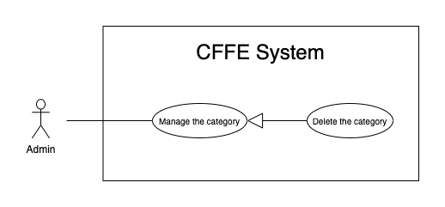

Figure . <Use Case> Delete the category

Table 58. <Use Case> Delete the category

|  |  |  |  |
| --- | --- | --- | --- |
| ID and Name: | **UC-44 Delete the category** | | |
| Created By: | HuuDN | Date Created: | 18/06/2021 |
| Primary Actor: | Admin | Secondary Actors: | N/A |
| Description: | This feature allows Admin to delete category in CFFE system. | | |
| Trigger: | Admin sends a request to delete the category. | | |
| Preconditions: | PRE-01. User has logged in the system as Admin role.  PRE-02. Admin is on “Category” page. | | |
| Post-conditions: | POST-01:   * Success: CFFE system shows success message and reloads "Category" page. * Fail: CFFE system shows error message. | | |
| Normal Flow: | **44.0 Delete the category**   1. Admin focuses on "Active" button then clicks on "Inactive" button. 2. CFFE system shows confirm popup with message: "Do you want to inactive this category?" and two buttons for Admin selecting:  * "OK": button * "Cancel" button  1. Admin clicks on "OK" button. (Alternative 44.0) 2. CFFE system validates the category. (Exception 44.0.E1, 44.0.E2) 3. CFFE system updates the category's status and returns the success message (MSG-013). | | |
| Alternative Flows: | **44.0 Admin cancels the deleting process.**   1. Admin clicks on "Cancel" button. 2. CFFE system closes this popup and terminates this use case. | | |
| Exceptions: | **44.0.E1 Category does not exist**   1. CFFE system returns error message (MSG-029) and terminates this use case.   **44.0.E2 Category has a product.**   1. CFFE system shows error message (MSG-066) and terminates this use case. | | |
| Priority: | Medium | | |
| Frequency of Use: | Often | | |
| Business Rules: | BR-057 | | |
| Other Information: | In case of internet connection failure, Admin cannot finish this use case properly. | | |
| Assumptions: | N/A | | |

##### 2.2.4.21 <Admin> Create the category

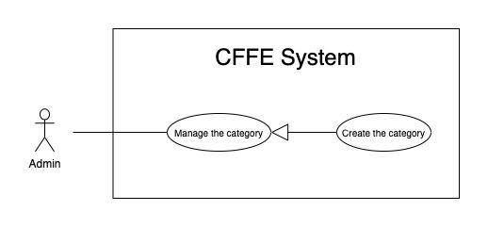

Figure . <Use Case> Create the category

Table 59. <Use Case> Create the category

|  |  |  |  |
| --- | --- | --- | --- |
| ID and Name: | **UC-45 Create the category** | | |
| Created By: | TruongTN | Date Created: | 10/05/2021 |
| Primary Actor: | Admin | Secondary Actors: | N/A |
| Description: | This feature allows Admin to create new category. | | |
| Trigger: | Admin sends a request to create new category. | | |
| Preconditions: | PRE-01. User has logged in the system as Admin role.  PRE-02. Admin is on “Category” page. | | |
| Post-conditions: | POST-01:   * Success: CFFE system shows success message and reloads "Category" page. * Fail: CFFE system shows error message. | | |
| Normal Flow: | **45.0 Create the category**   1. Admin clicks on "New" to create new category. 2. CFFE system shows creating category popup that includes:    * "Camera name": input text 3. Admin inputs the required fields. 4. Admin clicks on the "Create" button to create new category. (Alternative 45.0, 45.1) 5. CFFE system validates the required fields (Exception 45.0.E1, 45.0.E2). 6. CFFE system stores newly created category information and returns the success message (MSG-011). | | |
| Alternative Flows: | **45.0 Admin cancels the creating process.**   1. Admin clicks on "Cancel" button. 2. CFFE system closes this popup and terminates this use case.   **45.1 Admin clicks outside of popup.**   1. Admin clicks outside of popup. 2. CFFE system closes this popup and terminates this use case. | | |
| Exceptions: | **45.0.E1 Admin does not input the required fields**   1. CFFE system returns to Admin to input the required fields again (MSG-105). 2. If Admin inputs the required fields again, CFFE system returns to step 3 of the normal flow. 3. Else if Admin cancels the creating process, then CFFE system terminates this use case.   **45.0.E1 Admin inputs the fields that are not valid**   1. CFFE system returns to Admin to input the fields again (MSG-059, MSG-050). 2. If Admin inputs the fields again, CFFE system returns to step 3 of the normal flow. 3. Else if Admin cancels the creating process, then CFFE system terminates this use case. | | |
| Priority: | Medium | | |
| Frequency of Use: | Often | | |
| Business Rules: | BR-063 | | |
| Other Information: | In case of internet connection failure, Admin cannot finish this use case properly. | | |
| Assumptions: | N/A | | |

#### 2.2.5 <System AI> Overview Use Case

Figure . <Overview Use Case> System AI

##### 2.2.5.1 <System AI> Analyze facial emotion

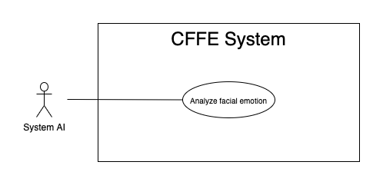

Figure . <Use Case> Analyze facial emotion

Table 60. <Use Case> Analyze facial emotion

|  |  |  |  |
| --- | --- | --- | --- |
| ID and Name: | **UC-46 Analyze facial emotion** | | |
| Created By: | HieuHD | Date Created: | 25/06/2021 |
| Primary Actor: | System AI | Secondary Actors: | N/A |
| Description: | This feature allows the System AI to analyze facial emotions. | | |
| Trigger: | When system is received a request to analyse video. | | |
| Pre-conditions: | PRE-01. Manager uploads the video successfully.  PRE-02. Uploaded videos are emotion type. | | |
| Post-conditions: | POST-01:   * Success: CFFE system shows complete notification and stores the detected videos and result. * Fail: CFFE system shows error message. | | |
| Normal Flow: | **46.0 Analyze facial emotion**   1. System AI detects the videos base on video type. 2. CFFE system shows "Detecting" notification during the detection process. 3. System AI sends the complete notification with success and error videos, detection result. 4. CFFE system shows "Complete" notification and stores the detected videos and result. | | |
| Alternative Flows: | N/A | | |
| Exceptions: | N/A | | |
| Priority: | High | | |
| Frequency of Use: | Always | | |
| Business Rules: | N/A | | |
| Other Information: | In case of internet connection failure, System AI cannot finish this use case. | | |
| Assumptions: | N/A | | |

##### 2.2.5.2 <System AI> Count the customers

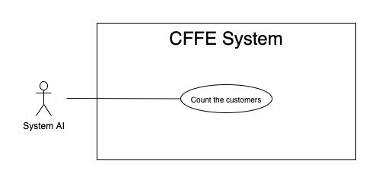

Figure . <Use Case> Count the customers

Table 61. <Use Case> Count the customers

|  |  |  |  |
| --- | --- | --- | --- |
| ID and Name: | **UC-47 Count the costumers** | | |
| Created By: | HieuHD | Date Created: | 25/06/2021 |
| Primary Actor: | System AI | Secondary Actors: | N/A |
| Description: | This feature allows the System AI to count the customers. | | |
| Trigger: | When system is received a request analyze videos. | | |
| Pre-conditions: | PRE-01. Manager uploads the videos successfully.  PRE-02. Uploaded videos are counting type. | | |
| Post-conditions: | POST-01:   * Success: CFFE system shows complete notification and stores the detected videos and result. * Fail: CFFE system shows error message. | | |
| Normal Flow: | **47.0 Count the customers**   1. System AI detects the videos base on video type. 2. CFFE system shows "Detecting" notification during the detection process. 3. System AI sends the complete notification with success and error videos, detection result. 4. CFFE system shows "Complete" notification and stores the detected videos and result. | | |
| Alternative Flows: | N/A | | |
| Exceptions: | N/A | | |
| Priority: | High | | |
| Frequency of Use: | Always | | |
| Business Rules: | N/A | | |
| Other Information: | In case of internet connection failure, System AI cannot finish this use case. | | |
| Assumptions: | N/A | | |

### 2.3 User case specification (Mobile)

#### 2.3.1 <Unauthenticated User> Overview Use Case



Figure . <Overview Use Case> Unauthenticated User

##### 2.3.1.1 <Unauthenticated User> Login by account



Figure . <Use Case> Login by account

Table 62. <Use Case> Login by account

|  |  |  |  |
| --- | --- | --- | --- |
| ID and Name: | **UC-01 Login by account** | | |
| Created By: | TruongTN | Date Created: | 25/06/2021 |
| Primary Actor: | Unauthenticated User | Secondary Actors: | N/A |
| Description: | This feature allows the unauthenticated user to login to CFFE system to verify the role and gives them access to more features. | | |
| Trigger: | Unauthenticated User sends a request to login to CFFE system. | | |
| Pre-conditions: | PRE-01. User's account has been created.  PRE-02. User's account has been authorized as Admin or Manager role.  PRE-03. User has not logged in to CFFE system. | | |
| Post-conditions: | POST-01:   * Success: User logins to CFFE system with own role successfully and redirect to "Dashboard" page. * Fail: CFFE system shows error message. | | |
| Normal Flow: | **1.0 Login by account**   1. Unauthenticated User send a request to login to the CFFE system. 2. CFFE system shows required form that includes:  * “Username”: input text * “Password”: input text * “Login”: button  1. Unauthenticated User inputs the required fields. 2. Unauthenticated User clicks on “Login” button. 3. CFFE system validates the username and password. (Exception 1.0.E1, 1.0.E2) 4. CFFE system determines the user’s identity, role, and permission then redirects to the manager page. | | |
| Alternative Flows: | N/A | | |
| Exceptions: | **1.0.E1 Unauthenticated User does not enter the required fields**   1. CFFE system returns to Unauthenticated User to fill the required fields again (MSG-001, MSG-002). 2. If Unauthenticated User inputs the required fields again, CFFE system returns to step 3 of the normal flow. 3. Else if Unauthenticated User cancels the login process, then CFFE system terminates this use case.   **1.0.E2 Unauthenticated User enters wrong username or password.**   1. CFFE system returns to Unauthenticated User to fill the required fields again (MSG-003). 2. If Unauthenticated User inputs username and password again, CFFE system returns to step 3 of the normal flow. 3. Else if Unauthenticated User cancels the login process, then CFFE system terminates this use case. | | |
| Priority: | High | | |
| Frequency of Use: | Always | | |
| Business Rules: | BR-001, BR-002, BR-007 | | |
| Other Information: | In case of internet connection failure, Unauthenticated User cannot finish this use case. | | |
| Assumptions: | N/A | | |

#### 2.3.2 <Authenticated User> Overview Use Case



Figure . <Overview Use Case> Authenticated User

##### 2.3.2.1 <Authenticated User> Logout



Figure . <Use Case> Logout

Table 63. <Use Case> Logout

|  |  |  |  |
| --- | --- | --- | --- |
| ID and Name: | **UC-02 Logout** | | |
| Created By: | TruongTN | Date Created: | 25/06/2021 |
| Primary Actor: | Authenticated User | Secondary Actors: | N/A |
| Description: | This feature allows the authenticated user to log out from CFFE system. | | |
| Trigger: | Authenticated user sends a request to log out from CFFE system. | | |
| Pre-conditions: | PRE-01. User has logged into CFFE system. | | |
| Post-conditions: | POST-01. User has successfully logged out CFFE system. | | |
| Normal Flow: | **2.0 Logout**   1. Authenticated user clicks on “Logout” button of the navigation bar. 2. CFFE system deletes information on their local storage and cookie. 3. CFFE system redirects to the login page. | | |
| Alternative Flows: | N/A | | |
| Exceptions: | N/A | | |
| Priority: | Medium | | |
| Frequency of Use: | Usually | | |
| Business Rules: | BR-004, BR-005, BR-006 | | |
| Other Information: | In case of internet connection failure, Authenticated User cannot finish this use case. | | |
| Assumptions: | N/A | | |

##### 2.3.2.2 <Authenticated User> Get own profile



Figure . <Use Case> Get own profile

Table 64. <Use Case> Get own profile

|  |  |  |  |
| --- | --- | --- | --- |
| ID and Name: | **UC-03 Get own profile** | | |
| Created By: | HuuDN | Date Created: | 17/06/2021 |
| Primary Actor: | Authenticated User | Secondary Actors: | N/A |
| Description: | This feature allows the authenticated user to get own profile. | | |
| Trigger: | Authenticated User sends a request to get own profile. | | |
| Preconditions: | PRE-01. User has logged into CFFE system. | | |
| Post-conditions: | POST-01:   * Success: CFFE system redirects to own profile page. * Fail: CFFE system shows error message. | | |
| Normal Flow: | **3.0 Get own profile**   1. Authenticated User clicks on "Profile" button of the navigation bar. 2. CFFE system returns own information and redirects to the profile page. (Exception 3.0.E1) | | |
| Alternative Flows: | N/A | | |
| Exceptions: | **3.0.E1 Authenticated User does not exist.**  1. CFFE system returns the message (MSG-041) and terminates this use case. | | |
| Priority: | Normal | | |
| Frequency of Use: | Sometime | | |
| Business Rules: | N/A | | |
| Other Information: | In case of internet connection failure, Authenticated User cannot finish this use case properly. | | |
| Assumptions: | N/A | | |

##### 2.3.2.3 <Authenticated User> Update own profile



Figure . <Use Case> Update own profile

Table 65. <Use Case> Update own profile

|  |  |  |  |
| --- | --- | --- | --- |
| ID and Name: | **UC-04 Update own profile** | | |
| Created By: | HuuDN | Date Created: | 17/06/2021 |
| Primary Actor: | Authenticated User | Secondary Actors: | N/A |
| Description: | This feature allows the authenticated user to update own profile. | | |
| Trigger: | Authenticated User sends a request to update own profile. | | |
| Preconditions: | PRE-01. User has logged in CFFE system.  PRE-02. User is on “Profile” page. | | |
| Post-conditions: | POST-01:   * Success: CFFE system shows success message and reloads "Profile" page. * Fail: CFFE system shows error message. | | |
| Normal Flow: | **4.0 Update information** (Alternative 4.0, 4.1)   1. Authenticated User clicks on "Update Information" button. 2. CFFE system redirects to the update information page and shows required form that includes:  * “Full name”: input text * “Gender”: radio button * “Birthday”: date picker * “Identity card”: input text * “Phone number”: input text * “Email”: input text * “Address”: input text * “City”: select box * “District”: select box * “Back”: button * “Save”: button  1. Authenticated User inputs the required fields. 2. Authenticated User clicks on “Save” button. (Alternative 4.2) 3. CFFE system validates the fields (Exception 4.0.E1, 4.0.E2) 4. CFFE system updates own information and redirects to the profile page with the success message (MSG-013). | | |
| Alternative Flows: | **4.0 Update Avatar**   1. Authenticated User clicks on "Change avatar" button. 2. CFFE system redirects to the change avatar page and shows required form that includes:    * "Choose": button    * "Save": button    * “Back”: button 3. Authenticated User clicks on "Choose" button and selects an image. 4. Authenticated User clicks on "Save" button. (Alternative 4.2) 5. CFFE system validates the image (Exception 4.0.E3, 4.0.E4, 4.0.E7) 6. CFFE system updates own avatar and redirects to the profile page with the success message (MSG-013).   **4.1 Update password**   1. Authenticated User clicks on "Change password" button. 2. CFFE system redirects to change password page requires form that includes:    * "Old password": input text    * "New password": input text    * "Retype password": input text    * "Update": button    * “Back”: button 3. Authenticated User inputs/selects the fields. 4. Authenticated User clicks on "Update" button. (Alternative 4.2) 5. CFFE system validates the image (Exception 4.0.E5, 4.0.E6) 6. CFFE system updates own password and redirects to the profile page with the success message (MSG-013).   **4.2 Authenticated User cancels the updating process.**   1. Authenticated User clicks on “Back” button. 2. CFFE system redirects to the profile page and terminates this use case. | | |
| Exceptions: | **4.0.E1 Authenticated User does not input/select the required fields**   1. CFFE system returns to Authenticated User to input/select the required fields again (MSG-014, MSG-036, MSG-038, MSG-039, MSG-049, MSG-044, MSG-047, MSG-051, MSG-054). 2. If Authenticated User inputs/selects the required fields again, CFFE system returns to step 3 of the normal flow. 3. Else if Authenticated User cancels the updating process, then CFFE system terminates this use case.   **4.0.E2 Authenticated User inputs/selects the fields that are not valid**   1. CFFE system returns to Authenticated Users to input/select the fields again (MSG-015, MSG-037, MSG-042, MSG-045, MSG-052, MSG-073). 2. If Authenticated User inputs/selects the fields again, CFFE system returns to step 3 of the normal flow. 3. Else if Authenticated User cancels the updating process, then CFFE system terminates this use case.   **4.0.E3 Authenticated User does not select an image**   1. CFFE system will not show “Save” button until User selects an image. 2. If Authenticated User click on “Choose” button, CFFE system returns to step 4 of the alternative flow 4.0. 3. Else if Authenticated User cancels the updating process, then CFFE system terminates this use case.   **4.0.E4 Image is not png/jpg/jpeg format.**   1. CFFE system shows message (MSG-027) and terminates this use case.   **4.0.E5 Authenticated User does not input the required fields**   1. CFFE system returns to Authenticated User to input/select the required fields again (MSG-004, MSG-005, MSG-006). 2. If Authenticated User inputs/selects the required fields again, CFFE system returns to step 3 of the alternative flow 4.1. 3. Else if Authenticated User cancels the updating process, then CFFE system terminates this use case.   **4.0.E6 Authenticated User inputs the fields that are not valid**   1. CFFE system returns to Authenticated Users to input/select the fields again (MSG-007, MSG-008, MSG-068). 2. If Authenticated User inputs/selects the fields again, CFFE system returns to step 3 of the alternative flow 4.1. 3. Else if Authenticated User cancels the updating process, then CFFE system terminates this use case.   **4.0.E7 CFFE system cannot upload the image.**   1. CFFE system shows error message (MSG-114) and terminates this use case. | | |
| Priority: | Medium | | |
| Frequency of Use: | Often | | |
| Business Rules: | BR-032, BR-034, BR-060 | | |
| Other Information: | In case of internet connection failure, Authenticated User cannot finish this use case properly. | | |
| Assumptions: | N/A | | |

##### 2.3.2.4 <Authenticated User> Get the report



Figure . <Use Case> Get the report

Table 66. <Use Case> Get the report

|  |  |  |  |
| --- | --- | --- | --- |
| ID and Name: | **UC-05 Get the report** | | |
| Created By: | HuuDN | Date Created: | 15/06/2021 |
| Primary Actor: | Authenticated User | Secondary Actors: | N/A |
| Description: | This feature allows the Authenticated User to get the report. | | |
| Trigger: | Authenticated User sends a request to get the report. | | |
| Preconditions: | PRE-01. User has logged into CFFE system as admin or manager role. | | |
| Post-conditions: | POST-01. Authenticated User has successfully got the report. | | |
| Normal Flow: | **5.0 Get the facial expression analysis report** (Alternative 5.0)   1. Authenticated User clicks on "Dashboard" button on the navigation bar. 2. CFFE system requires the report's information from Authenticated User:  * “Product name”: select box * “Store name”: select box * “Date rage”: date range picker  1. Authenticated User selects the fields. 2. CFFE system returns the reports (Exception 5.0.E1). | | |
| Alternative Flows: | **5.0 Get the counting customer report**   1. Authenticated User clicks on "Dashboard" button of the navigation bar. 2. Authenticated User clicks on "Counting customer" button on the left-bottom navigation bar of the frame. 3. CFFE system requires the report's information from Authenticated User:  * “Store name”: select box * “Shelf name”: select box * “Date rage”: date range picker  1. Authenticated User selects the fields. 2. CFFE system returns the reports (Exception 5.0.E1). | | |
| Exceptions: | **5.0.E1 The report has no data.**   1. CFFE system returns the message (MSG-009). | | |
| Priority: | High | | |
| Frequency of Use: | Often | | |
| Business Rules: | BR-013, BR-014, BR-016 | | |
| Other Information: | In case of internet connection failure, Authenticated User cannot finish this use case properly. | | |
| Assumptions: | N/A | | |

##### 2.3.2.5 <Authenticated User> Download the report



Figure . <Use Case> Download the report

Table 67. <Use Case> Download the report

|  |  |  |  |
| --- | --- | --- | --- |
| ID and Name: | **UC-06 Download the report** | | |
| Created By: | HuuDN | Date Created: | 18/06/2021 |
| Primary Actor: | Authenticated User | Secondary Actors: | N/A |
| Description: | This feature allows Authenticated User to download the report. | | |
| Trigger: | Authenticated User sends a request to download the report. | | |
| Preconditions: | PRE-01. User has logged into CFFE system as admin or manager role.  PRE-02. Authenticated User on "Dashboard" page. | | |
| Post-conditions: | POST-01. Authenticated User has successfully downloaded the report. | | |
| Normal Flow: | **6.0 Download the report**   1. Authenticated User right clicks on "Dashboard" page. 2. Authenticated User clicks on "Download as PDF" 3. CFFE system shows the popup that includes:    * "All pages": radio button    * "Select pages": radio button    * "Additional Options": dropdown list      + "Ignore custom background color": check box      + "Add a link back to report": check box      + "Password protect report": check box    * "Download": button    * "Cancel": button 4. Authenticated User selects that fields 5. Authenticated User clicks on "Download" button. (Alternative 6.0, 6.1) 6. CFFE system downloads this report on client-side. | | |
| Alternative Flows: | **6.0 Authenticated User cancels the downloading process.**   1. Authenticated User clicks on "Cancel" button. 2. CFFE system closes this popup and terminates this use case.   **6.1 Authenticated User clicks outside of popup.**   1. Authenticated User clicks outside of popup. 2. CFFE system closes this popup and terminates this use case. | | |
| Exceptions: | N/A | | |
| Priority: | High | | |
| Frequency of Use: | Often | | |
| Business Rules: | BR-008, BR-009. | | |
| Other Information: | In case of internet connection failure, Authenticated User cannot finish this use case properly. | | |
| Assumptions: | N/A | | |

##### 2.3.2.6 <Authenticated User> Get the video



Figure . <Use Case> Get the video

Table 68. <Use Case> Get the video

|  |  |  |  |
| --- | --- | --- | --- |
| ID and Name: | **UC-07 Get the video** | | |
| Created By: | HuuDN | Date Created: | 11/06/2021 |
| Primary Actor: | Authenticated User | Secondary Actors: | N/A |
| Description: | This feature allows Authenticated User to get the video. | | |
| Trigger: | Authenticated User sends a request to get the video. | | |
| Preconditions: | PRE-01. User has logged into CFFE system as admin or manager role. | | |
| Post-conditions: | POST-01. Authenticated User has successfully got the video. | | |
| Normal Flow: | **7.0 Get the video**   1. Authenticated User clicks on "Video" button on the navigation bar. 2. CFFE system requires the video's information from Authenticated User:  * “Start Date”: text input * “End Date”: text input * “Counting”: check box * “Emotion”: check box * “Store”: select box * “Shelf”: select box * “Product”: select box  1. Authenticated User inputs/selects the fields. 2. CFFE system returns the corresponding videos (Exception 7.0.E1). | | |
| Alternative Flows: | N/A | | |
| Exceptions: | **7.0.E1 The video list has no data.**   1. CFFE system returns the message (MSG-009). | | |
| Priority: | High | | |
| Frequency of Use: | Often | | |
| Business Rules: | BR-010, BR-011, BR-021 | | |
| Other Information: | In case of internet connection failure, Authenticated User cannot finish this use case properly. | | |
| Assumptions: | N/A | | |

##### 2.3.2.7 <Authenticated User> Get the products



Figure . <Use Case> Get the products

Table 69. <Use Case> Get the products

|  |  |  |  |
| --- | --- | --- | --- |
| ID and Name: | **UC-08 Get the products** | | |
| Created By: | HieuNT | Date Created: | 08/05/2021 |
| Primary Actor: | Authenticated User | Secondary Actors: | N/A |
| Description: | This feature allows authenticated user to get the products. | | |
| Trigger: | Authenticated user sends a request to get the products. | | |
| Pre-conditions: | PRE-01. User has logged into the system as admin or manager role. | | |
| Post-conditions: | POST-01. CFFE system returns the list of products. | | |
| Normal Flow: | **8.0 Get the products**   1. Authenticated User clicks on "Product" button on the navigation bar. 2. CFFE system requires the product information:  * “Product name”: input text * “Status”: select box  1. Authenticated user inputs/selects the fields: product name, status. 2. CFFE system returns the list of products based on below conditions and display them (Exception 8.0.E1). | | |
| Alternative Flows: | N/A | | |
| Exceptions: | **8.0.E1 The list of product has no data.**   1. CFFE system returns the message (MSG-009). | | |
| Priority: | High | | |
| Frequency of Use: | Usually | | |
| Business Rules: | BR-044, BR-045 | | |
| Other Information: | In case of internet connection failure, authenticated user cannot finish this use case properly. | | |
| Assumptions: | N/A | | |

##### 2.3.2.8 <Authenticated User> Get product detail



Figure . <Use Case> Get product detail

Table 70. <Use Case> Get product detail

|  |  |  |  |
| --- | --- | --- | --- |
| ID and Name: | **UC-09 Get product detail** | | |
| Created By: | HieuNT | Date Created: | 10/05/2021 |
| Primary Actor: | Authenticated User | Secondary Actors: | N/A |
| Description: | This feature allows the authenticated user to getproductdetail. | | |
| Trigger: | Authenticated user sends a request to get product detail. | | |
| Preconditions: | PRE-01. User has logged in the system as admin or manager role.  PRE-02. There is at least one product link. | | |
| Post-conditions: | POST-01:   * Success: CFFE system redirects to "Product Detail" page. * Fail: CFFE system shows error message. | | |
| Normal Flow: | **9.0 Get product detail**   1. Authenticated user clicks on the product item. 2. CFFE system validates the product exists (Exception 9.0.E1) 3. CFFE system returns the product information and redirects to product detail page. | | |
| Alternative Flows: | N/A | | |
| Exceptions: | **9.0.E1 The product does not exist.**  1. CFFE system returns the message (MSG-023) and terminates this use case. | | |
| Priority: | High | | |
| Frequency of Use: | Usually | | |
| Business Rules: | BR-046 | | |
| Other Information: | In case of internet connection failure, Authenticated user cannot finish this use case properly. | | |
| Assumptions: | N/A | | |

##### 2.3.2.9 <Authenticated User> Get the categories



Figure . <Use Case> Get the categories

Table 71. <Use Case> Get the categories

|  |  |  |  |
| --- | --- | --- | --- |
| ID and Name: | **UC-10 Get the categories** | | |
| Created By: | TruongTN | Date Created: | 08/05/2021 |
| Primary Actor: | Authenticated user | Secondary Actors: | N/A |
| Description: | This feature allows manager to get the categories. | | |
| Trigger: | Authenticated user sends a request to get the categories. | | |
| Pre-conditions: | PRE-01. User has logged into the system as admin or manager role. | | |
| Post-conditions: | POST-01. CFFE system returns the list of categories. | | |
| Normal Flow: | **10.0 Get the categories**   1. Authenticated user clicks on "Category" button on the navigation bar. 2. CFFE system requires the category information:  * “Category name”: input text * “Status”: select box  1. Authenticated user inputs/selects the fields 2. CFFE system returns the list of categories based on below conditions and display them (Exception 10.0.E1). | | |
| Alternative Flows: | N/A | | |
| Exceptions: | **10.0.E1 The list of categories has no data.**   1. CFFE system returns the message (MSG-009). | | |
| Priority: | High | | |
| Frequency of Use: | Usually | | |
| Business Rules: | BR-013, BR-062 | | |
| Other Information: | In case of internet connection failure, authenticated user cannot finish this use case properly. | | |
| Assumptions: | N/A | | |

##### 2.3.2.10 <Authenticated User> Get category detail



Figure . <Use Case> Get category detail

Table 72. <Use Case> Get category detail

|  |  |  |  |
| --- | --- | --- | --- |
| ID and Name: | **UC-11 Get category detail** | | |
| Created By: | HuuDN | Date Created: | 10/05/2021 |
| Primary Actor: | Authenticated User | Secondary Actors: | N/A |
| Description: | This feature allows the authenticated user to getcategorydetail. | | |
| Trigger: | Authenticated user sends a request to get categorydetail. | | |
| Preconditions: | PRE-01. User has logged in the system as admin or manager role.  PRE-02. User is on "Category" page. | | |
| Post-conditions: | POST-01:   * Success: CFFE system returns category detail successfully. * Fail: CFFE system shows error message. | | |
| Normal Flow: | **11.0 Get category detail**   1. Authenticated user clicks on the category item. 2. CFFE system validates the categoryexists (Exception 11.0.E1) 3. CFFE system returns the category information and redirects to “Category Detail” page. | | |
| Alternative Flows: | N/A | | |
| Exceptions: | **11.0.E1 The category does not exist.**  1. CFFE system returns the message (MSG-029) and terminates this use case.  **11.0.E2 The list of products that belong to this category has no data.**  1. CFFE system returns the message (MSG-009). | | |
| Priority: | High | | |
| Frequency of Use: | Usually | | |
| Business Rules: | BR-062 | | |
| Other Information: | In case of internet connection failure, Authenticated User cannot finish this use case properly. | | |
| Assumptions: | N/A | | |

##### 2.3.2.11 <Authenticated User> Get the cameras



Figure . <Use Case> Get the cameras

Table 73. <Use Case> Get the cameras

|  |  |  |  |
| --- | --- | --- | --- |
| ID and Name: | **UC-12 Get the cameras** | | |
| Created By: | HuuDN | Date Created: | 08/05/2021 |
| Primary Actor: | Authenticated user | Secondary Actors: | N/A |
| Description: | This feature allows authenticated user to get the cameras. | | |
| Trigger: | Authenticated user sends a request to get the cameras. | | |
| Pre-conditions: | PRE-01. User has logged into the system as admin or manager role. | | |
| Post-conditions: | POST-01. CFFE system returns the list of cameras. | | |
| Normal Flow: | **12.0 Get the cameras**   1. Authenticated user clicks on “Camera” button on the navigation bar. 2. CFFE system requires the camera information:  * “Camera name”: input text * “Status”: select box  1. Authenticated user inputs/selects the fields. 2. CFFE system returns the list of cameras based on below conditions and display them (Exception 12.0.E1). | | |
| Alternative Flows: | N/A | | |
| Exceptions: | **12.0.E1 The list of cameras has no data.**   1. CFFE system returns the message (MSG-009). | | |
| Priority: | High | | |
| Frequency of Use: | Usually | | |
| Business Rules: | BR-052, BR-053, BR-056 | | |
| Other Information: | In case of internet connection failure, authenticated user cannot finish this use case properly. | | |
| Assumptions: | N/A | | |

##### 2.3.2.12 <Authenticated User> Get camera detail



Figure . <Use Case> Get camera detail

Table 74. <Use Case> Get camera detail

|  |  |  |  |
| --- | --- | --- | --- |
| ID and Name: | **UC-13 Get camera detail** | | |
| Created By: | HuuDN | Date Created: | 10/05/2021 |
| Primary Actor: | Authenticated User | Secondary Actors: | N/A |
| Description: | This feature allows the authenticated user to getcameradetail. | | |
| Trigger: | Authenticated User sends a request to get camera detail. | | |
| Preconditions: | PRE-01. User has logged in the system as admin or manager role.  PRE-02. There is at least one camera link. | | |
| Post-conditions: | POST-01:   * Success: CFFE system returns camera detail successfully and redirects to "Camera Detail" page. * Fail: CFFE system shows error message. | | |
| Normal Flow: | **13.0 Get camera detail**   1. Authenticated User clicks on the camera item. 2. CFFE system validates the camera exists (Exception 13.0.E1, 13.1.E1). 3. CFFE system returns the camera information and redirects to “Camera Detail” page. | | |
| Alternative Flows: | N/A | | |
| Exceptions: | **13.0.E1 The camera does not exist.**  1. CFFE system returns the message (MSG-009) and terminates this use case.  **13.1.E1 The camera access is not allowed.**  1. CFFE system returns the message (MSG-120) and terminates this use case. | | |
| Priority: | High | | |
| Frequency of Use: | Usually | | |
| Business Rules: | BR-022, BR-054, BR-056 | | |
| Other Information: | In case of internet connection failure, Authenticated User cannot finish this use case properly. | | |
| Assumptions: | N/A | | |

#### 2.3.3 <Manager> Overview Use Case

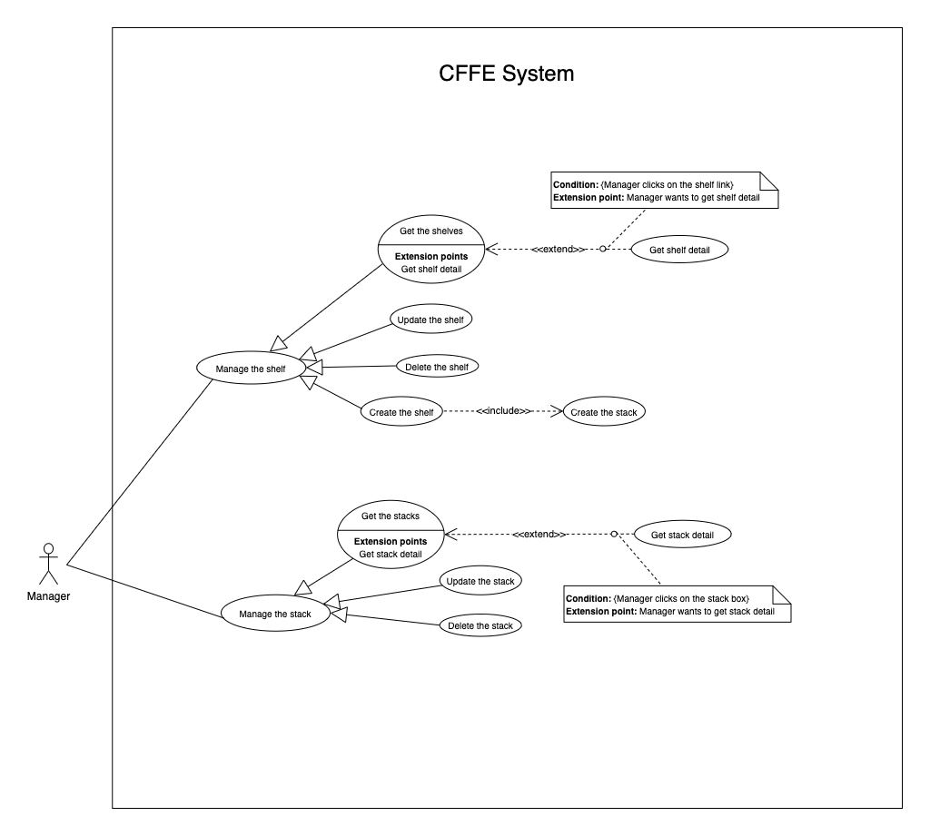

Figure . <Overview Use Case> Manager

##### 2.3.3.1 <Manager> Get the shelves



Figure . <Use Case> Get the shelves

Table 75. <Use Case> Get the shelves

|  |  |  |  |
| --- | --- | --- | --- |
| ID and Name: | **UC-14 Get the shelves** | | |
| Created By: | TruongTN | Date Created: | 08/05/2021 |
| Primary Actor: | Manager | Secondary Actors: | N/A |
| Description: | This feature allows Manager to get the shelves. | | |
| Trigger: | Manager sends a request to get the shelves. | | |
| Pre-conditions: | PRE-01. User has logged into the system as manager role.  PRE-02. Manager is managing a store. | | |
| Post-conditions: | POST-01. CFFE system returns the list of shelves. | | |
| Normal Flow: | **14.0 Get the shelves**   1. Manager clicks on "Shelf" button on the navigation bar. 2. CFFE system requires the shelf information:  * “Shelf name”: input text * “Status”: select box  1. Manager inputs/selects the fields. 2. CFFE system returns the shelves based on below conditions and display them (Exception 14.0.E1). | | |
| Alternative Flows: | N/A | | |
| Exceptions: | **14.0.E1 The list of shelves has no data.**   1. CFFE system returns the message (MSG-009). | | |
| Priority: | High | | |
| Frequency of Use: | Usually | | |
| Business Rules: | BR-026, BR-027, BR-048 | | |
| Other Information: | In case of internet connection failure, Manager cannot finish this use case properly. | | |
| Assumptions: | N/A | | |

##### 2.3.3.2 <Manager> Get shelf detail



Figure . <Use Case> Get shelf detail

Table 76. <Use Case> Get shelf detail

|  |  |  |  |
| --- | --- | --- | --- |
| ID and Name: | **UC-15 Get shelf detail** | | |
| Created By: | TruongTN | Date Created: | 10/05/2021 |
| Primary Actor: | Manager | Secondary Actors: | N/A |
| Description: | This feature allows Manager to get shelf detail. | | |
| Trigger: | Manager sends a request to get shelf detail. | | |
| Preconditions: | PRE-01. User has logged in the system as manager role.  PRE-02. There is at least one shelf link. | | |
| Post-conditions: | POST-01:   * Success: CFFE system returns shelf detail successfully and redirects to "Shelf Detail" page. * Fail: CFFE system shows error message. | | |
| Normal Flow: | **15.0 Get shelf detail**   1. Manager clicks on the shelf item. 2. CFFE system validates the shelf exists (Exception 15.0.E1) 3. CFFE system returns the shelf information and redirects to “Shelf Detail” page. | | |
| Alternative Flows: | N/A | | |
| Exceptions: | **15.0.E1 The shelf does not exist.**  1. CFFE system returns the message (MSG-009) and terminates this use case. | | |
| Priority: | High | | |
| Frequency of Use: | Usually | | |
| Business Rules: | BR-028, BR-048 | | |
| Other Information: | In case of internet connection failure, Manager cannot finish this use case properly. | | |
| Assumptions: | N/A | | |

##### 2.3.3.3 <Manager> Update the shelf



Figure . <Use Case> Update the shelf

Table 77. <Use Case> Update the shelf

|  |  |  |  |
| --- | --- | --- | --- |
| ID and Name: | **UC-16 Update the shelf** | | |
| Created By: | TruongTN | Date Created: | 18/06/2021 |
| Primary Actor: | Manager | Secondary Actors: | N/A |
| Description: | This feature allows Manager to update shelf in CFFE system. | | |
| Trigger: | Manager sends a request to update the shelf. | | |
| Preconditions: | PRE-01. User has logged in the system as manager role.  PRE-02. Manager is on “Shelf detail” page. | | |
| Post-conditions: | POST-01:   * Success: CFFE system shows success message and reloads "Shelf Detail" page. * Fail: CFFE system shows error message. | | |
| Normal Flow: | **16.0 Update the shelf information** (Alternative 16.0, 16.1, 16.2)   1. Manager clicks on "Update Information". 2. CFFE system redirects to “Update Shelf” page and shows required form that includes:  * “Shelf name”: input text * “Description”: input text * “Save”: button * “Back”: button  1. Manager inputs all required fields. 2. Manager clicks on “Save” button. (Alternative 16.3) 3. CFFE system validates the required fields (Exception 16.0.E1, 16.0.E2) 4. CFFE system updates shelf information and redirects to “Shelf Detail” page with the success message (MSG-013). | | |
| Alternative Flows: | **16.0 Adding the camera to the shelf**   1. Manager clicks on "Add camera" button on the camera box. 2. CFFE system redirects to “Choose Camera” page and shows:    * “Camera”: list box 3. Manager clicks on the Camera item. 4. CFFE system shows confirm popup with message "Are you sure to add this camera?" and two buttons for Manager selecting:    * "Yes": button    * "No": button 5. Manager clicks on "Yes" button. (Alternative 16.3) 6. CFFE system validates the chosen camera and shelf. (Exception 16.0.E3, 16.0.E4, 16.0.E5) 7. CFFE system adds the camera to the shelf and redirects to “Shelf Detail” page with the success message (MSG-013).   **16.1 Removing the camera from the shelf**   1. Manager clicks on "Remove camera" button on the camera box. 2. CFFE system shows confirm popup with message "Are you sure to remove this camera" and two buttons for Manager selecting:    * "Yes" button    * "No" button 3. Manager clicks on "Yes" button. (Alternative 16.3) 4. CFFE system validates the camera and shelf. (Exception 16.0.E6) 5. CFFE system remove the camera from the shelf and returns the success message (MSG-013).   **16.2 Reactivate the inactive shelf.**   1. Manager clicks on "Change to Pending" button. 2. CFFE system shows confirm popup with message "The status will change to Pending. Are you sure?" and two buttons for Manager select:    * "Yes" button    * "No" button 3. Manager clicks on "Yes" button. (Alternative 16.3) 4. CFFE system validates the shelf. (Exception 16.0.E7) 5. CFFE system updates the shelf's status and returns the success message (MSG-013).   **16.3 Manager cancels the updating process.**   1. Manager clicks on "No" button. 2. CFFE system closes this popup and terminates this use case. | | |
| Exceptions: | **16.0.E1 Manager does not input the required fields**   1. CFFE system returns to Manager to fill the required fields again (MSG-079, MSG-016). 2. If Manager inputs the required fields again, CFFE system returns to step 3 of the normal flow. 3. Else if Manager cancels the updating process, then CFFE system terminates this use case.   **16.0.E2 Manager inputs the required fields that are not valid**   1. CFFE system returns to Manager to fill the required fields again (MSG-080, MSG-017). 2. If Manager inputs the required fields again, CFFE system returns to step 3 of the normal flow. 3. Else if Manager cancels the updating process, then CFFE system terminates this use case.   **16.0.E3 Shelf does not exist or is active.**   1. CFFE system returns error message (MSG-085) and terminates this use case.   **16.0.E4 Camera does not exist or is active.**   1. CFFE system returns the error message (MSG-086) and terminates this use case.   **16.0.E5 Shelf does not exist.**   1. CFFE system returns the error message (MSG-012) and terminates this use case.   **16.0.E6 Camera on the shelf is full.**   1. CFFE system returns the error message (MSG-128) and terminates this use case.   **16.0.E7 Camera is not on the shelf.**   1. CFFE system returns the error message (MSG-088) and terminates this use case. | | |
| Priority: | High | | |
| Frequency of Use: | Usually | | |
| Business Rules: | BR-024, BR-031, BR-032, BR-039, BR-048, BR-051 | | |
| Other Information: | In case of internet connection failure, Manager cannot finish this use case properly. | | |
| Assumptions: | N/A | | |

##### 2.3.3.4 <Manager> Delete the shelf



Figure . <Use Case> Delete the shelf

Table 78. <Use Case> Delete the shelf

|  |  |  |  |
| --- | --- | --- | --- |
| ID and Name: | **UC-17 Delete the shelf** | | |
| Created By: | TruongTN | Date Created: | 18/06/2021 |
| Primary Actor: | Manager | Secondary Actors: | N/A |
| Description: | This feature allows Manager to delete the shelf. | | |
| Trigger: | Manager sends a request to delete the shelf. | | |
| Preconditions: | PRE-01. User has logged in the system as manager role.  PRE-02. Manager is on “Shelf detail” page. | | |
| Post-conditions: | POST-01:   * Success: CFFE system shows success message and reloads "Shelf Detail" page. * Fail: CFFE system shows error message. | | |
| Normal Flow: | **17.0 Delete the shelf**   1. Manager clicks on "Change to Inactive" button. 2. CFFE system redirects to “Inactive” page and shows required form:  * "Reason": text area * "Save": button * “Back”: button  1. Manager inputs the fields. 2. Manager clicks on "Save" button. (Alternative 17.0) 3. CFFE system validates the required field and the shelf. (Exception 17.0.E1, 17.0.E2, 17.0.E3) 4. CFFE system updates the shelf's status and redirects to “Shelf Detail” page with the success message (MSG-040). | | |
| Alternative Flows: | **17.0 Manager cancels the deleting process.**   1. Manager clicks on “Back” button. 2. CFFE system redirects to “Shelf Detail” page and terminates this use case. | | |
| Exceptions: | **17.0.E1 The shelf does not exist**   1. CFFE system returns error message (MSG-012) and terminates this use case.   **17.0.E2 Manager does not input the inactive reason and remove all stacks, cameras.**   1. CFFE system returns error message (MSG-066) and terminates this use case.   **17.0.E3 Manager inputs the inactive reason fields that are not valid**   1. CFFE system returns error message (MSG-067) and terminates this use case. | | |
| Priority: | Medium | | |
| Frequency of Use: | Often | | |
| Business Rules: | BR-030, BR-032, BR-033, BR-048 | | |
| Other Information: | In case of internet connection failure, Manager cannot finish this use case properly. | | |
| Assumptions: | N/A | | |

##### 2.3.3.5 <Manager> Create the shelf



Figure . <Use Case> Create the shelf

Table 79. <Use Case> Create the shelf

|  |  |  |  |
| --- | --- | --- | --- |
| ID and Name: | **UC-18 Create the shelf** | | |
| Created By: | TruongTN | Date Created: | 10/05/2021 |
| Primary Actor: | Manager | Secondary Actors: | N/A |
| Description: | This feature allows Manager to create the shelf. | | |
| Trigger: | Manager sends a request to create the shelf. | | |
| Preconditions: | PRE-01. User has logged in the system as manager role.  PRE-02. Manager is on “Manage Shelf” page. | | |
| Post-conditions: | POST-01:   * Success: CFFE system shows success message and reloads "Shelf" page. * Fail: CFFE system shows error message. | | |
| Normal Flow: | **18.0 Create the** **shelf**   1. Manager clicks on "New" button. 2. CFFE system redirect to create shelf page and shows required form that includes:  * “Shelf name”: input text * “Description”: input text * “Number of stacks”: drop down list * “Create”: button * “Back”: button  1. Manager inputs the fields. 2. Manager clicks on “Create” button. (Alternative 18.0) 3. CFFE system validates the required fields. (Exception 18.0.E1, 18.0.E2) 4. CFFE system creates newly shelf and redirects to “Shelf” page with the success message (MSG-011). | | |
| Alternative Flows: | **18.0 Manager cancels the creating process.**   1. Manager clicks on “Back” button. 2. CFFE system closes this popup and terminates this use case. | | |
| Exceptions: | **18.0.E1 Manager does not input the required fields**   1. CFFE system returns to Manager to fill the required fields again (MSG-079, MSG-016). 2. If Manager inputs the required fields again, CFFE system returns to step 3 of the normal flow. 3. Else if Manager cancels the creating process, then CFFE system terminates this use case.   **18.0.E2 Manager inputs the required fields that are not valid**   1. CFFE system returns to Manager to fill the required fields again (MSG-080, MSG-017, MSG-019). 2. If Manager inputs the required fields again, CFFE system returns to step 3 of the normal flow. 3. Else if Manager cancels the creating process, then CFFE system terminates this use case. | | |
| Priority: | Medium | | |
| Frequency of Use: | Often | | |
| Business Rules: | BR-025, BR-031, BR-035, BR-048, BR-070 | | |
| Other Information: | In case of internet connection failure, Manager cannot finish this use case properly. | | |
| Assumptions: | N/A | | |

##### 2.3.3.6 <Manager> Get the stacks



Figure . <Use Case> Get the stacks

Table . <Use Case> Get the stacks

|  |  |  |  |
| --- | --- | --- | --- |
| ID and Name: | **UC19- Get the stacks** | | |
| Created By: | LuanNM | Date Created: | 08/05/2021 |
| Primary Actor: | Manager | Secondary Actors: | N/A |
| Description: | This feature allows manager to get the stacks. | | |
| Trigger: | Manager sends a request to get the stacks. | | |
| Pre-conditions: | PRE-01. User has logged into the system as manager role.  PRE-02. Manager is managing a store.  PRE-03. There is at least one shelf link. | | |
| Post-conditions: | POST-01. CFFE system returns the list of stacks. | | |
| Normal Flow: | **19.0 Get the stacks**   1. Manager clicks on the shelf item. 2. CFFE system validates the shelf exists (Exception 19.0.E1, 19.0.E2) 3. CFFE system returns the stack list and redirects to “Shelf Detail” page. | | |
| Alternative Flows: | N/A | | |
| Exceptions: | **19.0.E1 The shelf does not exist.**  1. CFFE system returns the message (MSG-046) and terminates this use case.  **19.0.E2 The list of stacks has no data.**   1. CFFE system returns the message (MSG-009) and terminates this use case. | | |
| Priority: | High | | |
| Frequency of Use: | Usually | | |
| Business Rules: | BR-009, BR-037 | | |
| Other Information: | In case of internet connection failure, Manager cannot finish this use case properly. | | |
| Assumptions: | N/A | | |

##### 2.3.3.7 <Manager> Get stack detail



Figure . <Use Case> Get stack detail

Table . <Use Case> Get stack detail

|  |  |  |  |
| --- | --- | --- | --- |
| ID and Name: | **UC-20 Get stack detail** | | |
| Created By: | LuanNM | Date Created: | 10/05/2021 |
| Primary Actor: | Manager | Secondary Actors: | N/A |
| Description: | This feature allows Manager to getstackdetail. | | |
| Trigger: | Manager sends a request to get stack detail. | | |
| Preconditions: | PRE-01. User has logged in the system as manager role.  PRE-02. Manager is on "Shelf Detail" page. | | |
| Post-conditions: | POST-01. CFFE system returns stack information. | | |
| Normal Flow: | **20.0 Get stack detail**   1. Manager clicks on the stack item. 2. CFFE system validates the stack exists (Exception 20.0.E1) 3. CFFE system returns the stack information and redirects to “Stack Detail” page. | | |
| Alternative Flows: | N/A | | |
| Exceptions: | **20.0.E1 The stack does not exist.**  1. CFFE system returns the message (MSG-022) and terminates this use case. | | |
| Priority: | High | | |
| Frequency of Use: | Usually | | |
| Business Rules: | BR-009, BR-038 | | |
| Other Information: | In case of internet connection failure, Manager cannot finish this use case properly. | | |
| Assumptions: | N/A | | |

##### 2.3.3.8 <Manager> Update the stack



Figure . <Use Case> Update the stack

Table . <Use Case> Update the stack

|  |  |  |  |
| --- | --- | --- | --- |
| ID and Name: | **UC-21 Update the stack** | | |
| Created By: | LuanNM | Date Created: | 18/06/2021 |
| Primary Actor: | Manager | Secondary Actors: | N/A |
| Description: | This feature allows Manager to update stack in CFFE system. | | |
| Trigger: | Manager sends a request to update the stack. | | |
| Preconditions: | PRE-01. User has logged in the system as manager role.  PRE-02. Manager is on “Stack detail” page. | | |
| Post-conditions: | POST-01:   * Success: CFFE system shows success message and reloads "Shelf Detail" page. * Fail: CFFE system shows error message. | | |
| Normal Flow: | **21.0 Reactive the inactive stack.** (Alternative 21.0, 21.1, 21.2, 21.3)   1. Manager "Change to Pending" button. 2. CFFE system shows confirm popup with message "The status will change to Pending. Are you sure?" and two buttons for Manager selecting:  * “Yes” button * “No” button  1. Manager clicks on "Yes" button. (Alternative 21.4) 2. CFFE system validates the stack. (Exception 21.0.E1) 3. CFFE system updates stack information and returns the success message (MSG-013). | | |
| Alternative Flows: | **21.0 Adding the product to the stack**   1. Manager clicks on "Add product" button on the product box. 2. CFFE system redirects to “Choose Product” page and shows:    * "Product": list box 3. Manager clicks on the product item. 4. CFFE system shows confirm popup with message "Are you sure to add this product?" and two buttons for Manager selecting:    * "Yes": button    * "No": button 5. Manager clicks on "Yes" button. (Alternative 21.4) 6. CFFE system validates the chosen product and stack (Exception 21.0.E1, 21.0.E2, 21.0.E3, 21.0.E4) 7. CFFE system adds the product to the stack and redirects to “Stack Detail” page with the success message (MSG-013).   **21.1 Removing the product from the stack**   1. Manager clicks on "Remove product" button on the product box. 2. CFFE system shows confirm popup with message "Are you sure to remove this product?" and two buttons for Manager selecting:    * "Yes" button    * "No" button 3. Manager clicks on "Yes" button. (Alternative 21.4) 4. CFFE system validates the product and stack. (Exception 21.0.E1, 21.0.E5) 5. CFFE system remove the product from the shelf and return the success message (MSG-013).   **21.2 Adding the camera to the stack**   1. Manager clicks on "Add camera" button on the camera box. 2. CFFE system redirects to “Choose Camera” page and shows:    * “Camera”: list box 3. Manager clicks on the camera item. 4. CFFE system shows confirm popup with message "Are you sure to add this camera?" and two buttons for Manager selecting:    * "Yes": button    * "No": button 5. Manager clicks on "Yes" button. (Alternative 21.4, 21.5) 6. CFFE system validates the chosen camera and stack. (Exception 21.0.E1, 21.0.E6, 21.0.E7, 21.0.E8) 7. CFFE system adds the camera to the stack and redirects to “Stack Detail” page with the success message (MSG-013).   **21.3 Removing the camera from the stack**   1. Manager clicks on "Remove camera" button on the camera box. 2. CFFE system shows confirm popup with message "Are you sure to remove this camera?" and two buttons for Manager selecting:    * "Yes" button    * "No" button 3. Manager clicks on "Yes" button. (Alternative 21.4, 21.5) 4. CFFE system validates the camera and stack. (Exception 21.0.E1, 21.0.E9) 5. CFFE system remove the camera from the stack and returns the success message (MSG-013).   **21.4 Manager cancels the updating process.**   1. Manager clicks on "No" button. 2. CFFE system closes this popup and terminates this use case. | | |
| Exceptions: | **21.0.E1 Stack does not exist.**   1. CFFE system returns error message (MSG-022) and terminates this use case.   **21.0.E2 Product does not exist.**   1. CFFE system returns error message (MSG-023) and terminates this use case.   **21.0.E3 Product is inactive.**   1. CFFE system returns error message (MSG-089) and terminates this use case.   **21.0.E4 Stack already has a product.**   1. CFFE system returns error message (MSG-089) and terminates this use case.   **21.0.E5 Product is not on this stack or Camera is already on this stack.**   1. CFFE system returns error message (MSG-092) and terminates this use case.   **21.0.E6 Camera does not exist.**   1. CFFE system returns error message (MSG-020) and terminates this use case.   **21.0.E7 Camera has active or inactive status.**   1. CFFE system returns error message (MSG-093) and terminates this use case.   **21.0.E8 Stack has not a product.**   1. CFFE system returns error message (MSG-100) and terminates this use case.   **21.0.E9 Camera is not on this stack.**   1. CFFE system returns error message (MSG-094) and terminates this use case. | | |
| Priority: | High | | |
| Frequency of Use: | Often | | |
| Business Rules: | BR-009, BR-029, BR-032, BR-036, BR-039, BR-042 | | |
| Other Information: | In case of internet connection failure, Manager cannot finish this use case properly. | | |
| Assumptions: | N/A | | |

##### 2.3.3.9 <Manager> Delete the stack



Figure . <Use Case> Delete the shelf

Table . <Use Case> Delete the shelf

|  |  |  |  |
| --- | --- | --- | --- |
| ID and Name: | **UC-22 Delete the stack** | | |
| Created By: | LuanNM | Date Created: | 10/05/2021 |
| Primary Actor: | Manager | Secondary Actors: | N/A |
| Description: | This feature allows Manager to delete the stack. | | |
| Trigger: | Manager sends a request to delete the stack. | | |
| Preconditions: | PRE-01. User has logged in the system as manager role.  PRE-02. Manager is on “Shelf detail” page.  PRE-03. Manager selects a stack. | | |
| Post-conditions: | POST-01:   * Success: CFFE system shows success message and reloads "Shelf Detail" page. * Fail: CFFE system shows error message. | | |
| Normal Flow: | **22.0 Delete the stack**   1. Manager clicks on "Change to Inactive" button. 2. CFFE system redirects to “Inactive” page and shows required form:  * "Reason": text area * "Save": button * “Back”: button  1. Manager inputs the field. 2. Manager clicks on "Save" button. (Alternative 22.0) 3. CFFE system validates the required field and the stack. (Exception 22.0.E1, 22.0.E2, 22.0.E3) 4. CFFE system updates the stack's status and redirects to “Stack Detail” page with the success message (MSG-040). | | |
| Alternative Flows: | **22.0 Manager cancels the deleting process.**   1. Manager clicks on “Back” button. 2. CFFE system redirects to “Stack Detail” page and terminates this use case. | | |
| Exceptions: | **22.0.E1 The stack does not exist**   1. CFFE system returns error message (MSG-022) and terminates this use case.   **22.0.E2 Manager does not input the inactive reason and remove the product.**   1. CFFE system returns error message (MSG-095) and terminates this use case.   **22.0.E3 Manager inputs the inactive reason fields that are not valid**   1. CFFE system returns error message (MSG-067) and terminates this use case. | | |
| Priority: | Medium | | |
| Frequency of Use: | Often | | |
| Business Rules: | BR-009, BR-032, BR-033, BR-041 | | |
| Other Information: | In case of internet connection failure, Manager cannot finish this use case properly. | | |
| Assumptions: | N/A | | |

##### 2.3.3.10 <Manager> Create the stack



Figure . <Use Case> Create the stack

Table . <Use Case> Create the stack

|  |  |  |  |
| --- | --- | --- | --- |
| ID and Name: | **UC-23 Create the stack** | | |
| Created By: | LuanNM | Date Created: | 10/05/2021 |
| Primary Actor: | Manager | Secondary Actors: | N/A |
| Description: | This feature allows Manager to create the stack. | | |
| Trigger: | Manager sends a request to create the stack. | | |
| Preconditions: | PRE-01. User has logged in the system as manager role.  PRE-02. Manager creates the shelf successfully. | | |
| Post-conditions: | POST-01. CFFE system stores newly created stack information. | | |
| Normal Flow: | **23.0 Create the stack**   1. CFFE system creates the stacks based on "Number of stacks" of the shelf. | | |
| Alternative Flows: | N/A | | |
| Exceptions: | N/A | | |
| Priority: | Medium | | |
| Frequency of Use: | Often | | |
| Business Rules: | BR-009, BR-035, BR-50, BR-070 | | |
| Other Information: | In case of internet connection failure, Manager cannot finish this use case properly. | | |
| Assumptions: | N/A | | |

#### 2.3.4 <Admin> Overview Use Case



Figure . <Use Case> Get the cameras

##### 2.3.4.1 <Admin> Get the stores



Figure . <Use Case> Get the stores

Table . <Use Case> Get the stores

|  |  |  |  |
| --- | --- | --- | --- |
| ID and Name: | **UC-25 Get the stores** | | |
| Created By: | LuanNM | Date Created: | 08/05/2021 |
| Primary Actor: | Admin | Secondary Actors: | N/A |
| Description: | This feature allows admin to get the stores. | | |
| Trigger: | Admin sends a request to get the stores. | | |
| Pre-conditions: | PRE-01. User has logged into the system as admin role. | | |
| Post-conditions: | POST-01. CFFE system returns the list of stores. | | |
| Normal Flow: | **25.0 Get the stores**   1. Admin clicks on "Store" button on the navigation bar. 2. CFFE system requires the store information:  * “Store name”: input text * “Status”: select box  1. Admin inputs/selects the fields. 2. CFFE system returns the list of stores based on below conditions and display them (Exception 25.0.E1). | | |
| Alternative Flows: | N/A | | |
| Exceptions: | **25.0.E1 The list of stores has no data.**   1. CFFE system returns the message (MSG-009). | | |
| Priority: | High | | |
| Frequency of Use: | Usually | | |
| Business Rules: | BR-059, BR-064, BR-065 | | |
| Other Information: | In case of internet connection failure, Admin cannot finish this use case properly. | | |
| Assumptions: | N/A | | |

##### 2.3.4.2 <Admin> Get store detail



Figure . <Use Case> Get store detail

Table . <Use Case> Get store detail

|  |  |  |  |
| --- | --- | --- | --- |
| ID and Name: | **UC-26 Get store detail** | | |
| Created By: | LuanNM | Date Created: | 10/05/2021 |
| Primary Actor: | Admin | Secondary Actors: | N/A |
| Description: | This feature allows Admin to getstoredetail. | | |
| Trigger: | Admin sends a request to get store detail. | | |
| Preconditions: | PRE-01. User has logged in the system as admin role.  PRE-02. There is at least one store link. | | |
| Post-conditions: | POST-01:   * Success: CFFE system returns store detail successfully and redirects to "Store Detail" page. * Fail: CFFE system shows error message. | | |
| Normal Flow: | **26.0 Get store detail**   1. Admin clicks on the store item. 2. CFFE system validates the store exists (Exception 26.0.E1) 3. CFFE system returns the stores information and redirects to “Store Detail” page. | | |
| Alternative Flows: | N/A | | |
| Exceptions: | **26.0.E1 The stores does not exist.**  1. CFFE system returns the message (MSG-035) and terminates this use case. | | |
| Priority: | High | | |
| Frequency of Use: | Usually | | |
| Business Rules: | BR-059, BR-066 | | |
| Other Information: | In case of internet connection failure, Admin cannot finish this use case properly. | | |
| Assumptions: | N/A | | |

##### 2.3.4.3 <Admin> Update the store



Figure . <Use Case> Update the store

Table . <Use Case> Update the store

|  |  |  |  |
| --- | --- | --- | --- |
| ID and Name: | **UC-27 Update the store** | | |
| Created By: | LuanNM | Date Created: | 18/06/2021 |
| Primary Actor: | Admin | Secondary Actors: | N/A |
| Description: | This feature allows Admin to update store in CFFE system. | | |
| Trigger: | Admin sends a request to update the store. | | |
| Preconditions: | PRE-01. User has logged in the system as admin role.  PRE-02. Admin is on “Store detail” page. | | |
| Post-conditions: | POST-01:   * Success: CFFE system shows success message and reloads "Store Detail" page. * Fail: CFFE system shows error message. | | |
| Normal Flow: | **27.0 Update the store information** (Alternative 27.0, 27.1, 27.2, 27.3)   1. Admin clicks on "Update Information" button. 2. CFFE system redirects to “Update Information” page and show required form that includes:  * “Store Name”: input text * “Address”: input text * “City”: select box * “District”: select box * “Save”: button * “Back”: button  1. Admin inputs/selects the required fields. 2. Admin clicks on “Save” button. (Alternative 27.5) 3. CFFE system validates the fields (Exception 27.0.E1, 27.0.E2) 4. CFFE system updates store information and redirects to “Store Detail” page with the success message (MSG-013). | | |
| Alternative Flows: | **27.0 Adding the manager to managing this store**   1. Admin clicks on "Choose manager" button. 2. CFFE system redirects to “Choose Manager” page and shows:    * "Manager": list box 3. Admin clicks on the manager item. 4. CFFE system shows confirm popup with message "Are you sure to map this manager?" and two buttons for Admin selecting:    * "Yes": button    * "No": button 5. Admin clicks on "Yes" button. (Alternative 27.4) 6. CFFE system validates the chosen manager and store. (Exception 27.0.E3, 27.0.E4) 7. CFFE system adds the manager to the store and redirects to “Store Detail” page with the success message. (MSG-013)   **27.1 Removing the manager from this store**   1. Admin clicks on "Remove manager" button. 2. CFFE system shows confirm popup with message "Are you sure to remove this manager?" and two buttons for Admin selecting:    * "Yes" button    * "No" button 3. Admin clicks on "Yes" button. (Alternative 27.4) 4. CFFE system validates the manager and store. (Exception 27.0.E5, 27.0.E6, 27.0.E7) 5. CFFE system remove the manager from the store and returns the success message (MSG-013).   **27.2 Updating store's image.**   1. Admin clicks on "Change image" button. 2. CFFE system redirects to change image page requires form that includes:    * "Choose": button    * "Save": button    * “Back”: button 3. Authenticated User clicks on "Choose" button and selects an image. 4. Admin clicks on "Save" button. (Alternative 27.4) 5. CFFE system validates the image. (Exception 27.0.E9, 27.0.E10, 27.0.E11) 6. CFFE system updates the store's image and redirects to “Store Detail” page with the success message (MSG-013).   **27.3 Reactivate the inactive store.**   1. Admin clicks on "Change to Pending" button. 2. CFFE system shows confirm popup with message "The status will change to Pending. Are you sure?" and two buttons for Admin selecting:    * "Yes" button    * "No" button 3. Admin clicks on "Yes" button. (Alternative 27.4) 4. CFFE system validates the store. (Exception 27.0.E5) 5. CFFE system updates the store's status and returns the success message (MSG-013).   **27.4 Admin cancels the updating process.**   1. Admin clicks on "No" button. 2. CFFE system closes this popup and terminates this use case.   **27.5 Admin cancels the updating process.**   1. Admin clicks on “Back” button. 2. CFFE system redirects to “Store Detail” page and terminates this use case. | | |
| Exceptions: | **27.0.E1 Admin does not input/select the required fields**   1. CFFE system returns to Admin to input/select the required fields again (MSG-106, MSG-036, MSG-038, MSG-039). 2. If Admin inputs/selects the required fields again, CFFE system returns to step 3 of the normal flow. 3. Else if Admin cancels the updating process, then CFFE system terminates this use case.   **27.0.E2 Admin inputs/selects the fields that are not valid**   1. CFFE system returns to Admin to input/select the fields again (MSG-129, MSG-037). 2. If Admin inputs/selects the fields again, CFFE system returns to step 3 of the normal flow. 3. Else if Admin cancels the updating process, then CFFE system terminates this use case.   **27.0.E3 Store does not exist or has not pending status.**   1. CFFE system returns error message (MSG-075) and terminates this use case.   **27.0.E4 Manager does not exist or has not pending status.**   1. CFFE system returns error message (MSG-074) and terminates this use case.   **27.0.E5 Store does not exist.**   1. CFFE system returns error message (MSG-035) and terminates this use case.   **27.0.E6 Manager does not exist.**   1. CFFE system returns error message (MSG-041) and terminates this use case.   **27.0.E7 Manager is not managing this store**   1. CFFE system returns error message (MSG-077) and terminates this use case.   **27.0.E8 Manager is not managing this store**   1. CFFE system returns error message (MSG-077) and terminates this use case.   **27.0.E9 Admin does not select the image**   1. CFFE system returns to Admin to select the image again (MSG-112). 2. If Admin selects the image again, CFFE system returns to step 3 of the alternative flow 27.2. 3. Else if Admin cancels the updating process, then CFFE system terminates this use case.   **27.0.E10 Image is not jpg/jpeg/png format.**   1. CFFE system returns to Admin to select the image again (MSG-113). 2. If Admin selects the image again, CFFE system returns to step 3 of the alternative flow 27.2. 3. Else if Admin cancels the updating process, then CFFE system terminates this use case.   **27.0.E11 CFFE system cannot upload the image.**   1. CFFE system shows error message (MSG-114) and terminates this use case. | | |
| Priority: | Medium | | |
| Frequency of Use: | Often | | |
| Business Rules: | BR-032, BR-040, BR-059, BR-067, BR-68 | | |
| Other Information: | In case of internet connection failure, Admin cannot finish this use case properly. | | |
| Assumptions: | N/A | | |

##### 2.3.4.4 <Admin> Delete the store

Figure . <Use Case> Delete the store

Table . <Use Case> Delete the store

|  |  |  |  |
| --- | --- | --- | --- |
| ID and Name: | **UC-28 Delete the store** | | |
| Created By: | LuanNM | Date Created: | 10/05/2021 |
| Primary Actor: | Admin | Secondary Actors: | N/A |
| Description: | This feature allows Admin to delete the store. | | |
| Trigger: | Admin sends a request to delete the store. | | |
| Preconditions: | PRE-01. User has logged in the system as admin role.  PRE-02. Admin is on “Store detail” page. | | |
| Post-conditions: | POST-01:   * Success: CFFE system shows success message and reloads "Store Detail" page. * Fail: CFFE system shows error message. | | |
| Normal Flow: | **28.0 Delete the store**   1. Admin clicks on "Change to Inactive" button. 2. CFFE system redirects to “Inactive Page” and shows required form:    * "Reason": text area    * "Save": button    * “Back”: button 3. Admin inputs the field. 4. Admin clicks on "Save" button. (Alternative 28.0) 5. CFFE system validates the required field and the store. (Exception 28.0.E1, 28.0.E2, 28.0.E3) 6. CFFE system updates the store's status and redirects to “Store Detail” page with the success message (MSG-040). | | |
| Alternative Flows: | **28.0 Admin cancels the deleting process.**   1. Admin clicks on “Back” button. 2. CFFE system redirects to “Store Detail” page and terminates this use case. | | |
| Exceptions: | **28.0.E1 The store does not exist**   1. CFFE system returns error message (MSG-012) and terminates this use case.   **28.0.E2 The store has an manager that is managing and has active or pending shelves.**   1. CFFE system returns error message (MSG-066, MSG-081) and terminates this use case.   **28.0.E3 Admin inputs the inactive reason fields that are not valid**   1. CFFE system returns error message (MSG-067) and terminates this use case. | | |
| Priority: | Medium | | |
| Frequency of Use: | Often | | |
| Business Rules: | BR-032, BR-033, BR-059, BR-069 | | |
| Other Information: | In case of internet connection failure, Admin cannot finish this use case properly. | | |
| Assumptions: | N/A | | |

##### 2.3.4.5 <Admin> Create the store

Figure . <Use Case> Create the store

Table . <Use Case> Create the store

|  |  |  |  |
| --- | --- | --- | --- |
| ID and Name: | **UC-29 Create the store** | | |
| Created By: | LuanNM | Date Created: | 10/05/2021 |
| Primary Actor: | Admin | Secondary Actors: | N/A |
| Description: | This feature allows Admin to create the store. | | |
| Trigger: | Admin sends a request to create the store. | | |
| Preconditions: | PRE-01. User has logged in the system as admin role.  PRE-02. Admin is on “Store” page. | | |
| Post-conditions: | POST-01:   * Success: CFFE system shows success message and reloads "Store" page. * Fail: CFFE system shows error message. | | |
| Normal Flow: | **29.0 Create the store**   1. Admin clicks on "New" button. 2. CFFE system redirects to “Create Store” page and shows required form that includes:    * "Store name": input text    * "Image": button    * "Address": input text    * "City": select box    * "District": select box    * "Create": button    * “Back”: button 3. Admin inputs/selects the required fields. 4. Admin clicks on the "Create" button to create the store. (Alternative 29.0) 5. CFFE system validates the required fields (Exception 29.0.E1, 29.0.E2). 6. CFFE system stores newly created store and redirects to “Store” page with the success message (MSG-011). | | |
| Alternative Flows: | **29.0 Admin cancels the creating process.**   1. Admin clicks on “Back” button. 2. CFFE system redirects to “Store” page and terminates this use case. | | |
| Exceptions: | **29.0.E1 Admin does not input/select the required fields**   1. CFFE system returns to Admin to input/select the required fields again (MSG-106, MSG-036, MSG-038, MSG-039). 2. If Admin inputs/selects the required fields again, CFFE system returns to step 3 of the normal flow. 3. Else if Admin cancels the creating process, then CFFE system terminates this use case.   **29.0.E2 Admin** **inputs/selects the fields that are not valid**   1. CFFE system returns to Admin to input/select the fields again (MSG-109, MSG-037, MSG-062). 2. If Admin inputs/selects the fields again, CFFE system returns to step 3 of the normal flow. 3. Else if Admin cancels the creating process, then CFFE system terminates this use case. | | |
| Priority: | Medium | | |
| Frequency of Use: | Often | | |
| Business Rules: | BR-035, BR-059, BR-067, BR-070 | | |
| Other Information: | In case of internet connection failure, Admin cannot finish this use case properly. | | |
| Assumptions: | N/A | | |

##### 2.3.4.6 <Admin> Get the managers



Figure . <Use Case> Get the manager

Table . <Use Case> Get the manager

|  |  |  |  |
| --- | --- | --- | --- |
| ID and Name: | **UC-30 Get the managers** | | |
| Created By: | HieuNT | Date Created: | 08/05/2021 |
| Primary Actor: | Admin | Secondary Actors: | N/A |
| Description: | This feature allows admin to get the managers. | | |
| Trigger: | Admin sends a request to get the managers. | | |
| Pre-conditions: | PRE-01. User has logged into the system as admin role. | | |
| Post-conditions: | POST-01. CFFE system returns the list of stores. | | |
| Normal Flow: | **30.0 Get the managers**   1. Admin clicks on "Manager" button on the navigation bar. 2. CFFE system requires the manager information from Admin:  * “Manager full name”: input text * “Status”: select box  1. Admin inputs/selects the fields. 2. CFFE system returns the list of managers based on below conditions and display them (Exception 30.0.E1). | | |
| Alternative Flows: | N/A | | |
| Exceptions: | **30.0.E1 The list of managers has no data.**   1. CFFE system returns the message (MSG-009). | | |
| Priority: | High | | |
| Frequency of Use: | Usually | | |
| Business Rules: | BR-015, BR-017, BR-034 | | |
| Other Information: | In case of internet connection failure, Admin cannot finish this use case properly. | | |
| Assumptions: | N/A | | |

##### 2.3.4.7 <Admin> Get manager detail



Figure . <Use Case> Get store detail

Table . <Use Case> Get store detail

|  |  |  |  |
| --- | --- | --- | --- |
| ID and Name: | **UC-31 Get manager detail** | | |
| Created By: | HieuNT | Date Created: | 10/05/2021 |
| Primary Actor: | Admin | Secondary Actors: | N/A |
| Description: | This feature allows Admin to getmanagerdetail. | | |
| Trigger: | Admin sends a request to get manager detail. | | |
| Preconditions: | PRE-01. User has logged in the system as admin role.  PRE-02. There is at least one manager link. | | |
| Post-conditions: | POST-01:   * Success: CFFE system returns manager detail successfully and redirects to "Manager Detail" page. * Fail: CFFE system shows error message. | | |
| Normal Flow: | **31.0 Get manager detail**   1. Admin clicks on the manager item. 2. CFFE system validates the manager exists (Exception 31.0.E1) 3. CFFE system returns the manager information and redirects to “Manager Detail” page. | | |
| Alternative Flows: | N/A | | |
| Exceptions: | **31.0.E1 The manager does not exist.**  1. CFFE system returns the message (MSG-041) and terminates this use case. | | |
| Priority: | High | | |
| Frequency of Use: | Usually | | |
| Business Rules: | BR-034, BR-061 | | |
| Other Information: | In case of internet connection failure, Admin cannot finish this use case properly. | | |
| Assumptions: | N/A | | |

##### 2.3.4.8 <Admin> Update the manager



Figure . <Use Case> Update the manager

Table . <Use Case> Update the manager

|  |  |  |  |
| --- | --- | --- | --- |
| ID and Name: | **UC-32 Update the manager** | | |
| Created By: | HieuNT | Date Created: | 18/06/2021 |
| Primary Actor: | Admin | Secondary Actors: | N/A |
| Description: | This feature allows Admin to update manager in CFFE system. | | |
| Trigger: | Admin sends a request to update the manager. | | |
| Preconditions: | PRE-01. User has logged in the system as admin role.  PRE-02. Admin is on “Manager detail” page. | | |
| Post-conditions: | POST-01:   * Success: CFFE system shows success message and reloads "Manager Detail" page. * Fail: CFFE system shows error message. | | |
| Normal Flow: | **32.0 Update the manager information** (Alternative 32.0, 32.1, 32.2, 32.3, 32.4)   1. Admin clicks on "Update information" button. 2. CFFE system redirects to “Update Information” page and shows required form that includes:  * “Full name”: input text * “Gender”: checkbox * “Birthday”: date picker * “Identify card”: input text * “Phone number”: input text * “Email”: input text * “Address”: input text * “City”: select box * “District”: select box * “Save”: button * “Back”: button  1. Admin inputs/selects the required fields. 2. Admin clicks on “Save” button. (Alternative 32.5) 3. CFFE system validates the fields (Exception 32.0.E1, 32.0.E2) 4. CFFE system updates manager information and redirects to “Manager Detail” page with the success message (MSG-013). | | |
| Alternative Flows: | **32.0 Adding the store to manage**   1. Admin clicks on " Choose store" button. 2. CFFE system redirects to “Choose Store” page and shows:    * "Store": list box 3. Admin clicks on the store item. 4. CFFE system shows confirm popup with message "Are you sure to map this store?" and two buttons for Admin selecting:    * "Yes": button    * "No": button 5. Admin clicks on "Yes" button. (Alternative 32.4) 6. CFFE system validates the chosen store and manager. (Exception 32.0.E3, 32.0.E4) 7. CFFE system adds the store to the manager and redirects to “Manager Detail” page with the success message. (MSG-013)   **32.1 Removing the store that is managing**   1. Admin clicks on "Remove store" button. 2. CFFE system shows confirm popup with message "Are you sure to remove this store?" and two buttons for Admin selecting:    * "Yes”: button    * "No": button 3. Admin clicks on "Yes" button. (Alternative 32.4) 4. CFFE system validates the manager and store. (Exception 32.0.E5, 32.0.E6, 32.0.E7) 5. CFFE system remove the store from the manager and returns the success message (MSG-013).   **32.2 Updating manager avatar.**   1. Admin clicks on "Change avatar" button. 2. CFFE system redirects to “Change Avatar” page and shows required form that includes:    * "Choose": button    * "Save": button    * “Back”: button 3. Authenticated User clicks on "Choose" button and selects an image. 4. Admin clicks on "Save" button. (Alternative 32.5) 5. CFFE system validates the image. (Exception 32.0.E9, 32.0.E10, 32.0.E11) 6. CFFE system updates the manager's avatar and redirects to “Manager Detail” page with the success message (MSG-013).   **32.3 Reactivate the inactive manager.**   1. Admin clicks on "Change to Pending" button. 2. CFFE system shows confirm popup with message "The status will change to Pending. Are you sure?" and two buttons for Admin selecting:    * "Yes" button    * "No" button 3. Admin clicks on "Yes" button. (Alternative 32.4) 4. CFFE system validates the manager. (Exception 32.0.E6) 5. CFFE system updates the manager's status and returns the success message (MSG-013).   **32.4 Admin cancels the updating process.**   1. Admin clicks on "No" button. 2. CFFE system closes this popup and terminates this use case.   **32.5 Admin cancels the updating process.**   1. Admin clicks on “Back” button. 2. CFFE system redirects to “Manager Detail” page and terminates this use case. | | |
| Exceptions: | **32.0.E1 Admin does not input/select the required fields**   1. CFFE system returns to Admin to input/select the required fields again (MSG-014, MSG-036, MSG-038, MSG-039, MSG-049, MSG-044, MSG-047, MSG-051, MSG-054). 2. If Admin inputs/selects the required fields again, CFFE system returns to step 3 of the normal flow. 3. Else if Admin cancels the updating process, then CFFE system terminates this use case.   **32.0.E2 Admin inputs/selects the fields that are not valid**   1. CFFE system returns to Admin to input/select the fields again (MSG-015, MSG-037, MSG-042, MSG-045, MSG-052, MSG-073). 2. If Admin inputs/selects the fields again, CFFE system returns to step 3 of the normal flow. 3. Else if Admin cancels the updating process, then CFFE system terminates this use case.   **32.0.E3 Store does not exist or has not pending status.**   1. CFFE system returns error message (MSG-075) and terminates this use case.   **32.0.E4 Manager does not exist or has not pending status.**   1. CFFE system returns error message (MSG-074) and terminates this use case.   **32.0.E5 Store does not exist.**   1. CFFE system returns error message (MSG-035) and terminates this use case.   **32.0.E6 Manager does not exist.**   1. CFFE system returns error message (MSG-041) and terminates this use case.   **32.0.E7 Manager is not managing this store**   1. CFFE system returns error message (MSG-077) and terminates this use case.   **32.0.E9 Admin does not select the image**   1. CFFE system returns to Admin to select the image again (MSG-112). 2. If Admin selects the image again, CFFE system returns to step 3 of the alternative flow 32.2. 3. Else if Admin cancels the updating process, then CFFE system terminates this use case.   **32.0.E10 Image is not jpg/jpeg/png format.**   1. CFFE system returns to Admin to select the image again (MSG-113). 2. If Admin selects the image again, CFFE system returns to step 3 of the alternative flow 32.2. 3. Else if Admin cancels the updating process, then CFFE system terminates this use case.   **32.0.E11 CFFE system cannot upload the image.**   1. CFFE system shows error message (MSG-114) and terminates this use case. | | |
| Priority: | Medium | | |
| Frequency of Use: | Often | | |
| Business Rules: | BR-032, BR-034, BR-040, BR-060, BR-068 | | |
| Other Information: | In case of internet connection failure, Admin cannot finish this use case properly. | | |
| Assumptions: | N/A | | |

##### 2.3.4.9 <Admin> Reset account's password



Figure . <Use Case> Reset account's password

Table . <Use Case> Reset account's password

|  |  |  |  |
| --- | --- | --- | --- |
| ID and Name: | **UC-33 Reset account's password** | | |
| Created By: | HieuNT | Date Created: | 18/06/2021 |
| Primary Actor: | Admin | Secondary Actors: | N/A |
| Description: | This feature allows Admin to reset account's password in CFFE system. | | |
| Trigger: | Admin sends a request to reset account's password. | | |
| Preconditions: | PRE-01. User has logged in the system as admin role.  PRE-02. Admin is on “Manager detail” page. | | |
| Post-conditions: | POST-01:   * Success: CFFE system shows success message and sends account's password to manager's email. * Fail: CFFE system shows error message. | | |
| Normal Flow: | **33.0 Reset account's password**   1. Admin clicks on "Reset password" button. 2. CFFE system shows confirm popup with message "Are you sure to reset password for this manager?" and two buttons for Admin selecting:    * "yes" button    * "No" button 3. Admin clicks on “Yes” button. (Alternative 33.0) 4. CFFE system validates the manager and send account's new password to manager's email (Exception 33.0.E1, 33.0.E2) 5. CFFE system updates manager information and returns the success message (MSG-013). | | |
| Alternative Flows: | **33.0 Admin cancels the resetting process.**   1. Admin clicks on "No" button. 2. CFFE system closes this popup and terminates this use case. | | |
| Exceptions: | **33.0.E1 Manager is not found**   1. CFFE system returns error message (MSG-063) and terminates this use case.   **33.0.E2 Send email failed**   1. CFFE system shows error message (MSG-124) and terminates this use case. | | |
| Priority: | Medium | | |
| Frequency of Use: | Often | | |
| Business Rules: | BR-008, BR-012 | | |
| Other Information: | In case of internet connection failure, Admin cannot finish this use case properly. | | |
| Assumptions: | N/A | | |

##### 2.3.4.10 <Admin> Delete the manager



Figure . <Use Case> Delete the manager

Table . <Use Case> Delete the manager

|  |  |  |  |
| --- | --- | --- | --- |
| ID and Name: | **UC-34 Delete the manager** | | |
| Created By: | LuanNM | Date Created: | 10/05/2021 |
| Primary Actor: | Admin | Secondary Actors: | N/A |
| Description: | This feature allows Admin to delete the manager. | | |
| Trigger: | Admin sends a request to delete the manager. | | |
| Preconditions: | PRE-01. User has logged in the system as admin role.  PRE-02. Admin is on “Manager detail” page. | | |
| Post-conditions: | POST-01:   * Success: CFFE system shows success message and reloads "Manager Detail" page. * Fail: CFFE system shows error message. | | |
| Normal Flow: | **34.0 Delete the manager**   1. Admin clicks on "Change to Inactive" button. 2. CFFE system redirects to “Inactive” page and shows required form:  * "Inactive reason": text area * "Save": button * “Back” button  1. Admin inputs the field. 2. Admin clicks on "Save" button. (Alternative 34.0) 3. CFFE system validates the required field and the manager. (Exception 34.0.E1, 34.0.E2, 34.0.E3) 4. CFFE system updates the manager's status and returns the success message (MSG-040). | | |
| Alternative Flows: | **34.0 Admin cancels the deleting process.**   1. Admin clicks on "No" button. 2. CFFE system redirects to “Manager Detail” page and terminates this use case. | | |
| Exceptions: | **34.0.E1 Manager is not found**   1. CFFE system returns error message (MSG-063) and terminates this use case.   **34.0.E2 Manager is managing a store**   1. CFFE system shows error message (MSG-066) and terminates this use case.   **34.0.E3 Admin inputs the inactive reason fields that are not valid**   1. CFFE system returns error message (MSG-067) and terminates this use case. | | |
| Priority: | Medium | | |
| Frequency of Use: | Often | | |
| Business Rules: | BR-003, BR-032, BR-033, BR-034 | | |
| Other Information: | In case of internet connection failure, Admin cannot finish this use case properly. | | |
| Assumptions: | N/A | | |

##### 2.3.4.11 <Admin> Create the manager



Figure . <Use Case> Create the manager

Table . <Use Case> Create the manager

|  |  |  |  |
| --- | --- | --- | --- |
| ID and Name: | **UC-35 Create the manager** | | |
| Created By: | LuanNM | Date Created: | 10/05/2021 |
| Primary Actor: | Admin | Secondary Actors: | N/A |
| Description: | This feature allows Admin to create the manager. | | |
| Trigger: | Admin sends a request to create the manager. | | |
| Preconditions: | PRE-01. User has logged in the system as admin role.  PRE-02. Admin is on “Manager” page. | | |
| Post-conditions: | POST-01:   * Success: CFFE system shows success message and reloads "Manager" page. * Fail: CFFE system shows error message. | | |
| Normal Flow: | **35.0 Create the manager**   1. Admin clicks on "New" button. 2. CFFE system redirects to “Create Manager” page and shows required form that includes:    * "Avatar": button    * "Full name": input text    * "Email": input text    * "Identity card": input text    * "Phone number": input text    * "Gender": checkbox    * "Birthday": date picker    * "Address": input text    * "City": select box    * "District": select box    * "Create": button    * "Cancel": button 3. Admin inputs/selects the required fields. 4. Admin clicks on the "Create" button to create the manager. (Alternative 35.0) 5. CFFE system validates the required fields. (Exception 35.0.E1, 35.0.E2) 6. CFFE system stores newly created manager and redirects to “Manager” page with the success message (MSG-011). | | |
| Alternative Flows: | **35.0 Admin cancels the creating process.**   1. Admin clicks on “Back” button. 2. CFFE system redirects to “Manager” page and terminates this use case. | | |
| Exceptions: | **35.0.E1 Admin does not input/select the required fields**   1. CFFE system returns to Admin to input/select the required fields again (MSG-014, MSG-036, MSG-038, MSG-039, MSG-044, MSG-047, MSG-049, MSG-051, MSG-054). 2. If Admin inputs/selects the required fields again, CFFE system returns to step 3 of the normal flow. 3. Else if Admin cancels the creating process, then CFFE system terminates this use case.   **35.0.E2 Admin inputs/selects the fields that are not valid**   1. CFFE system returns to Admin to input/select the fields again (MSG-015, MSG-037, MSG-042, MSG-045, MSG-048, MSG-052, MSG-055, MSG-056, MSG-073). 2. If Admin inputs/selects the fields again, CFFE system returns to step 3 of the normal flow. 3. Else if Admin cancels the creating process, then CFFE system terminates this use case. | | |
| Priority: | Medium | | |
| Frequency of Use: | Often | | |
| Business Rules: | BR-034, BR-035, BR-060, BR-070 | | |
| Other Information: | In case of internet connection failure, Admin cannot finish this use case properly. | | |
| Assumptions: | N/A | | |

##### 2.3.4.12 <Admin> Create the account



Figure . <Use Case> Create the account

Table . <Use Case> Create the account

|  |  |  |  |
| --- | --- | --- | --- |
| ID and Name: | **UC-36 Create the account** | | |
| Created By: | LuanNM | Date Created: | 10/05/2021 |
| Primary Actor: | Admin | Secondary Actors: | N/A |
| Description: | This feature allows Admin to create the manager. | | |
| Trigger: | Admin sends a request to create the account. | | |
| Preconditions: | PRE-01. User has logged in the system as admin role.  PRE-02. Admin creates a manager successfully. | | |
| Post-conditions: | POST-01. CFFE system stores newly accounts and sends manager's account to manager's email. | | |
| Normal Flow: | **36.0 Create the account**   1. CFFE system creates the account for newly manager and sends account to manager's email (Exception 36.0.E1). | | |
| Alternative Flows: | N/A | | |
| Exceptions: | **36.0.E1 Send email failed**   1. CFFE system shows error message (MSG-124) and terminates this use case. | | |
| Priority: | Medium | | |
| Frequency of Use: | Often | | |
| Business Rules: | BR-008, BR-012, BR-043 | | |
| Other Information: | In case of internet connection failure, Admin cannot finish this use case properly. | | |
| Assumptions: | N/A | | |

##### 2.3.4.13 <Admin> Update the product

Figure . <Use Case> Update the product

Table . <Use Case> Update the product

|  |  |  |  |
| --- | --- | --- | --- |
| ID and Name: | **UC-37 Update the product** | | |
| Created By: | HieuNT | Date Created: | 18/06/2021 |
| Primary Actor: | Admin | Secondary Actors: | N/A |
| Description: | This feature allows admin to update product in CFFE system. | | |
| Trigger: | Admin sends a request to update the product. | | |
| Preconditions: | PRE-01. User has logged in the system as admin role.  PRE-02. Admin is on “Product detail” page. | | |
| Post-conditions: | POST-01:   * Success: CFFE system shows success message and reloads "Product Detail" page. * Fail: CFFE system shows error message. | | |
| Normal Flow: | **37.0 Update the product information** (Alternative 37.0, 37.1)   1. Admin clicks on "Update information" button. 2. CFFE requires product information that includes:  * “Product name”: input text * “Description”: input text * “Category”: dropdown list * "Save": button * “Back”: button  1. Admin inputs/selects the required fields. 2. Admin clicks on “Save” button. (Alternative 37.3) 3. CFFE system validates the fields. (Exception 37.0.E1, 37.0.E2, 37.0.E6) 4. CFFE system updates product information and redirects to “Product Detail” page with the success message (MSG-013). | | |
| Alternative Flows: | **37.0 Updating product’s image.**   1. Admin clicks on "Change image" button. 2. CFFE system redirects to “Change Image” page requires form that includes:    * "Choose": button    * "Save": button    * “Back”: button 3. Admin clicks on "Choose" button and selects an image. 4. Admin clicks on "Save" button. (Alternative 37.3) 5. CFFE system validates the image. (Exception 37.0.E3, 37.0.E4, 37.0.E5, 37.0.E6) 6. CFFE system updates the product's image and redirects to “Product Detail” page with the success message (MSG-013).   **37.1 Reactivate the inactive product.**   1. Admin clicks on "Change to Pending" button. 2. CFFE system shows confirm popup with message "The status will change to Pending. Are you sure?" and two buttons for Admin selecting:    * "Yes" button    * "No" button 3. Admin clicks on "Yes" button. (Alternative 37.2) 4. CFFE system validates the product. (Exception 37.0.E6) 5. CFFE system updates the product's status and returns the success message (MSG-013).   **37.2 Admin cancels the updating process.**   1. Admin clicks on "Cancel" button. 2. CFFE system closes this popup and terminates this use case.   **37.3 Admin cancels the updating process.**   1. Admin clicks on “Back” button. 2. CFFE system redirects to “Product Detail” page and terminates this use case. | | |
| Exceptions: | **37.0.E1 Admin does not input/select the required fields**   1. CFFE system returns to Admin to input/select the required fields again (MSG-016, MSG-099, MSG-102). 2. If Admin inputs/selects the required fields again, CFFE system returns to step 3 of the normal flow. 3. Else if Admin cancels the updating process, then CFFE system terminates this use case.   **37.0.E2 Admin inputs/selects the fields that are not valid**   1. CFFE system returns to Admin to input/select the fields again (MSG-017, MSG-060, MSG-103, MSG-104, MSG-130). 2. If Admin inputs/selects the fields again, CFFE system returns to step 3 of the normal flow. 3. Else if Admin cancels the updating process, then CFFE system terminates this use case.   **37.0.E3 Admin does not select the image**   1. CFFE system returns to Admin to select the image again (MSG-112). 2. If Admin selects the image again, CFFE system returns to step 3 of the alternative flow 37.0. 3. Else if Admin cancels the updating process, then CFFE system terminates this use case.   **37.0.E4 Image is not jpg/jpeg/png format.**   1. CFFE system returns to Admin to select the image again (MSG-113). 2. If Admin selects the image again, CFFE system returns to step 3 of the alternative flow 37.0. 3. Else if Admin cancels the updating process, then CFFE system terminates this use case.   **37.0.E5 CFFE system cannot upload the image.**   1. CFFE system shows error message (MSG-114) and terminates this use case.   **37.0.E6 Product does not exist.**   1. CFFE system returns error message (MSG-023) and terminates this use case. | | |
| Priority: | Medium | | |
| Frequency of Use: | Often | | |
| Business Rules: | BR-032, BR-047 | | |
| Other Information: | In case of internet connection failure, Admin cannot finish this use case properly. | | |
| Assumptions: | N/A | | |

##### 2.3.4.14 <Admin> Delete the product



Figure . <Use Case> Delete the product

Table . <Use Case> Delete the product

|  |  |  |  |
| --- | --- | --- | --- |
| ID and Name: | **UC-38 Delete the product** | | |
| Created By: | HieuNT | Date Created: | 10/05/2021 |
| Primary Actor: | Admin | Secondary Actors: | N/A |
| Description: | This feature allows Admin to delete the product. | | |
| Trigger: | Admin sends a request to delete the product. | | |
| Preconditions: | PRE-01. User has logged in the system as Admin role.  PRE-02. Admin is on “Product detail” page. | | |
| Post-conditions: | POST-01:   * Success: CFFE system shows success message and reloads "Product Detail" page. * Fail: CFFE system shows error message. | | |
| Normal Flow: | **38.0 Delete the product**   1. Admin on "Change to Inactive" button. 2. CFFE system redirects to inactive page and shows required form:  * "Inactive reason": text area * " Save": button * " Back " button  1. Admin inputs the field. 2. Admin clicks on " Save " button. (Alternative 38.0) 3. CFFE system validates the product. (Exception 38.0.E1, 38.0.E2, 38.E3) 4. CFFE system updates the product's status and redirects to product detail page with the success message (MSG-040). | | |
| Alternative Flows: | **38.0 Admin cancels the deleting process.**   1. Admin clicks on “Back” button. 2. CFFE system redirects to “Product Detail” page and terminates this use case. | | |
| Exceptions: | **38.0.E1 Product does not exist**   1. CFFE system returns error message (MSG-023) and terminates this use case.   **38.0.E2 The product is still on the stack.**   1. CFFE system shows error message (MSG-097) and terminates this use case.   **38.0.E3 Admin inputs the inactive reason fields that are not valid**   1. CFFE system returns error message (MSG-067) and terminates this use case. | | |
| Priority: | Medium | | |
| Frequency of Use: | Often | | |
| Business Rules: | BR-032, BR-033, BR-049 | | |
| Other Information: | In case of internet connection failure, Admin cannot finish this use case properly. | | |
| Assumptions: | N/A | | |

##### 2.3.4.15 <Admin> Create the product



Figure . <Use Case> Create the product

Table . <Use Case> Create the product

|  |  |  |  |
| --- | --- | --- | --- |
| ID and Name: | **UC-39 Create the product** | | |
| Created By: | HieuNT | Date Created: | 10/05/2021 |
| Primary Actor: | Admin | Secondary Actors: | N/A |
| Description: | This feature allows Admin to create the product. | | |
| Trigger: | Admin sends a request to create the product. | | |
| Preconditions: | PRE-01. User has logged in the system as Admin role.  PRE-02. Admin is on “Product” page. | | |
| Post-conditions: | POST-01:   * Success: CFFE system shows success message and reloads "Product" page. * Fail: CFFE system shows error message. | | |
| Normal Flow: | **39.0 Create the product**   1. Admin clicks on "New" button. 2. CFFE system redirects to create product page and shows required form that includes:    * "Image": button    * "Product name": input text    * "Description": input text    * "Category": dropdown list    * "Create": button    * “Back”: button 3. Admin inputs/selects the required fields. 4. Admin clicks on the "Create" button to create the product. (Alternative 39.0) 5. CFFE system validates the required fields (Exception 39.0.E1, 39.0.E2) 6. CFFE system stores newly created product information and redirects to “Product” page with the success message (MSG-011). | | |
| Alternative Flows: | **39.0 Admin cancels the creating process.**   1. Admin clicks on “Back” button. 2. CFFE system redirects to “Product” page and terminates this use case. | | |
| Exceptions: | **39.0.E1 Admin does not input/select the required fields**   1. CFFE system returns to Admin to input/select the required fields again (MSG-016, MSG-099, MSG-102). 2. If Admin inputs/selects the required fields again, CFFE system returns to step 3 of the normal flow. 3. Else if Admin cancels the updating process, then CFFE system terminates this use case.   **39.0.E2 Admin inputs/selects the fields that are not valid**   1. CFFE system returns to Admin to input/select the fields again (MSG-017, MSG-060, MSG-103, MSG-104, MSG-130). 2. If Admin inputs/selects the fields again, CFFE system returns to step 3 of the normal flow. 3. Else if Admin cancels the updating process, then CFFE system terminates this use case. | | |
| Priority: | Medium | | |
| Frequency of Use: | Often | | |
| Business Rules: | BR-035, BR-047, BR-070 | | |
| Other Information: | In case of internet connection failure, Admin cannot finish this use case properly. | | |
| Assumptions: | N/A | | |

##### 2.3.4.16 <Admin> Update the camera

Figure . <Use Case> Update the camera

Table . <Use Case> Update the camera

|  |  |  |  |
| --- | --- | --- | --- |
| ID and Name: | **UC-40 Update the camera** | | |
| Created By: | HuuDN | Date Created: | 18/06/2021 |
| Primary Actor: | Admin | Secondary Actors: | N/A |
| Description: | This feature allows Admin to update camera in CFFE system. | | |
| Trigger: | Admin sends a request to update the camera. | | |
| Preconditions: | PRE-01. User has logged in the system as Admin role.  PRE-02. Manager is on “Camera detail” page. | | |
| Post-conditions: | POST-01:   * Success: CFFE system shows success message and reloads "Camera Detail" page. * Fail: CFFE system shows error message. | | |
| Normal Flow: | **40.0 Update the camera information**   1. Admin clicks on "Update information" button. 2. CFFE system redirects to “Update Camera” page and shows required form that includes:  * “Camera name”: input text * “IP address”: input text * "MAC address": input text * “RTSP string”: input text * “Save”: button * “Back”: button  1. Admin inputs the required fields. 2. Admin clicks on “Save” button to update camera information. (Alternative 40.3) 3. CFFE system validates the fields (Exception 40.0.E1, 40.0.E2, 40.0.E6) 4. CFFE system updates camera information and redirects to “Camera Detail” page with the success message (MSG-013). | | |
| Alternative Flows: | **40.0 Updating camera image.**   1. Admin clicks on "Change image " button. 2. CFFE system redirects to “Change Image” page and shows required form that includes:    * "Choose": button    * "Save": button    * “Back”: button 3. Admin clicks on "Choose" button and select an image. 4. Admin clicks on "Save" button. (Alternative 40.3) 5. CFFE system validates the image. (Exception 40.0.E3, 40.0.E4, 40.0.E5, 40.0.E6) 6. CFFE system updates the camera's image and redirects to “Camera Detail” page with the success message (MSG-013).   **40.1 Reactivate the inactive camera.**   1. Admin clicks on "Change to Pending" button. 2. CFFE system shows confirm popup with message " The status will change to Pending. Are you sure?" and two buttons for Admin selecting:    * "Yes" button    * "No" button 3. Admin clicks on "Yes" button. (Alternative 40.2) 4. CFFE system validates the camera. (Exception 40.0.E6) 5. CFFE system updates the camera's status and returns the success message (MSG-013).   **40.2 Admin cancels the updating process.**   1. Admin clicks on "Cancel" button. 2. CFFE system closes this popup and terminates this use case.   **40.3 Admin cancels the updating process.**   1. Admin clicks on “Back” button. 2. CFFE system redirects to “Camera Detail” page and terminates this use case. | | |
| Exceptions: | **40.0.E1 Admin does not input the required fields**   1. CFFE system returns to Admin to input the required fields again (MSG-031, MSG-030, MSG-082, MSG-125). 2. If Admin inputs the required fields again, CFFE system returns to step 3 of the normal flow. 3. Else if Admin cancels the updating process, then CFFE system terminates this use case.   **40.0.E2 Admin inputs the fields that are not valid**   1. CFFE system returns to Admin to input the fields again (MSG-032, MSG-059, MSG-083, MSG-126). 2. If Admin inputs the fields again, CFFE system returns to step 3 of the normal flow. 3. Else if Admin cancels the updating process, then CFFE system terminates this use case.   **40.0.E3 Admin does not select the image**   1. CFFE system returns to Admin to select the image again (MSG-112). 2. If Admin selects the image again, CFFE system returns to step 3 of the alternative flow 40.0. 3. Else if Admin cancels the updating process, then CFFE system terminates this use case.   **40.0.E4 Image is not jpg/jpeg/png format.**   1. CFFE system returns to Admin to select the image again (MSG-113). 2. If Admin selects the image again, CFFE system returns to step 3 of the alternative flow 40.0. 3. Else if Admin cancels the updating process, then CFFE system terminates this use case.   **40.0.E5 CFFE system cannot upload the image.**   1. CFFE system shows error message (MSG-114) and terminates this use case.   **40.0.E6 Camera does not exist.**   1. CFFE system returns error message (MSG-020) and terminates this use case. | | |
| Priority: | Medium | | |
| Frequency of Use: | Often | | |
| Business Rules: | BR-029, BR-032, BR-055, BR-056 | | |
| Other Information: | In case of internet connection failure, Admin cannot finish this use case properly. | | |
| Assumptions: | N/A | | |

##### 2.3.4.17 <Admin> Delete the camera



Figure . <Use Case> Delete the camera

Table . <Use Case> Delete the camera

|  |  |  |  |
| --- | --- | --- | --- |
| ID and Name: | **UC-41 Delete the camera** | | |
| Created By: | HuuDN | Date Created: | 10/05/2021 |
| Primary Actor: | Admin | Secondary Actors: | N/A |
| Description: | This feature allows Admin to delete the camera. | | |
| Trigger: | Admin sends a request to delete the camera. | | |
| Preconditions: | PRE-01. User has logged in the system as manager role.  PRE-02. Admin is on “Camera detail” page. | | |
| Post-conditions: | POST-01:   * Success: CFFE system shows success message and reloads "Camera Detail" page. * Fail: CFFE system shows error message. | | |
| Normal Flow: | **41.0 Delete the camera**   1. Admin clicks on "Change to Inactive" button. 2. CFFE system redirects to “Inactive” page and shows required form that includes:  * "Inactive reason": text area * "Save": button * “Back” button  1. Admin inputs the field. 2. Admin clicks on "Save" button. (Alternative 41.0) 3. CFFE system validates the product. (Exception 41.0.E1, 41.0.E2, 41.0.E3) 4. CFFE system updates the camera's status and redirects to “Camera Detail” page with the success message (MSG-040). | | |
| Alternative Flows: | **41.0 Admin cancels the deleting process.**   1. Admin clicks on “Back” button. 2. CFFE system redirects to “Camera Detail” page and terminates this use case. | | |
| Exceptions: | **41.0.E1 Camera does not exist**   1. CFFE system returns error message (MSG-020) and terminates this use case.   **41.0.E2 The camera is still on the shelf or stack.**   1. CFFE system shows error message (MSG-066) and terminates this use case.   **41.0.E3 Admin inputs the inactive reason fields that are not valid**   1. CFFE system returns error message (MSG-067) and terminates this use case. | | |
| Priority: | Medium | | |
| Frequency of Use: | Often | | |
| Business Rules: | BR-032, BR-033, BR-056, BR-058 | | |
| Other Information: | In case of internet connection failure, Admin cannot finish this use case properly. | | |
| Assumptions: | N/A | | |

##### 2.3.4.18 <Admin> Create the camera



Figure . <Use Case> Create the camera

Table . <Use Case> Create the camera

|  |  |  |  |
| --- | --- | --- | --- |
| ID and Name: | **UC-42 Create the camera** | | |
| Created By: | HuuDN | Date Created: | 10/05/2021 |
| Primary Actor: | Admin | Secondary Actors: | N/A |
| Description: | This feature allows Admin to create the camera. | | |
| Trigger: | Admin sends a request to create the camera. | | |
| Preconditions: | PRE-01. User has logged in the system as Admin role.  PRE-02. Admin is on “Camera” page. | | |
| Post-conditions: | POST-01:   * Success: CFFE system shows success message and reloads “Camera” page. * Fail: CFFE system shows error message. | | |
| Normal Flow: | **42.0 Create the camera**   1. Admin clicks on "New" button. 2. CFFE system redirects to “Create Camera” page and shows required form that includes:    * "Image" button    * "Camera name": input text    * "IP address": input text    * "MAC address": input text    * "RPST string": input text    * "Type detect": radio button    * "Create": button    * “Back”: button 3. Admin inputs/selects the required fields. 4. Admin clicks on the "Create" button to create the camera (Alternative 42.0). 5. CFFE system validates the required fields (Exception 42.0.E1, 42.0.E2). 6. CFFE system stores newly created camera information and redirects to “Camera” page with the success message (MSG-011). | | |
| Alternative Flows: | **42.0 Admin cancels the creating process.**   1. Admin clicks on “Back” button. 2. CFFE system redirects to “Camera” page and terminates this use case. | | |
| Exceptions: | **42.0.E1 Admin does not input/select the required fields**   1. CFFE system returns to Admin to input/select the required fields again (MSG-031, MSG-030, MSG-082, MSG-125). 2. If Admin inputs/selects the required fields again, CFFE system returns to step 3 of the normal flow. 3. Else if Admin cancels the creating process, then CFFE system terminates this use case.   **42.0.E1 Admin inputs/selects the fields that are not valid**   1. CFFE system returns to Admin to input/select the fields again (MSG-032, MSG-059, MSG-083, MSG-084, MSG-126). 2. If Admin inputs/selects the fields again, CFFE system returns to step 3 of the normal flow. 3. Else if Admin cancels the creating process, then CFFE system terminates this use case. | | |
| Priority: | Medium | | |
| Frequency of Use: | Often | | |
| Business Rules: | BR-035, BR-055, BR-056, BR-070 | | |
| Other Information: | In case of internet connection failure, Admin cannot finish this use case properly. | | |
| Assumptions: | N/A | | |

##### 2.3.4.19 <Admin> Update the category



Figure . <Use Case> Update the category

Table . <Use Case> Update the category

|  |  |  |  |
| --- | --- | --- | --- |
| ID and Name: | **UC-43 Update the category** | | |
| Created By: | HuuDN | Date Created: | 18/06/2021 |
| Primary Actor: | Admin | Secondary Actors: | N/A |
| Description: | This feature allows Admin to update category in CFFE system. | | |
| Trigger: | Admin sends a request to update the category. | | |
| Preconditions: | PRE-01. User has logged in the system as Admin role.  PRE-02. Admin is on “Category” page. | | |
| Post-conditions: | POST-01:   * Success: CFFE system shows success message and reloads "Category" page. * Fail: CFFE system shows error message. | | |
| Normal Flow: | **43.0 Update the category** (Alternative 43.0)   1. Admin clicks on "Update information" button. 2. CFFE system redirects to update category page and shows required form that includes:  * “Category name”: input text * “Save”: button * “Back”: button  1. Admin inputs the required fields. 2. Admin clicks on “Save” button. (Alternative 43.2) 3. CFFE system validates the fields (Exception 43.0.E1, 43.0.E2, 43.0.E3) 4. CFFE system updates camera information and redirects to category detail page with the success message (MSG-013). | | |
| Alternative Flows: | **43.0 Reactivate the inactive camera.**   1. Admin clicks on "Change to Active" button. 2. CFFE system shows confirm popup with message " The status will change to Pending. Are you sure?" and two buttons for Admin selecting:    * "Yes": button    * "No": button 3. Admin clicks on "Yes" button. (Alternative 43.1) 4. CFFE system validates the camera. (Exception 43.0.E3) 5. CFFE system updates the camera's status and returns the success message (MSG-013).   **43.1 Admin cancels the updating process.**   1. Admin clicks on "No" button. 2. CFFE system closes this popup and terminates this use case.   **43.2 Admin cancels the updating process.**   1. Admin clicks on “Back” button. 2. CFFE system redirects to “Category Detail” page and terminates this use case. | | |
| Exceptions: | **43.0.E1 Admin does not input the required fields**   1. CFFE system returns to Admin to input/select the required fields again (MSG-105). 2. If Admin inputs the required fields again, CFFE system returns to step 3 of the normal flow. 3. Else if Admin cancels the login process, then CFFE system terminates this use case.   **43.0.E2 Admin inputs the fields that are not valid**   1. CFFE system returns to Admin to input/select the fields again (MSG-059, MSG-050). 2. If Admin inputs the fields again, CFFE system returns to step 3 of the normal flow. 3. Else if Admin cancels the login process, then CFFE system terminates this use case.   **43.0.E3 Category does not exist.**   1. CFFE system returns error message (MSG-029) and terminates this use case. | | |
| Priority: | Medium | | |
| Frequency of Use: | Often | | |
| Business Rules: | BR-032, BR-063 | | |
| Other Information: | In case of internet connection failure, Admin cannot finish this use case properly. | | |
| Assumptions: | N/A | | |

##### 2.3.4.20 <Admin> Delete the category



Figure . <Use Case> Update the category

Table . <Use Case> Update the category

|  |  |  |  |
| --- | --- | --- | --- |
| ID and Name: | **UC-44 Delete the category** | | |
| Created By: | HuuDN | Date Created: | 18/06/2021 |
| Primary Actor: | Admin | Secondary Actors: | N/A |
| Description: | This feature allows Admin to delete category in CFFE system. | | |
| Trigger: | Admin sends a request to delete the category. | | |
| Preconditions: | PRE-01. User has logged in the system as Admin role.  PRE-02. Admin is on “Category” page. | | |
| Post-conditions: | POST-01:   * Success: CFFE system shows success message and reloads "Category" page. * Fail: CFFE system shows error message. | | |
| Normal Flow: | **44.0 Delete the category**   1. Admin clicks on "Change to Inactive" button. 2. CFFE system redirects to “Inactive” page and shows required form that includes:    * "Inactive reason": text area    * "Save": button    * “Back”: button 3. Admin clicks on "Save" button. (Alternative 44.0) 4. CFFE system validates the product. (Exception 44.0.E1, 44.0.E2) 5. CFFE system updates the camera's status and redirects to category detail page with the success message (MSG-013). | | |
| Alternative Flows: | **44.0 Admin cancels the deleting process.**   1. Admin clicks on “Back” button. 2. CFFE system redirects to “Detail” page and terminates this use case. | | |
| Exceptions: | **44.0.E1 Category does not exist**   1. CFFE system returns error message (MSG-029) and terminates this use case.   **44.0.E2 Category has a product.**   1. CFFE system shows error message (MSG-066) and terminates this use case. | | |
| Priority: | Medium | | |
| Frequency of Use: | Often | | |
| Business Rules: | BR-057 | | |
| Other Information: | In case of internet connection failure, Admin cannot finish this use case properly. | | |
| Assumptions: | N/A | | |

##### 2.3.4.21 <Admin> Create the category



Figure . <Use Case> Create the category

Table . <Use Case> Create the category

|  |  |  |  |
| --- | --- | --- | --- |
| ID and Name: | **UC-45 Create the category** | | |
| Created By: | TruongTN | Date Created: | 10/05/2021 |
| Primary Actor: | Admin | Secondary Actors: | N/A |
| Description: | This feature allows Admin to create the category. | | |
| Trigger: | Admin sends a request to create the category. | | |
| Preconditions: | PRE-01. User has logged in the system as Admin role.  PRE-02. Admin is on “Category” page. | | |
| Post-conditions: | POST-01:   * Success: CFFE system shows success message and reloads "Category" page. * Fail: CFFE system shows error message. | | |
| Normal Flow: | **45.0 Create the category**   1. Admin clicks on "New" button. 2. CFFE system redirects to create category page and shows required form that includes:    * "Category name": input text    * “Create”: button    * “Back”: button 3. Admin inputs the required fields. 4. Admin clicks on the "Create" button to create the category. (Alternative 45.0) 5. CFFE system validates the required fields (Exception 45.0.E1, 45.0.E2). 6. CFFE system stores newly created category information and redirects to “Category” page with the success message (MSG-011). | | |
| Alternative Flows: | **45.0 Admin cancels the creating process.**   1. Admin clicks on “Back” button. 2. CFFE system closes this popup and terminates this use case. | | |
| Exceptions: | **45.0.E1 Admin does not input the required fields**   1. CFFE system returns to Admin to input the required fields again (MSG-105). 2. If Admin inputs the required fields again, CFFE system returns to step 3 of the normal flow. 3. Else if Admin cancels the creating process, then CFFE system terminates this use case.   **45.0.E1 Admin inputs the fields that are not valid**   1. CFFE system returns to Admin to input the fields again (MSG-059, MSG-050). 2. If Admin inputs the fields again, CFFE system returns to step 3 of the normal flow. 3. Else if Admin cancels the creating process, then CFFE system terminates this use case. | | |
| Priority: | Medium | | |
| Frequency of Use: | Often | | |
| Business Rules: | BR-063 | | |
| Other Information: | In case of internet connection failure, Admin cannot finish this use case properly. | | |
| Assumptions: | N/A | | |

## 3. Functional Requirements

### 3.1 System Functional Overview

#### a. Screen Flow

* **Admin**



Figure . <Screen Flow> Admin Mobile App



Figure . <Screen Flow> Admin Web App

* **Manager**



Figure . <Screen Flow> Manager Mobile App



Figure . <Screen Flow> Manager Web App

#### b. Screen Detail

* **Admin – mobile**

Table . Admin Mobile App Screen Detail

|  |  |  |  |
| --- | --- | --- | --- |
| **Id** | **Feature** | **Screen** | **Description** |
| 01 | Login | Login | Allow user to login with a role |
| 02 | Display general information report | Dashboard | Allow user to view general information report |
| 03 | Download file report | Download file report | Allow user download file report PDF format |
| 04 | Get user’s profile | Profile | Show user’s profile information |
| 05 | Edit user’s profile | Edit Profile | Allow user edit profile |
| 06 | Change password | Change Password | Allow user change password |
| 07 | Get list video detected | List Video Detected | Show list of videos detected |
| 08 | Get video information | Video Detail | Show video information |
| 09 | Get the mangers | Manage Managers | Show list of managers in system |
| 10 | Create the manager | Create Manager | Allow user create the manager |
| 11 | Search a manager | Search Manager | Allow user search a manager |
| 12 | Get manager information | Manager Detail | Show manager information |
| 13 | Change manager’s picture | Change Profile Picture | Allow user change manager’s picture |
| 14 | Edit manager information | Edit Manager Information | Allow user update manager information |
| 15 | Change manager status | Change Manager Status | Allow user change manager status |
| 16 | Reset manager’s password | Reset Password | Allow user reset manager’s password |
| 17 | Add manager to a store, or remove manager from a store | Add/Remove Manager – Store Mapping | Allow user add manager to a store, or remove manager from a store |
| 18 | Get the stores | Manage Stores | Show list of stores |
| 19 | Create the store | Create Store | Allow user create the store |
| 20 | Search a store | Search Store | Allow user search a store |
| 21 | Get store information | Store Detail | Show store information |
| 22 | Change store status | Change Store Status | Allow user change store status |
| 23 | Edit store information | Edit Store Information | Allow user edit store information |
| 24 | Change store image | Change Store Image | Allow user change store image |
| 25 | Get the cameras | Manage Cameras | Show list of cameras |
| 26 | Create the camera | Create Camera | Allow user create the camera |
| 27 | Search a camera | Search Camera | Allow user search a camera |
| 28 | Get camera information | Camera Detail | Show camera information |
| 29 | Edit camera information | Edit Camera Information | Allow user edit camera information |
| 30 | Change camera’s status | Change Camera Status | Allow user change camera status |
| 31 | Get the products | Manage Products | Show list of products in system |
| 32 | Create the product | Create Product | Allow user create the product |
| 33 | Search a product | Search Product | Allow user search a product |
| 34 | Get product information | Product Detail | Show product information |
| 35 | Edit product information | Edit Product Information | Allow user edit product information |
| 36 | Change product’s status | Change Product Status | Allow user change product’s status |
| 37 | Get the categories | Manage Categories | Show list of categories |
| 38 | Create the category | Create Category | Allow user create the category |
| 39 | Search a category | Search Category | Allow user search a category |
| 40 | Get category information | Category Detail | Show category information |
| 41 | Edit category information | Edit Category Information | Allow user edit category information |
| 42 | Change category’s status | Change Category Status | Allow user change category status |
| 43 | Logout | Logout | Logout of the system. |

* **Admin – web**

Table . Admin Web App Screen Detail

|  |  |  |  |
| --- | --- | --- | --- |
| **Id** | **Feature** | **Screen** | **Description** |
| 01 | Login | Login | Allow user to login with a role |
| 02 | Display general information report | Dashboard | Allow user to view general information report |
| 03 | Download file report | Download file report | Allow user download file report PDF format |
| 04 | Get user’s profile | Profile | Show user’s profile information |
| 05 | Edit user’s profile | Edit Profile | Allow user edit profile |
| 06 | Change password | Change Password | Allow user change password |
| 07 | Get list video detected | List Video Detected | Show list of video detected |
| 08 | Get video information | Video Detail | Show video information |
| 09 | Get the mangers | Manage Managers | Show list of manager in system |
| 10 | Create the manager | Create Manager | Allow user create a new manager |
| 11 | Search a manager | Search Manager | Allow user search a manager |
| 12 | Get manager information | Manager Detail | Show manager information |
| 13 | Change manager’s picture | Change Profile Picture | Allow user change manager’s picture |
| 14 | Edit manager information | Edit Manager Information | Allow user update manager information |
| 15 | Change manager status | Change Manager Status | Allow user change manager status |
| 16 | Reset manager’s password | Reset Password | Allow user reset manager’s password |
| 17 | Add manager to a store, or remove manager from a store | Add/Remove Manager – Store Mapping | Allow user add manager to a store, or remove manager from a store |
| 18 | Get the stores | Manage Stores | Show list of stores |
| 19 | Create the store | Create Store | Allow user create new store |
| 20 | Search a store | Search Store | Allow user search a store |
| 21 | Get store information | Store Detail | Show store information |
| 22 | Change store status | Change Store Status | Allow user change store status |
| 23 | Edit store information | Edit Store Information | Allow user edit store information |
| 24 | Change store image | Change Store Image | Allow user change store image |
| 25 | Get the cameras | Manage Cameras | Show list of cameras |
| 26 | Create the camera | Create Camera | Allow user create new camera |
| 27 | Search a camera | Search Camera | Allow user search a camera |
| 28 | Get camera information | Camera Detail | Show camera information |
| 29 | Edit camera information | Edit Camera Information | Allow user edit camera information |
| 30 | Change camera’s status | Change Camera Status | Allow user change camera status |
| 31 | Get the products | Manage Products | Show list of products in system |
| 32 | Create the product | Create Product | Allow user create new product |
| 33 | Search a product | Search Product | Allow user search a product |
| 34 | Get product information | Product Detail | Show product information |
| 35 | Edit product information | Edit Product Information | Allow user edit product information |
| 36 | Change product’s status | Change Product Status | Allow user change product’s status |
| 37 | Get the categories | Manage Categories | Show list of categories |
| 38 | Create the category | Create Category | Allow user create new category |
| 39 | Search a category | Search Category | Allow user search a category |
| 40 | Get category information | Category Detail | Show category information |
| 41 | Edit category information | Edit Category Information | Allow user edit category information |
| 42 | Change category’s status | Change Category Status | Allow user change category status |
| 43 | Logout | Logout | Logout of the system. |

* **Manager – mobile**

Table . Manager Mobile App Screen Detail

|  |  |  |  |
| --- | --- | --- | --- |
| **Id** | **Feature** | **Screen** | **Description** |
| 01 | Login | Login | Allow user to login with a role |
| 02 | Display general information report | Dashboard | Allow user to view general information report |
| 03 | Download file report | Download file report | Allow user download file report PDF format |
| 04 | Get user’s profile | Profile | Show user’s profile information |
| 05 | Edit user’s profile | Edit Profile | Allow user edit profile |
| 06 | Change password | Change Password | Allow user change password |
| 07 | Get list video detected | List Video Detected | Show list of video detected |
| 08 | Get video information | Video Detail | Show video information |
| 25 | Get the cameras | Manage Cameras | Show list of cameras |
| 27 | Search a camera | Search Camera | Allow user search a camera |
| 28 | Get camera information | Camera Detail | Show camera information |
| 31 | Get the products | Manage Products | Show list of products in system |
| 33 | Search a product | Search Product | Allow user search a product |
| 34 | Get product information | Product Detail | Show product information |
| 37 | Get the categories | Manage Categories | Show list of categories |
| 39 | Search a category | Search Category | Allow user search a category |
| 40 | Get category information | Category Detail | Show category information |
| 43 | Logout | Logout | Logout of the system. |
| 44 | Get the Shelves | Manage Shelves | Show list of shelf |
| 45 | Create the shelf | Create Shelf | Allow user create new shelf |
| 46 | Search a shelf | Search Shelf | Allow user search a shelf |
| 47 | Get shelf information | Shelf Detail | Show shelf information |
| 48 | Edit shelf information | Edit Shelf Information | Allow user edit shelf information |
| 49 | Add camera to shelf, or remove camera from shelf | Add/Remove Shelf’s Camera | Allow user add camera to shelf, or remove camera form shelf |
| 50 | Get stack detail | Stack Detail | Show stack information |
| 51 | Add product to stack, or remove product from stack | Add/Remove Product To Stack | Allow user add product to stack, or remove product from stack |
| 52 | Add camera to stack, or remove camera from stack | Add/Remove Stack’s Camera | Allow user add camera to stack, or remove camera from stack |

* **Manager – web**

Table . Manager Web App Screen Detail

|  |  |  |  |
| --- | --- | --- | --- |
| **Id** | **Feature** | **Screen** | **Description** |
| 01 | Login | Login | Allow user to login with a role |
| 02 | Display general information report | Dashboard | Allow user to view general information report |
| 03 | Download file report | Download file report | Allow user download file report PDF format |
| 04 | Get user’s profile | Profile | Show user’s profile information |
| 05 | Edit user’s profile | Edit Profile | Allow user edit profile |
| 06 | Change password | Change Password | Allow user change password |
| 07 | Get list video detected | List Video Detected | Show list of video detected |
| 08 | Get video information | Video Detail | Show video information |
| 25 | Get the cameras | Manage Cameras | Show list of cameras |
| 27 | Search a camera | Search Camera | Allow user search a camera |
| 28 | Get camera information | Camera Detail | Show camera information |
| 31 | Get the products | Manage Products | Show list of products in system |
| 33 | Search a product | Search Product | Allow user search a product |
| 34 | Get product information | Product Detail | Show product information |
| 37 | Get the categories | Manage Categories | Show list of categories |
| 39 | Search a category | Search Category | Allow user search a category |
| 40 | Get category information | Category Detail | Show category information |
| 43 | Logout | Logout | Logout of the system. |
| 44 | Get the Shelves | Manage Shelves | Show list of shelf |
| 45 | Create the shelf | Create Shelf | Allow user create new shelf |
| 46 | Search a shelf | Search Shelf | Allow user search a shelf |
| 47 | Get shelf information | Shelf Detail | Show shelf information |
| 48 | Edit shelf information | Edit Shelf Information | Allow user edit shelf information |
| 49 | Add camera to shelf, or remove camera from shelf | Add/Remove Shelf’s Camera | Allow user add camera to shelf, or remove camera form shelf |
| 50 | Get stack detail | Stack Detail | Show stack information |
| 51 | Add product to stack, or remove product from stack | Add/Remove Product To Stack | Allow user add product to stack, or remove product from stack |
| 52 | Add camera to stack, or remove camera from stack | Add/Remove Stack’s Camera | Allow user add camera to stack, or remove camera from stack |
| 53 | Upload video | Upload Video | Allow user upload video to detect |

#### c. Screen Authorization

##### c1. Web Application Screen Authorization

Table . Web Application Screen Authorization

|  |  |  |  |
| --- | --- | --- | --- |
| **Screen/Popup** | **Unauthenticated User** | **Administrator** | **Manager** |
| Login | X |  |  |
| Logout |  | X | X |
| Dashboard |  | X | X |
| Download file report |  | X | X |
| Profile |  | X | X |
| Edit profile |  | X | X |
| Change password |  | X | X |
| List video detected |  | X | X |
| Video detected detail |  | X | X |
| Get the managers |  | X |  |
| Create the manager |  | X |  |
| Search a manager |  | X |  |
| Manager detail |  | X |  |
| Edit manager information |  | X |  |
| Change manager status |  | X |  |
| Reset manager password |  | X |  |
| Add/Remove manager store mapping |  | X |  |
| Get the store |  | X |  |
| Create the store |  | X |  |
| Search a store |  | X |  |
| Store detail |  | X | X |
| Change store status |  | X |  |
| Edit store information |  | X |  |
| Get the cameras |  | X | X |
| Create the camera |  | X |  |
| Search a camera |  | X | X |
| Camera detail |  | X | X |
| Edit camera information |  | X |  |
| Change camera status |  | X |  |
| Get the products |  | X | X |
| Create the product |  | X |  |
| Search a product |  | X | X |
| Product detail |  | X | X |
| Edit product information |  | X |  |
| Change product status |  | X |  |
| Get the categories |  | X |  |
| Create the category |  | X |  |
| Search a category |  | X | X |
| Category detail |  | X | X |
| Edit category information |  | X |  |
| Change category status |  | X |  |
| Upload video |  |  | X |
| Get the shelves |  |  | X |
| Create the shelf |  |  | X |
| Search a shelf |  |  | X |
| Shelf detail |  |  | X |
| Edit shelf information |  |  | X |
| Add/Remove camera to shelf |  |  | X |
| Stack detail |  |  | X |
| Add/Remove product to stack |  |  | X |
| Add/Remove camera to stack |  |  | X |

***Annotation:***

* Unauthenticated User: a user who has not logged in to CFFE.
* Administrator: a user who has logged in to CFFE with role admin.
* Manager: a user who has logged in to CFFE with role manager.

##### c2. Web Application Screen Authorization

Table . Web Application Screen Authorization

|  |  |  |  |
| --- | --- | --- | --- |
| **Screen/Popup** | **Unauthenticated User** | **Administrator** | **Manager** |
| Login | X |  |  |
| Logout |  | X | X |
| Dashboard |  | X | X |
| Download file report |  | X | X |
| Profile |  | X | X |
| Edit profile |  | X | X |
| Change password |  | X | X |
| List video detected |  | X | X |
| Video detected detail |  | X | X |
| Get the managers |  | X |  |
| Create the manager |  | X |  |
| Search a manager |  | X |  |
| Manager detail |  | X |  |
| Edit manager information |  | X |  |
| Change manager status |  | X |  |
| Reset manager password |  | X |  |
| Add/Remove manager store mapping |  | X |  |
| Get the stores |  | X |  |
| Create the store |  | X |  |
| Search a store |  | X |  |
| Store detail |  | X | X |
| Change store status |  | X |  |
| Edit store information |  | X |  |
| Get the cameras |  | X | X |
| Create the camera |  | X |  |
| Search a camera |  | X | X |
| Camera detail |  | X | X |
| Edit camera information |  | X |  |
| Change camera status |  | X |  |
| Get the products |  | X | X |
| Create the product |  | X |  |
| Search a product |  | X | X |
| Product detail |  | X | X |
| Edit product information |  | X |  |
| Change product status |  | X |  |
| Get the categories |  | X | X |
| Create the category |  | X |  |
| Search a category |  | X | X |
| Category detail |  | X | X |
| Edit category information |  | X |  |
| Change category status |  | X |  |
| Get the shelves |  |  | X |
| Create the shelf |  |  | X |
| Search a shelf |  |  | X |
| Shelf detail |  |  | X |
| Edit shelf information |  |  | X |
| Add/Remove camera to shelf |  |  | X |
| Stack detail |  |  | X |
| Add/Remove product to stack |  |  | X |
| Add/Remove camera to stack |  |  | X |

***Annotation:***

* Unauthenticated User: a user who has not logged in to CFFE.
* Administrator: a user who has logged in to CFFE with role admin.
* Manager: a user who has logged in to CFFE with role manager.

#### d. Non-Screen Functions

Table . Non-Screen functions

|  |  |  |
| --- | --- | --- |
| **#** | **System Function** | **Description** |
| 1 | Count the customer | System AI will statistic number of customers |
| 2 | Detect emotion | System AI will recognise facial emotions |

#### e. Entity Relationship Diagram

***Note:*** *using Crow's foot notation*

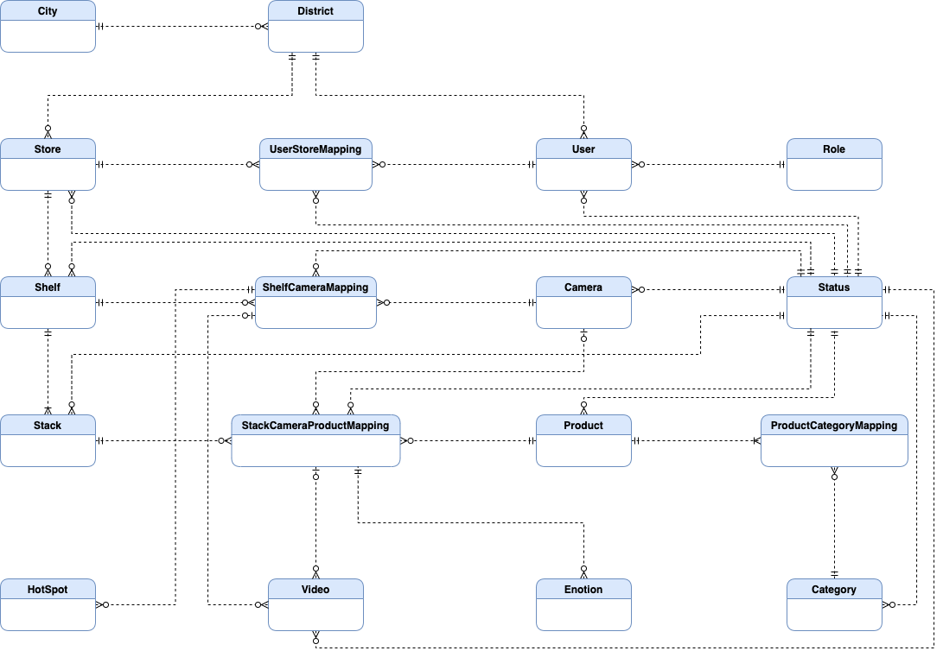

Figure . <Entity Relationship Diagram> Conceptual

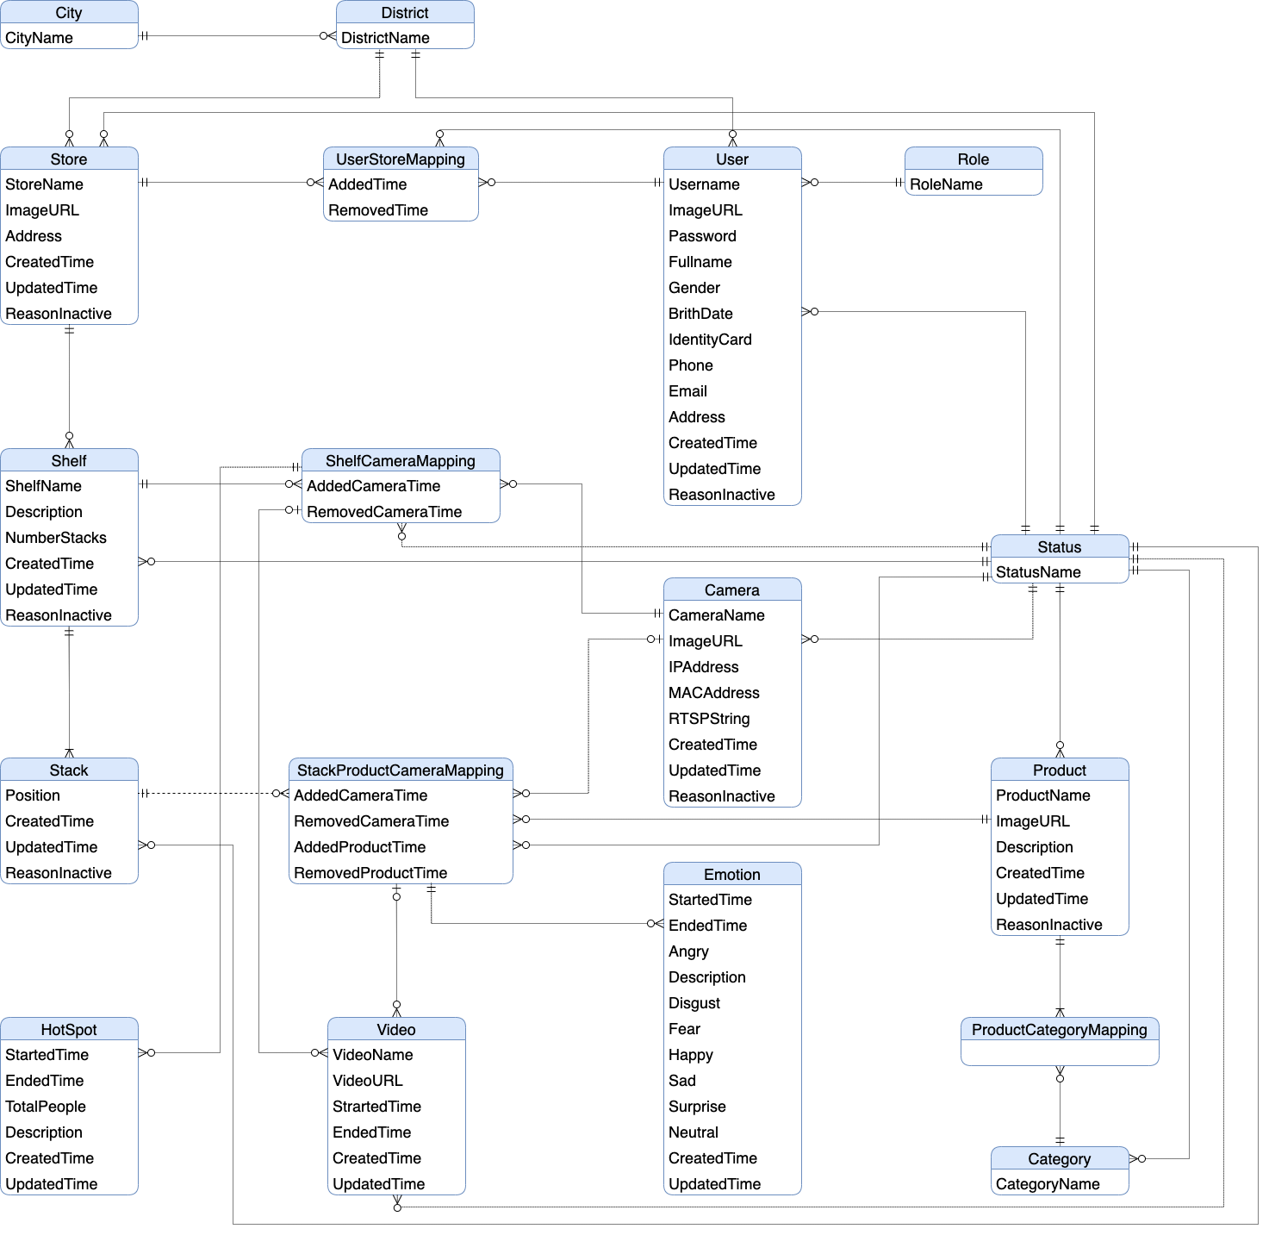

Figure . <Entity Relationship Diagram> Logical

Table . Entity Description

|  |  |  |
| --- | --- | --- |
| **#** | **Entity** | **Description** |
| 1 | tblCity | tblCity represents the cities in the system. |
| 2 | tblDistrict | tblCity represents the districts in the system. |
| 3 | tblCategory | tblCategory represents the category of products in the system. |
| 4 | tblStatus | tblStatus represents the status in the system. |
| 5 | tblRole | tblRole represents the role in the system. |
| 6 | tblUser | tblUser store information of user in the system includes username and password. |
| 7 | tblStore | tblStore represents the information of stores in the system. |
| 8 | tblUserStoreMapping | Mapping user with store, it means a manager manage stores. |
| 9 | tblShelf | tblShelf represents the information of shelf in a store. |
| 10 | tblStack | tblStack represents the information of stack on the shelf. |
| 11 | tblShelfCameraMapping | Mapping camera with shelf, it means mount the camera on the shelf. |
| 12 | tblStackProductCameraMapping | Mapping product and camera with stack, it means mount the camera and product on stack. |
| 13 | tblCamera | tblCamera represent the cameras that are running and operating in the system. Cameras are used for record video of shelf or stack. That includes the camera’s information. |
| 14 | tblProduct | tblProduct represent the products that are running in the system. Product are used for show on the stack in store. That includes the product’s information. |
| 15 | tblProductCategoryMapping | Mapping product with categories. |
| 16 | tblVideo | tblVideo represent the products that are detected in the system. That includes the video’s informantion. |
| 17 | tblEmotion | Store result of video detect emotion. |
| 18 | tblHotSpot | Store result of video detect “hot spot”. |

## 4. Non-Functional Requirements

### 4.1 External Interfaces

#### a. User Interfaces

UI-1: UI must be in English.

UI-2: GUI must be friendly, clear and easy to use.

UI-3: Information content pages should be concise, clear and users can focus easily.

UI-4: Elements are designed for touching gesture to help users interact with app easily and more comfortable.

UI-5: Background and font colors have great contrast to help users easy to read text.

#### b. Software Interfaces

SI-1:Web application: browser Safari (version 14.1.2 or higher), Google Chrome (version 70 or higher), Firefox (version 60 or higher), Internet Explorer (version 10 or higher).

SI-2:Mobile application: phone operating system requires Android version 9.0 or higher.

#### c. Hardware Interfaces

HI-1: Desktop or laptop.

HI-2: Camera IP.

#### d. Communications Interfaces

CI-1: System handler will send emails to manager based on specific functions.

### 4.2 Quality Attributes

#### a. Usability

* Users will probably take at least 2 days to learn how to use the system.
* The UI of website fits for each browser on each device.
* The system should be intuitive and easy so that even non-IT staff can use.

#### b. Reliability

* The accuracy of detect emotion must be over 60%.
* The accuracy of counting customer must be over 60%.

#### c. Performance

* Normal response time is less than 500ms.

#### d. Dependability

##### d1. Security

* Each role in system can only access its own functions.
* Before saving data to database, all input is validated.

##### d2. Safety

* Integration of CFFE system is low-impact on the workflow of manager.

#### e. Supportability

* Should apply RESTFUL Web API Standard.
* Should follow the coding convention.
* All development tools should be listed with attached documents.

#### f. Design Constraints

* Using OpenCV, Tensorflow and open source frameworks.
* Coding language:
  + Python: video processing and detection.
  + Java: back-end server.
  + Dart: UI of mobile programming.
  + JavaScript, CSS, HTML: UI of web programming.

#### g. Support Documents

* Manual documents should be step-by-step, simple and clear.
* Installation instructions should be easy and straightforward.
* Include full of configuration parameters.

#### h. Purchased Components

* Google Cloud Service

## 5. Other Requirements

### 5.1 Messages List

Table . Message List

|  |  |  |  |  |
| --- | --- | --- | --- | --- |
| **No** | **Message code** | **Message Type** | **Context** | **Content** |
| 1 | MSG-001 | In red, under the text box | Username is empty | Username is required |
| 2 | MSG-002 | In red, under the text box | Password is empty | Password is required |
| 3 | MSG-003 | In red | Login with invalid username or password | Invalid username or password |
| 4 | MSG-004 | In red, under the text box | Old password is empty | Old password is required |
| 5 | MSG-005 | In red, under the text box | New password is empty | New password is required |
| 6 | MSG-006 | In red, under the text box | Retype password is empty | Retype password is required |
| 7 | MSG-007 | In red, under the text box | New password and Retype password are not matched | New password and retype password must be matched |
| 8 | MSG-008 | In red, under the text box | The password is not following format:  - At least one digit. - At least one lowercase character. - At least one uppercase character. - At least one special character. - At least 8 characters and a maximum of 20 characters. | The password format is wrong |
| 9 | MSG-009 | Icon in the table | The list has no data | No data |
| 10 | MSG-010 | Notification | Uploading video is successful | Videos upload is successful! |
| 11 | MSG-011 | Notification | Creating objects process is successful | Creating process is successful |
| 12 | MSG-012 | Notification | The shelf doesn't exist | Shelf doesn't exist |
| 13 | MSG-013 | Notification | Updating objects process is successful | Updating process is successful |
| 14 | MSG-014 | In red, under the text box | Full name is empty | Full name is required |
| 15 | MSG-015 | In red, under the text box | Full name is not between 1 to 100 characters | Full name is between 1 to 100 characters |
| 16 | MSG-016 | In red, under the text box | Description is empty | Description is required |
| 17 | MSG-017 | In red, under the text box | Description is not between 1 to 250 characters | Description is between 1 to 250 characters |
| 18 | MSG-018 | In red, under the text box | Number of stacks is empty | Shelf's number of stacks is required |
| 19 | MSG-019 | In red, under the text box | Number of stacks is not between 1 to 30 stacks | Shelf's number of stacks is between 1 to 30 stacks |
| 20 | MSG-020 | In red, under the text box | The camera doesn't exist in CFFE system. | Camera doesn't exist |
| 21 | MSG-021 | Notification | Deleting objects process is successful | Deleting process is successful |
| 22 | MSG-022 | Notification | The stack doesn't exist in CFFE system | Stack doesn't exist |
| 23 | MSG-023 | Notification | The product doesn't exist in CFFE system | Product doesn't exist |
| 24 | MSG-024 | In red, under the text box | The camera id is empty | Camera id is required |
| 25 | MSG-025 | Notification | The shelf has number of stacks is maximum | Shelf is full |
| 26 | MSG-026 | In red, under the text box | The image is empty | Image is required |
| 27 | MSG-027 | Notification | The image is not png, jpg, jpeg format | The image must be png, jpg, jpeg format |
| 28 | MSG-028 | In red, under the text box | The category is empty | Category is required |
| 29 | MSG-029 | Notification | The category does not exist | Category does not exist |
| 30 | MSG-030 | In red, under the text box | The RTSP is empty | The RTSP string is required |
| 31 | MSG-031 | In red, under the text box | The IP address is empty | The IP address is required |
| 32 | MSG-032 | In red, under the text box | The IP address is wrong format | The IP address must be x.x.x.x format (x is number between 0 to 255) |
| 33 | MSG-033 | Notification | The category doesn't exist | Category doesn't exist |
| 34 | MSG-034 | Notification | The name already exists | Name already exists |
| 35 | MSG-035 | Notification | The store doesn't exist | Store doesn't exist |
| 36 | MSG-036 | In red, under the text box | The address is empty | Address is required |
| 37 | MSG-037 | In red, under the text box | Address is not between 1 to 250 characters | Address is between 1 to 250 characters |
| 38 | MSG-038 | In red, under the text box | City has not been selected | City is required |
| 39 | MSG-039 | In red, under the text box | District has not been selected | District is required |
| 40 | MSG-040 | Notification | Deleting object process is successful | Deleting process is successful |
| 41 | MSG-041 | Notification | The user doesn't exist | The user doesn't exist |
| 42 | MSG-042 | In red, under the text box | Phone number is not between 10 to 13 digits | Phone is between 10 to 13 digits |
| 43 | MSG-043 | Notification | Manager already exists | Manager already exists |
| 44 | MSG-044 | In red, under the text box | Email is empty | Email is required |
| 45 | MSG-045 | In red, under the text box | Email does not match /^(([^<>()[\]\\.,;:\s@"]+(\.[^<>()[\]\\.,;:\s@"]+)*)|(".+"))@((\[[0-9]{1,3}\.[0-9]{1,3}\.[0-9]{1,3}\.[0-9]{1,3}\])|(([a-zA-Z\-0-9]+\.)+[a-zA-Z]{2,}))$/ regex | The email format is wrong |
| 46 | MSG-046 | Notification | Status doesn't exist | Status doesn't exist |
| 47 | MSG-047 | In red, under the text box | Birthdate is empty | Birthdate is required |
| 48 | MSG-048 | In red, under the text box | Birthdate is greater than current date. | Birthdate is invalid |
| 49 | MSG-049 | In red, under the text box | Phone is empty | Phone is required |
| 50 | MSG-050 | In red, under the text box | Category name is not between 1 to 100 characters | Category name is between 1 to 100 characters |
| 51 | MSG-051 | In red, under the text box | Identity card is empty | Identity card is required |
| 52 | MSG-052 | In red, under the text box | Identity card does not include from 9 to 12 digits | Identity card includes from 9 to 12 digits |
| 53 | MSG-053 | Notification | Password is wrong | Password is wrong |
| 54 | MSG-054 | In red, under the text box | Gender is not selected | Gender is required |
| 55 | MSG-055 | Notification | Email exists. | Email already exists |
| 56 | MSG-056 | Notification | Identify card is exist | Identify card already exists |
| 57 | MSG-057 | Notification | IP address exists | IP address already exists |
| 58 | MSG-058 | Notification | RTSP String exists | RTSP string already exists |
| 59 | MSG-059 | Notification | Category name exists | Category name already exists |
| 60 | MSG-060 | Notification | Product name exists | Product name already exists |
| 61 | MSG-061 | Notification | Shelf name exists | Shelf name already exists |
| 62 | MSG-062 | Notification | Store name exists | Store name already exists |
| 63 | MSG-063 | Notification | The manager is not found. | The manager is not found |
| 64 | MSG-064 | Notification | Create manager successfully. | Create manager successfully |
| 65 | MSG-065 | Notification | This status does not exist. | Status does not exist |
| 66 | MSG-066 | Notification | Pending status can be changed to be inactive status if it has an inactive reason and mappings are inactive.  Inactive status only changing to be pending status. | Changing status fail |
| 67 | MSG-067 | In red, under the text box | Inactive reason is not from 1 to 250 characters. | Inactive reason must be from 1 to 250 characters |
| 68 | MSG-068 | Notification | The old password is not correct. | Old password is not correct |
| 69 | MSG-069 | Notification | Store ID cannot empty. | Store ID is required |
| 70 | MSG-070 | In red, under the text box | Analyzed time cannot empty. | Analyzed time is required |
| 71 | MSG-071 | Notification | Shelf Id cannot empty when get shelf detail | Shelf Id is required |
| 72 | MSG-072 | Notification | Wrong time format (HH:MM:SS) | Time must be format (HH:MM:SS) |
| 73 | MSG-073 | In red, under the text box | Birthday is not YYYY-MM-DD format | Birthday must be followed by YYYY-MM-DD format |
| 74 | MSG-074 | Notification | Manager is not found  Manager status is not pending | Manager is not available |
| 75 | MSG-075 | Notification | Store is not found Store status is not pending | Store is not available |
| 76 | MSG-076 | Notification | System cannot finish this action | System cannot finish this action |
| 77 | MSG-077 | Notification | Store and Manager is not mapping | Store and Manager is not mapping |
| 78 | MSG-078 | Notification | Stack ID is empty | Stack ID is required |
| 79 | MSG-079 | In red, under the text box | Shelf name is empty | Shelf name is required |
| 80 | MSG-080 | In red, under the text box | Shelf name is not from 1 to 100 characters. | Shelf name must be from 1 to 100 characters |
| 81 | MSG-081 | Notification | Store contain shelfs active or pending. | Store contain shelves active or pending |
| 82 | MSG-082 | In red, under the text box | Camera name cannot be empty | Camera name is required |
| 83 | MSG-083 | In red, under the text box | Camera name is not from 1 to 100 characters. | Camera name must be from 1 to 100 characters |
| 84 | MSG-084 | Notification | Type detect is not 1 or 2. | Type detect does not exist |
| 85 | MSG-085 | Notification | Shelf must be existed and not active. | Shelf must be existed |
| 86 | MSG-086 | Notification | Camera must be existed and not active. | Camera must be existed and not active |
| 87 | MSG-087 | Notification | Camera or Shelf is not available. | Camera or Shelf is not available |
| 88 | MSG-088 | Notification | Shelf and Camera is not mapping | Shelf and Camera is not mapping |
| 89 | MSG-089 | Notification | Product is not active. | Product is not active |
| 90 | MSG-090 | Notification | Stack's status is active or inactive. | Stack is already active or inactive |
| 91 | MSG-091 | Notification | Stack already has a product. | Stack already has a product |
| 92 | MSG-092 | Notification | Product and Stack is not mapping. | Product and Stack is not mapping or stack already has camera |
| 93 | MSG-093 | Notification | Camera is already active or inactive. | Camera is already active or inactive |
| 94 | MSG-094 | Notification | Camera and Stack is not mapping. | Camera and Stack is not mapping |
| 95 | MSG-095 | Notification | Stack contain product. | Stack contain product |
| 96 | MSG-096 | Notification | Product ID is required. | Product ID is required |
| 97 | MSG-097 | Notification | Have stack contain this product. | Have stack contain this product |
| 98 | MSG-098 | Notification | Active status can be changed to be inactive status if it has an inactive reason, and no any stack contain it. | Changing status fail |
| 99 | MSG-099 | In red, under the text box | Product name is required. | Product name is required |
| 100 | MSG-100 | Notification | Stack must contain product. | Stack must contain product |
| 101 | MSG-101 | Notification | Stack already active. | Stack already active |
| 102 | MSG-102 | Notification | Category is required. | Category is required |
| 103 | MSG-103 | In red, under the text box | Product does not belong 1 - 3 categories | Category list at least 1 item, and maximum is 3 |
| 104 | MSG-104 | Notification | Category list contain invalid id. | Category list contain invalid id |
| 105 | MSG-105 | In red, under the text box | Category name is required. | Category name is required |
| 106 | MSG-106 | In red, under the text box | Store name is required. | Store name is required |
| 107 | MSG-107 | In red, under the text box | Store address is required. | Store address is required |
| 108 | MSG-108 | In red, under the text box | Store analysed time is required. | Store analyzed time is required |
| 109 | MSG-109 | Notification | This category is being used. | This category is being used |
| 110 | MSG-110 | Notification | Active status can be changed to be inactive status if it has no product using it | Changing status fail |
| 111 | MSG-111 | Notification | System have some problem | System have some problem Please try later |
| 112 | MSG-112 | In red, under the text box | Don't select the image to change image | Please select an image |
| 113 | MSG-113 | Notification | Image is not jpg, jpeg, png format. | jpg/jpeg/png file types are supported |
| 114 | MSG-114 | Notification | System upload video to storage fail. | System could not create the directory where the uploaded files will be stored in server |
| 115 | MSG-115 | Notification | End date is empty | End date is required |
| 116 | MSG-116 | Notification | Choose End date greater than Start date | End date need to greater than Start date |
| 117 | MSG-117 | Notification | Date is wrong format | Date must be followed by format YYY-MM-dd |
| 118 | MSG-118 | Notification | Uploading videos is not mp4 format | Mp4 file type is supported |
| 119 | MSG-119 | In red, under the text box | Don't select the video to upload | Please select a video |
| 120 | MSG-120 | Notification | Access to URL is not permission | You have no permission to access |
| 121 | MSG-121 | Notification | Uploading videos is wrong name format | There are at least 1 video have invalid name |
| 122 | MSG-122 | Notification | Uploading videos don't belong to any store's cameras | There are at least 1 video does not map with camera |
| 123 | MSG-123 | Notification | Uploading videos are duplicated | There are at least 1 video duplicated |
| 124 | MSG-124 | Notification | Sending email for the manager is failed | Sending email fail |
| 125 | MSG-125 | In red, under the text box | MAC address is empty | MAC address is required |
| 126 | MSG-126 | In red, under the text box | MAC address is wrong format | MAC address must contain 12 hexadecimal digits (XX-XX-XX-XX-XX-XX) |
| 127 | MSG-127 | Notification | MAC address exists in CFFE system | MAC address already exists |
| 128 | MSG-128 | Notification | The number of cameras added to the shelf exceeds 2 | The maximum camera on the shelf is 2 |
| 129 | MSG-129 | In red, under the text box | Store name is between 1 to 100 characters | Store name is between 1 to 100 characters. |
| 130 | MSG-130 | In red, under the text box | Product name is not between 1 to 100 characters | Product name is between 1 to 100 characters. |

# IV. Software Design Description

## 1. Overall Description

### 1.1 Assumptions

This system is designed basing on these following assumptions:

* Software/OS:
  + MacOS 11.5.2
  + Safari browser 14.1.2
  + MySQL 8.0
  + Java 8.0
  + NodeJS 14.16.1
  + Flutter 2.0.6
* Hardware:
  + Computer that has internet connection
  + Camera IP

### 1.2 Design Constraints

* End-user environment: OS with have Safari, android phone, camera.
* Network communication: this system works based on the network connection.

## 2. System Architecture Design

### 2.1 Overall Architecture

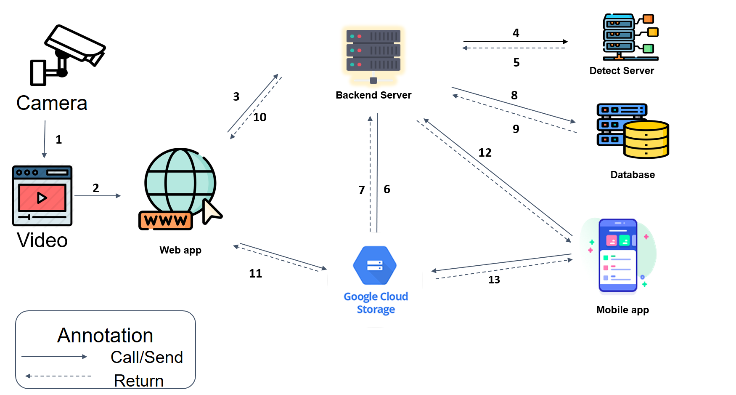

Figure . Overall architecture

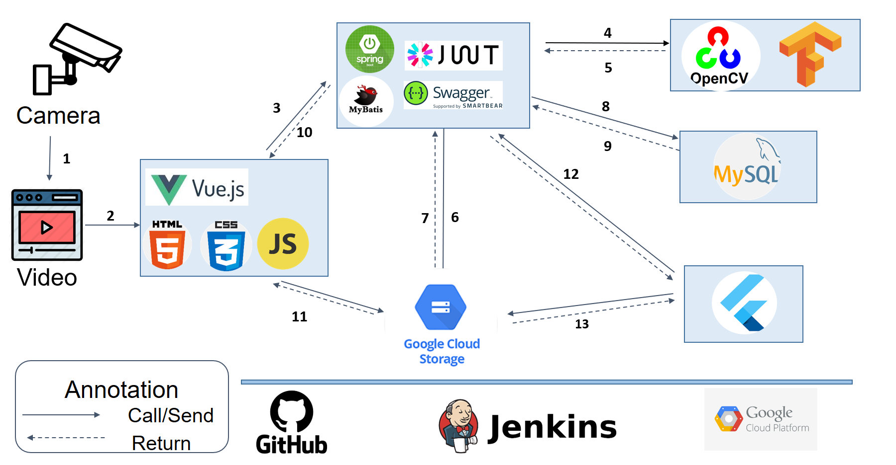

Figure . Overall architecture technology applied

### 2.2 Package Diagram

**

Figure . <Package Diagram> Back-end



Figure . <Package Diagram> Web App



Figure . <Package Diagram> Mobile App

## 3. System Detailed Design

### 3.1 Class Diagram

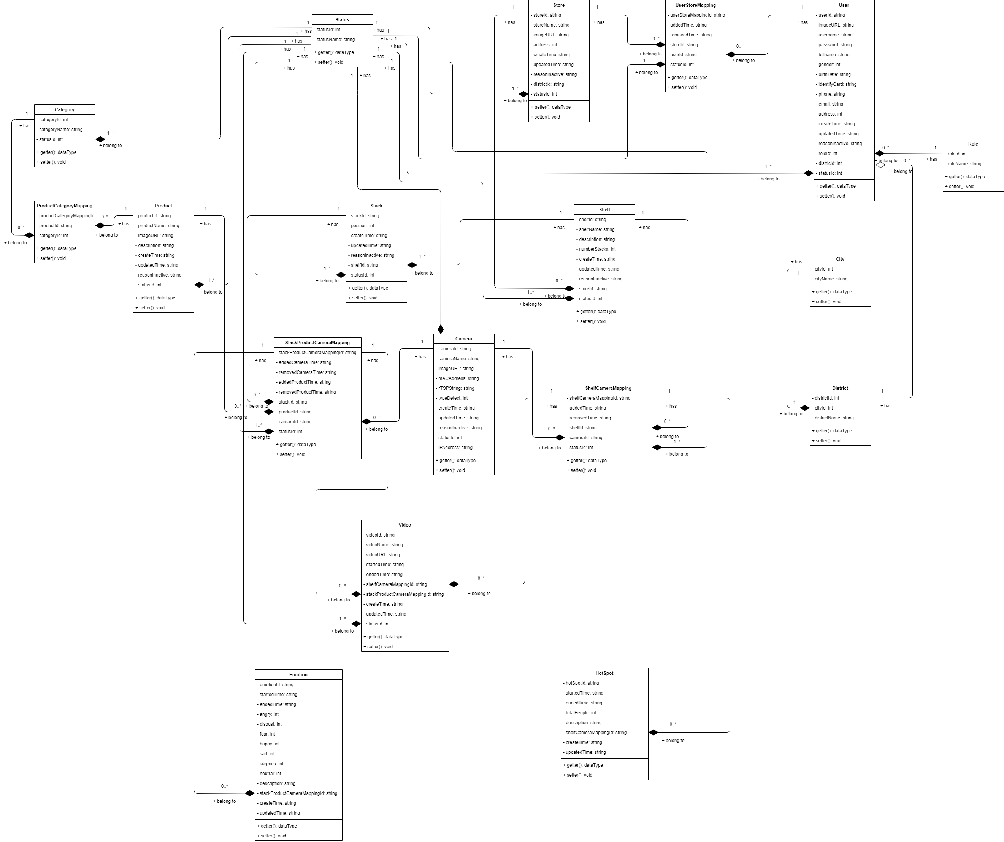

Figure . Class Diagram

### 3.2 Class Specification

#### 3.2.1 Camera

Table . <Class Specification> Camera

|  |  |  |
| --- | --- | --- |
| **Property** | **Type** | **Description** |
| CameraId | string | Unique identifier of camera |
| CameraName | string | Name of camera |
| ImageURL | string | Image of camera |
| MACAddress | string | MAC address of camera |
| RTSPString | string | RTSP of camera |
| TypeDetect | int | Type of camera |
| CreatedTime | string | Created date of camera |
| UpdatedTime | string | Last modified date of camera |
| ReasonInactive | string | Reason inactive of camera |
| StatusId | int | Unique identifier of status |
| IPAddress | String | IP address of camera |
| getter() | data type | Get attribute of class |
| setter() | void | Set value of class’s attribute |

#### 3.2.2 Category

Table . <Class Specification> Category

|  |  |  |
| --- | --- | --- |
| **Property** | **Type** | **Description** |
| CategoryId | int | Unique identifier of category |
| CategoryName | string | Name of category |
| StatusId | int | Unique identifier of status |
| getter() | data type | Get attribute of class |
| setter() | void | Set value of class’s attribute |

#### 3.2.3 City

Table . <Class Specification> City

|  |  |  |
| --- | --- | --- |
| **Property** | **Type** | **Description** |
| CityId | int | Unique identifier of city |
| CityName | string | Name of city |
| getter() | data type | Get attribute of class |
| setter() | void | Set value of class’s attribute |

#### 3.2.4 District

Table . <Class Specification> District

|  |  |  |
| --- | --- | --- |
| **Property** | **Type** | **Description** |
| DistrictId | int | Unique identifier of district |
| CityId | Int | Unique identifier of city |
| DistrictName | string | Name of district |
| getter() | data type | Get attribute of class |
| setter() | void | Set value of class’s attribute |

#### 3.2.5 Emotion

Table . <Class Specification> Emotion

|  |  |  |
| --- | --- | --- |
| **Property** | **Type** | **Description** |
| EmotionId | string | Unique identifier of emotion |
| StartedTime | string | Time started of video |
| EndedTime | string | Time ended of video |
| Angry | int | Number of angry |
| Disgust | int | Number of disgust |
| Fear | int | Number of fear |
| Happy | int | Number of happy |
| Sad | int | Number of sad |
| Surprise | int | Number of surprise |
| Neutral | int | Number of neutral |
| Description | string | Description of emotion |
| StackProductCameraMappingId | string | Unique identifier of stack product camera mapping |
| CreatedTime | string | Created date of emotion |
| UpdatedTime | string | Last modified date of emotion |
| getter() | data type | Get attribute of class |
| setter() | void | Set value of class’s attribute |

#### 3.2.6 HotSpot

Table . <Class Specification> HotSpot

|  |  |  |
| --- | --- | --- |
| **Property** | **Type** | **Description** |
| HotspotId | string | Unique identifier of hot spot |
| StartedTime | string | Time started of video |
| EndedTime | string | Time ended of video |
| TotalPeople | int | Number of customer |
| Description | string | Description of hot spot |
| ShelfCameraMappingId | string | Unique identifier of shelf camera mapping |
| CreatedTime | string | Created date of hot spot |
| UpdatedTime | string | Last modified date of hot spot |
| getter() | data type | Get attribute of class |
| setter() | void | Set value of class’s attribute |

#### 3.2.7 Product

Table . <Class Specification> Product

|  |  |  |
| --- | --- | --- |
| **Property** | **Type** | **Description** |
| ProductId | string | Unique identifier of product |
| ProductName | string | Name of product |
| ImageURL | string | Image URL of product |
| Description | string | Description of product |
| CreatedTime | string | Created date of product |
| UpdatedTime | string | Last modified date of product |
| ReasonInactive | string | Reason inactive of product |
| StatusId | int | Unique identifier of status |
| getter() | data type | Get attribute of class |
| setter() | void | Set value of class’s attribute |

#### 3.2.8 ProductCategoryMapping

Table . <Class Specification> ProductCategoryMapping

|  |  |  |
| --- | --- | --- |
| **Property** | **Type** | **Description** |
| ProductCategoryMappingId | string | Unique identifier of product category mapping |
| ProductId | string | Unique identifier of product |
| CategoryId | int | Unique identifier of category |
| getter() | data type | Get attribute of class |
| setter() | void | Set value of class’s attribute |

#### 3.2.9 Role

Table . <Class Specification> Role

|  |  |  |
| --- | --- | --- |
| **Property** | **Type** | **Description** |
| RoleId | int | Unique identifier of role |
| RoleName | string | Name of role |
| getter() | data type | Get attribute of class |
| setter() | void | Set value of class’s attribute |

#### 3.2.10 Shelf

Table . <Class Specification> Shelf

|  |  |  |
| --- | --- | --- |
| **Property** | **Type** | **Description** |
| ShelfId | string | Unique identifier of shelf |
| ShelfName | string | Name of shelf |
| Description | string | Description of shelf |
| NumberStacks | int | Number stack of shelf |
| CreatedTime | string | Created date of shelf |
| UpdatedTime | string | Last modified date of shelf |
| ReasonInactive | string | Reason inactive of shelf |
| StoreId | string | Unique identifier of store |
| StatusId | int | Unique identifier of status |
| getter() | data type | Get attribute of class |
| setter() | void | Set value of class’s attribute |

#### 3.2.11 ShelfCameraMapping

Table . <Class Specification> ShelfCameraMapping

|  |  |  |
| --- | --- | --- |
| **Property** | **Type** | **Description** |
| ShelfCameraMappingId | string | Unique identifier of shelf camera mapping |
| AddedTime | string | Added time of camera |
| RemovedTime | string | Removed time ò camera |
| ShelfId | string | Unique identifier of shelf |
| CameraId | string | Unique identifier of camera |
| StatusId | int | Unique identifier of status |
| getter() | data type | Get attribute of class |
| setter() | void | Set value of class’s attribute |

#### 3.2.12 Stack

Table . <Class Specification> Stack

|  |  |  |
| --- | --- | --- |
| **Property** | **Type** | **Description** |
| StackId | string | Unique identifier of stack |
| Position | int | Position of stack |
| CreatedTime | string | Created date of stack |
| UpdatedTime | string | Last modified date of stack |
| ReasonInactive | string | Reason inactive of stack |
| ShelfId | string | Unique identifier of shelf |
| StatusId | int | Unique identifier of status |
| getter() | data type | Get attribute of class |
| setter() | void | Set value of class’s attribute |

#### 3.2.13 StackProductCameraMapping

Table . <Class Specification> StackProductCameraMapping

|  |  |  |
| --- | --- | --- |
| **Property** | **Type** | **Description** |
| StackProductCameraMappingId | string | Unique identifier of stack product camera mapping |
| AddedCameraTime | string | Added time of camera |
| RemovedCameraTime | string | Removed time of camera |
| AddedProductTime | string | Added time of product |
| RemoveProductTime | string | Removed time of product |
| StackId | string | Unique identifier of stack |
| ProductId | string | Unique identifier of product |
| CameraId | string | Unique identifier of camera |
| StatusId | int | Unique identifier of status |
| getter() | data type | Get attribute of class |
| setter() | void | Set value of class’s attribute |

#### 3.2.14 Status

Table . <Class Specification> Status

|  |  |  |
| --- | --- | --- |
| **Property** | **Type** | **Description** |
| StatusId | int | Unique identifier of status |
| StatusName | string | Name of status |
| getter() | data type | Get attribute of class |
| setter() | void | Set value of class’s attribute |

#### 3.2.15 Store

Table . <Class Specification> Store

|  |  |  |
| --- | --- | --- |
| **Property** | **Type** | **Description** |
| StoreId | string | Unique identifier of store |
| StoreName | string | Name of store |
| ImageURL | string | Image URL of store |
| Address | string | Address of store |
| CreatedTime | string | Created date of store |
| UpdatedTime | string | Last modified date of store |
| ReasonInactive | string | Reason Inactive of store |
| DistrictId | int | Unique identifier of district |
| StatusId | int | Unique identifier of status |
| getter() | data type | Get attribute of class |
| setter() | void | Set value of class’s attribute |

#### 3.2.16 User

Table . <Class Specification> User

|  |  |  |
| --- | --- | --- |
| **Property** | **Type** | **Description** |
| UserId | string | Unique identifier of user |
| ImageURL | string | Image URL of user |
| Username | string | Username of user |
| Password | string | Password of user |
| Fullname | string | Name of user |
| Gender | int | Gender of user |
| BirthDate | string | Day of birth of user |
| IdentifyCard | string | Identify card of user |
| Phone | string | Phone number of user |
| Email | string | Email of user |
| Address | string | Address of user |
| CreatedTime | string | Created date of user |
| UpdatedTime | string | Last modified date of user |
| ReasonInactive | string | Reason inactive of user |
| RoleId | int | Unique identifier of role |
| DistrictId | int | Unique identifier of district |
| StatusId | int | Unique identifier of status |
| getter() | data type | Get attribute of class |
| setter() | void | Set value of class’s attribute |

#### 3.2.17 UserStoreMapping

Table . <Class Specification> UserStoreMapping

|  |  |  |
| --- | --- | --- |
| **Property** | **Type** | **Description** |
| UserStoreMappingId | string | Unique identifier of user store mapping |
| AddedTime | string | Added time of user |
| RemovedTime | string | Removed time of user |
| StoreId | string | Unique identifier of store |
| UserId | string | Unique identifier of user |
| StatusId | int | Unique identifier of status |
| getter() | data type | Get attribute of class |
| setter() | void | Set value of class’s attribute |

#### 3.2.18 Video

Table . <Class Specification> Video

|  |  |  |
| --- | --- | --- |
| **Property** | **Type** | **Description** |
| VideoId | string | Unique identifier of video |
| VideoName | string | Name of video |
| VideoURL | string | URL of video |
| StartedTime | string | Started time of video |
| EndedTime | string | Ended time of video |
| ShelfCameraMappingId | string | Unique identifier of shelf camera mapping |
| StackProductCameraMappingId | string | Unique identifier of stack product camera mapping |
| UpdatedTime | string | Created date of video |
| CreatedTime | string | Last modified date of video |
| getter() | data type | Get attribute of class |
| setter() | void | Set value of class’s attribute |

### 3.3 Sequence Diagrams

#### 3.3.1. Login case



Figure . <Sequence Diagram> Login

#### 3.3.2. Reset manager’s account password case



Figure . <Sequence Diagram> Reset manager’s account password

#### 3.3.3. Change the password case



Figure . <Sequence Diagram> Change the password

#### 3.3.4. Get own profile case

Figure . <Sequence Diagram> Get own profile

#### 3.3.5. Update own profile case



Figure . <Sequence Diagram> Update the own profile

#### 3.3.6. Create the manager case



Figure . <Sequence Diagram> Create the manager

#### 3.3.7. Delete the manager case



Figure . <Sequence Diagram> Delete the manager

#### 3.3.8. Update the manager case



Figure . <Sequence Diagram> Update the manager

#### 3.3.9. Get the manager detail case



Figure . <Sequence Diagram> Get the manager detail

#### 3.3.10. Get the managers case



Figure . <Sequence Diagram> Get the managers

#### 3.3.11. Create the store case



Figure . <Sequence Diagram> Create the store

#### 3.3.12. Delete the store case



Figure . <Sequence Diagram> Delete the store

#### 3.3.13. Update the store case



Figure . <Sequence Diagram> Update the store

#### 3.3.14. Get the store detail case

Figure . <Sequence Diagram> Get the store detail

#### 3.3.15. Get the stores case



Figure . <Sequence Diagram> Get the stores

#### 3.3.16. Create the shelf case



Figure . <Sequence Diagram> Create the shelf

#### 3.3.17. Delete the shelf case



Figure . <Sequence Diagram> Delete the shelf

#### 3.3.18. Update the shelf case



Figure . <Sequence Diagram> Update the shelf

#### 3.3.19. Get the shelf detail case



Figure . <Sequence Diagram> Get the shelf detail

#### 3.3.20. Get the shelves case



Figure . <Sequence Diagram> Get the shelves

#### 3.3.21. Create the stack case



Figure . <Sequence Diagram> Create the stack

#### 3.3.22. Delete the stack case



Figure . <Sequence Diagram> Delete the stack

#### 3.3.23. Update the stack case



Figure . <Sequence Diagram> Update the stack

#### 3.3.24. Get the stack detail case



Figure . <Sequence Diagram> Get the stack detail

#### 3.3.25. Get the stacks case



Figure . <Sequence Diagram> Get the stacks

#### 3.3.26. Create the product case



Figure . <Sequence Diagram> Create the product

#### 3.3.27. Delete the product case



Figure . <Sequence Diagram> Delete the product

#### 3.3.28. Update the product case



Figure . <Sequence Diagram> Update the product

#### 3.3.29. Get the product detail case



Figure . <Sequence Diagram> Get the product detail

#### 3.3.30. Get the products case



Figure . <Sequence Diagram> Get the products

#### 3.3.31. Create the category case



Figure . <Sequence Diagram> Create the category

#### 3.3.32. Delete the category case



Figure . <Sequence Diagram> Delete the category

#### 3.3.33. Update the category case



Figure . <Sequence Diagram> Update the category

#### 3.3.34. Get the category detail case



Figure . <Sequence Diagram> Get the category detail

#### 3.3.35. Get the categories case



Figure . <Sequence Diagram> Get the categories

#### 3.3.36. Get the video case



Figure . <Sequence Diagram> Get the video

#### 3.3.37. Upload the video case



Figure . <Sequence Diagram> Upload the video

### 3.4 Activity Diagrams

#### 3.4.1 <Unauthenticated User> Login by account

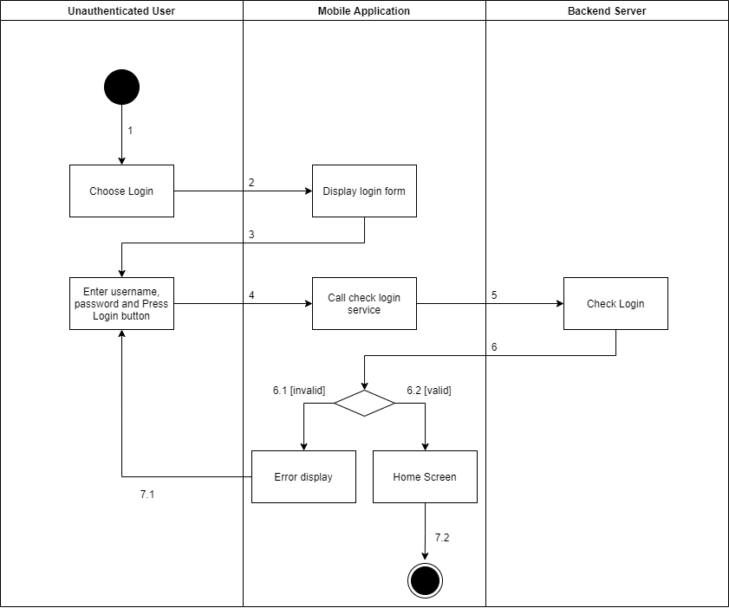

Figure . <Activity Diagram> Login

#### 3.4.2 <Admin> Get the stores

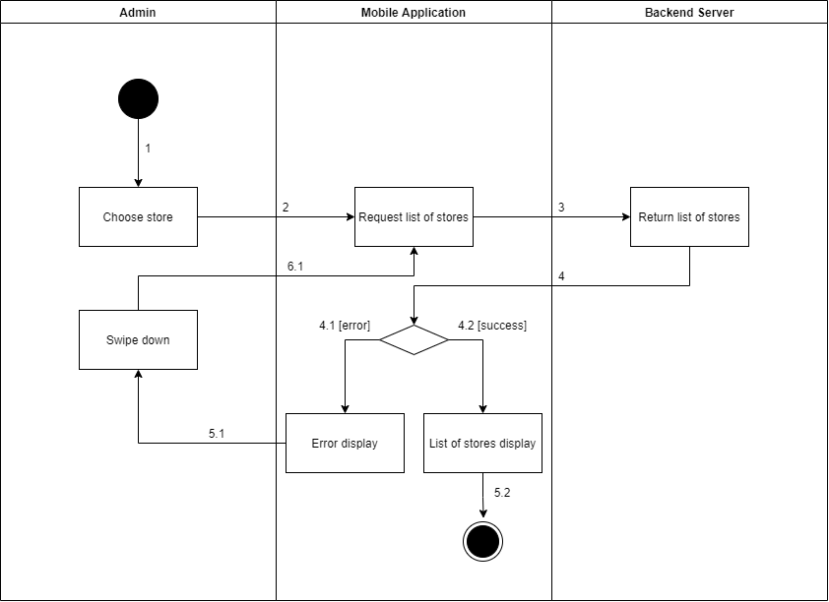

Figure . <Activity Diagram> Get the stores

#### 3.4.3 <Admin> Get store detail

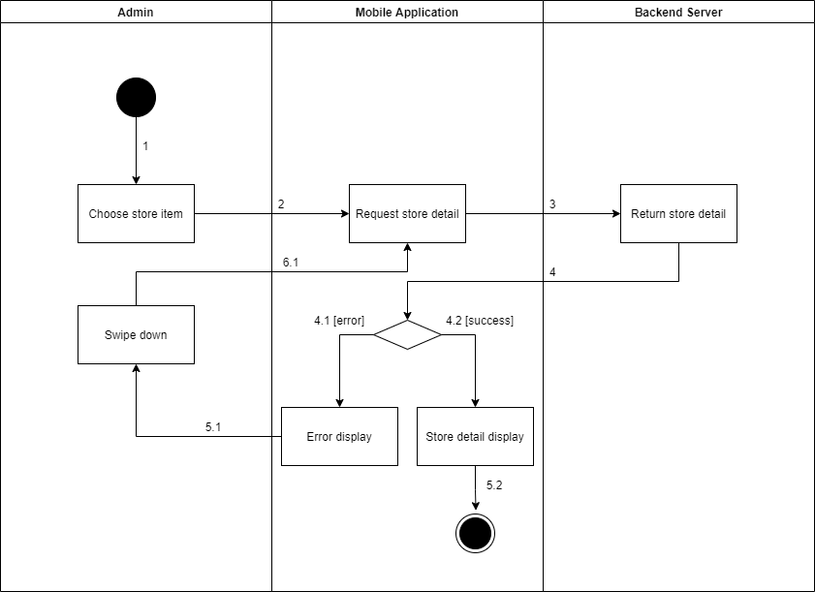

Figure . <Activity Diagram> Get store detail

#### 3.4.4 <Admin> Update the store

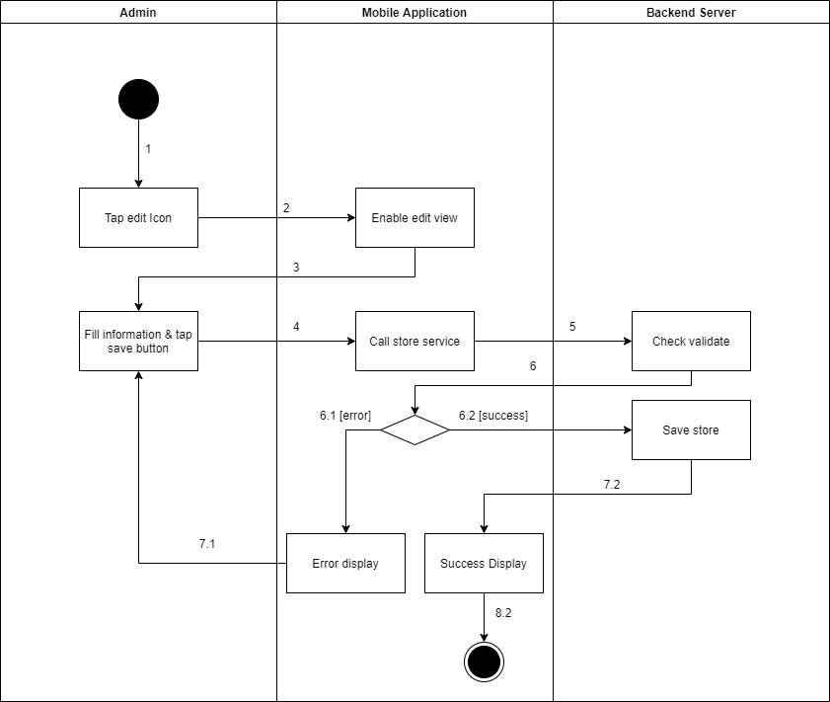

Figure . <Activity Diagram> Update the store

#### 3.4.5 <Admin> Delete the store

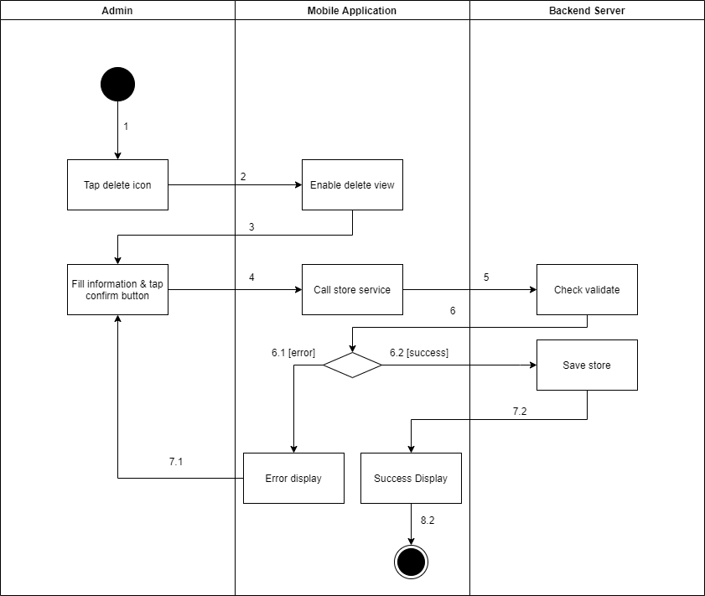

Figure . <Activity Diagram> Delete the store

#### 3.4.6 <Admin> Create the store

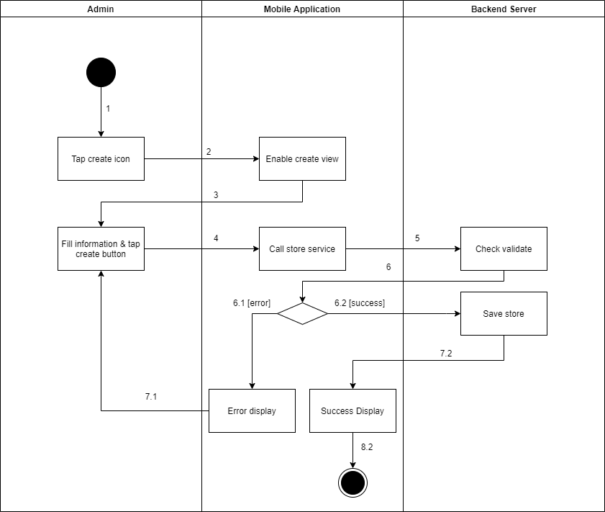

Figure . <Activity Diagram> Create the store

#### 3.4.7 <Admin> Get the managers

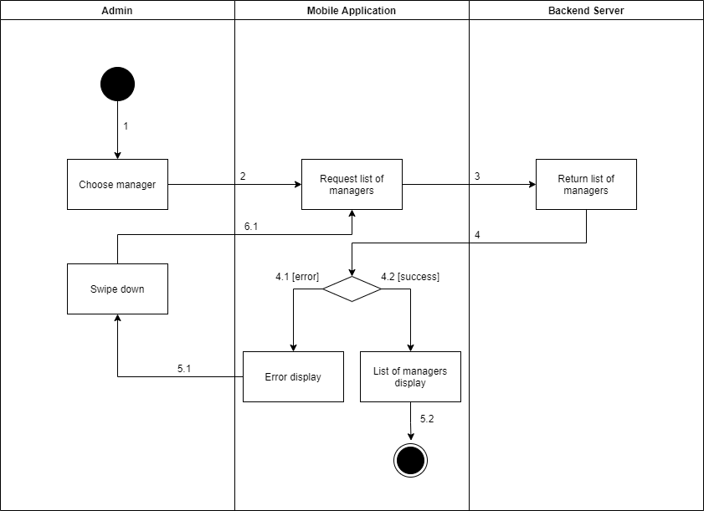

Figure . <Activity Diagram> Get the managers

#### 3.4.8 <Admin> Get manager detail

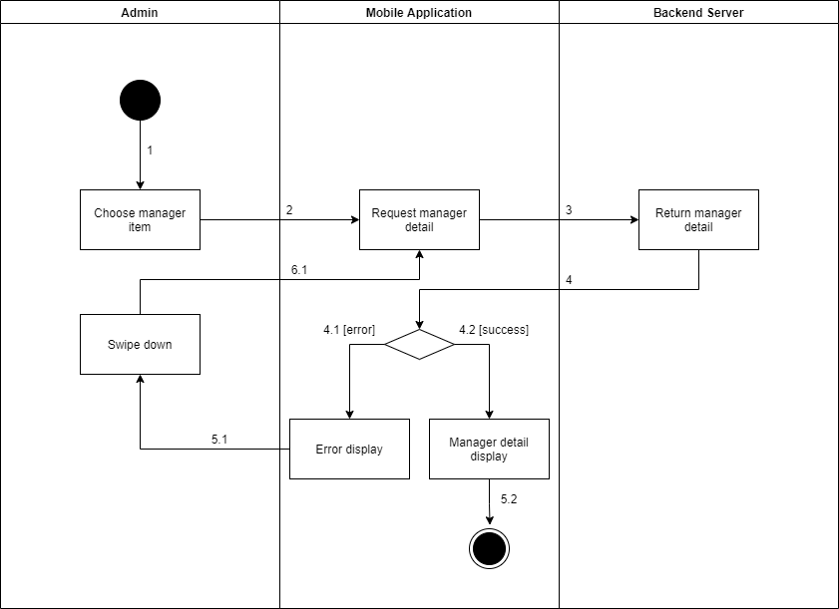

Figure . <Activity Diagram> Get manager detail

#### 3.4.9 <Admin> Update the manager

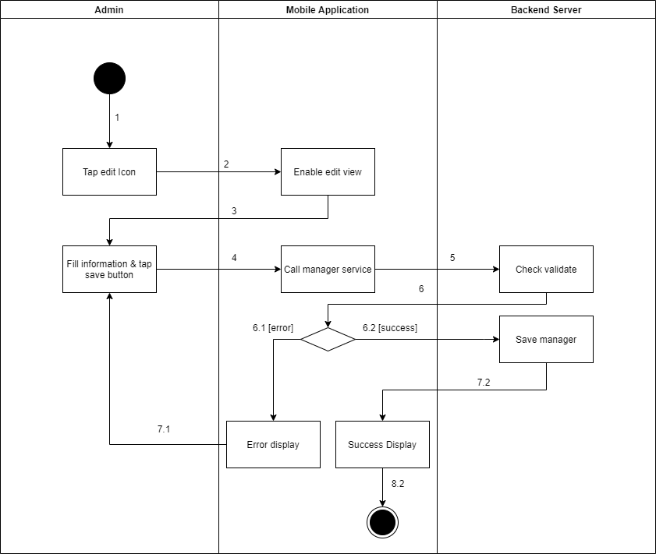

Figure . <Activity Diagram> Update the manager

#### 3.4.10 <Admin> Delete the manager

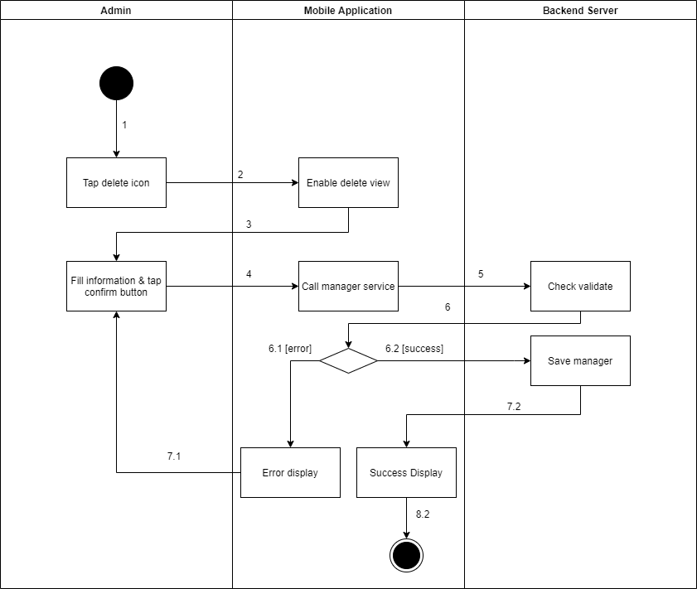

Figure . <Activity Diagram> Delete the manager

#### 3.4.11 <Admin> Create the manager

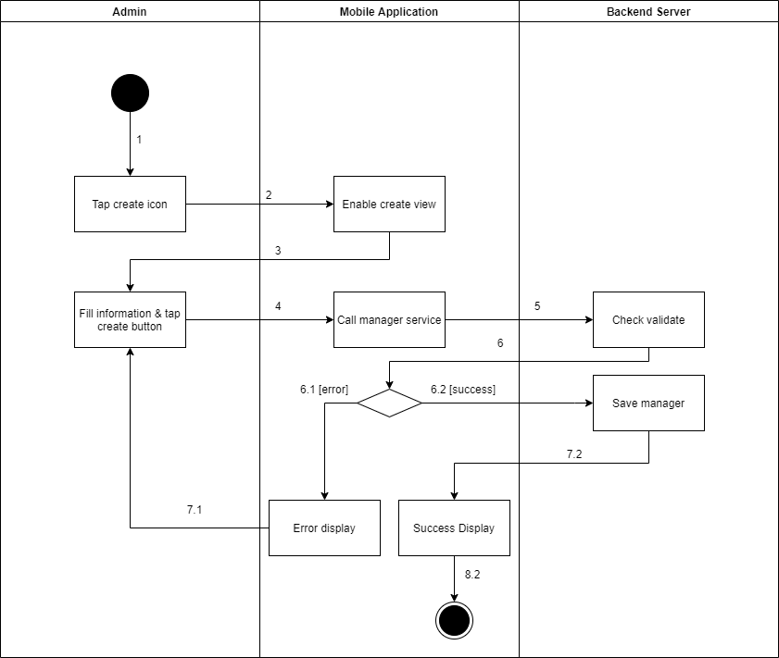

Figure . <Activity Diagram> Create the manager

#### 3.4.12 <Admin> Update the product

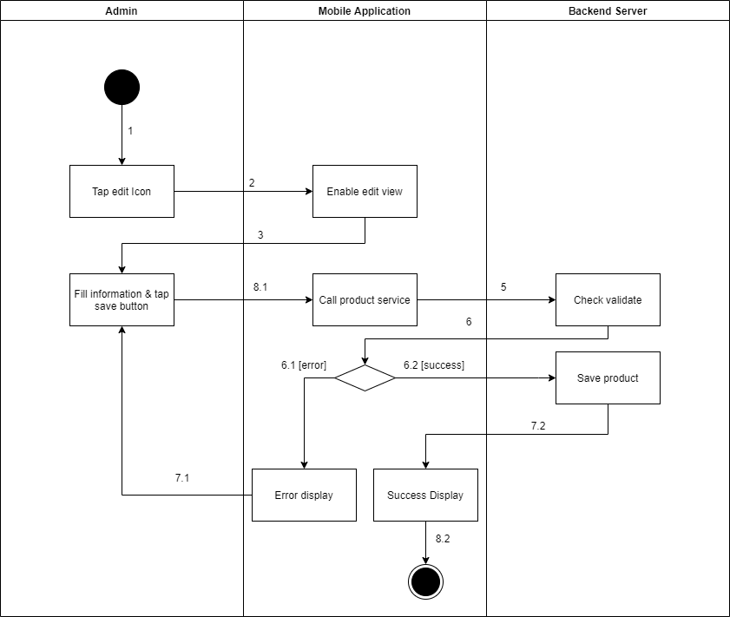

Figure . <Activity Diagram> Update the product

#### 3.4.13 <Admin> Delete the product

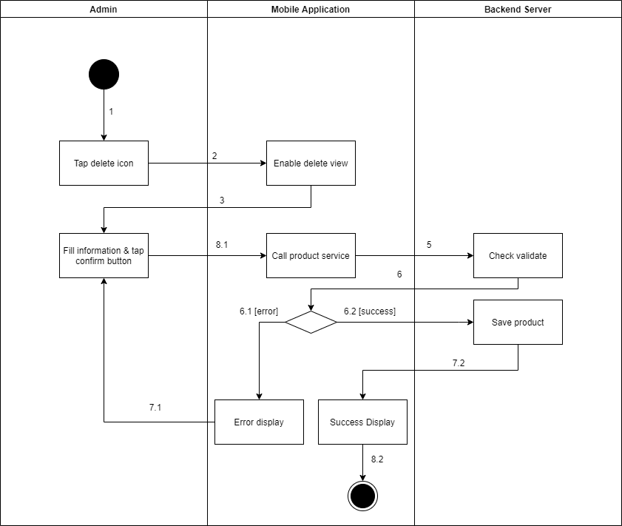

Figure . <Activity Diagram> Delete the product

#### 3.4.14 <Admin> Create the product

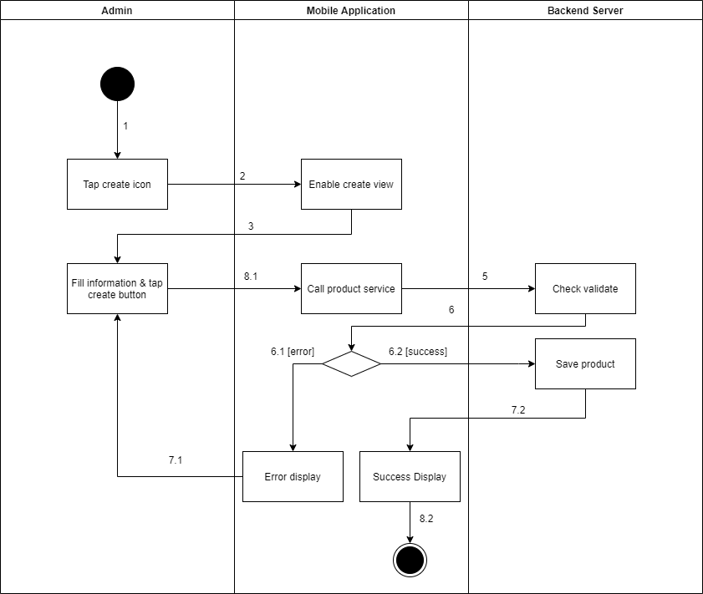

Figure . <Activity Diagram> Create the product

#### 3.4.15 <Admin> Update the camera

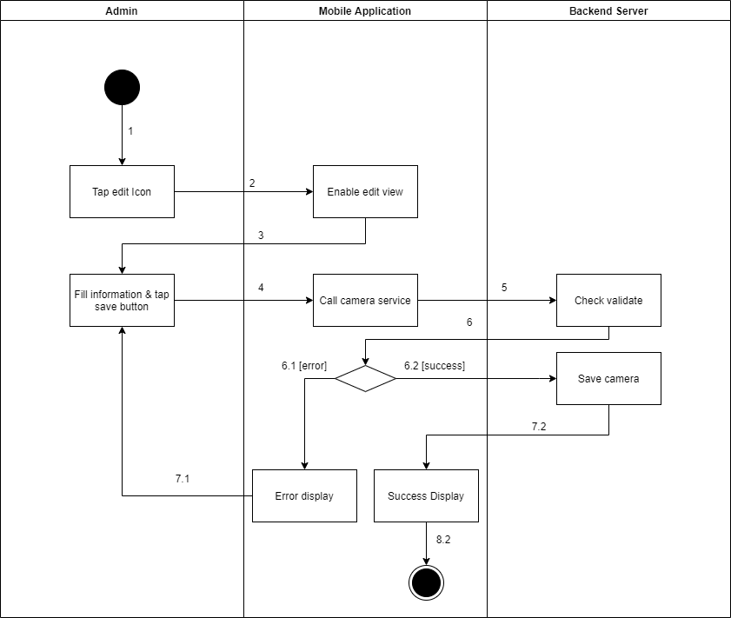

Figure . <Activity Diagram> Update the camera

#### 3.4.16 <Admin> Create the camera

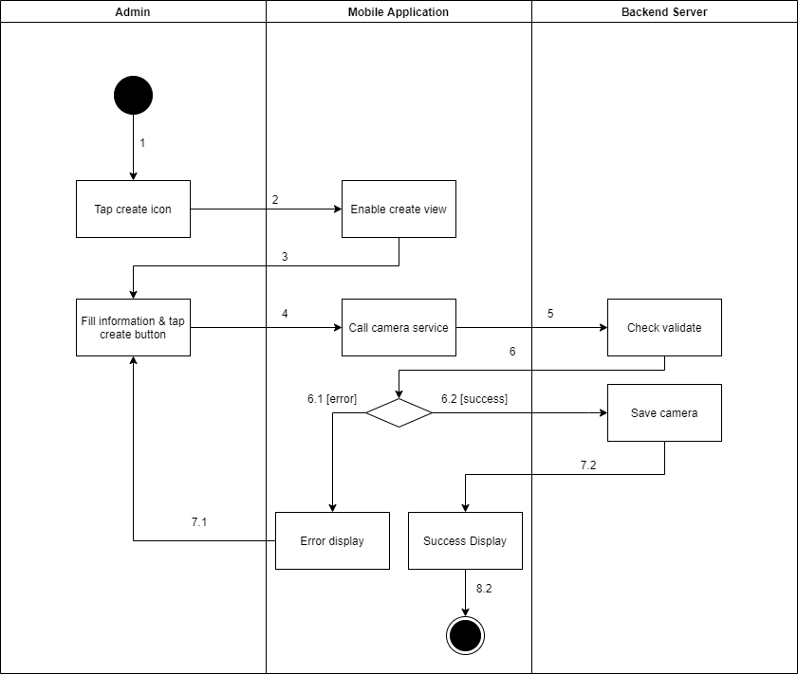

Figure . <Activity Diagram> Create the camera

#### 3.4.17 <Admin> Delete the camera

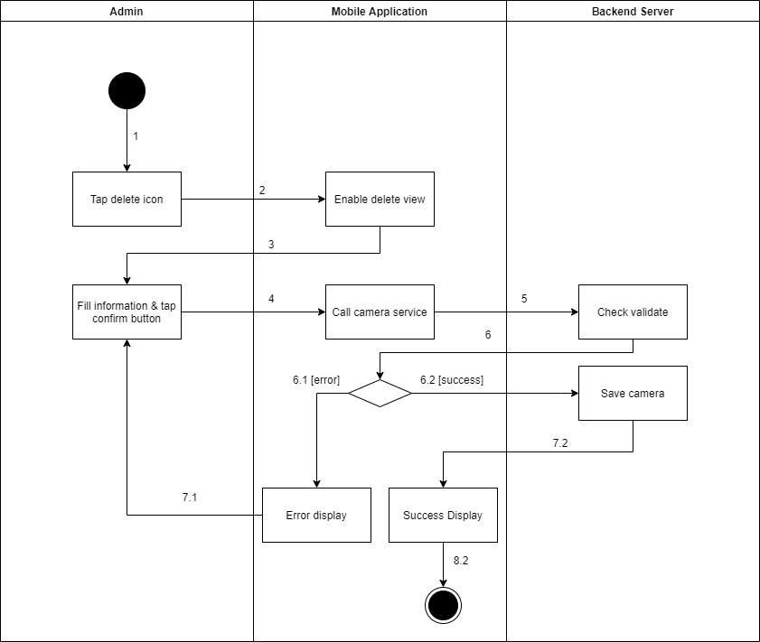

Figure . <Activity Diagram> Delete the camera

#### 3.4.18 <Admin> Update the category

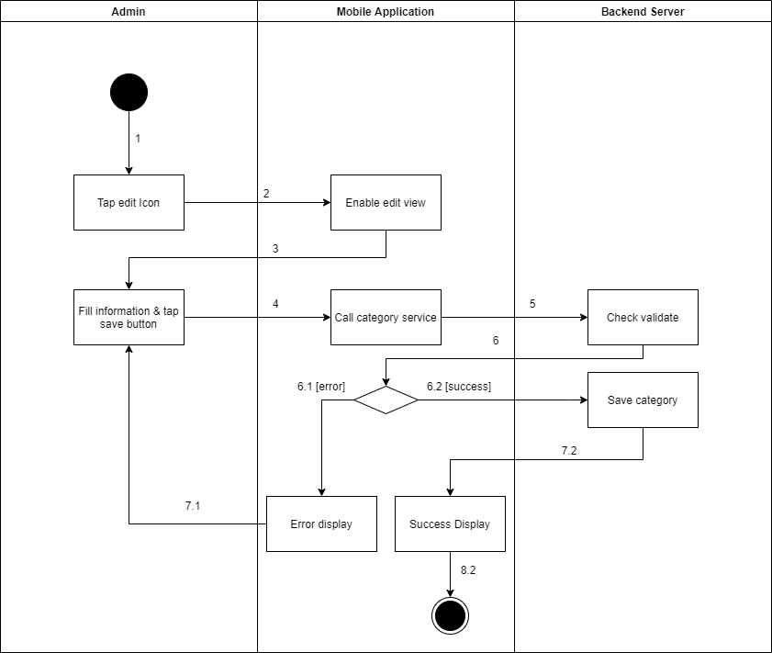

Figure . <Activity Diagram> Update the category

#### 3.4.19 <Admin> Create the category

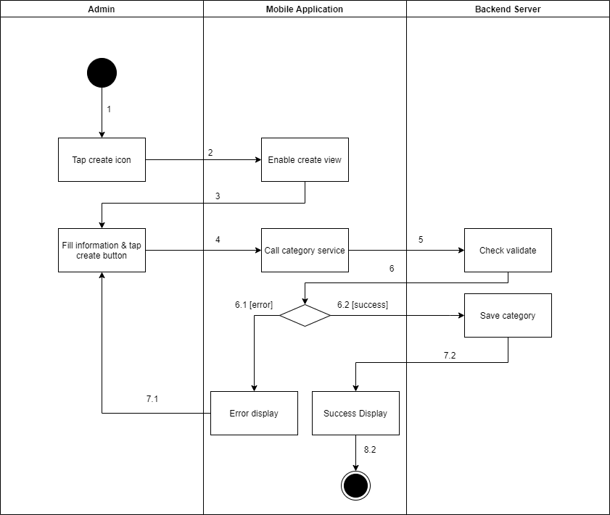

Figure . <Activity Diagram> Create the category

#### 3.4.20 <Manager> Get the shelves

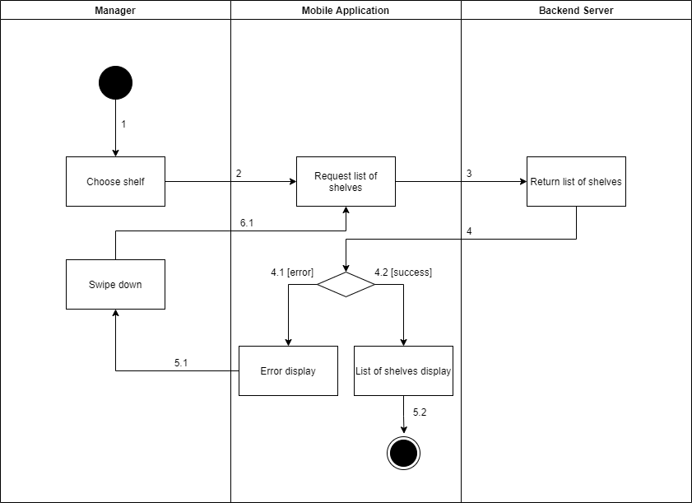

Figure . <Activity Diagram> Get the shelves

#### 3.4.21 <Manager> Get shelf detail

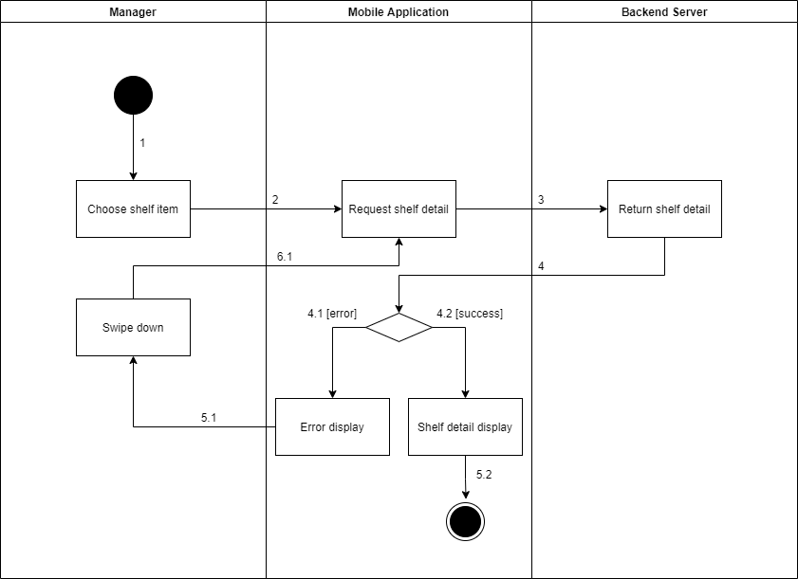

Figure . <Activity Diagram> Get shelf detail

#### 3.4.22 <Manager> Update the shelf

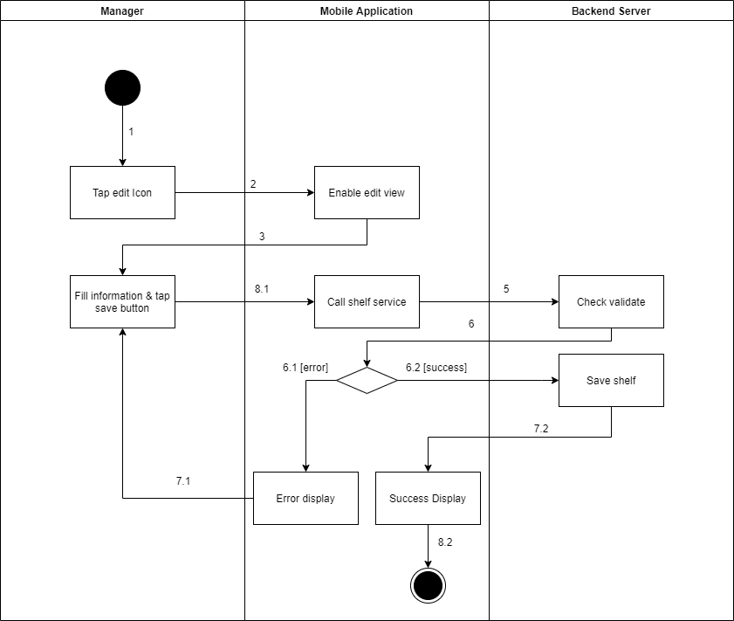

Figure . <Activity Diagram> Update the shelf

#### 3.4.23 <Manager> Delete the shelf

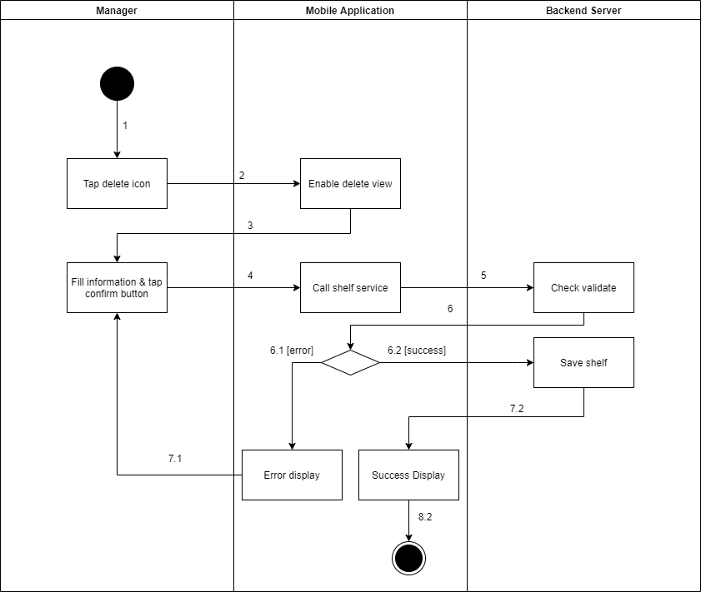

Figure . <Activity Diagram> Delete the shelf

#### 3.4.24 <Manager> Create the shelf

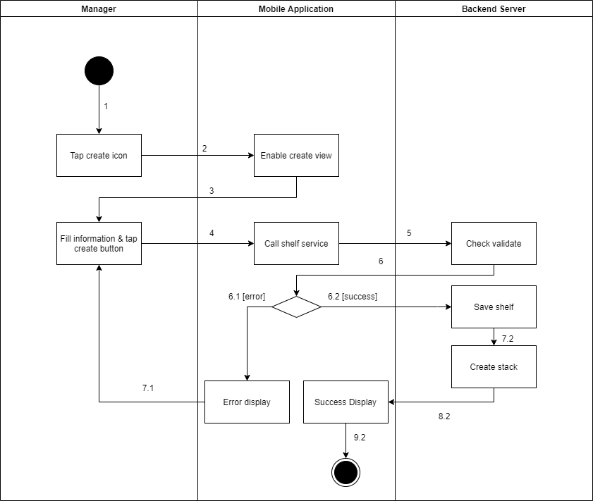

Figure . <Activity Diagram> Create the shelf

#### 3.4.25 <Manager> Get the stacks

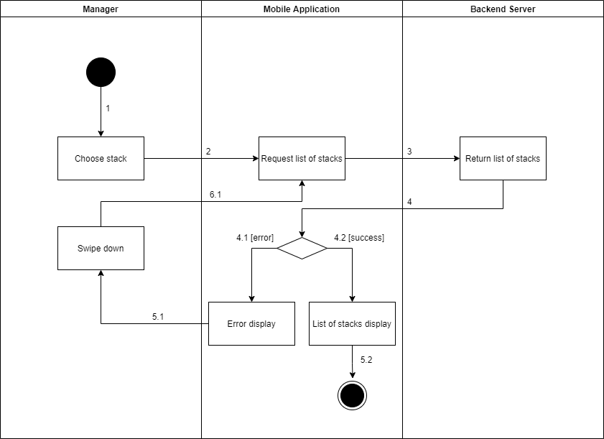

Figure . <Activity Diagram> Get the stacks

#### 3.4.26 <Manager> Get stack detail

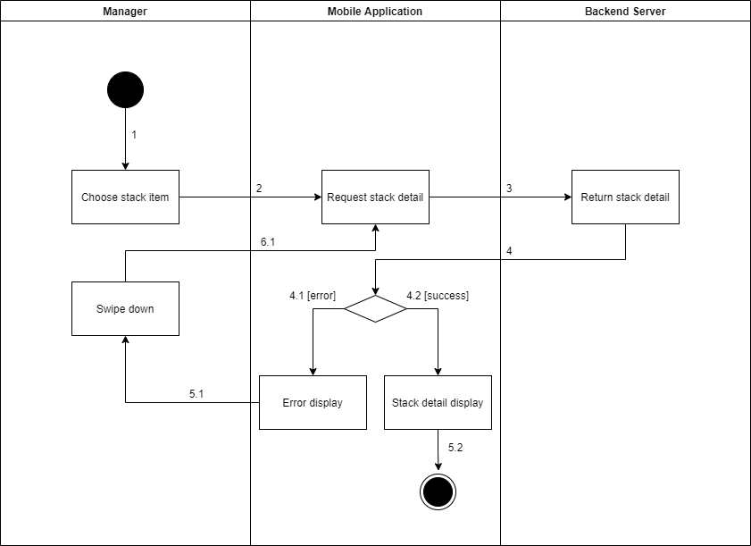

Figure . <Activity Diagram> Get stack detail

#### 3.4.27 <Manager> Update the stack

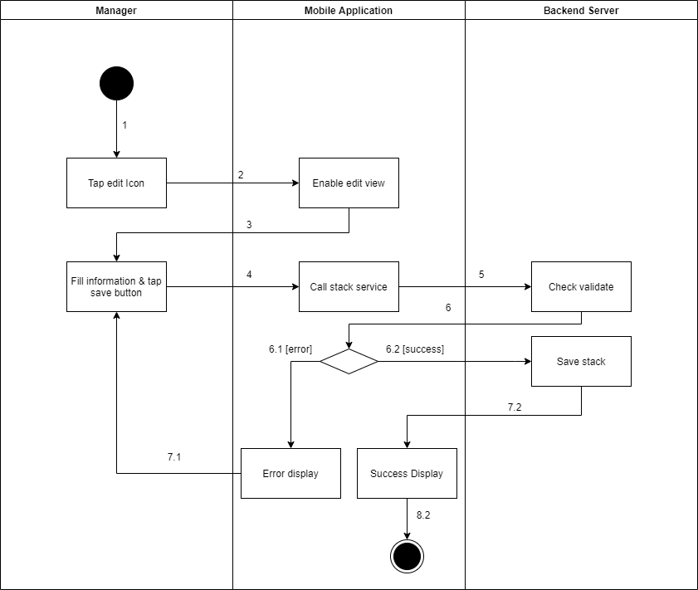

Figure . <Activity Diagram> Update the stack

#### 3.4.28 <Manager> Delete the stack

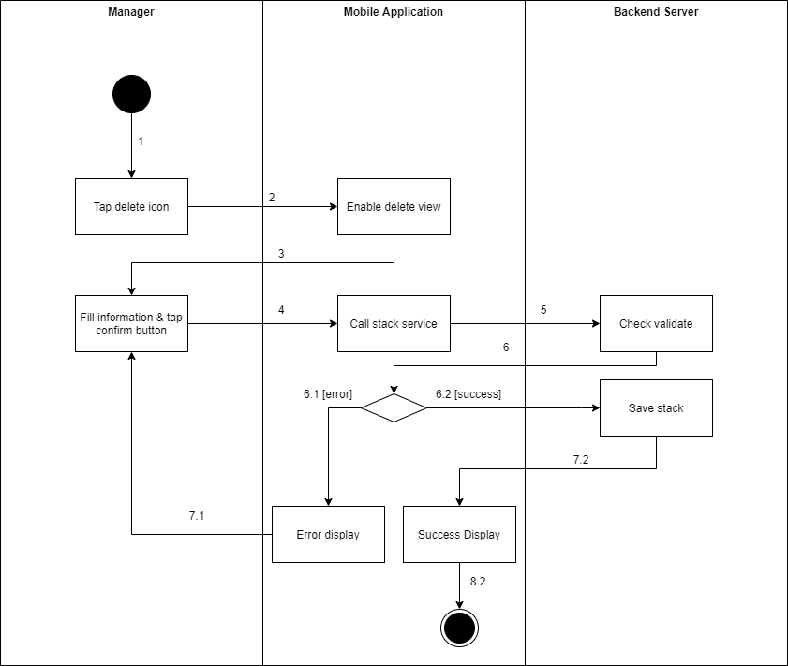

Figure . <Activity Diagram> Delete the stack

#### 3.4.29 <Authenticated User> Logout

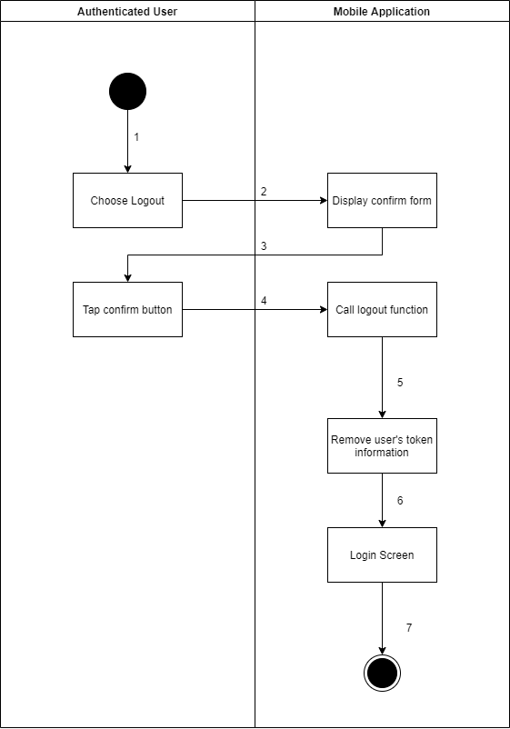

Figure . <Activity Diagram> Logout

#### 3.4.30 <Authenticated User> Change account's password

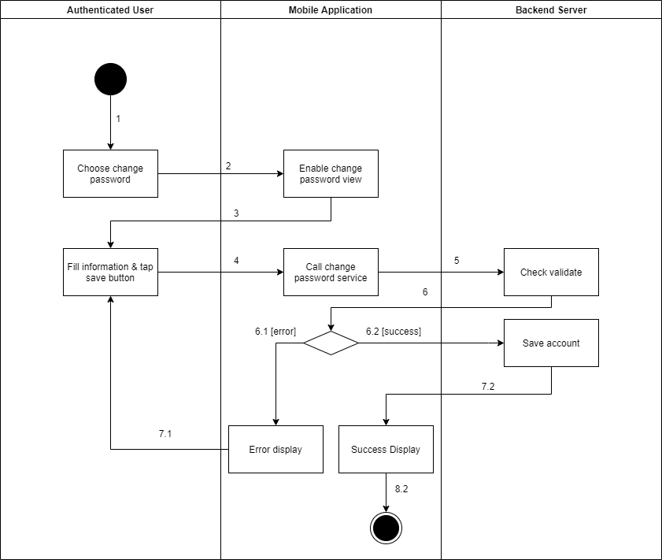

Figure . <Activity Diagram> Change account's password

#### 3.4.31 <Authenticated User> Get the report

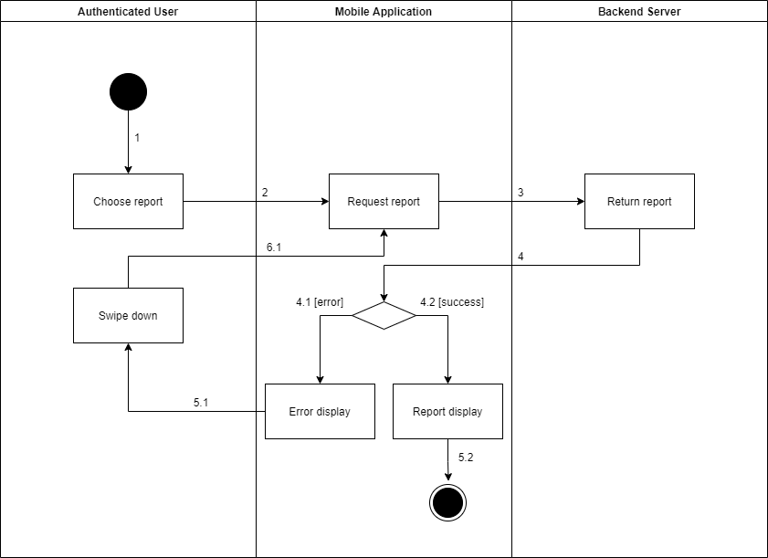

Figure . <Activity Diagram> Get the report

#### 3.4.32 <Authenticated User> Get the video

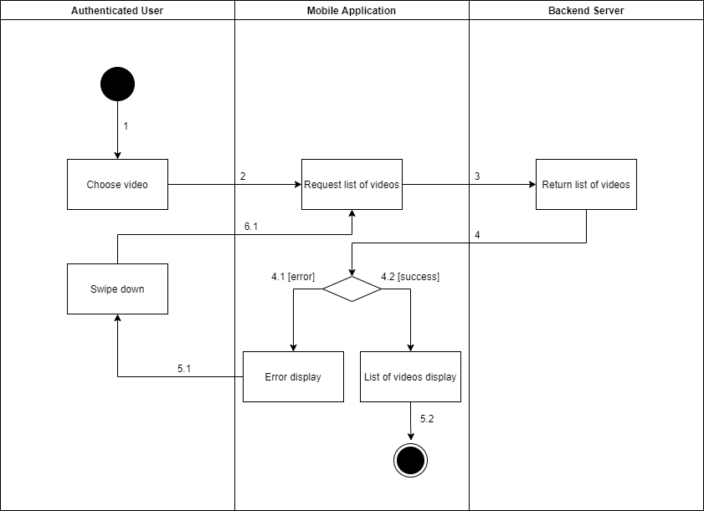

Figure . <Activity Diagram> Get the video

#### 3.4.33 <Authenticated User> Get the products

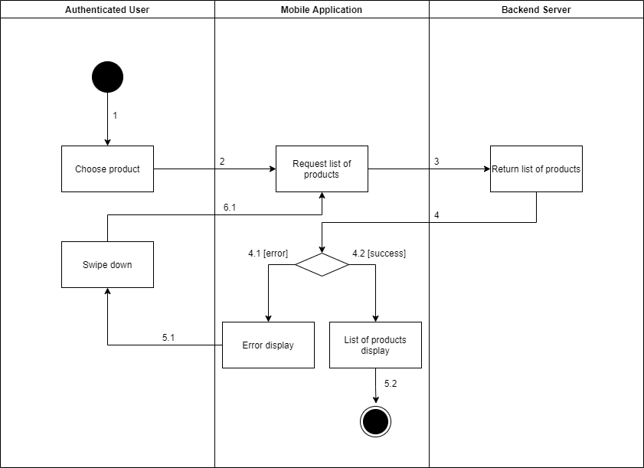

Figure . <Activity Diagram> Get the products

#### 3.4.34 <Authenticated User> Get product detail

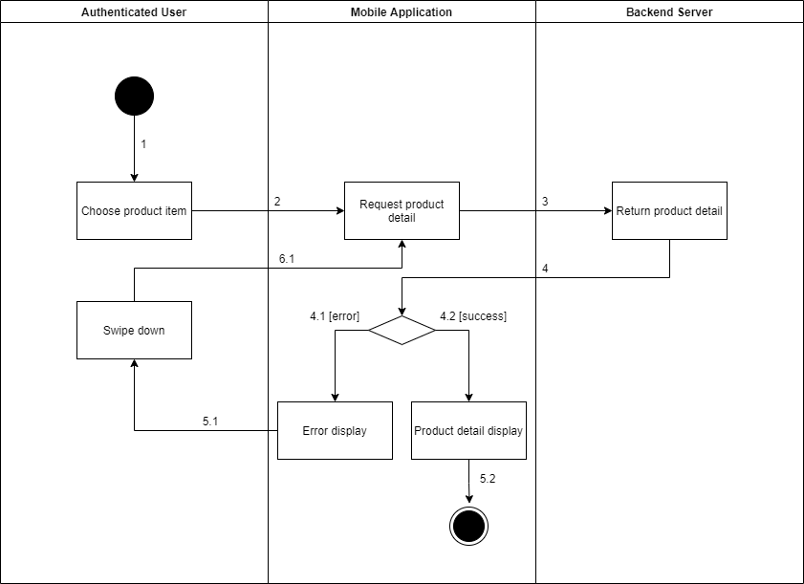

Figure . <Activity Diagram> Get product detail

#### 3.4.35 <Authenticated User> Get the categories

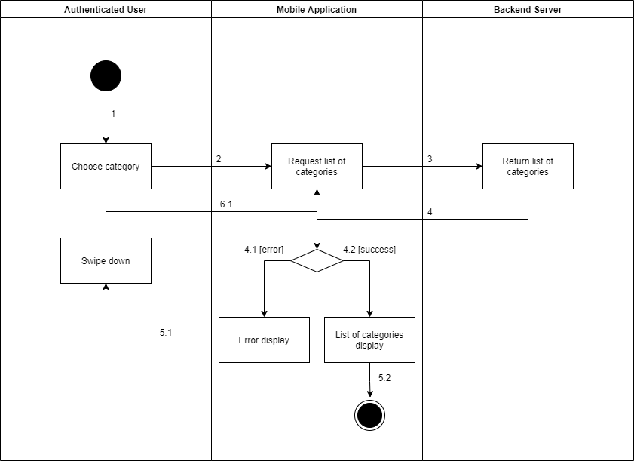

Figure . <Activity Diagram> Get the categories

#### 3.4.36 <Authenticated User> Get category detail

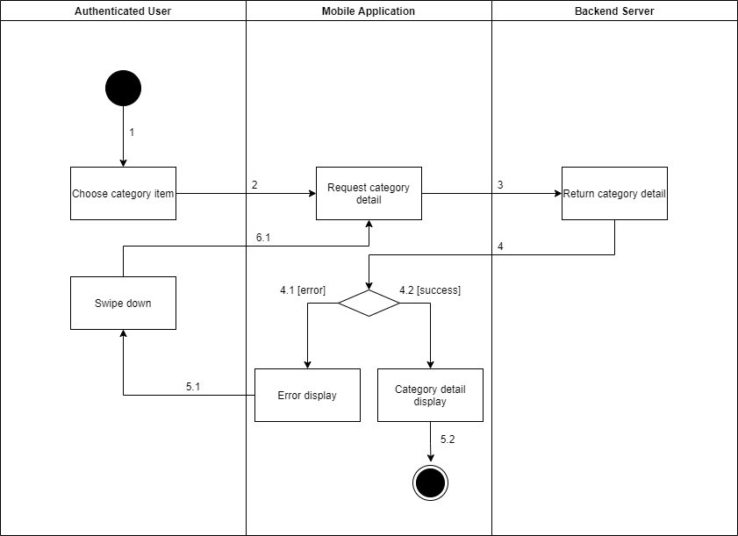

Figure . <Activity Diagram> Get category detail

#### 3.4.37 <Authenticated User> Get camera detail

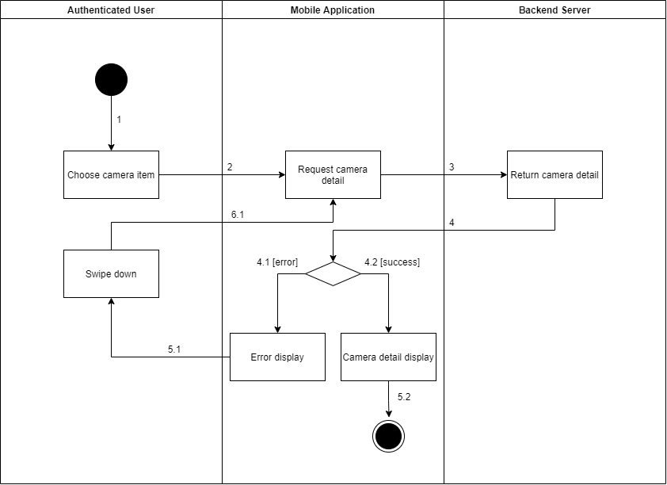

Figure . <Activity Diagram> Get camera detail

#### 3.4.38 <Authenticated User> Get the cameras

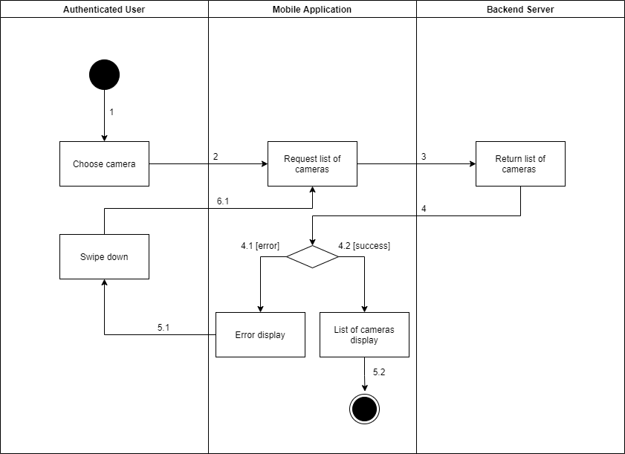

Figure . <Activity Diagram> Get the cameras

## 4. Data & Database Design

### 4.1 Database Design

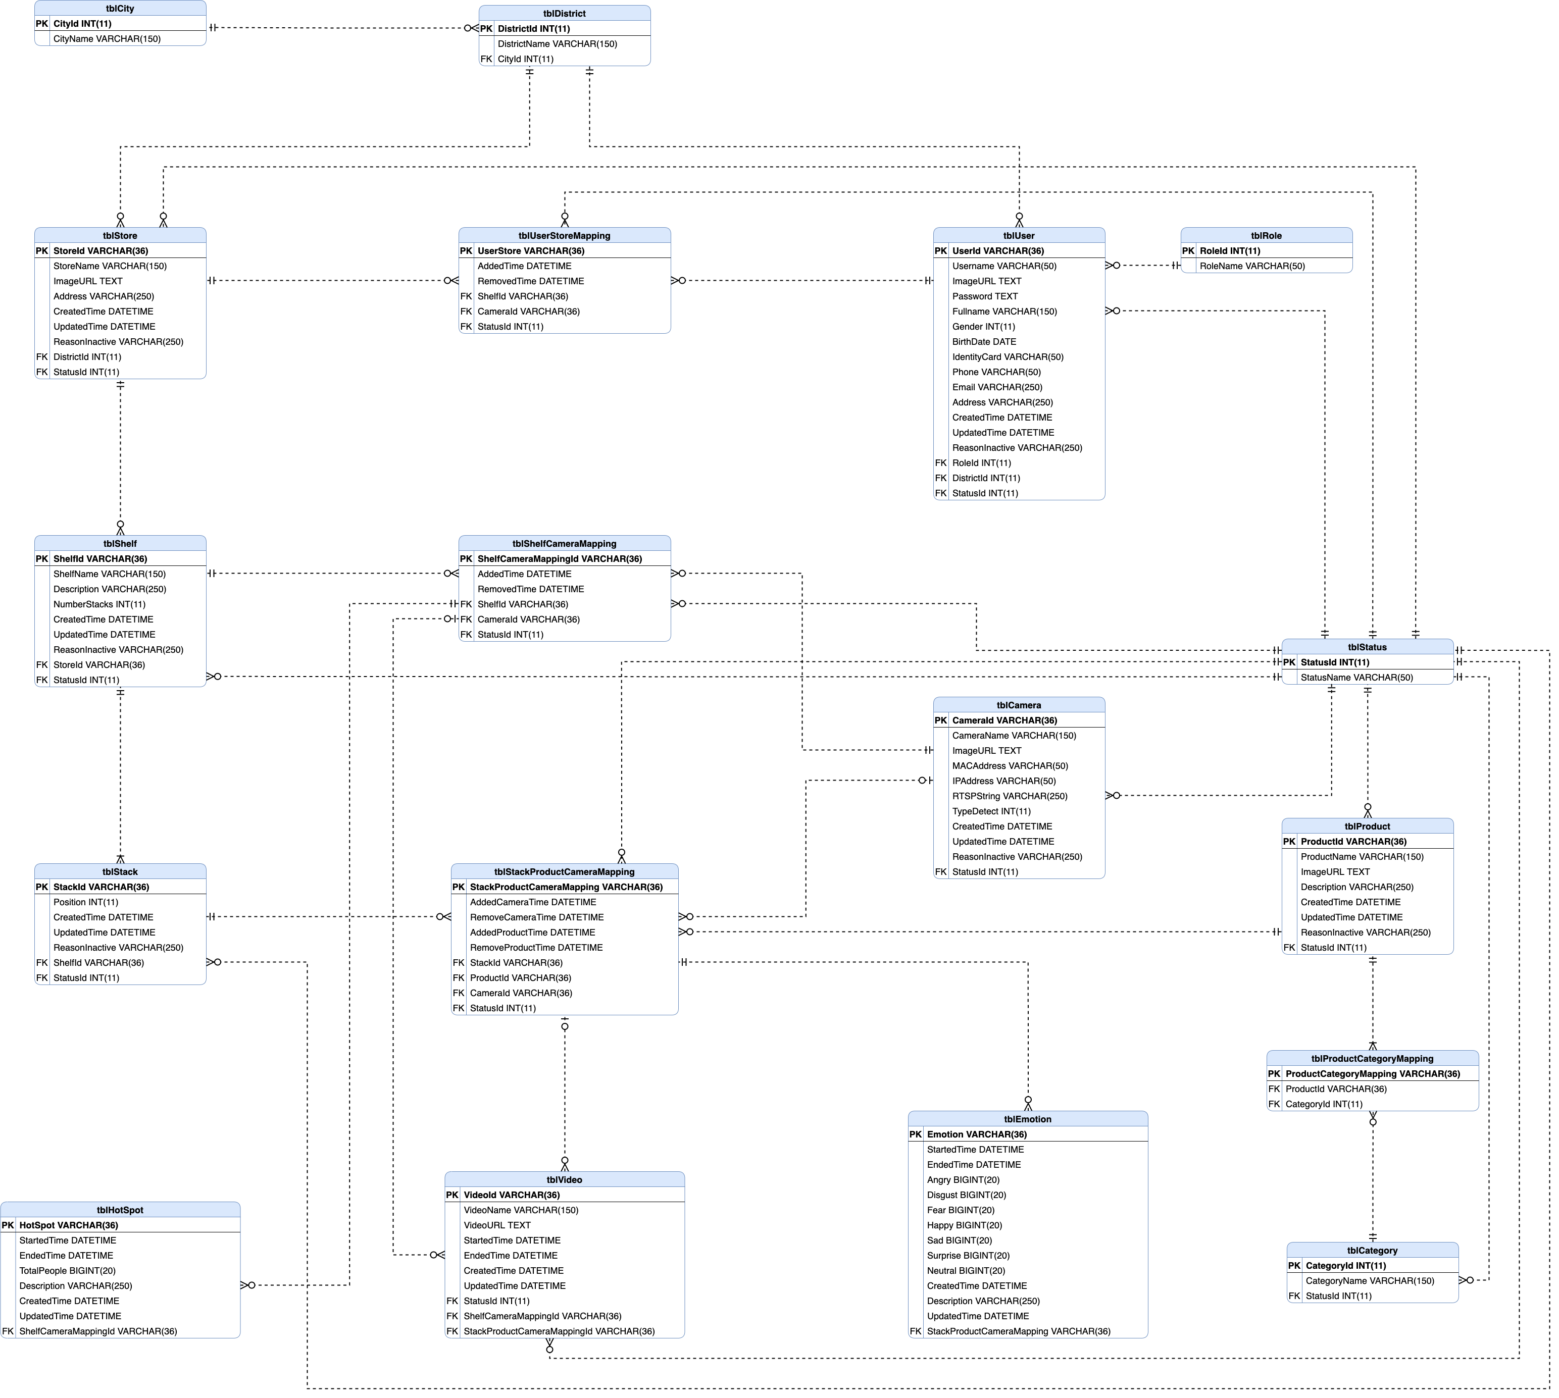

Figure . Database Design

#### 4.1.1 tblCity

Table . <Database Design> tblCity

|  |  |  |  |  |  |  |
| --- | --- | --- | --- | --- | --- | --- |
| **Field name** | **Type** | **Size** | **Unique** | **Not Null** | **PK/FK** | **Notes** |
| CityId | int | 11 | Yes | Yes | PK | Unique identifier of city |
| CityName | varchar | 150 | Yes | Yes |  | Name of city |

#### 4.1.2 tblDistrict

Table 134. <Database Design> tblDistrict

|  |  |  |  |  |  |  |
| --- | --- | --- | --- | --- | --- | --- |
| **Field name** | **Type** | **Size** | **Unique** | **Not Null** | **PK/FK** | **Notes** |
| DistrictId | int | 11 | Yes | Yes | PK | Unique identifier of district |
| CityId | int | 11 | Yes | Yes | FK | Unique identifier of city |
| DistrictName | varchar | 150 | No | Yes |  | Name of district |

#### 4.1.3 tblRole

Table 135. <Database Design> tblRole

|  |  |  |  |  |  |  |
| --- | --- | --- | --- | --- | --- | --- |
| **Field name** | **Type** | **Size** | **Unique** | **Not Null** | **PK/FK** | **Notes** |
| RoleId | int | 11 | Yes | Yes | PK | Unique identifier of role |
| RoleName | varchar | 50 | Yes | Yes |  | Name of role |

#### 4.1.4 tblStatus

Table 136. <Database Design> tblStatus

|  |  |  |  |  |  |  |
| --- | --- | --- | --- | --- | --- | --- |
| **Field name** | **Type** | **Size** | **Unique** | **Not Null** | **PK/FK** | **Notes** |
| StatusId | int | 11 | Yes | Yes | PK | Unique identifier of status |
| StatusName | varchar | 50 | Yes | Yes |  | Name of status |

#### 4.1.5 tblUser

Table 137. <Database Design> tblUser

|  |  |  |  |  |  |  |
| --- | --- | --- | --- | --- | --- | --- |
| **Field name** | **Type** | **Size** | **Unique** | **Not Null** | **PK/FK** | **Notes** |
| UserId | varchar | 36 | Yes | Yes | PK | Unique identifier of user |
| ImageURL | text |  | No | No |  | Image URL of user |
| UserName | varchar | 50 | Yes | Yes |  | Username of user |
| Password | text |  | No | Yes |  | Password of user |
| Fullname | varchar | 150 | No | Yes |  | Name of user |
| Gender | int | 11 | No | Yes |  | Gender of user |
| BirthDate | date |  | No | Yes |  | Day of birth of user |
| IdentifyCard | varchar | 50 | Yes | Yes |  | Identify card of user |
| Phone | varchar | 50 | Yes | Yes |  | Phone number of user |
| Email | varchar | 250 | Yes | Yes |  | Email of user |
| Address | varchar | 250 | No | Yes |  | Address of user |
| CreatedTime | datetime |  | No | Yes |  | Created date of user |
| UpdatedTime | datetime |  | No | No |  | Last modified date of user |
| ReasonInactive | varchar | 250 | No | No |  | Reason inactive of user |
| RoleId | int | 11 | No | Yes | FK | Unique identifier of role |
| DistrictId | int | 11 | No | Yes | FK | Unique identifier of district |
| StatusId | int | 11 | No | Yes | FK | Unique identifier of status |

#### 4.1.6 tblStore

Table 138. <Database Design> tblStore

|  |  |  |  |  |  |  |
| --- | --- | --- | --- | --- | --- | --- |
| **Field name** | **Type** | **Size** | **Unique** | **Not Null** | **PK/FK** | **Notes** |
| StoreId | varchar | 36 | Yes | Yes | PK | Unique identifier of store |
| StoreName | varchar | 150 | Yes | Yes |  | Name of store |
| ImageURL | text |  | No | No |  | Image URL of store |
| Address | varchar | 250 | No | Yes |  | Address of store |
| CreatedTime | datetime |  | No | Yes |  | Created date of store |
| UpdatedTime | datetime |  | Yes | No |  | Last modified date of store |
| ReasonInactive | varchar | 250 | No | Yes |  | Reason Inactive of store |
| DistrictId | int | 11 | No | Yes | FK | Unique identifier of district |
| StatusId | int | 11 | No | Yes | FK | Unique identifier of status |

#### 4.1.7 tblCamera

Table 139. <Database Design> tblCamera

|  |  |  |  |  |  |  |
| --- | --- | --- | --- | --- | --- | --- |
| **Field name** | **Type** | **Size** | **Unique** | **Not Null** | **PK/FK** | **Notes** |
| CameraId | varchar | 36 | Yes | Yes | PK | Unique identifier of camera |
| CameraName | varchar | 150 | Yes | Yes |  | Name of camera |
| ImageURL | text |  | No | No |  | Image of camera |
| MACAddress | varchar | 150 | Yes | Yes |  | MAC address of camera |
| RTSPString | varchar | 150 | Yes | Yes |  | RTSP of camera |
| TypeDetect | int | 11 | No | Yes |  | Type of camera |
| CreatedTime | datetime |  | No | Yes |  | Created date of camera |
| UpdatedTime | datetime |  | No | No |  | Last modified date of camera |
| ReasonInactive | varchar | 250 | No | No |  | Reason inactive of camera |
| StatusId | int | 11 | No | Yes | FK | Unique identifier of status |
| IPAddress | varchar | 150 | Yes | Yes |  | IP address of camera |

#### 4.1.8 tblCategory

Table 140. <Database Design> tblCategory

|  |  |  |  |  |  |  |
| --- | --- | --- | --- | --- | --- | --- |
| **Field name** | **Type** | **Size** | **Unique** | **Not Null** | **PK/FK** | **Notes** |
| CategoryId | int | 11 | Yes | Yes | PK | Unique identifier of category |
| CategoryName | varchar | 50 | Yes | Yes |  | Name of category |
| StatusId | int | 11 | No | Yes | FK | Unique identifier of status |

#### 4.1.9 tblEmotion

Table 141. <Database Design> tblEmotion

|  |  |  |  |  |  |  |
| --- | --- | --- | --- | --- | --- | --- |
| **Field name** | **Type** | **Size** | **Unique** | **Not Null** | **PK/FK** | **Notes** |
| EmotionId | varchar | 36 | Yes | Yes | PK | Unique identifier of emotion |
| StartedTime | datetime |  | No | Yes |  | Time started of video |
| EndedTime | datetime |  | No | Yes |  | Time ended of video |
| Angry | bigint | 20 | No | Yes |  | Number of angry |
| Disgust | bigint | 20 | No | Yes |  | Number of disgusted |
| Fear | bigint | 20 | No | Yes |  | Number of feared |
| Happy | bigint | 20 | No | Yes |  | Number of happy |
| Sad | bigint | 20 | No | Yes |  | Number of sad |
| Surprise | bigint | 20 | No | Yes |  | Number of surprised |
| Neutral | bigint | 20 | No | Yes |  | Number of neutral |
| Description | varchar | 250 | No | No |  | Description of emotion |
| StackProductCameraMappingId | varchar | 36 | No | Yes | FK | Unique identifier of stack product camera mapping |
| CreatedTime | datetime |  | No | Yes |  | Created date of emotion |
| UpdatedTime | datetime |  | No | No |  | Last modified date of emotion |

#### 4.1.10 tblHotSpot

Table 142. <Database Design> tblHotSpot

|  |  |  |  |  |  |  |
| --- | --- | --- | --- | --- | --- | --- |
| **Field name** | **Type** | **Size** | **Unique** | **Not Null** | **PK/FK** | **Notes** |
| HotspotId | varchar | 36 | Yes | Yes | PK | Unique identifier of hot spot |
| StartedTime | datetime |  | No | Yes |  | Time started of video |
| EndedTime | datetime |  | No | Yes |  | Time ended of video |
| TotalPeople | bigint | 20 | No | Yes |  | Number of customers |
| Description | varchar | 250 | No | No |  | Description of hot spot |
| ShelfCameraMappingId | varchar | 36 | No | Yes | FK | Unique identifier of shelf camera mapping |
| CreatedTime | datetime |  | No | Yes |  | Created date of hot spot |
| UpdatedTime | datetime |  | No | No |  | Last modified date of hot spot |

#### 4.1.11 tblProduct

Table 143. <Database Design> tblProduct

|  |  |  |  |  |  |  |
| --- | --- | --- | --- | --- | --- | --- |
| **Field name** | **Type** | **Size** | **Unique** | **Not Null** | **PK/FK** | **Notes** |
| ProductId | varchar | 36 | Yes | Yes | PK | Unique identifier of product |
| ProductName | varchar | 150 | Yes | Yes |  | Name of product |
| ImageURL | text |  | No | No |  | Image URL of product |
| Description | varchar | 250 | No | No |  | Description of product |
| CreatedTime | datetime |  | No | Yes |  | Created date of product |
| UpdatedTime | datetime |  | No | No |  | Last modified date of product |
| ReasonInactive | varchar | 250 | No | No |  | Reason inactive of product |
| StatusId | int | 11 | No | Yes | FK | Unique identifier of status |

#### 4.1.12 tblProductCategoryMapping

Table 144. <Database Design> tblProductCategoryMapping

|  |  |  |  |  |  |  |
| --- | --- | --- | --- | --- | --- | --- |
| **Field name** | **Type** | **Size** | **Unique** | **Not Null** | **PK/FK** | **Notes** |
| ProductCategoryMappingId | varchar | 36 | Yes | Yes | PK | Unique identifier of product category mapping |
| ProductId | varchar | 36 | No | Yes | FK | Unique identifier of product |
| CategoryId | int | 11 | No | Yes | FK | Unique identifier of category |

#### 4.1.13 tblShelf

Table 145. <Database Design> tblShelf

|  |  |  |  |  |  |  |
| --- | --- | --- | --- | --- | --- | --- |
| **Field name** | **Type** | **Size** | **Unique** | **Not Null** | **PK/FK** | **Notes** |
| ShelfId | varchar | 36 | Yes | Yes | PK | Unique identifier of shelf |
| ShelfName | varchar | 150 | No | Yes |  | Name of shelf |
| Description | varchar | 250 | No | Yes |  | Description of shelf |
| NumberStacks | int | 11 | No | Yes |  | Number stack of shelf |
| CreatedTime | datetime |  | No | Yes |  | Created date of shelf |
| UpdatedTime | datetime |  | No | No |  | Last modified date of shelf |
| ReasonInactive | varchar | 250 | Yes | No |  | Reason inactive of shelf |
| StoreId | varchar | 36 | No | Yes | FK | Unique identifier of store |
| StatusId | Int | 11 | No | Yes | FK | Unique identifier of status |

#### 4.1.14 tblShelfCameraMapping

Table 146. <Database Design> tblShelfCameraMapping

|  |  |  |  |  |  |  |
| --- | --- | --- | --- | --- | --- | --- |
| **Field name** | **Type** | **Size** | **Unique** | **Not Null** | **PK/FK** | **Notes** |
| ShelfCameraMappingId | varchar | 36 | Yes | Yes | PK | Unique identifier of shelf camera mapping |
| AddedTime | datetime |  | No | Yes |  | Added time of camera |
| RemovedTime | datetime |  | No | No |  | Removed time of camera |
| ShelfId | varchar | 36 | No | Yes | FK | Unique identifier of shelf |
| CameraId | varchar | 36 | No | Yes | FK | Unique identifier of camera |
| StatusId | int | 11 | No | Yes | FK | Unique identifier of status |

#### 4.1.15 tblStack

Table 147. <Database Design> tblStack

|  |  |  |  |  |  |  |
| --- | --- | --- | --- | --- | --- | --- |
| **Field name** | **Type** | **Size** | **Unique** | **Not Null** | **PK/FK** | **Notes** |
| StackId | varchar | 36 | Yes | Yes | PK | Unique identifier of stack |
| Position | int | 11 | No | Yes |  | Position of stack |
| CreatedTime | datetime |  | No | Yes |  | Created date of stack |
| UpdatedTime | datetime |  | No | No |  | Last modified date of stack |
| ReasonInactive | varchar | 250 | No | No |  | Reason inactive of stack |
| ShelfId | varchar | 36 | No | Yes | FK | Unique identifier of shelf |
| StatusId | int | 11 | No | Yes | FK | Unique identifier of status |

#### 4.1.16 tblStackProductCameraMapping

Table 148. <Database Design> tblStackProductCameraMapping

|  |  |  |  |  |  |  |
| --- | --- | --- | --- | --- | --- | --- |
| **Field name** | **Type** | **Size** | **Unique** | **Not Null** | **PK/FK** | **Notes** |
| StackProductCameraMappingId | varchar | 36 | Yes | Yes | PK | Unique identifier of stack product camera mapping |
| AddedCameraTime | datetime |  | No | No |  | Added time of camera |
| RemovedCameraTime | datetime |  | No | No |  | Removed time of camera |
| AddedProductTime | datetime |  | No | No |  | Added time of product |
| RemovedProductTime | datetime |  | No | No |  | Removed time of product |
| StackId | varchar | 36 | No | Yes | FK | Unique identifier of stack |
| ProductId | varchar | 36 | No | No | FK | Unique identifier of product |
| CameraId | varchar | 36 | No | No | FK | Unique identifier of camera |
| StatusId | int | 11 | No | Yes | FK | Unique identifier of status |

#### 4.1.17 tblUserStoreMapping

Table 149. <Database Design> tblUserStoreMapping

|  |  |  |  |  |  |  |
| --- | --- | --- | --- | --- | --- | --- |
| **Field name** | **Type** | **Size** | **Unique** | **Not Null** | **PK/FK** | **Notes** |
| UserStoreMappingId | varchar | 36 | Yes | Yes | PK | Unique identifier of user store mapping |
| AddedTime | datetime |  | No | Yes |  | Added time of user |
| RemovedTime | datetime |  | No | No |  | Removed time of user |
| StoreId | varchar | 36 | No | Yes | FK | Unique identifier of store |
| UserId | varchar | 36 | No | Yes | FK | Unique identifier of user |
| StatusId | int | 11 | No | Yes | FK | Unique identifier of status |

#### 4.1.18 tblVideo

Table 150. <Database Design> tblVideo

|  |  |  |  |  |  |  |
| --- | --- | --- | --- | --- | --- | --- |
| **Field name** | **Type** | **Size** | **Unique** | **Not Null** | **PK/FK** | **Notes** |
| VideoId | varchar | 36 | Yes | Yes | PK | Unique identifier of video |
| VideoName | varchar | 150 | No | Yes |  | Name of video |
| VideoURL | text |  | No | Yes |  | URL of video |
| StartedTime | datetime |  | No | Yes |  | Started time of video |
| EndedTime | datetime |  | No | No |  | Ended time of video |
| ShelfCameraMappingId | varchar | 36 | No | No | FK | Unique identifier of shelf camera mapping |
| StackProductCameraMappingId | varchar | 36 | No | No | FK | Unique identifier of stack product camera mapping |
| UpdatedTime | datetime |  | No | No |  | Last modified date of video |
| CreatedTime | datetime |  | No | Yes |  | Created date of video |

## 5. Algorithms & Research

### 5.1 Detect emotion

#### 5.1.1. Problem definition

Import a video and recognize all faces which appear in the video then emotion classification based on facial expression.

#### 5.1.2. Requirement

* Almost all faces have been successfully identified.
* Emotion classification has the least error.

#### 5.1.3. Solution

* We use machine learning to recognize faces and classify emotions. We choose two models: MTCNN (face recognition) and VGG-Face (emotion classification).
* Advantages of MTCNN: using Deep Learning to recognize faces, high accuracy.
* Advantages of VGG-Face: using Deep Learning to emotions classification, high accuracy.

1. **Base Concept**
2. **CNN Architecture**

The CNN architecture is one of the advanced Deep Learning architectures, it simulates how the human brain works through neural neurons to perform some human ability. This architecture is widely used in image recognition with extremely high accuracy. Below is a basic CNN architecture with three main layers that are convolution, pooling, and fully-connected.

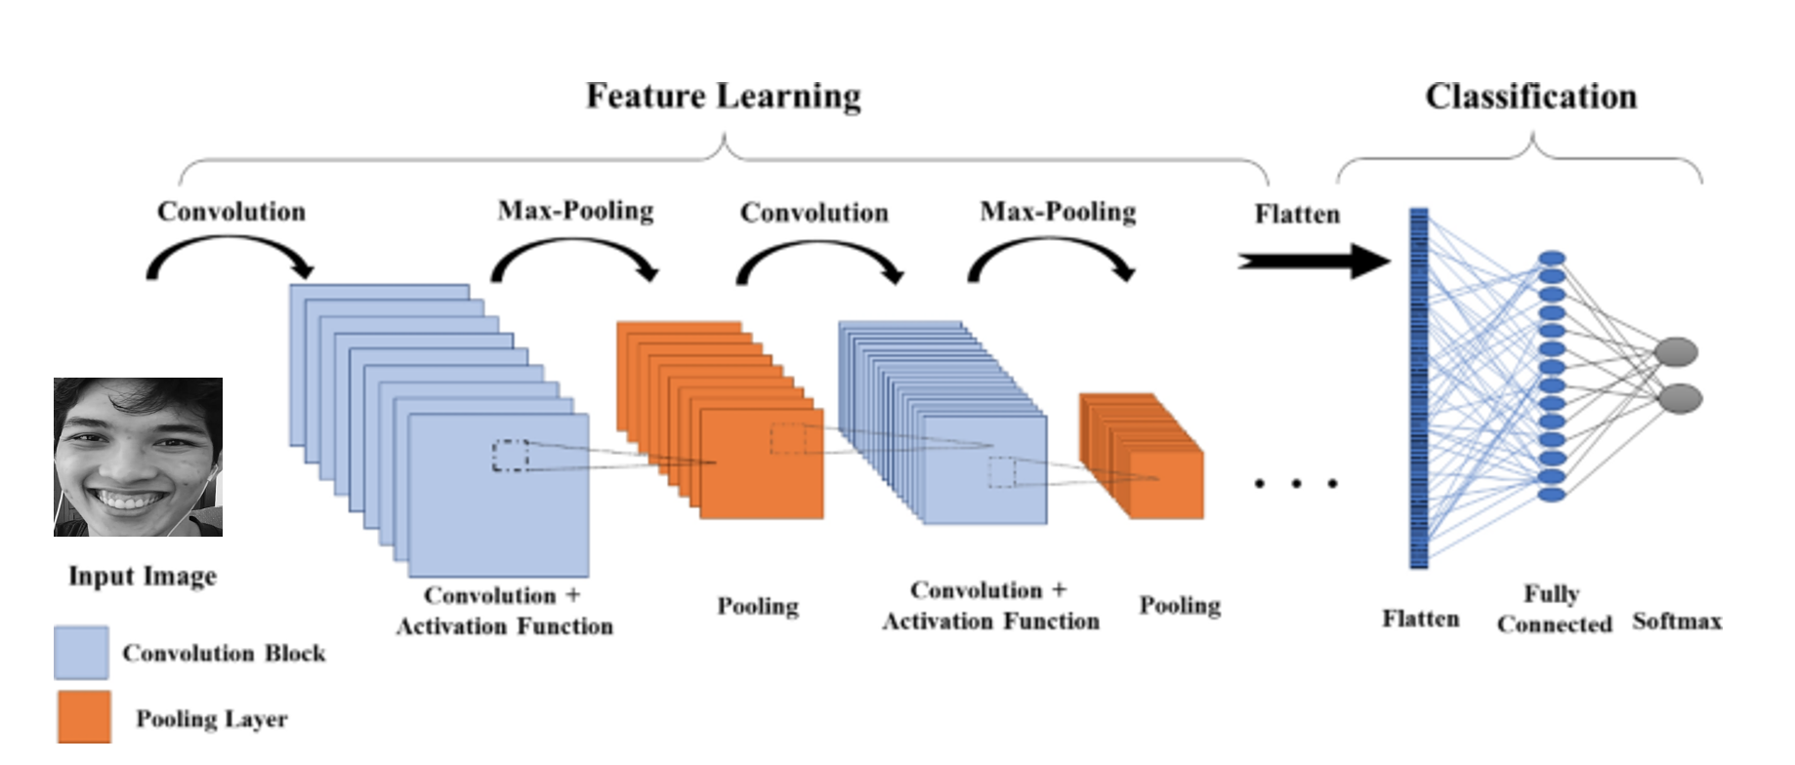

Figure . CNN architecture

* Convolutional Layer: extracts critical features from input images by filter matrix.

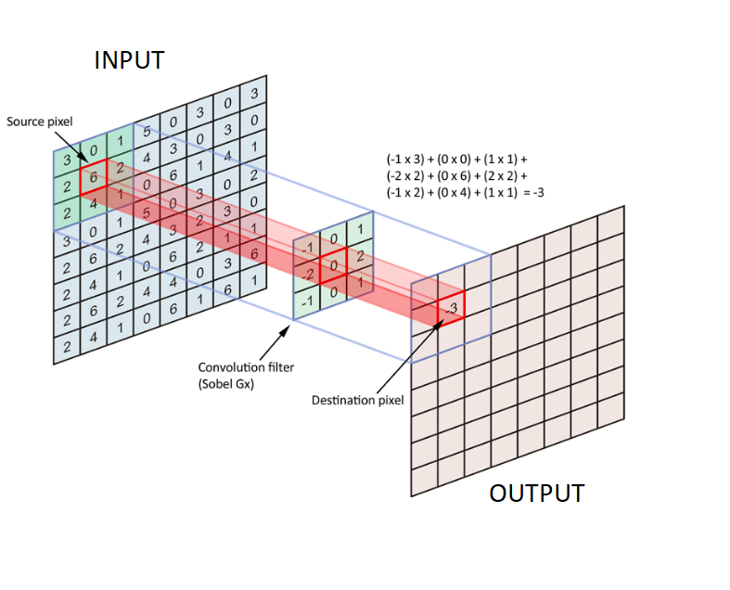

Figure . Extracting critical features in convolution layer

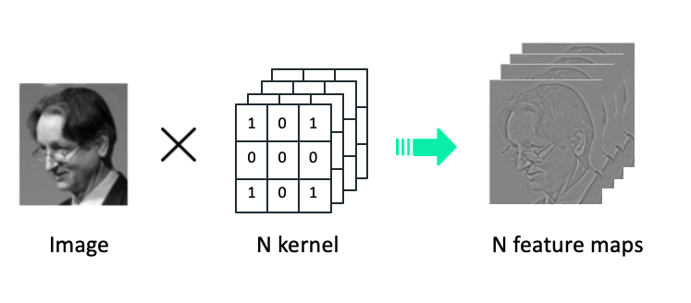

Figure . Convolution example in process

* Pooling layer: provides an approach to down sampling of features to reduces the number of learning parameters and the amount of computation performed in the network.

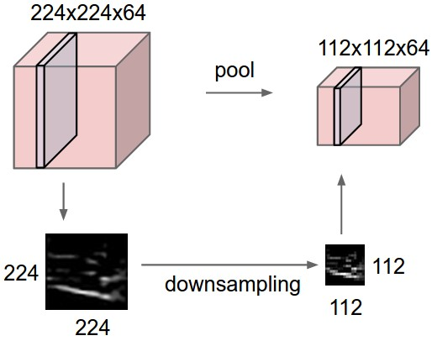

Figure . Pooling example in process

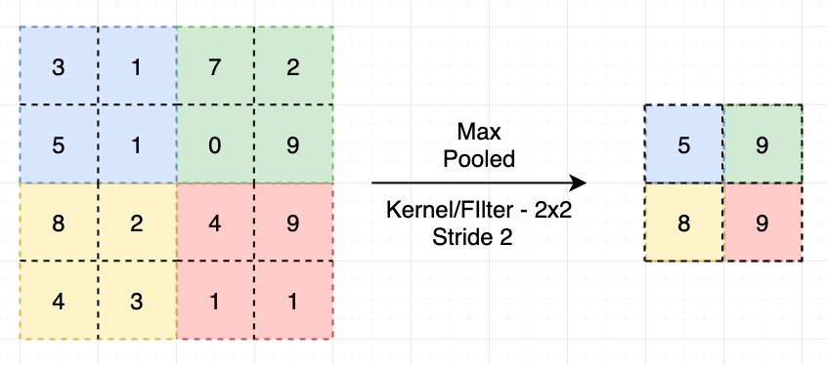

Figure . Max pooling

* Fully-connected layer: The feature maps will be flattened by converting the feature maps to vectors before entering the Fully connected layer. The purpose of this class is to combine the features of an image and produce an output.

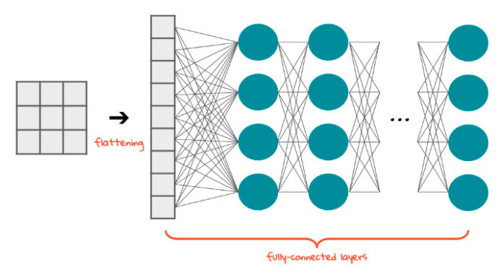

Figure . Fully-connected example in process

In Convolution and Fully-connected layers, several activation functions are often applied with different purposes.

* ReLU (Rectified Linear Unit): removes negative values on feature maps and return those values to 0, these are the parts that do not match the characteristics of the recognized object or in other words remove the neurons that are no longer active.

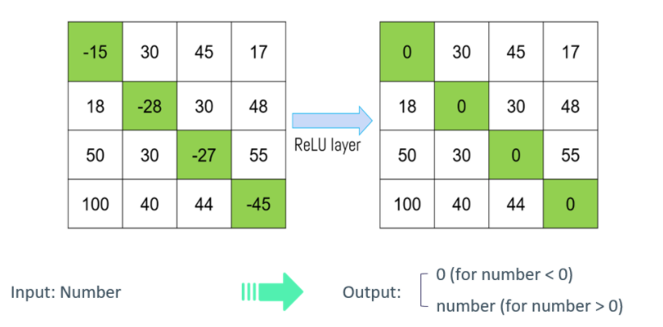

Figure . ReLU example in process

* Softmax: converts the actual values in the nodes in the output layer to the percentage value with which the predicted probability corresponds to the label.

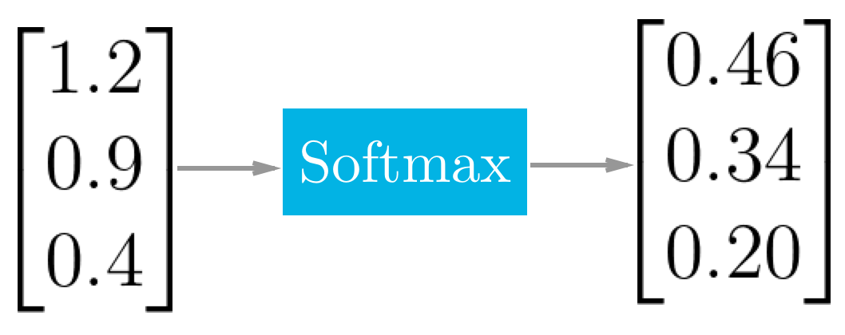

Figure . Softmax example in process

1. **MTCNN Architecture**

MTCNN (Layered Multitasking Network) architecture consists of three CNNs stacked on top of each other: P-NET (Recommended Network), R-NET (Tune Network), O-NET (Output Network).

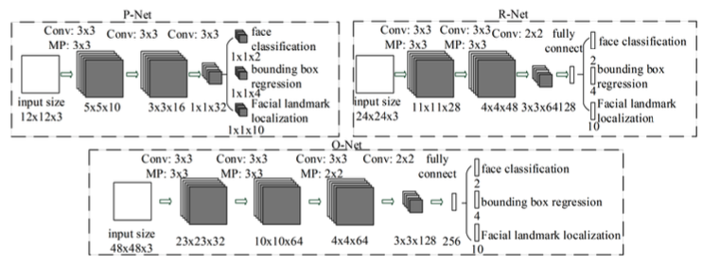

Figure . MTCNN architecture

The first step is to take the image and resize it to different scales in order to build an image pyramid, which is the input of the following three-stage cascaded network.

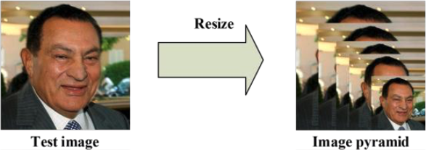

Figure . Resizing image

* Stage 1: Feeding the image into P-Net are obtain candidate windows and their bounding box regression vectors. Then using estimated bounding box regression vectors to calibrate the candidates and use a non-maximum suppression (NMS) to merge highly duplicated candidates.

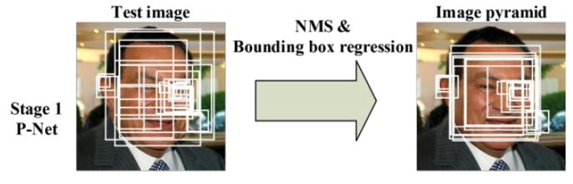

Figure . Stage 1 example process

* Stage 2: All candidates are fed to R-Net which further rejects a large number of false candidates, performs calibration with bounding box regression, and NMS candidate merge.

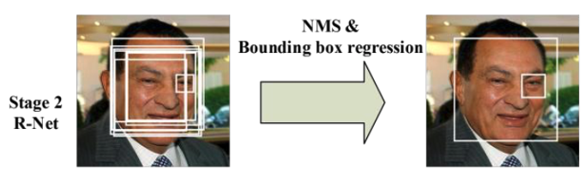

Figure . Stage 2 example process

* Stage 3: All candidates are fed to O-Net which aims to describe the face in more details.

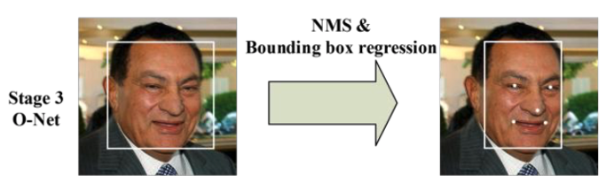

Figure . Stage 3 example process

1. **VGG-Face Architecture**

The VGG-Face using CNN implementation based on VGG-Very-Deep 16 (VGG-16) CNN architecture on the labelled faces in the Wild and the YouTube faces dataset. The purpose of the VGG-Face model is to recognize celebrities so for the purpose of classifying emotions by percentage, we modify the last layer to a fully-connected layer with softmax activation function.

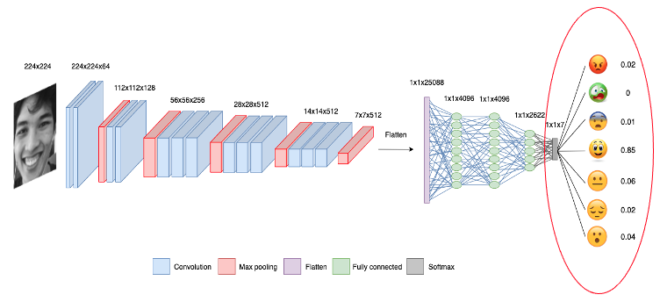

Figure . Modified VGG-Face model architecture

1. **Application**

CFFE system applies emotion classification including the following steps:

* Step 1: Read frames from an input video. However, human emotions change little across frames, so we only take certain frames for analysis.

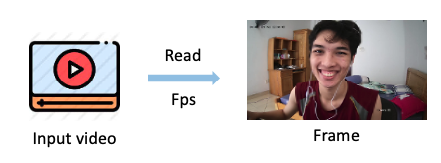

Figure . Step 1 in emotion classification

* Step 2: Feed frames into the MTCNN model for face recognition. We will remove faces with less than 95% accuracy.

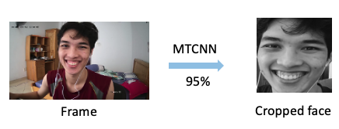

Figure . Step 2 in emotion classification

* Step 3: Feeding the remaining cropped face into the VGG-Face model to classify emotions according to the probability of each emotion label.

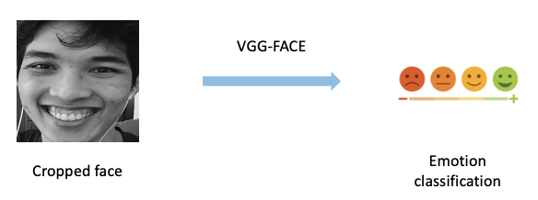

Figure . Step 3 in emotion classification

* Step 4: We will label emotion the perception by getting the highest prediction probability to compare with “confidence” variable (CFFE system is setting to 50%). Predictions that have probability less than "confidence" variable will be labelled "Unknown".

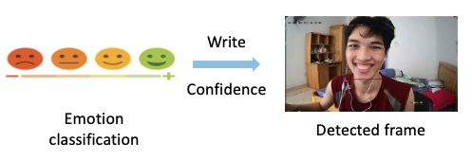

Figure . Step 4 in emotion classification

* Step 5: Save analyzed video and results.

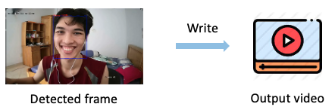

Figure . Step 5 in emotion classification

1. **Prepare data and train process**

* Data augmentation: Using methods such as flipping, increasing and decreasing the brightness, rotating, scaling ... before training model to increase the accuracy of the model's prediction under different conditions.

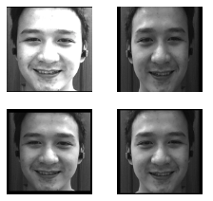

Figure . Data augmentation

* Dataset:
  + Data train: 28688 images (280 images of our members + Fer2013 dataset)
  + Data test: 7275 images (70 images of our members + FER2013 dataset)
* Train 32 epochs in 6 hours.
* Data features: An image contains 1 face corresponding to 7 types of emotions



Figure . Single image

1. **Evaluate Model**

* We evaluate model base on accuracy, loss.
* Accuracy: is the count of predictions where the predicted value is equal to the true value.
$$Accuracy = \frac{Number of correct predictions}{Total number of predictions}$$

* Loss: takes into account the probabilities or uncertainty of a prediction based on how much the prediction varies from the true value.

$$Loss = -\sum_{i=1}^{n}{\sum_{j=1}^{m}{y_{i,j}\log_{e}{(p_{i,j})}}}$$

In there,

$n$: Number of data points

$m$: Number of classes

$y_{i,j}$: Correct label

$p_{i,j}$: Prediction label

* Evaluate MTCNN mode

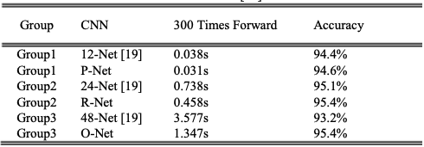

Figure . Evaluate MTCNN model

*Source:* [*https://arxiv.org/abs/1604.02878*](https://arxiv.org/abs/1604.02878)

MTCNN model contains 3 CNNs: P-Net, R-Net and O-Net. So, its accuracy will be calculated as follows:

$$Accuracy of MTCNN model=94.6\% * 95.4\% * 95.4\% = 86.09\%$$

* Evaluate VGG-Face model

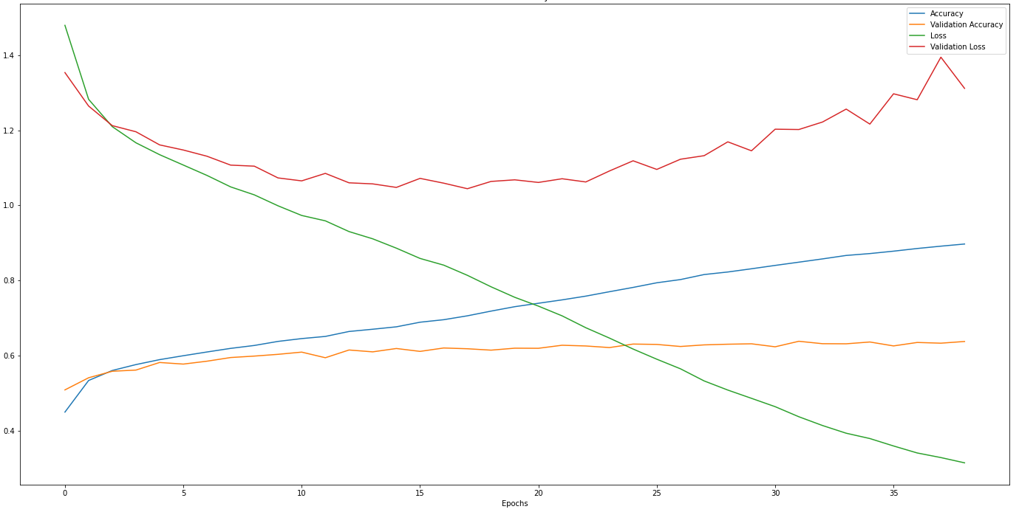

Figure . Evaluate VGG-Face model

Because during the training, the validation accuracy from the 32nd epoch onward does not increase anymore, so we using it as the weight to apply CFFE system. The result of the 32nd epoch is:

* Accuracy: 84.89%
* Loss: 0.4372
* Conclude: Emotion classification is dependent on 2 models: MTCNN and VGG-Face, so the accuracy is calculated as follows:

$$Accuracy=86.09\% * 84.89\% =73.08\%$$

The accuracy of our model is acceptable.

### 5.2 Counting the customers

#### 5.2.1. Problem definition

Import a video and count the number of customers cross the shelf boundary.

#### 5.2.2. Requirement

* + Detecting time is not too long.
  + Almost all people cross the line who are counted.

#### 5.2.3. Solution

We divide solution into 2 main parts:

* + **Object Detector** is using to determine coordinate of the people.
  + **Tracking Object** is using to track peoples from the determined coordinates.

1. **Object Detector**

* We choose SSD300(VGG16) pre-trained model to determine coordinate of the people.
* Advantages of SSD300(VGG16) pre-trained model:
  + - Save time to train model.
    - Detecting time and accuracy is accepted when compared to other models.

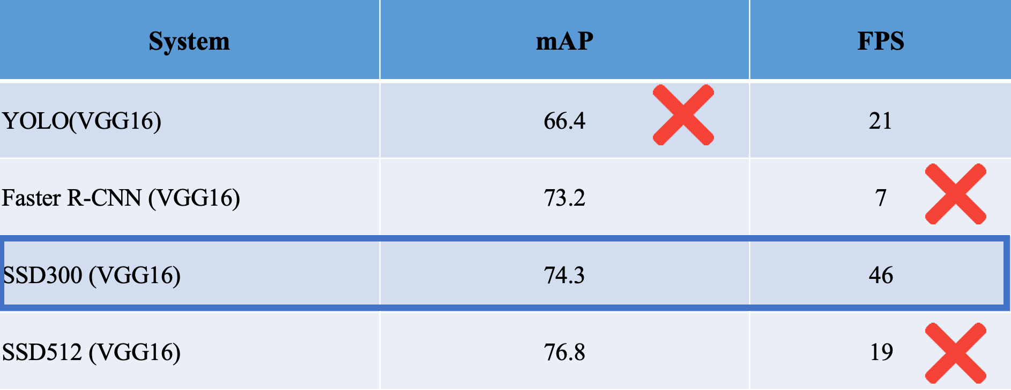

Figure . Compare between models

* + SSD300(VGG16) model:
    - Mean accuracy is 74.3% and speed is 46 fps.
    - The SSD (Single Shot Multi Box Detector) architecture is based on a feed forward convolutional network.
    - VGG16 is a convolutional neural network model.
    - SSD300(VGG16) architecture include:
      * Using VGG16 Base Network.
      * Layers of the SSD Model with the input layer size is 300x300.
      * Apply feature maps with different sizes.
      * Prediction through the convolutional network for object.
      * Applying Non-Maximum Suppression to remove boxes with low object probability.



Figure . SSD300(VGG16) Architecture

1. **Tracking Object**

After Object Detector we have coordinates of the people. Then we start to tracking object process with 5 steps:

* Step 1: Compute centroids from box coordinates:

The centroid tracking algorithm assumes that we are passing in a set of the bounding box (x, y)-coordinates for each detected object in every single frame. Then, we compute the centroid or the center (x, y)-coordinates from box coordinates follow by formula:

($x_{centriod}$, $y_{centriod}$) $=(\frac{x_{end}-x_{start}}{2}$, $\frac{y_{start}-y_{end}}{2})$



Figure . Step 1 in Tracking Object Algorithm

* Step 2: Compute distance between new and existing objects:

From every subsequent frame we compute in Step #1; we need to determine if we can associate the new object centroids (yellow) with the old object centroids (purple). We compute the Euclidean distance (highlighted lines) between each pair of existing object centroids and input object centroids.

Euclidean distance formula: In two dimensions, let 2 point $p\left(p_{1}, p_{2}\right), q\left(q_{1}, q_{2}\right)$. The distance between p and q given by:

$$d\left(p,q\right)= \sqrt{{\left(q_{1} -p_{1}\right)}^{2}+{\left(q_{2}-p_{2}\right)}^{2}}$$



Figure . Step 2 in Tracking Object Algorithm

* Step 3: Update *(x, y)*-coordinates of existing objects

The primary assumption is a given object will potentially move in between subsequent frames, but the distance between the centroids for frames $F_{t}$ and $F_{t+1}$ will be smaller than all other distances between objects. So, if we choose to associate centroids with minimum distances between subsequent frames we can define an existing object. The existing object has two coordinates $F_{0}$ and $F_{t+1}$, we compare coordinates object with coordinates line to determine the direction of the existing object.

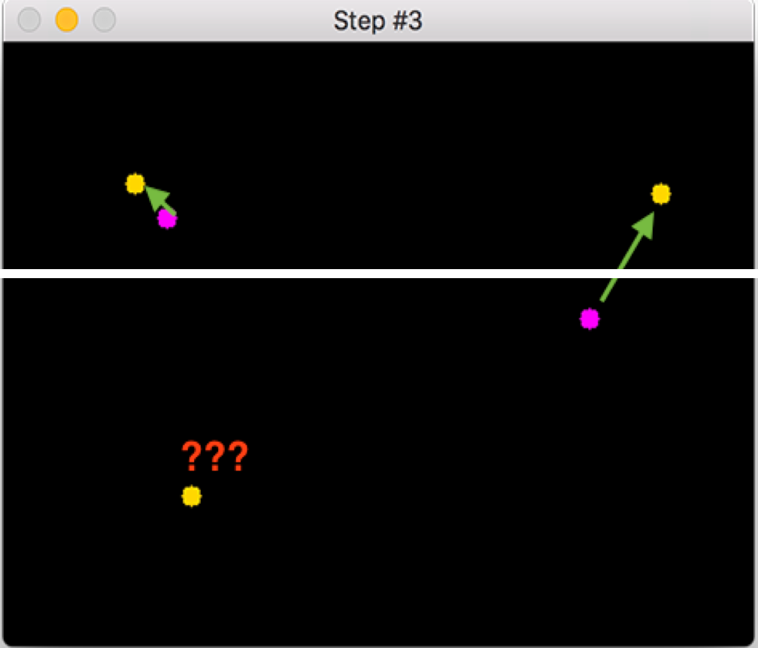

Figure . Step 3 in Tracking Object Algorithm

* Step 4: Register new objects

If there are more input detections than existing objects being tracked, we register the new object by assigning it a new object ID and storing the centroid of the bounding box coordinates for the new object.



Figure . Step 4 in Tracking Object Algorithm

* Step 5: Deregister old objects

We will deregister people IDs when they cannot be matched to any existing person objects for the next 40 frames and the max distance is 50px.

# V. Software Testing Documentation

## 1. Overall Description

### 1.1 Test Model

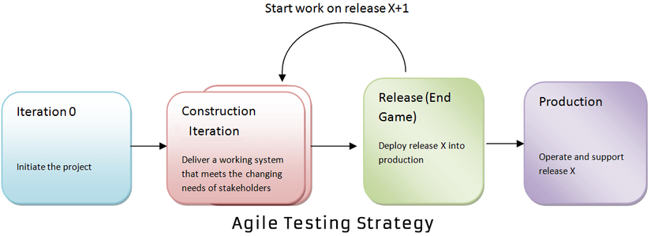

Figure . Agile model

***Source:***[*What is Agile Testing? Methodology, Process & Life Cycle (guru99.com)*](https://www.guru99.com/agile-testing-a-beginner-s-guide.html)

We apply Agile Testing because of the following reasons:

* It makes the interaction between developers and customers are faster and simpler.
* It can quickly adapt to the rate of change required.
* It helps developers pay more attention to quality, performance and usability.

### 1.2 Testing Levels

* Unit testing
* Integration testing
* System testing

### 1.3 Testing Types

* Function testing
* UI testing

## 2. Test Plan

### 2.1 Test Stages

Table 151. Test stages

|  |  |  |  |  |
| --- | --- | --- | --- | --- |
| **Type of Tests** | **Stage of Test** | | | |
| **Unit** | **Integration** | **System** | **Acceptance** |
| Function Test | X | X | X | X |
| User Interface Test | X |  | X |  |

### 2.2 Resources

#### a. Human Resources

Table 152. Human resources

|  |  |  |
| --- | --- | --- |
| **Worker/Doer** | **Role** | **Specific Responsibilities/Comments** |
| Nguyen Minh Luan | Test Leader | Write test plans, test cases, do test, and report |
| Than Nhat Truong | Tester | Do test and report |
| Do Ngoc Huu | Tester | Do test and report |
| Nguyen Thanh Hieu | Tester | Do test and report |

### 2.3 Test Milestones

Table 153. Test milestones

|  |  |  |  |
| --- | --- | --- | --- |
| **Milestone Task** | **Effort (md)** | **Start Date** | **End Date** |
| Create Test Plan | 3 | 27/07/2021 | 27/07/2021 |
| Create unit tests for module Web App | 2 | 28/07/2021 | 30/07/2021 |
| Create integration test cases for Web App | 2 | 01/08/2021 | 03/08/2021 |
| Create system test cases for Web App | 2 | 05/08/2021 | 07/08/2021 |
| Create unit tests for module Mobile App | 2 | 09/08/2021 | 11/08/2021 |
| Create integration test cases for Mobile App | 2 | 12/08/2021 | 14/08/2021 |
| Create system test cases for Mobile App | 2 | 14/08/2021 | 16/08/2021 |
| Create reports for testing | 2 | 16/08/2021 | 17/08/2021 |

### 2.4 Deliverables

Table 154. Deliverables

|  |  |  |
| --- | --- | --- |
| **No** | **Deliverables** | **Due Date** |
| 1 | Test Plan | 27/07/2021 |
| 2 | Test Case Suite for Web App | 07/07/2021 |
| 3 | Test Case Suite for Mobile App | 16/08/2021 |
| 4 | Report on Testing | 17/08/2021 |

## 3. Test Cases

* Unit Test Cases: Report5_Unit Test Case.xls
* Other Test Cases: Report5_ Test Case.xls

## 4. Test Reports

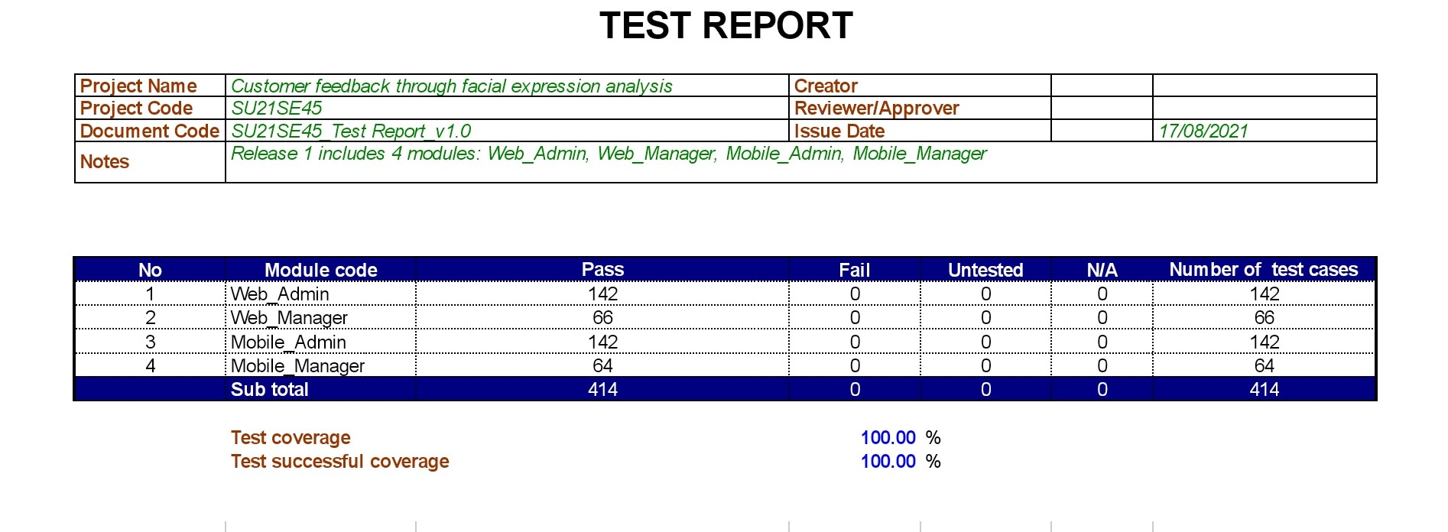

Figure . Test Case Report

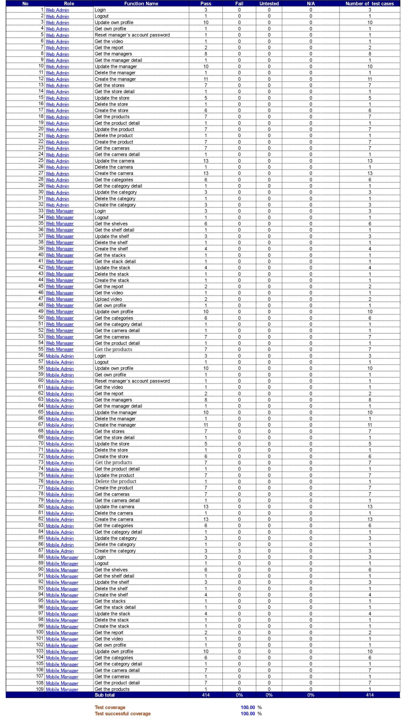

Figure . Unit Test Case Report

# VI. Release Package & User Guides

## 1. Deliverable Package

### 1.1 Source codes & documents

Table . Source Codes & Documents

|  |  |  |
| --- | --- | --- |
| **No** | **Items** | **Sub-Items** |
| **Code packages** | | |
| 1 | CFFE.CapstoneBE.zip | Counting-People, Facial-Emotion-Recognition |
| 2 | CFFE.CapstoneFE.zip |  |
| 3 | CFFE.Mobile.apk |  |
| **Databases** | | |
| 1 | Script | CFFE_Database.sql |
| **Install environments** | | |
| 1 | Script | InstallModules.sh |
| **Deploy server application** | | |
| 1 | Script | DeploymentApp.sh |

### 1.2 Known Issues, Limitations & Restrictions

- Due to the influence of the Covid-19 epidemic, testing is limited.

- The application only serves one system with many stores, not for managing many different systems at the same time.

## 2. Installation Guides

### 2.1 System Requirements

#### 2.1.1. Back End Server requirements

* Tested OS: RedHat 8 or above.
* Network: LAN, Internet access capability.
* Hardware configurations:

Table . Back End Server – Recommended Hardware Configuration

|  |  |  |  |
| --- | --- | --- | --- |
| **Type** | **Part/Component** | **Minimum** | **Recommended** |
| Computer | OS supported | RedHat | _ |
| Computer | Network | Internet | _ |
| Computer | RAM | 2GB | > 2GB |
| Computer | Cluster | 4 machines | > 4 machines |
| Computer | Storage Space | 50GB | > 50GB |
| Computer | Ports | Network | _ |

* Software requirements:
  + Java SE Development Kit 8u281
  + Apache Maven 3.6.3
  + MySQL 8.0
  + Python 3.8.2

#### 2.1.2. Web Server requirements

* Tested OS: RedHat 8 or above.
* Network: LAN, Internet access capability.
* Hardware configurations:

Table . Web Server – Recommended hardware configuration

|  |  |  |  |
| --- | --- | --- | --- |
| **Type** | **Part/Component** | **Minimum** | **Recommended** |
| Computer | OS supported | RedHat | _ |
| Computer | Network | Internet | _ |
| Computer | RAM | 2GB | > 2GB |
| Computer | Cluster | 4 machines | > 4 machines |
| Computer | Storage Space | 50GB | > 50GB |
| Computer | Ports | Network | _ |

* Software requirements:
  + Nodejs
  + Vue3

#### 2.1.3. Mobile requirements

* Tested OS: EMUI 9.1 (Based on Android 9).
* Network: WLAN, Internet access capability.
* Hardware configurations:

Table . Mobile Device – Recommended hardware configuration

|  |  |  |  |
| --- | --- | --- | --- |
| **Type** | **Part/Component** | **Minimum** | **Recommended** |
| Mobile | Android supported | Version 9 | _ |
| Mobile | Network | Internet | _ |
| Mobile | RAM | 2GB | > 2GB |
| Mobile | Storage Space | 32GB | >32GB |
| Mobile | Ports | Network | _ |

### 2.2 Environment setup requirements

* Operating system: RedHat 8.
* Java SE Runtime 8.
* Soft wares: MySQL 8.0.

### 2.3 Setup Files

* CFFE.CapstoneBE.zip: API for applications.
* CFFE.CapstoneWeb.zip: Web for Module Web.
* CFFE.CapstoneDetect.zip: Detect for Module Detect.
* CFFE.Mobile.apk: APK mobile for android.
* InstallModules.sh: Install the environments.
* DeploymentApp.sh: Deploy back-end server and font-end server.

### 2.4 Installation Instruction

#### a. Setup server environment

##### 1. Setup and start a RedHat OS (RedHat 8 or above).

**1.** Open browser and go to this URL: [Console Google Cloud](https://console.cloud.google.com/) then Login in with **Google account**



Figure . Login GCP form

**2.** Create a VM Instance with Red Hat Enterprise Linux 8:

1. Further information: Go to this URL [Create a Linux VM Instance | GCP](https://cloud.google.com/compute/docs/quickstart-linux)

2. Fill information and choose Boot Disk is Red Hat Enterprise Linux 8 image (1). Then, click “Create” Button (2).



Figure . Choose configs VM

##### 2. Install Java Development Kit, Apache Maven, Python, NodeJS, MySQL.

1. Connect Linux VM Instance. Further information: [Connecting to Linux VM Instance | GCP](https://cloud.google.com/compute/docs/instances/ssh#console)

2. Install the environments using the script file:

1. Run as root user with this command: **sudo su –**



Figure . Run as root user

2. Prepare a “InstallModules.sh” file with this content:



Figure . “InstallModules.sh” file contents.

3.Start to install environment: **yes y | source ./InstallModules.sh**



Figure . Run the bash script file

4. Reload bash file system with this command: **source ~/.bashrc**



Figure . Reload the config bash file

5. Verification modules installed with commands:

* Check installed JDK (1): **java -version**
* Check installed Apache Maven (2): **mvn ––version**
* Check installed Python (3): **python3.8 ––version**
* Check installed NodeJS (4): **node ––version**
* Check installed MySQL (5): **mysql ––version**
* Check MySQL active status (6): **systemctl status mysqld.service**



Figure . Check the installed modules

6. Check “CFFE_SYSTEM.zip” file is downloaded with this command: **ls**



Figure . Check “CFFE_SYSTEM.zip” file

##### 3. Deploy the CFFE application.

1. Create the “CFFE_Database”:

1. Get the temporary password with this command: **grep 'temporary password' /var/log/mysqld.log**



Figure . View MySQL temporary password

2. Change the password MySQL with this command: **mysql_secure_installation**

1. Input temporary password (1)

2. Input “y” to the change password (2)

3. Input new password (3)

4. Input re-type password (4)

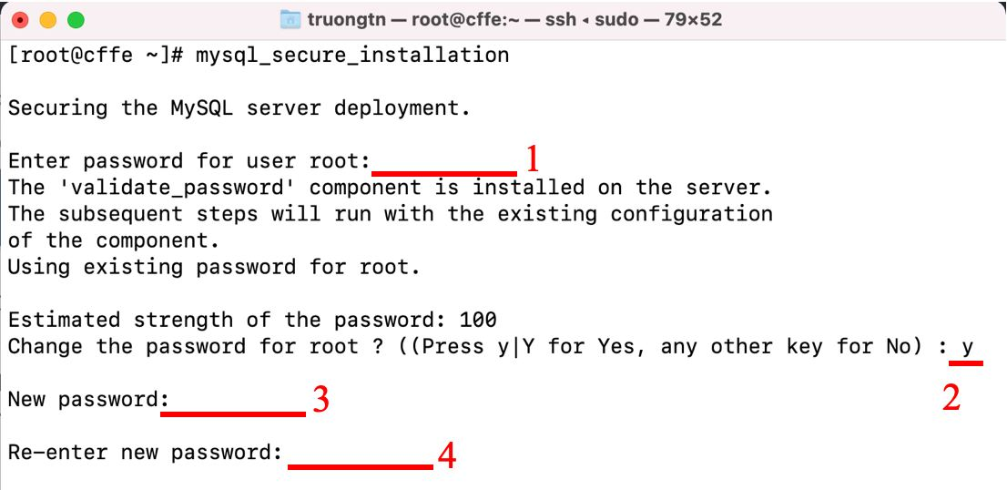

Figure . Change MySQL password

2. Create the “CFFE_Database” by running **mysql -u root -p < CFFE_Create_All_Table.sql** command with the password.



Figure . Execute database script file

3. Check created “CFFE_Database”: run **mysql -u root -p** command with the password. Then, run **show databases;** command.



Figure . Check database created

2. Edit config files.

1. Edit password MySQL in the file: **/root/CapstoneAPI/src/main/resources/SqlMapConfig.xml**



Figure . Configure the MySQL new password for Backend API

2. Get the public IP address with this command: **curl ifconfig.me**



Figure . Get public IP backend API server

3. Change the public IP address in this file:

**Capstone-web/src/services/api.js**



Figure . Configure URL API for Font-end

3. Deployment CFFE application.

1. Deploy the application with this command: **source ./DeploymentAPP.sh**



Figure . Deploy Backend API

2. Access Backend API: Open browser and input URL:

**[public IP Address]:9091/swagger-ui/index.html**



Figure . Access Backend API

3. Access CFFE web: Open browser and input URL:

**[public IP Address]:8080**



Figure . Access CFFE web Access CFFE web

##### 4. Run Mobile Application.

1. Click in Mobile.apkfile:



Figure . Mobile Install Step 1

2. Show popup then click **Install**.



Figure . Mobile Install Step 2

3. Wait for install Mobile app



Figure . Mobile Install Step 3

4. Finish install then click **Open**



Figure . Mobile Install Step 4

5. Show login page in Mobile app

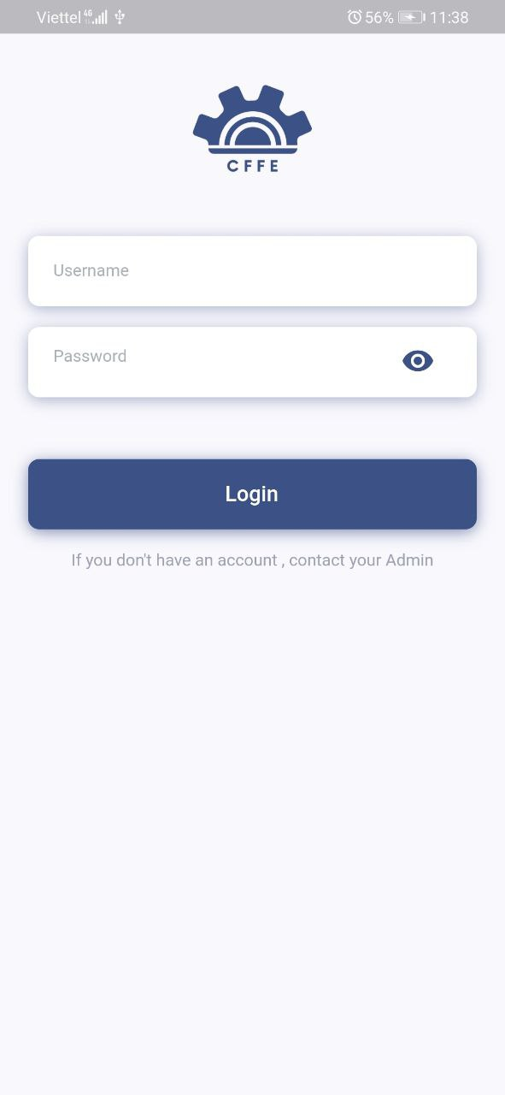

Figure . Login Page

## 3. User Manual

### 3.1 Application Usage

#### 3.1.1. CFFE-Web-Admin

##### a. Overview

Application used by admin when want to:

+ Login

+ Logout

+ View statistics

+ View video

+ Manage manager

+ Manage store

+ Manage camera

+ Manage product

+ Manage category

+ Manage own profile



Figure . <Flow Screen> Web Application - Admin

##### b. Login page



Figure . Login Page

Table . <User Guide> Login

|  |  |
| --- | --- |
| **Step** | **Description** |
| 1 | Admin inputs the own account information. |
| 2 | Admin clicks “Login” button. |

##### c. Home page



Figure . <User Guide> Home Page



Figure . <User Guide> Home Page

Table . <User Guide> Home Page

|  |  |
| --- | --- |
| **Step** | **Description** |
| 1 | Admin clicks own username to drop down items. |
| 2 | Admin clicks “Profile” item to view own profile. |
| 3 | Admin clicks “Logout” item to logout from the application. |
| 4 | Admin clicks “Emotion” to view the emotion report. |
| 5 | Admin clicks “Counting Customer” to view the counting customer reports. |

##### d. Profile page



Figure . Profile page

Table . <User Guide> Profile page

|  |  |
| --- | --- |
| **Step** | **Description** |
| 1 | Admin clicks the icon to change own avatar. |
| 2 | Admin clicks the icon to change own password. |
| 3 | Admin clicks the icon to update own information. |
| 4 | Admin clicks “Emotion” button to view the emotion report. |
| 5 | Admin clicks “Counting Customers” button to view the counting customers report. |

1. Change own avatar.



Figure . Change own avatar

Table . <User Guide> Change own avatar

|  |  |
| --- | --- |
| **Step** | **Description** |
| 1 | Admin clicks the icon to close the popup. |
| 2 | Admin clicks the button to choose an avatar from own computer. |
| 3 | Admin clicks “Cancel” button to cancel the command |
| 4 | Admin clicks “Ok” button to change own avatar. |

2. Change own password



Figure . Change own password

Table . <User Guide> Change own password

|  |  |
| --- | --- |
| **Step** | **Description** |
| 1 | Admin inputs own old password. |
| 2 | Admin inputs own new password. |
| 3 | Admin inputs own re-type password |
| 4 | Admin clicks “Cancel” button to cancel the command |
| 5 | Admin clicks “Ok” button to change own password. |

3. Update own information



Figure . Update own information

Table . <User Guide> Update own information

|  |  |
| --- | --- |
| **Step** | **Description** |
| 1 | Admin edits the necessary information. |
| 2 | Admin clicks “Cancel” button to cancel the command. |
| 3 | Admin clicks “Update” button to update own information |

##### e. Video page



Figure . Video page

Table . <User Guide> Video page

|  |  |
| --- | --- |
| **Step** | **Description** |
| 1 | Admin chooses a filter which is from start date to end date. |
| 2 | Admin chooses a filter which is counting or emotion. |
| 3 | Admin chooses a filter which is all stores or a store in the dropdown list. |
| 4 | Admin clicks a video to watch the video. |

##### f. Manager page



Figure . Manager page

Table . <User Guide> Manager page

|  |  |
| --- | --- |
| **Step** | **Description** |
| 1 | Admin inputs a search value. |
| 2 | Admin chooses a search field which is full name or username. |
| 3 | Admin chooses a filter which is all statuses, active, pending or inactive. |
| 4 | Admin clicks “New” button to create the new manager. |
| 5 | Admin clicks a username to view manager detail. |
| 6 | Admin clicks a store to view store detail |

1. Create the manager



Figure . Create the manager

Table . <User Guide> Create the manager

|  |  |
| --- | --- |
| **Step** | **Description** |
| 1 | Admin clicks the close button to close the pop up. |
| 2 | Admin enters the manager information. |
| 3 | Admin clicks “Cancel” button to cancel the command |
| 4 | Admin clicks “Ok” button to create the manager. |

##### g. Manager detail page



Figure . Manager detail page



Figure . Manager detail page

Table . <User Guide> Manager detail page

|  |  |
| --- | --- |
| **Step** | **Description** |
| 1 | Admin clicks the icon to change the manager avatar. |
| 2 | Admin clicks “Pending” button to show “Inactive” button. |
| 3 | Admin clicks “Inactive” button to delete the manager. |
| 4 | Admin clicks the icon to reset the manager’s account password. |
| 5 | Admin clicks the icon to update the manager’s information. |
| 6 | Admin clicks the icon to add the store into the manager. |
| 7 | Admin clicks the icon to remove the store from the manager. |

1. Change the manager avatar.



Figure . Change the manger avatar

Table . <User Guide> Manager detail page

|  |  |
| --- | --- |
| **Step** | **Description** |
| 1 | Admin clicks the icon to close the popup. |
| 2 | Admin clicks the button to choose the manager avatar from own computer. |
| 3 | Admin clicks “Cancel” button to cancel the command. |
| 4 | Admin clicks “Ok” button to change the manager avatar. |

2. Delete the manager



Figure . Delete the manger

Table . <User Guide> Delete the manger

|  |  |
| --- | --- |
| **Step** | **Description** |
| 1 | Admin inputs an inactive reason. |
| 2 | Admin clicks “Cancel” button to cancel the command |
| 3 | Admin clicks “Ok” button to delete the manager. |

3. Reset manager’s account password.



Figure . Reset the manager password

Table . <User Guide> Reset the manager password

|  |  |
| --- | --- |
| **Step** | **Description** |
| 1 | Admin clicks “Cancel” button to cancel the command. |
| 2 | Admin clicks “Ok” button to reset the manager’s account password. |

4. Update the manager information



Figure . Update the manger information

Table . <User Guide> Update the manger information

|  |  |
| --- | --- |
| **Step** | **Description** |
| 1 | Admin edits the necessary information of the manager. |
| 2 | Admin clicks “Cancel” button to cancel the command. |
| 3 | Admin clicks “Update” button to update the manager information. |

5.Add the store into the manager



Figure . Add the store into the manager

Table . <User Guide> Add the store into the manager

|  |  |
| --- | --- |
| **Step** | **Description** |
| 1 | Admin inputs a search value to find by store name. |
| 2 | Admin chooses a store in the available list. |
| 3 | Admin clicks “Cancel” button to cancel the command. |
| 4 | Admin clicks “Ok” button to add the store into the manager. |

6. Remove the store from the manager.



Figure . Remove the store from the manager

Table . <User Guide> Remove the store from the manager

|  |  |
| --- | --- |
| **Step** | **Description** |
| 1 | Admin clicks “Cancel” button to cancel the command. |
| 2 | Admin clicks “Ok” button to remove the store from the manager. |

##### h. Store page



Figure . Store page

Table . <User Guide> Store page

|  |  |
| --- | --- |
| **Step** | **Description** |
| 1 | Admin inputs a search value. |
| 2 | Admin chooses a filter which is all cities or a city in the dropdown list. |
| 3 | Admin chooses a filter which is all statuses, active, pending or inactive. |
| 4 | Admin clicks “New” button to create the new manager. |
| 5 | Admin clicks a username to view manager detail. |
| 6 | Admin clicks a store to view store detail. |

1. Create the store



Figure . Create the store

Table . <User Guide> Create the store

|  |  |
| --- | --- |
| **Step** | **Description** |
| 1 | Admin clicks the close button to close the pop up. |
| 2 | Admin enters store information. |
| 3 | Admin clicks “Cancel” button to cancel the command |
| 4 | Admin clicks “Ok” button to create the store. |

##### i. Store detail page



Figure . Store detail page



Figure . Store detail page

Table . <User Guide> Store detail page

|  |  |
| --- | --- |
| **Step** | **Description** |
| 1 | Admin clicks the icon to change the store avatar. |
| 2 | Admin clicks “Pending” button to show “Inactive” button. |
| 3 | Admin clicks “Inactive” button to delete the store |
| 4 | Admin clicks the icon to view the store information. |
| 5 | Admin clicks the icon to update the store information. |
| 6 | Admin clicks the icon to add the manager into the store. |
| 7 | Admin clicks the icon to view product list of the store. |
| 8 | Admin clicks the icon to view camera list of the store. |
| 9 | Admin clicks the icon to remove the manager from the store. |

1. Change the store avatar



Figure . Change the store avatar

Table . <User Guide> Change the store avatar

|  |  |
| --- | --- |
| **Step** | **Description** |
| 1 | Admin clicks the icon to close the popup. |
| 2 | Admin clicks the button to choose the store avatar from own computer. |
| 3 | Admin clicks “Cancel” button to cancel the command |
| 4 | Admin clicks “Ok” button to change the store avatar. |

2. Delete the store.



Figure . Delete the store

Table . <User Guide> Delete the store

|  |  |
| --- | --- |
| **Step** | **Description** |
| 1 | Admin inputs an inactive reason. |
| 2 | Admin clicks “Cancel” button to cancel the command |
| 3 | Admin clicks “Ok” button to delete the store. |

3. Update the store information.



Figure . Update the store information

Table . <User Guide> Update the store information

|  |  |
| --- | --- |
| **Step** | **Description** |
| 1 | Admin edits the necessary information of the store. |
| 2 | Admin clicks “Cancel” button to cancel the command. |
| 3 | Admin clicks “Update” button to update the store information. |

4. Add the manager into the store



Figure . Add the manager into the store

Table . <User Guide> Add the manager into the store

|  |  |
| --- | --- |
| **Step** | **Description** |
| 1 | Admin inputs a search value to find by username. |
| 2 | Admin chooses a store in the available list. |
| 3 | Admin clicks “Cancel” button to cancel the command. |
| 4 | Admin clicks “Ok” button to add the manager into the store. |

5. Remove the manager from the store



Figure . Remove the manager from the store

Table . <User Guide> Remove the manager from the store

|  |  |
| --- | --- |
| **Step** | **Description** |
| 1 | Admin clicks “Cancel” button to cancel the command. |
| 2 | Admin clicks “Ok” button to remove the manager from the store. |

##### j. Camera page



Figure . Camera page

Table . <User Guide> Camera page

|  |  |
| --- | --- |
| **Step** | **Description** |
| 1 | Admin inputs a search value to find by camera name. |
| 2 | Admin chooses a filter which is all stores or a store name in the dropdown list. |
| 3 | Admin chooses a filter which is all statuses, active, pending or inactive. |
| 4 | Admin clicks “New” button to create the new camera. |
| 5 | Admin clicks a camera name to view camera detail. |
| 6 | Admin clicks a store name to view store detail. |

1. Create the camera



Figure . Create the camera

Table . <User Guide> Create the camera

|  |  |
| --- | --- |
| **Step** | **Description** |
| 1 | Admin clicks the close button to close the pop up. |
| 2 | Admin enters camera information. |
| 3 | Admin clicks “Cancel” button to cancel the command |
| 4 | Admin clicks “Ok” button to create the camera. |

##### k. Camera detail



Figure . Camera detail page

Table . <User Guide> Camera detail page

|  |  |
| --- | --- |
| **Step** | **Description** |
| 1 | Admin clicks the icon to change the camera avatar. |
| 2 | Admin clicks “Pending” button to show “Inactive” button. |
| 3 | Admin clicks “Inactive” button to delete the camera. |
| 4 | Admin clicks the icon to update the camera information. |

1. Change the camera avatar.



Figure . Change the camera avatar

Table . <User Guide> Change the camera avatar

|  |  |
| --- | --- |
| **Step** | **Description** |
| 1 | Admin clicks the icon to close the popup. |
| 2 | Admin clicks the button to choose the camera avatar from own computer. |
| 3 | Admin clicks “Cancel” button to cancel the command |
| 4 | Admin clicks “Ok” button to change the camera avatar. |

2. Delete the camera



Figure . Delete the camera

Table . <User Guide> Delete the camera

|  |  |
| --- | --- |
| **Step** | **Description** |
| 1 | Admin inputs an inactive reason. |
| 2 | Admin clicks “Cancel” button to cancel the command |
| 3 | Admin clicks “Ok” button to delete the camera. |

3. Update the camera information



Figure . Update the camera information

Table . <User Guide> Update the camera information

|  |  |
| --- | --- |
| **Step** | **Description** |
| 1 | Admin edits the necessary information of the camera. |
| 2 | Admin clicks “Cancel” button to cancel the command. |
| 3 | Admin clicks “Update” button to update the camera information. |

##### l. Product page



Figure . Product page

Table . <User Guide> Product page

|  |  |
| --- | --- |
| **Step** | **Description** |
| 1 | Admin inputs a search value to find by product name. |
| 2 | Admin chooses a filter which is all categories or a category in the dropdown list. |
| 3 | Admin chooses a filter which is all statuses, active or inactive. |
| 4 | Admin clicks “New” button to create the product. |
| 5 | Admin clicks a camera name to view camera detail. |

1. Create the product



Figure . Create the product

Table . <User Guide> Create the product

|  |  |
| --- | --- |
| **Step** | **Description** |
| 1 | Admin clicks the close button to close the pop up. |
| 2 | Admin enters product information. |
| 3 | Admin clicks “Cancel” button to cancel the command |
| 4 | Admin clicks “Ok” button to create the product. |

##### m. Product detail page



Figure . Product detail page

Table . <User Guide> Product detail page

|  |  |
| --- | --- |
| **Step** | **Description** |
| 1 | Admin clicks the icon to change the product avatar. |
| 2 | Admin clicks “Active” button to show “Inactive” button. |
| 3 | Admin clicks “Inactive” button to delete the product. |
| 4 | Admin clicks the icon to update the product information. |

1. Change the product avatar.



Figure . Change the product avatar

Table . <User Guide> Change the product avatar

|  |  |
| --- | --- |
| **Step** | **Description** |
| 1 | Admin clicks the icon to close the popup. |
| 2 | Admin clicks the button to choose the product avatar from own computer. |
| 3 | Admin clicks “Cancel” button to cancel the command |
| 4 | Admin clicks “Ok” button to change the product avatar. |

2. Delete the product



Figure . Delete the product

Table . <User Guide> Delete the product

|  |  |
| --- | --- |
| **Step** | **Description** |
| 1 | Admin inputs an inactive reason. |
| 2 | Admin clicks “Cancel” button to cancel the command |
| 3 | Admin clicks “Ok” button to delete the product. |

3. Update the product information



Figure . Update the product information

Table . <User Guide> Update the product information

|  |  |
| --- | --- |
| **Step** | **Description** |
| 1 | Admin edits the necessary information of the product. |
| 2 | Admin clicks “Cancel” button to cancel the command. |
| 3 | Admin clicks “Update” button to update the product information. |

##### n. Category page



Figure . Category page



Figure . Category page

Table . <User Guide> Category page

|  |  |
| --- | --- |
| **Step** | **Description** |
| 1 | Admin inputs a search value to find by category name. |
| 2 | Admin chooses a filter which is all statuses, active or inactive. |
| 3 | Admin clicks the category name to view product list by the category. |
| 4 | Admin clicks “New” button to create the category. |
| 5 | Admin clicks the edit icon to edit the category name. |
| 6 | Admin clicks a product name to view the product detail. |
| 7 | Admin clicks “Active” button to show “Inactive” button. |
| 8 | Admin clicks “Inactive” button to delete the category. |

1. Create the category



Figure . Create the category

Table . <User Guide> Create the category

|  |  |
| --- | --- |
| **Step** | **Description** |
| 1 | Admin clicks the icon to close the popup. |
| 2 | Admin inputs the category name. |
| 3 | Admin clicks “Cancel” button to cancel the command |
| 4 | Admin clicks “Ok” button to create the category. |

2. Update the category information



Figure . Update the category information

Table . <User Guide> Update the category information

|  |  |
| --- | --- |
| **Step** | **Description** |
| 1 | Admin edits the category name. |
| 2 | Admin clicks “Cancel” button to cancel the command. |
| 3 | Admin clicks “Update” button to update the category. |

3. Delete the category



Figure . Delete the category

Table . <User Guide> Delete the category

|  |  |
| --- | --- |
| **Step** | **Description** |
| 1 | Admin clicks “Cancel” button to cancel the command. |
| 2 | Admin clicks “Ok” button to delete the category. |

#### 3.1.2. CFFE-Web-Manager

##### a. Overview

Application used by manager when want to:

+ Login

+ Logout

+ Manage own profile

+ View statistics

+ View video

+ Manage shelf

+ Manage stack

+ Manage camera

+ Manage product



Figure . <Flow Screen> Web Application - Manager

##### b. Login page



Figure . Login page

Table . <User Guide> Login page

|  |  |
| --- | --- |
| **Step** | **Description** |
| 1 | Manager inputs the own account information. |
| 2 | Manager clicks “Login” button. |

##### c. Home page



Figure . Home page



Figure . Home page

Table . <User Guide> Home page

|  |  |
| --- | --- |
| **Step** | **Description** |
| 1 | Manager clicks own username to drop down items. |
| 2 | Manager clicks “Profile” item to view own profile. |
| 3 | Manager clicks “Logout” item to logout from the application. |
| 4 | Manager clicks “Emotion” to view the emotion report. |
| 5 | Manager clicks “Counting Customer” to view the counting customer reports. |

##### d. Profile page



Figure . Profile page

Table . <User Guide> Profile page

|  |  |
| --- | --- |
| **Step** | **Description** |
| 1 | Manager clicks the icon to change own avatar. |
| 2 | Manager clicks the icon to change own password. |
| 3 | Manager clicks the icon to update own information. |

1. Change own avatar.



Figure . Change own avatar

Table . <User Guide> Change own avatar

|  |  |
| --- | --- |
| **Step** | **Description** |
| 1 | Manager clicks the icon to close the popup. |
| 2 | Manager clicks the button to choose an avatar from own computer. |
| 3 | Manager clicks “Cancel” button to cancel the command |
| 4 | Manager clicks “Ok” button to change own avatar. |

2. Change own password



Figure . Change own password

Table . <User Guide> Change own password

|  |  |
| --- | --- |
| **Step** | **Description** |
| 1 | Manager inputs own old password. |
| 2 | Manager inputs own new password. |
| 3 | Manager inputs own re-type password |
| 4 | Manager clicks “Cancel” button to cancel the command |
| 5 | Manager clicks “Ok” button to change own password. |

3. Update own information



Figure . Update own information

Table . <User Guide> Update own information

|  |  |
| --- | --- |
| **Step** | **Description** |
| 1 | Manager edits the necessary information. |
| 2 | Manager clicks “Cancel” button to cancel the command. |
| 3 | Manager clicks “Update” button to update own information |

##### e. Video page



Figure . Video page

Table . <User Guide> Video page

|  |  |
| --- | --- |
| **Step** | **Description** |
| 1 | Manager chooses a filter which is from start date to end date. |
| 2 | Manager chooses a filter which is counting or emotion. |
| 3 | Manager chooses a filter which is all stores or a store in the dropdown list. |
| 4 | Manager uploads videos to detect. |
| 5 | Manager clicks a video to watch the video. |

1. Upload videos



Figure . Upload video

Table . <User Guide> Upload video

|  |  |
| --- | --- |
| **Step** | **Description** |
| 1 | Manager chooses videos that need to detect. |
| 2 | Manager clicks “Cancel” button to cancel the command. |
| 3 | Manager clicks “Ok” button to upload videos. |

##### f. Shelf page



Figure . Shelf page

Table . <User Guide> Shelf page

|  |  |
| --- | --- |
| **Step** | **Description** |
| 1 | Manager inputs a search value to find by shelf name. |
| 2 | Manager chooses a filter which is all statuses, active, pending or inactive. |
| 3 | Manager clicks “New” button to create the shelf. |
| 4 | Manager clicks a shelf name to view shelf detail. |

1. Create the shelf



Figure . Create the shelf

Table . <User Guide> Create the shelf

|  |  |
| --- | --- |
| **Step** | **Description** |
| 1 | Manager clicks the close button to close the pop up. |
| 2 | Manager enters shelf information. |
| 3 | Manager clicks “Cancel” button to cancel the command |
| 4 | Manager clicks “Ok” button to create the shelf. |

##### g. Shelf detail page



Figure . Shelf detail page



Figure . Shelf detail page



Figure . Shelf detail page

Table . <User Guide> Shelf detail page

|  |  |
| --- | --- |
| **Step** | **Description** |
| 1 | Manager clicks the icon to update the shelf information. |
| 2 | Manager clicks “Pending” button to show “Inactive” button. |
| 3 | Manager clicks “Inactive” button to delete the shelf. |
| 4 | Manager clicks the box to view the stack detail. |
| 5 | Manager clicks the icon to add the camera into the shelf. |
| 6 | Manager clicks the icon to add the camera into the shelf. |
| 7 | Manager clicks the icon to add the product into the stack. |
| 8 | Manager clicks the icon to remove the camera from the shelf. |
| 9 | Manager clicks the icon to remove the camera from the shelf. |
| 10 | Manager click “Pending” button to show “Inactive” button. |
| 11 | Manager clicks “Inactive” button to delete the stack. |
| 12 | Manager clicks the icon to remove the product from the stack. |
| 13 | Manager clicks the icon to add the camera into the stack. |
| 14 | Manager clicks the icon to remove the camera from the stack. |

1. Update the shelf information



Figure . Update the shelf information

Table . <User Guide> Update the shelf information

|  |  |
| --- | --- |
| **Step** | **Description** |
| 1 | Manager edits the necessary information. |
| 2 | Manager clicks “Cancel” button to cancel the command. |
| 3 | Manager clicks “Update” button to update the shelf information. |

2. Delete the shelf



Figure . Delete the shelf

Table . <User Guide> Delete the shelf

|  |  |
| --- | --- |
| **Step** | **Description** |
| 1 | Manager inputs an inactive reason. |
| 2 | Manager clicks “Cancel” button to cancel the command |
| 3 | Manager clicks “Ok” button to delete the shelf. |

3. Add the camera into the shelf



Figure . Add the camera into the shelf

Table . <User Guide> Add the camera into the shelf

|  |  |
| --- | --- |
| **Step** | **Description** |
| 1 | Manager inputs a search value to find by camera name |
| 2 | Manager chooses a camera in the available list. |
| 3 | Manager clicks “Cancel” button to cancel the command. |
| 4 | Manager clicks “Ok” button to add the camera into the shelf. |

4. Add the product into the stack



Figure . Add the product into the stack

Table . <User Guide> Add the product into the stack

|  |  |
| --- | --- |
| **Step** | **Description** |
| 1 | Manager inputs a search value to find by product name |
| 2 | Manager chooses a camera in the available list. |
| 3 | Manager clicks “Cancel” button to cancel the command. |
| 4 | Manager clicks “Ok” button to add the product into the stack. |

5. Remove the camera from the shelf



Figure . Remove the camera from the shelf

Table . <User Guide> Remove the camera from the shelf

|  |  |
| --- | --- |
| **Step** | **Description** |
| 1 | Manager clicks “Cancel” button to cancel the command. |
| 2 | Manager clicks “Ok” button to remove the camera from the shelf. |

6. Delete the stack



Figure . Delete the stack

Table . <User Guide> Delete the stack

|  |  |
| --- | --- |
| **Step** | **Description** |
| 1 | Manager inputs an inactive reason. |
| 2 | Manager clicks “Cancel” button to cancel the command |
| 3 | Manager clicks “Ok” button to delete the stack. |

7. Remove the product from the stack



Figure . Remove the product from the stack

Table . <User Guide> Remove the product from the stack

|  |  |
| --- | --- |
| **Step** | **Description** |
| 1 | Manager clicks “Cancel” button to cancel the command. |
| 2 | Manager clicks “Ok” button to remove the camera from the shelf. |

8. Add the camera into the stack



Figure . Add the camera into the stack

Table . <User Guide> Add the camera into the stack

|  |  |
| --- | --- |
| **Step** | **Description** |
| 1 | Manager inputs a search value to find by camera name |
| 2 | Manager chooses a camera in the available list. |
| 3 | Manager clicks “Cancel” button to cancel the command. |
| 4 | Manager clicks “Ok” button to add the camera into the stack. |

9. Remove the camera from the stack



Figure . Remove the camera from the stack

Table . <User Guide> Remove the camera from the stack

|  |  |
| --- | --- |
| **Step** | **Description** |
| 1 | Manager clicks “Cancel” button to cancel the command. |
| 2 | Manager clicks “Ok” button to remove the camera from the stack. |

##### h. Camera page



Figure . Camera page

Table . <User Guide> Camera page

|  |  |
| --- | --- |
| **Step** | **Description** |
| 1 | Manager inputs a search value to find by camera name. |
| 2 | Manager chooses a filter which is all stores or a store in the dropdown list. |
| 3 | Manager chooses a filter which is all statuses, active, pending or inactive. |
| 4 | Manager clicks a camera name to view camera detail |
| 5 | Manager clicks an own store name to view own store detail. |

##### I. Product page



Figure . Product page

Table . <User Guide> Product page

|  |  |
| --- | --- |
| **Step** | **Description** |
| 1 | Manager inputs a search value to find by product name. |
| 2 | Manager chooses a filter which is all categories or a category in the dropdown list. |
| 3 | Manager chooses a filter which is all statuses, active or inactive. |
| 4 | Manager clicks a camera name to view camera detail. |

##### j. Category page



Figure . Category page

Table . <User Guide> Category page

|  |  |
| --- | --- |
| **Step** | **Description** |
| 1 | Manager inputs a search value to find by category name. |
| 2 | Manager chooses a filter which is all statuses, active or inactive. |
| 3 | Manager clicks a category name to view product list by the category. |
| 4 | Manager clicks a product name to view product detail. |

#### 3.1.3. CFFE-Mobile-Admin

##### a. Overview

Application used by admin when want to:

+ Login

+ Logout

+ View statistics

+ View video

+ Manage manager

+ Manage store

+ Manage camera

+ Manage product

+ Manage category

+ Manage own profile



Figure . <Flow Screen> Mobile Application - Admin

##### b. Login page



Figure . Login Page

Table . <User Guide> Login

|  |  |
| --- | --- |
| **Step** | **Description** |
| 1 | Admin inputs the account. |
| 2 | Admin clicks the “Login” button. |

##### c. Home page



Figure . Dashboard Page



Figure . Dashboard Page

Table . <User Guide> Navigation

|  |  |
| --- | --- |
| **Step** | **Description** |
| 1 | Admin clicks the “navigator” icon to view drawer navigator. |
| 2 | Admin clicks the “Profile” item to view own profile. |
| 3 | Admin clicks the “Logout” item to logout from the application. |

##### d. Profile page



Figure . Manager detail page

Table . <User Guide> Manager detail page

|  |  |
| --- | --- |
| **Step** | **Description** |
| 1 | Admin clicks the item to change own information. |
| 2 | Admin clicks the item to change own avatar. |
| 3 | Admin clicks the item to change own password. |

1. Change own information.



Figure . Change own information

Table . <User Guide> Change own information

|  |  |
| --- | --- |
| **Step** | **Description** |
| 1 | Admin clicks the “Back” icon to cancel the command. |
| 2 | Admin edits the information. |
| 3 | Admin clicks the “Save” button to change own information |

2. Change own avatar.



Figure . Change own avatar



Figure . Change own avatar

Table . <User Guide> Change own avatar

|  |  |
| --- | --- |
| **Step** | **Description** |
| 1 | Admin clicks the “Back” icon to cancel the command. |
| 2 | Admin clicks the “Camera” icon to choose image from mobile. |
| 3 | Admin clicks the “Save” button to change own avatar. |

1. Change own password



Figure . Change own password

Table . <User Guide> Change own password

|  |  |
| --- | --- |
| **Step** | **Description** |
| 1 | Admin clicks the “Back” icon to cancel the command. |
| 2 | Admin inputs the information. |
| 3 | Admin clicks the “Update” button to change own password. |

##### e. Video page



Figure . Video page

Table . <User Guide> Video page

|  |  |
| --- | --- |
| **Step** | **Description** |
| 1 | Admin chooses the value of filter to search the video. |
| 2 | Admin clicks the “Search” button to search the video. |
| 3 | Admin clicks the item to view the video detail page. |

##### f. Manager page



Figure . Manager page

Table . <User Guide> Manager page

|  |  |
| --- | --- |
| **Step** | **Description** |
| 1 | Admin inputs the search value and chooses the value of filter. |
| 2 | Admin clicks the item to view the manager detail page. |
| 3 | Admin clicks the “Add” icon to create the manager. |

1. Create the manager



Figure . Create the manager

Table . <User Guide> Create the manager

|  |  |
| --- | --- |
| **Step** | **Description** |
| 1 | Admin clicks the “Back” icon to cancel the command. |
| 2 | Admin inputs the manager’s information. |
| 3 | Admin clicks the “Create” button to create the manager. |

##### g. Manager Detail page



Figure . Manager detail page



Figure . Manager detail page

Table . <User Guide> Manager detail page

|  |  |
| --- | --- |
| **Step** | **Description** |
| 1 | Admin clicks the item to change the manager’s information. |
| 2 | Admin clicks the item to change the manager’s avatar. |
| 3 | Admin clicks the item to reset the manager’s password. |
| 4 | Admin clicks the item to delete the manager. |
| 5 | Admin clicks the “Choose Store” button to choose the store from the manager. |
| 6 | Admin clicks the “Remove Store” button remove the store from the manager. |

1. Change the manager’s information



Figure . Change the manager’s information

Table . <User Guide> Change the manager’s information

|  |  |
| --- | --- |
| **Step** | **Description** |
| 1 | Admin clicks the “Back” icon to cancel the command. |
| 2 | Admin inputs the manager’s information. |
| 3 | Admin clicks the “Save” button to change the manager’s information. |

2. Change the manager’s avatar.



Figure . Change the manager’s avatar



Figure . Change the manager’s avatar

Table . <User Guide> Change the manager’s avatar

|  |  |
| --- | --- |
| **Step** | **Description** |
| 1 | Admin clicks the “Back” icon to cancel the command. |
| 2 | Admin clicks the “Camera” icon to choose image from mobile. |
| 3 | Admin clicks the “Save” button to change the manager’s avatar. |

3. Reset the manager’s password.



Figure . Reset the manager’s password

Table . <User Guide> Reset the manager’s password

|  |  |
| --- | --- |
| **Step** | **Description** |
| 1 | Admin clicks the “No” button to cancel the command. |
| 2 | Admin clicks the “Yes” button to reset the manager’s password. |

1. Delete the manager



Figure . Delete the manager

Table . <User Guide> Delete the manager

|  |  |
| --- | --- |
| **Step** | **Description** |
| 1 | Admin clicks the “Back” icon to cancel the command. |
| 2 | Admin inputs an inactive reason. |
| 3 | Admin clicks the “Save” button to delete the manager. |

5.Add the store into the manager



Figure . Add the store into the manager



Figure . Add the store into the manager

Table . <User Guide> Add the store into the manager

|  |  |
| --- | --- |
| **Step** | **Description** |
| 1 | Admin inputs the search value to find the store by store name. |
| 2 | Admin chooses the store item. |
| 3 | Admin clicks the “No” button to cancel the command. |
| 4 | Admin clicks the “Yes” button to add the store into the manager. |

6. Remove the store from the manager.

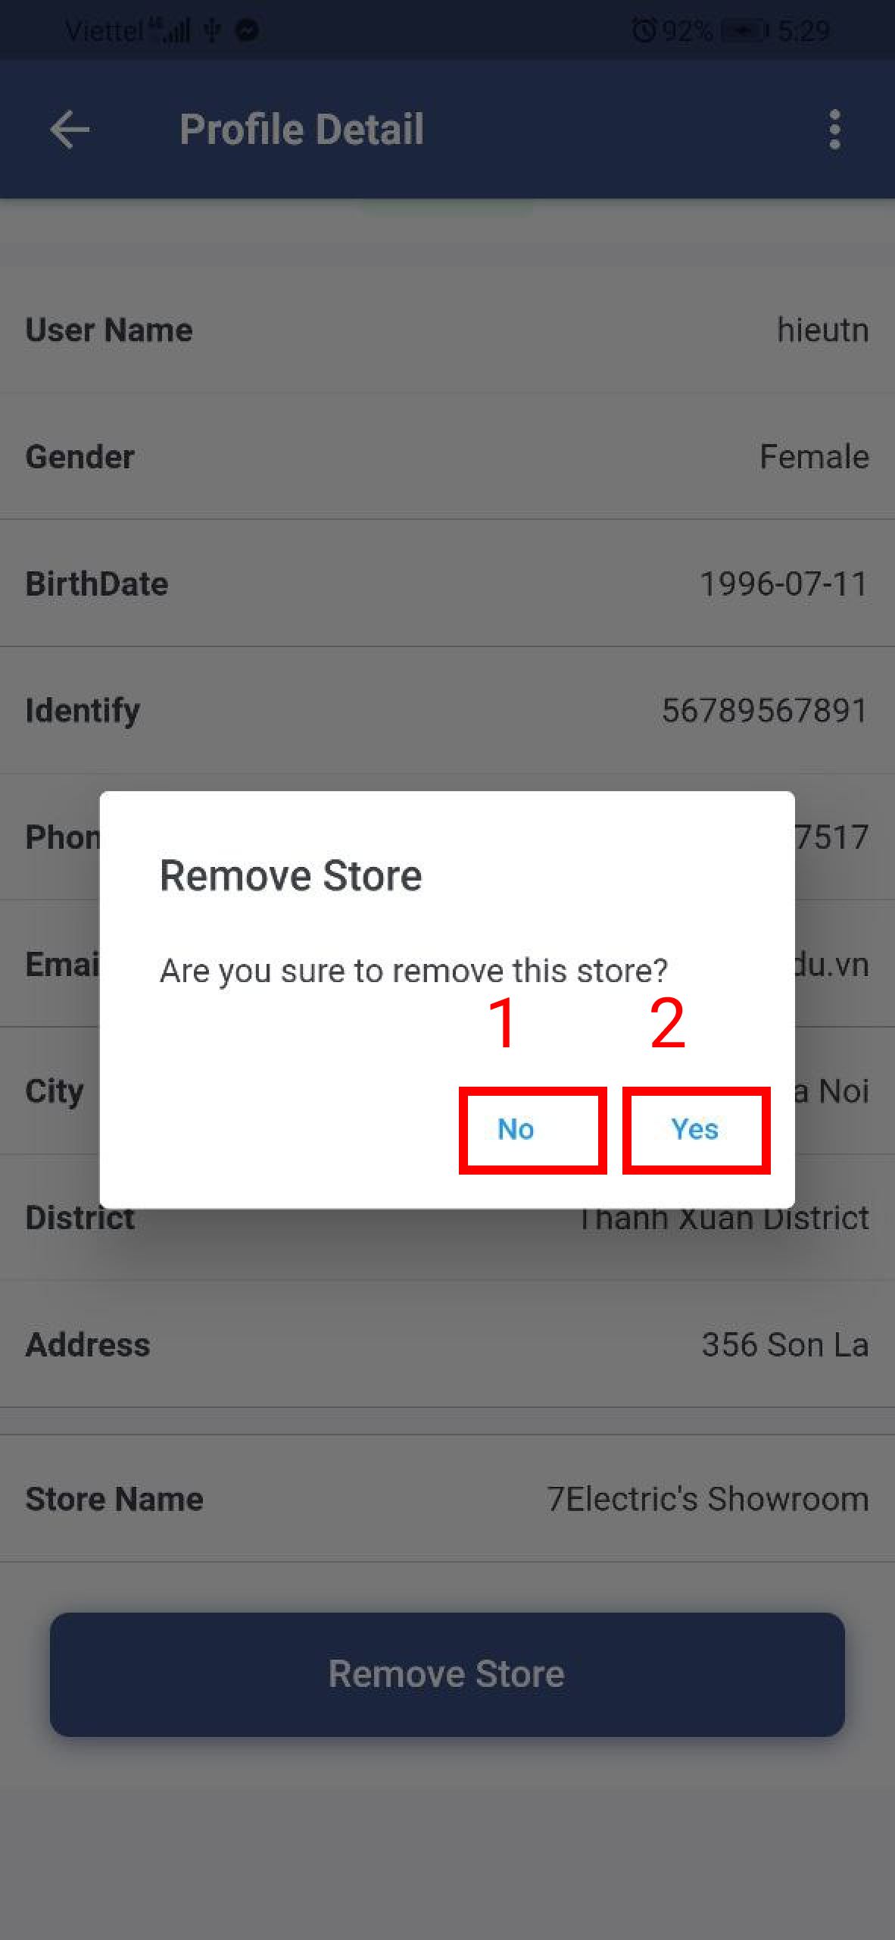

Figure . Remove the store from the manager

Table . <User Guide> Remove the store from the manager

|  |  |
| --- | --- |
| **Step** | **Description** |
| 1 | Admin clicks the “No” button to cancel the command. |
| 2 | Admin clicks the “Yes” button to remove the store from the manager. |

##### h. Store page



Figure . Store page

Table . <User Guide> Store page

|  |  |
| --- | --- |
| **Step** | **Description** |
| 1 | Admin inputs the search value and chooses the value of filter. |
| 2 | Admin clicks the item to view the store detail page. |
| 3 | Admin clicks the “Add” icon to create the store. |

1. Create the store



Figure . Create the store

Table . <User Guide> Create the store

|  |  |
| --- | --- |
| **Step** | **Description** |
| 1 | Admin clicks the “Back” icon to cancel the command. |
| 2 | Admin inputs the store’s information. |
| 3 | Admin clicks the “Create” button to create the store. |

##### i. Store detail page



Figure . Store detail page



Figure . Store detail page

Table . <User Guide> Store detail page

|  |  |
| --- | --- |
| **Step** | **Description** |
| 1 | Admin clicks the item to change the store’s information. |
| 2 | Admin clicks the item to change the store’s image. |
| 3 | Admin clicks the item to delete the store. |
| 4 | Admin clicks the “Choose Manager” button to choose the manager from the store. |
| 5 | Admin clicks the “Remove Manager” button remove the manager from the store. |

1. Change the store’s information



Figure . Change the store’s information

Table . <User Guide> Change the store’s information

|  |  |
| --- | --- |
| **Step** | **Description** |
| 1 | Admin clicks the “Back” icon to cancel the command. |
| 2 | Admin inputs the store’s information. |
| 3 | Admin clicks the “Save” button to change the store’s information. |

2. Change the store’s image.



Figure . Change the store’s image



Figure . Change the store’s image

Table . <User Guide> Change the store’s image

|  |  |
| --- | --- |
| **Step** | **Description** |
| 1 | Admin clicks the “Back” icon to cancel the command. |
| 2 | Admin clicks the “Camera” icon to choose image from mobile. |
| 3 | Admin clicks the “Save” button to change the store’s image. |

3. Delete the store.



Figure . Delete the store

Table . <User Guide> Delete the store

|  |  |
| --- | --- |
| **Step** | **Description** |
| 1 | Admin clicks the “Back” icon to cancel the command. |
| 2 | Admin inputs an inactive reason. |
| 3 | Admin clicks the “Save” button to delete the store. |

4. Add the manager into the store



Figure . Add the manager into the store



Figure . Add the manager into the store

Table . <User Guide> Add the manager into the store

|  |  |
| --- | --- |
| **Step** | **Description** |
| 1 | Admin inputs the search value to find the manager by full name. |
| 2 | Admin chooses the manager item. |
| 3 | Admin clicks the “No” button to cancel the command. |
| 4 | Admin clicks the “Yes” button to add the manager into the store. |

1. Remove the manager from the store



Figure . Remove the manager from the store

Table . <User Guide> Remove the manager from the store

|  |  |
| --- | --- |
| **Step** | **Description** |
| 1 | Admin clicks the “No” button to cancel the command. |
| 2 | Admin clicks the “Yes” button to remove the manager from the store. |

##### j. Camera page



Figure . Camera page

Table . <User Guide> Camera page

|  |  |
| --- | --- |
| **Step** | **Description** |
| 1 | Admin inputs the search value and chooses the value of filter. |
| 2 | Admin clicks the item to view the camera detail page. |
| 3 | Admin clicks the “Add” icon to create the camera. |

1. Create the camera



Figure . Create the camera

Table . <User Guide> Create the camera

|  |  |
| --- | --- |
| **Step** | **Description** |
| 1 | Admin clicks the “Back” icon to cancel the command. |
| 2 | Admin inputs the camera’s information. |
| 3 | Admin clicks the “Create” button to create the camera. |

##### k. Camera detail



Figure . Camera detail page

Table . <User Guide> Camera detail page

|  |  |
| --- | --- |
| **Step** | **Description** |
| 1 | Admin clicks the item to change the camera’s information. |
| 2 | Admin clicks the item to change the camera’s image. |
| 3 | Admin clicks the item to delete the camera. |

1. Change the camera’s information



Figure . Change the camera’s information

Table . <User Guide> Change the camera’s information

|  |  |
| --- | --- |
| **Step** | **Description** |
| 1 | Admin clicks the “Back” icon to cancel the command. |
| 2 | Admin inputs the camera’s information. |
| 3 | Admin clicks the “Save” button to change the camera’s information. |

2. Change the camera’s image.



Figure . Change the camera’s image



Figure . Change the camera’s image

Table . <User Guide> Change the camera’s image

|  |  |
| --- | --- |
| **Step** | **Description** |
| 1 | Admin clicks the “Back” icon to cancel the command. |
| 2 | Admin clicks the “Camera” icon to choose image from mobile. |
| 3 | Admin clicks the “Save” button to change the camera’s image. |

3. Delete the camera



Figure . Delete the camera

Table . <User Guide> Delete the camera

|  |  |
| --- | --- |
| **Step** | **Description** |
| 1 | Admin clicks the “Back” icon to cancel the command. |
| 2 | Admin inputs an inactive reason. |
| 3 | Admin clicks the “Save” button to delete the camera. |

##### l. Product page



Figure . Product page

Table . <User Guide> Product page

|  |  |
| --- | --- |
| **Step** | **Description** |
| 1 | Admin inputs the search value and chooses the value of filter. |
| 2 | Admin clicks the item to view the product detail page. |
| 3 | Admin clicks the “Add” icon to create the product. |

1. Create the product



Figure . Create the product

Table . <User Guide> Create the product

|  |  |
| --- | --- |
| **Step** | **Description** |
| 1 | Admin clicks the “Back” icon to cancel the command. |
| 2 | Admin inputs the product’s information. |
| 3 | Admin clicks the “Create” button to create the product. |

##### m. Product detail page



Figure . Product detail page

Table . <User Guide> Product detail page

|  |  |
| --- | --- |
| **Step** | **Description** |
| 1 | Admin clicks the item to change the product’s information. |
| 2 | Admin clicks the item to change the product’s image. |
| 3 | Admin clicks the item to delete the product. |

1. Change the product’s information.



Figure . Change the product’s information

Table . <User Guide> Change the product’s information

|  |  |
| --- | --- |
| **Step** | **Description** |
| 1 | Admin clicks the “Back” icon to cancel the command. |
| 2 | Admin inputs the product’s information. |
| 3 | Admin clicks the “Save” button to change the product’s information. |

2. Change the product’s image



Figure . Change the product’s image



Figure . Change the product’s image

Table . <User Guide> Change the product’s image

|  |  |
| --- | --- |
| **Step** | **Description** |
| 1 | Admin clicks the “Back” icon to cancel the command. |
| 2 | Admin clicks the “Camera” icon to choose image from mobile. |
| 3 | Admin clicks the “Save” button to change the product’s image. |

3. Delete the product



Figure . Delete the product

Table . <User Guide> Delete the product

|  |  |
| --- | --- |
| **Step** | **Description** |
| 1 | Admin clicks the “Back” icon to cancel the command. |
| 2 | Admin inputs an inactive reason. |
| 3 | Admin clicks the “Save” button to delete the product. |

##### n. Category page



Figure . Category page

Table . <User Guide> Category page

|  |  |
| --- | --- |
| **Step** | **Description** |
| 1 | Admin inputs the search value and chooses the value of filter. |
| 2 | Admin clicks the item to view the category detail page. |
| 3 | Admin clicks the “Add” icon to create the category. |

1. Create the category



Figure . Create the category

Table . <User Guide> Create the category

|  |  |
| --- | --- |
| **Step** | **Description** |
| 1 | Admin clicks the “Back” icon to cancel the command. |
| 2 | Admin inputs the category’s information. |
| 3 | Admin clicks the “Create” button to create the category. |

##### o. Category detail page



Figure . Category detail page

Table . <User Guide> Category detail page

|  |  |
| --- | --- |
| **Step** | **Description** |
| 1 | Admin clicks the item to change the category’s information. |
| 2 | Admin clicks the item to delete the category. |

1. Change the category’s information.



Figure . Change the category’s information

Table . <User Guide> Change the category’s information

|  |  |
| --- | --- |
| **Step** | **Description** |
| 1 | Admin clicks the “Back” icon to cancel the command. |
| 2 | Admin inputs the category’s information. |
| 3 | Admin clicks the “Save” button to change the category’s information. |

2. Delete the category



Figure . Delete the category

Table . <User Guide> Delete the category

|  |  |
| --- | --- |
| **Step** | **Description** |
| 1 | Admin clicks the “No” button to cancel the command. |
| 2 | Admin clicks the “Yes” button to delete the category. |

#### 3.1.4. CFFE-Mobile-Manager

##### a. Overview

Application used by manager when want to:

+ Login

+ Logout

+ Manage own profile

+ View statistics

+ View video

+ Manage shelf

+ Manage stack

+ Manage camera

+ Manage product



Figure . <Flow Screen> Mobile Application - Manager

##### b. Login page



Figure . Login page

Table . <User Guide> Login page

|  |  |
| --- | --- |
| **Step** | **Description** |
| 1 | Manager inputs the account. |
| 2 | Manager clicks the “Login” button. |

##### c. Home page



Figure . Dashboard page



Figure . Navigator

Table . <User Guide> Dashboard page

|  |  |
| --- | --- |
| **Step** | **Description** |
| 1 | Manager clicks the “navigator” icon to view drawer navigator. |
| 2 | Manager clicks the “Profile” item to view own profile. |
| 3 | Manager clicks the “Logout” item to logout from the application. |

##### d. Profile page



Figure . Manager profile page

Table . <User Guide> Manager profile page

|  |  |
| --- | --- |
| **Step** | **Description** |
| 1 | Manager clicks the item to change own information. |
| 2 | Manager clicks the item to change own avatar. |
| 3 | Manager clicks the item to change own password. |

1. Change own information.



Figure . Change the own information

Table . <User Guide> Change the own information

|  |  |
| --- | --- |
| **Step** | **Description** |
| 1 | Manager clicks the “Back” icon to cancel the command. |
| 2 | Manager edits the information. |
| 3 | Manager clicks the “Save” button to change own information |

2. Change own avatar.



Figure . Change own avatar



Figure . Change own avatar

Table . <User Guide> Change own avatar

|  |  |
| --- | --- |
| **Step** | **Description** |
| 1 | Manager clicks the “Back” icon to cancel the command. |
| 2 | Manager clicks the “Camera” icon to choose image from mobile. |
| 3 | Manager clicks the “Save” button to change own avatar. |

1. Change own password



Figure . Change own password

Table . <User Guide> Change own password

|  |  |
| --- | --- |
| **Step** | **Description** |
| 1 | Manager clicks the “Back” icon to cancel the command. |
| 2 | Manager inputs the information. |
| 3 | Manager clicks the “Update” button to change own password. |

##### e. Video page



Figure . Video page

Table . <User Guide> Video page

|  |  |
| --- | --- |
| **Step** | **Description** |
| 1 | Manager chooses the value of filter to search the video. |
| 2 | Manager clicks the “Search” button to search the video. |
| 3 | Manager clicks the item to view the video detail page. |

##### f. Shelf page



Figure . Shelf page

Table . <User Guide> Shelf page

|  |  |
| --- | --- |
| **Step** | **Description** |
| 1 | Manager inputs the search value and chooses the value of filter. |
| 2 | Manager clicks the item to view the shelf detail page. |
| 3 | Manager clicks the “Add” icon to create the shelf. |

1. Create the shelf



Figure . Create the shelf

Table . <User Guide> Create the shelf

|  |  |
| --- | --- |
| **Step** | **Description** |
| 1 | Manager clicks the “Back” icon to cancel the command. |
| 2 | Manager inputs the shelf’s information. |
| 3 | Manager clicks the “Create” button to create the shelf. |

##### g. Shelf detail page



Figure . Shelf detail page



Figure . Shelf detail page

Table . <User Guide> Shelf detail page

|  |  |
| --- | --- |
| **Step** | **Description** |
| 1 | Manager clicks the item to change the shelf’s information. |
| 2 | Manager clicks the item to delete the shelf. |
| 3 | Manager clicks the “Add” icon to add the camera into the shelf. |
| 4 | Manager clicks the item to view stack detail page. |
| 5 | Manager clicks the “Remove” icon to remove the camera from the shelf. |

1. Change the shelf’s information



Figure . Change the shelf’s information

Table . <User Guide> Change the shelf’s information

|  |  |
| --- | --- |
| **Step** | **Description** |
| 1 | Manager clicks the “Back” icon to cancel the command. |
| 2 | Manager inputs the shelf’s information. |
| 3 | Manager clicks the “Save” button to change the shelf’s information. |

1. Delete the shelf



Figure . Delete the shelf

Table . <User Guide> Delete the shelf

|  |  |
| --- | --- |
| **Step** | **Description** |
| 1 | Manager clicks the “Back” icon to cancel the command. |
| 2 | Manager inputs an inactive reason. |
| 3 | Manager clicks the “Save” button to delete the shelf. |

1. Add the camera into the shelf



Figure . Add the camera into the shelf

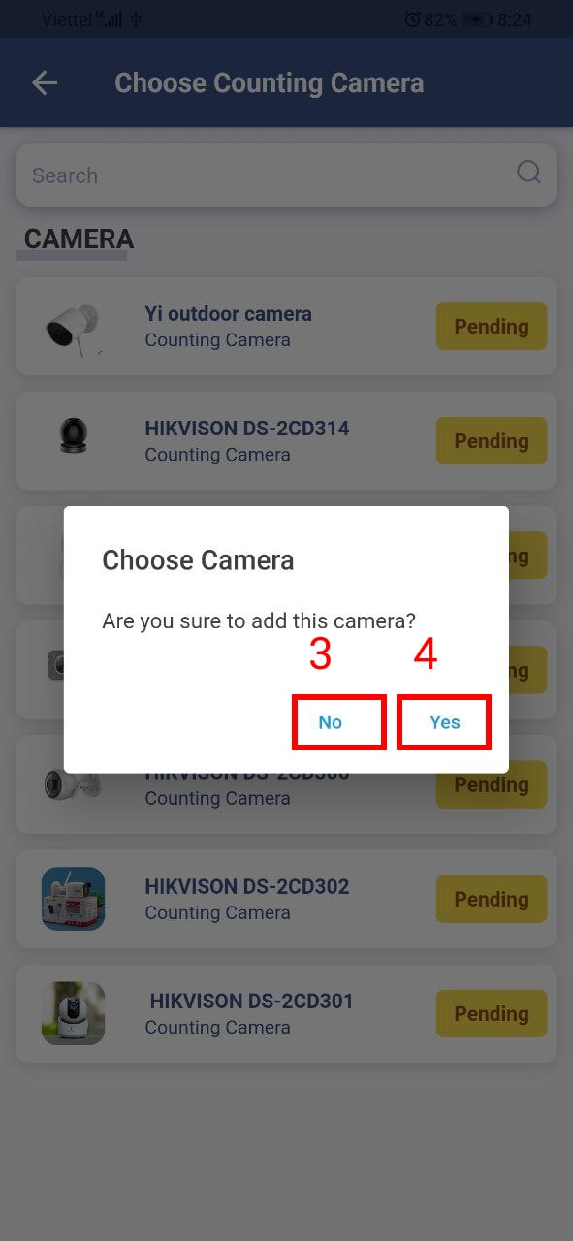

Figure . Add the camera into the shelf

Table . <User Guide> Add the camera into the shelf

|  |  |
| --- | --- |
| **Step** | **Description** |
| 1 | Manager inputs the search value to find the camera by name. |
| 2 | Manager chooses the camera item. |
| 3 | Manager clicks the “No” button to cancel the command. |
| 4 | Manager clicks the “Yes” button to add the camera into the shelf. |

1. Remove the camera from the shelf



Figure . Remove the camera form the shelf

Table . <User Guide> Remove the camera from the shelf

|  |  |
| --- | --- |
| **Step** | **Description** |
| 1 | Manager clicks the “No” button to cancel the command. |
| 2 | Manager clicks the “Yes” button to remove the camera from the shelf. |

##### h. Stack detail page



Figure . Stack detail page



Figure . Stack detail page

Table . <User Guide> Stack detail page

|  |  |
| --- | --- |
| **Step** | **Description** |
| 1 | Manager clicks the item to delete the stack. |
| 2 | Manager clicks the “Add” icon to add the product into the stack. |
| 3 | Manager clicks the “Add” icon to add the camera into the stack. |
| 4 | Manager clicks the “Remove” icon to remove the camera from the stack. |
| 5 | Manager clicks the “Remove” icon to remove the product from the stack. |

1. Delete the stack.



Figure . Delete the stack

Table . <User Guide> Delete the stack

|  |  |
| --- | --- |
| **Step** | **Description** |
| 1 | Manager clicks the “Back” icon to cancel the command. |
| 2 | Manager inputs an inactive reason. |
| 3 | Manager clicks the “Save” button to delete the stack. |

1. Add the product into the stack.



Figure . Add the product into the stack



Figure . Add the product into the stack

Table . <User Guide> Add the product into the stack

|  |  |
| --- | --- |
| **Step** | **Description** |
| 1 | Manager inputs the search value to find the product by name. |
| 2 | Manager chooses the product item. |
| 3 | Manager clicks the “No” button to cancel the command. |
| 4 | Manager clicks the “Yes” button to add the product into the stack. |

1. Add the camera into the stack.



Figure . Add the camera into the stack



Figure . Add the camera into the stack

Table . <User Guide> Add the camera into the stack

|  |  |
| --- | --- |
| **Step** | **Description** |
| 1 | Manager inputs the search value to find the camera by name. |
| 2 | Manager chooses the camera item. |
| 3 | Manager clicks the “No” button to cancel the command. |
| 4 | Manager clicks the “Yes” button to add the camera into the stack. |

1. Remove the camera from the stack.

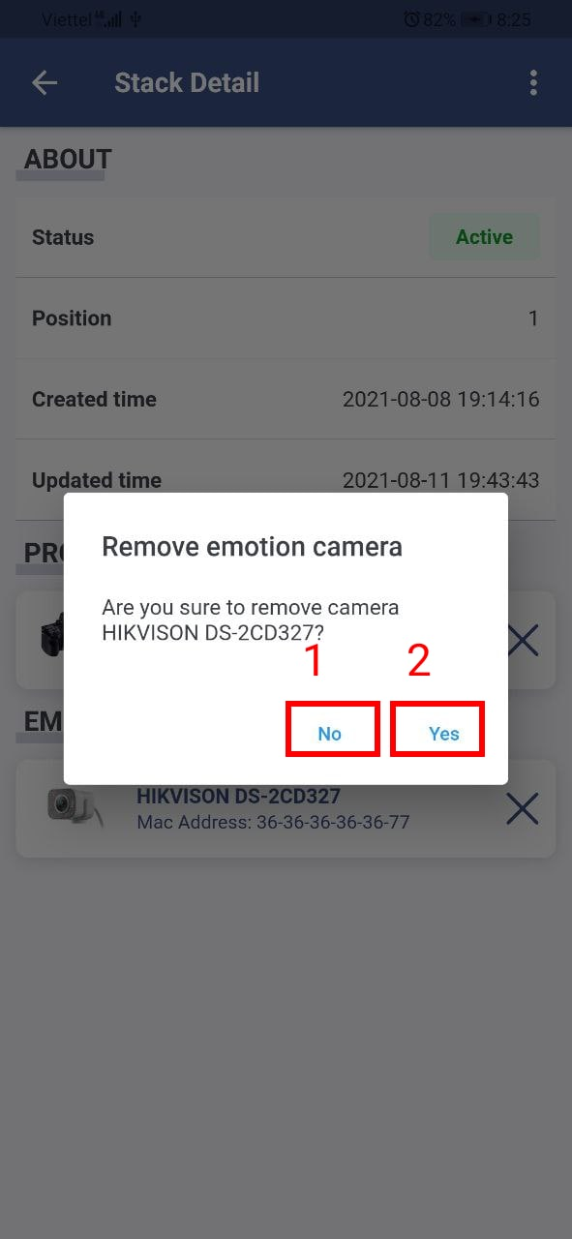

Figure . Remove the camera from the stack

Table . <User Guide> Remove the camera from the stack

|  |  |
| --- | --- |
| **Step** | **Description** |
| 1 | Manager clicks the “No” button to cancel the command. |
| 2 | Manager clicks the “Yes” button to remove the camera from the stack. |

1. Remove the product from the stack.



Figure . Remove the product from the stack

Table . <User Guide> Remove the product from the stack

|  |  |
| --- | --- |
| **Step** | **Description** |
| 1 | Manager clicks the “No” button to cancel the command. |
| 2 | Manager clicks the “Yes” button to remove the product from the stack. |

##### i. Camera page



Figure . Camera page

Table . <User Guide> Camera page

|  |  |
| --- | --- |
| **Step** | **Description** |
| 1 | Manager inputs the search value and chooses the value of filter. |
| 2 | Manager clicks the item to view the camera detail page. |

##### j. Product page



Figure . Product page

Table . <User Guide> Product page

|  |  |
| --- | --- |
| **Step** | **Description** |
| 1 | Manager inputs the search value and chooses the value of filter. |
| 2 | Manager clicks the item to view the product detail page. |

##### k. Category page



Figure . Category page

Table . <User Guide> Category page

|  |  |
| --- | --- |
| **Step** | **Description** |
| 1 | Manager inputs the search value and chooses the value of filter. |
| 2 | Manager clicks the item to view the category detail page. |

# VII. Appendix

## 1. Glossary

See section Definition and Acronyms.

## 2. References

1. [Transfer-learning](https://phamdinhkhanh.github.io/2020/04/15/TransferLearning.html)
2. [Basic deep learning](https://nttuan8.com/sach-deep-learning-co-ban/)
3. [Python documentation](https://www.python.org/doc/)
4. [Flutter documentation](https://flutter.dev/docs)
5. [Vuejs documentation](https://vuejs.org/v2/guide/)
6. [Ant-design UI components](https://antdv.com/docs/vue/introduce-cn/)
7. [Spring documentation](https://spring.io/projects/spring-boot)
8. [Mybatis documentation](https://mybatis.org/mybatis-3/)
9. [MySQL documentation](https://dev.mysql.com/doc/)
10. [Tensorflow documentation](https://www.tensorflow.org/tutorials)
11. [Keras documentation](https://keras.io/api/)
12. [Google Cloud documentation](https://cloud.google.com/docs)
13. [Jenkins documentation](https://www.jenkins.io/doc/)
14. [FER-2013 dataset](https://www.kaggle.com/msambare/fer2013)
15. [VGG-face descriptor](https://www.robots.ox.ac.uk/~vgg/software/vgg_face/)
16. [MTCNN paper](https://arxiv.org/abs/1604.02878)
17. [Very deep convolution networks for large-scale image recognition paper](https://arxiv.org/abs/1409.1556)
18. [SSD: Signle Shot Multibox detector paper](https://arxiv.org/pdf/1512.02325v4.pdf)
19. [Euchidean distance](https://en.wikipedia.org/wiki/Euclidean_distance)
20. [Emotion classification tutorial](https://github.com/aakashagarwal6898/Emotion-Detection-using-Keras)
21. [Deep Facial Expression Recognition](https://arxiv.org/pdf/1804.08348.pdf)
22. [Entity Relation Diagram](https://www.visual-paradigm.com/guide/data-modeling/what-is-entity-relationship-diagram/)
23. [Use case diagram](https://www.uml-diagrams.org/use-case-diagrams.html)
24. [Class diagram](https://www.uml-diagrams.org/class-diagrams-overview.html)
25. [Sequence diagram](https://www.uml-diagrams.org/sequence-diagrams.html)
26. [Activity diagram](https://www.uml-diagrams.org/activity-diagrams.html)
27. [DevOps tutorial](https://www.guru99.com/devops-tutorial.html)
28. [Single Shot MultiBox Detector architecture](https://phamdinhkhanh.github.io/2019/10/05/SSDModelObjectDetection.html)
29. [Object Tracking algorithm](https://www.pyimagesearch.com/2018/07/23/simple-object-tracking-with-opencv/)
30. [Single Shot MultiBox Detector science](https://www.cs.unc.edu/~wliu/papers/ssd_eccv2016_slide.pdf)